Complete Roadmap
Hum total 11 implementation steps karenge.
Phase 1 → Backend
✅ Step 1
Project verify karenge

✅ Step 2
Backend Dockerfile banayenge

✅ Step 3
Backend .dockerignore banayenge

✅ Step 4
Docker Image Build karenge

✅ Step 5
Backend Container Run karenge

✅ Step 6
Backend Test karenge
Browser
Postman
Docker logs

Phase 2
Frontend

✅ Step 7
Production Build

✅ Step 8
Frontend Dockerfile
(Multi-stage Build)

✅ Step 9
Frontend Docker Image Build

✅ Step 10
Run Frontend Container

✅ Step 11
Final Testing
Browser
Docker

Submission Ready
End mein hum ye sab ready karenge:
✅ Backend Dockerfile
✅ Backend .dockerignore
✅ Frontend Dockerfile
✅ docker ps screenshot
✅ Frontend screenshot
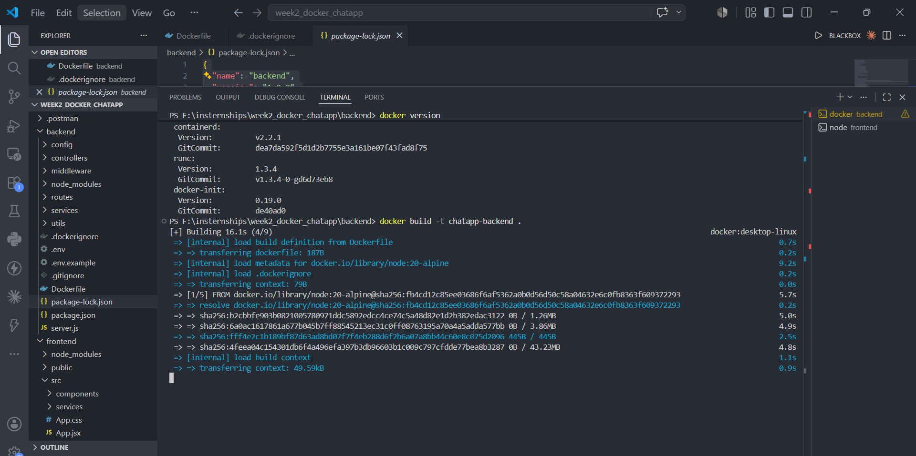
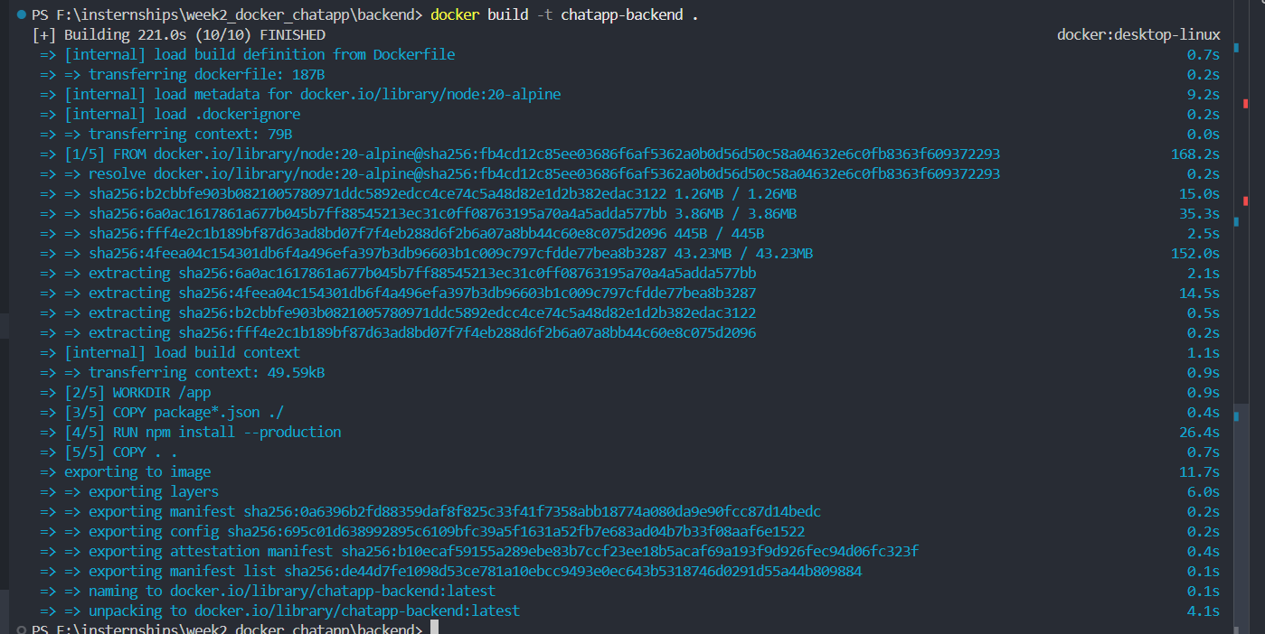
✅ Dockerfile read hua.
✅ .dockerignore read hui.
✅ node:20-alpine image download hui.
✅ npm install --production successful hua.
✅ Image successfully create ho gayi.
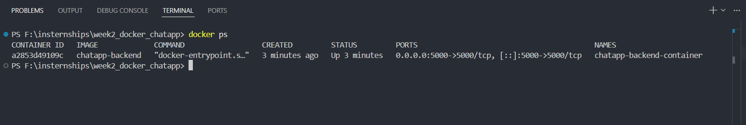
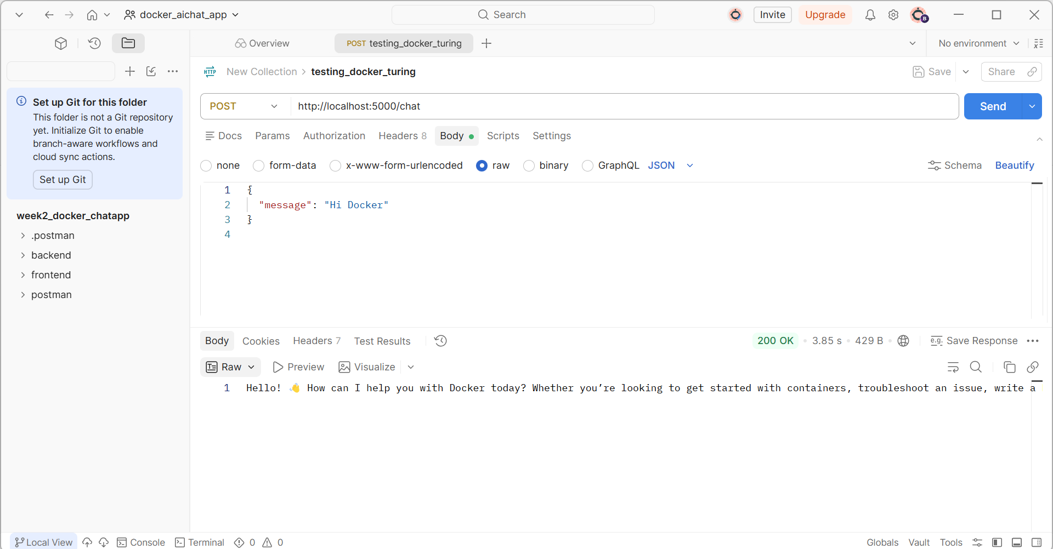
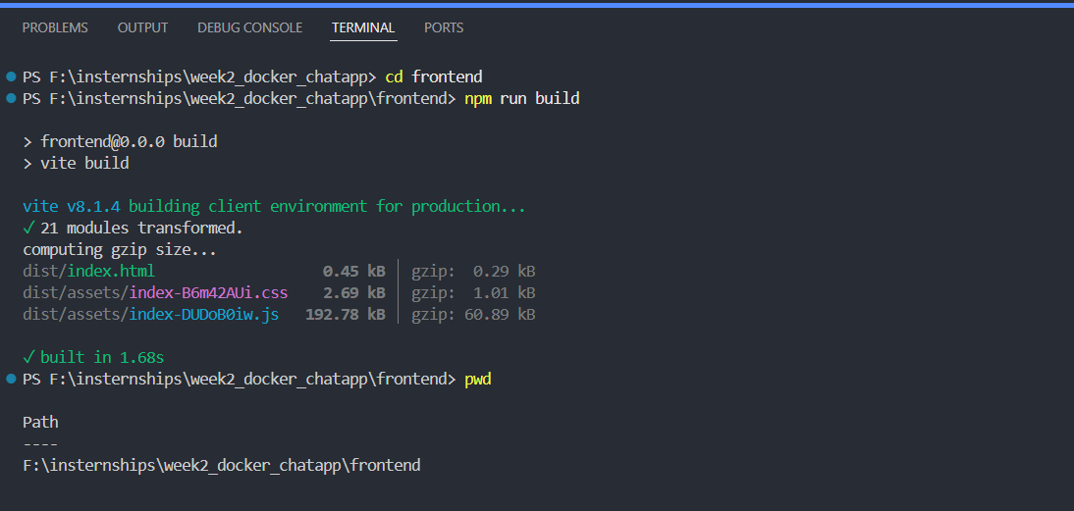
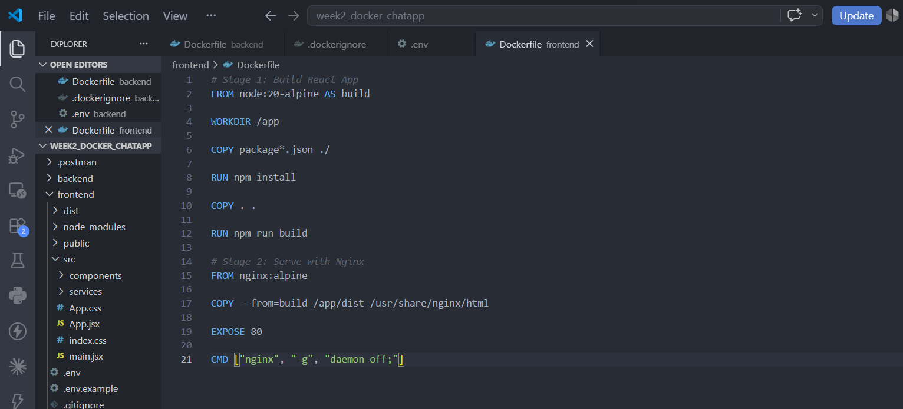
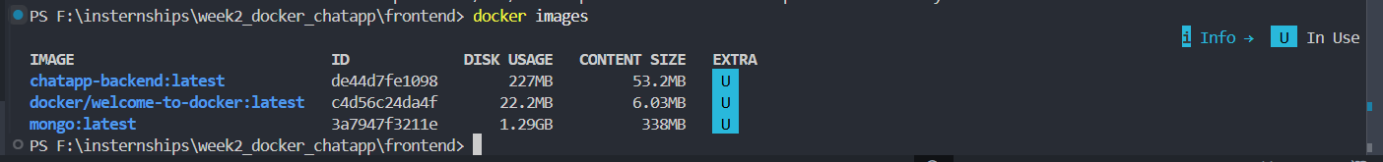
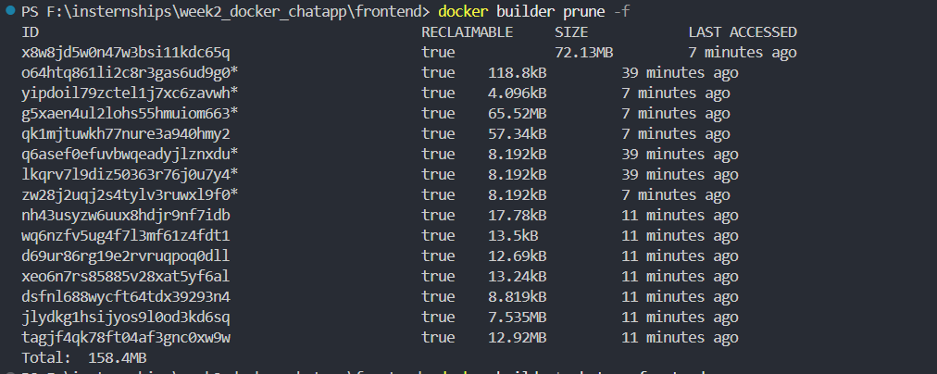

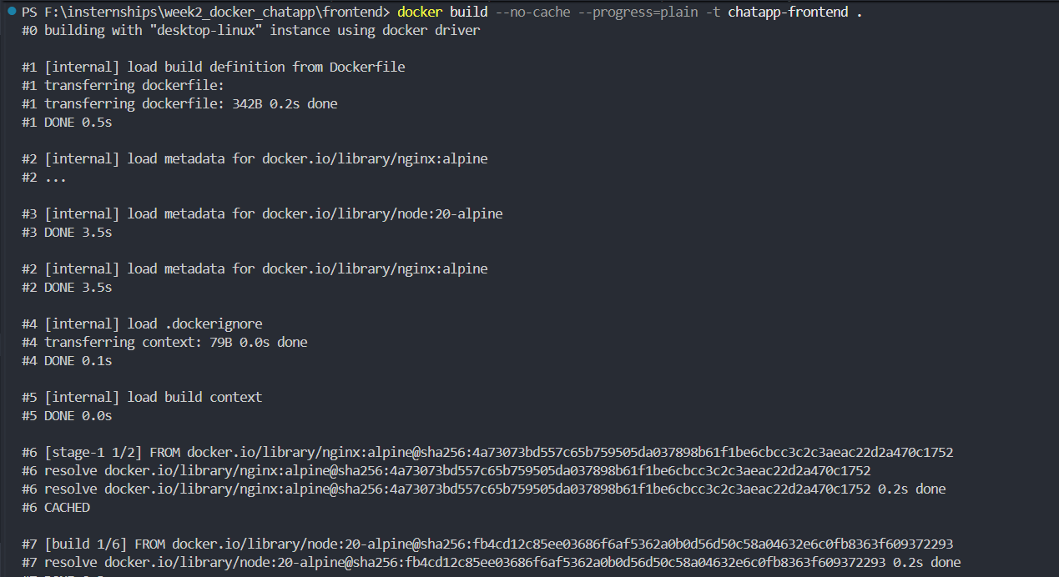
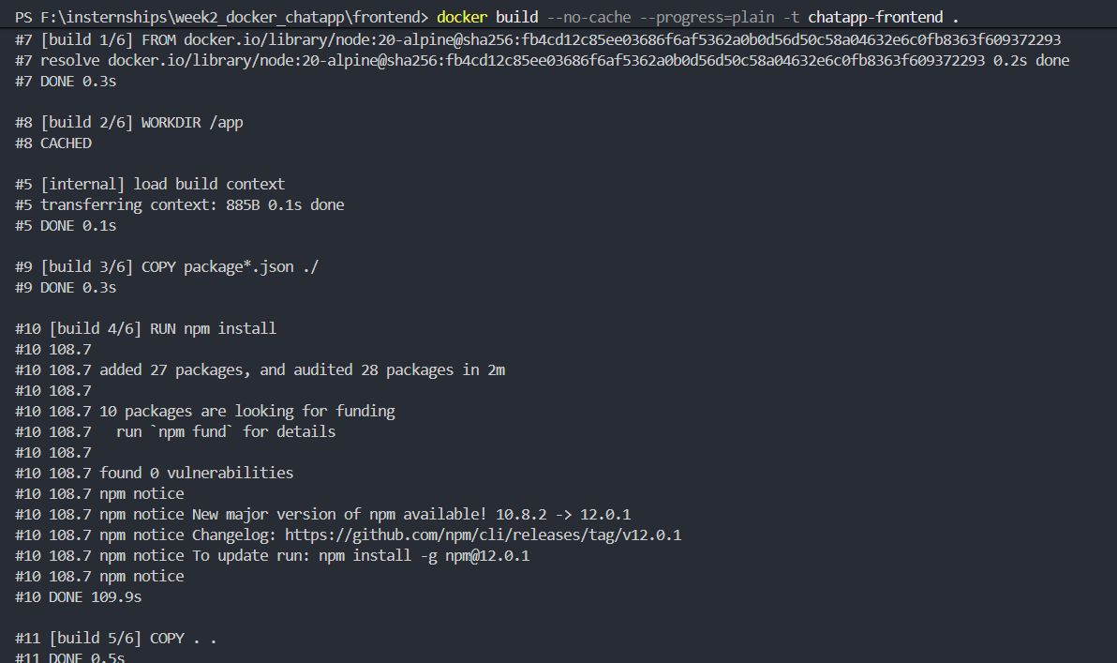
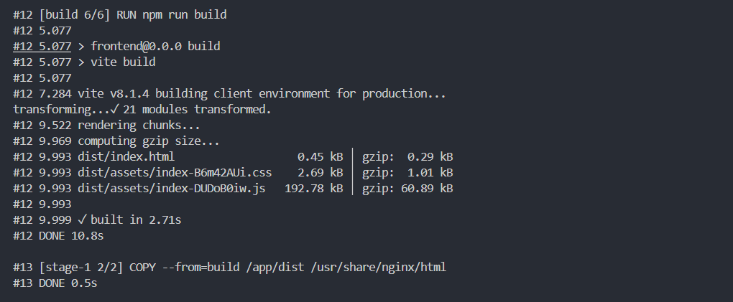
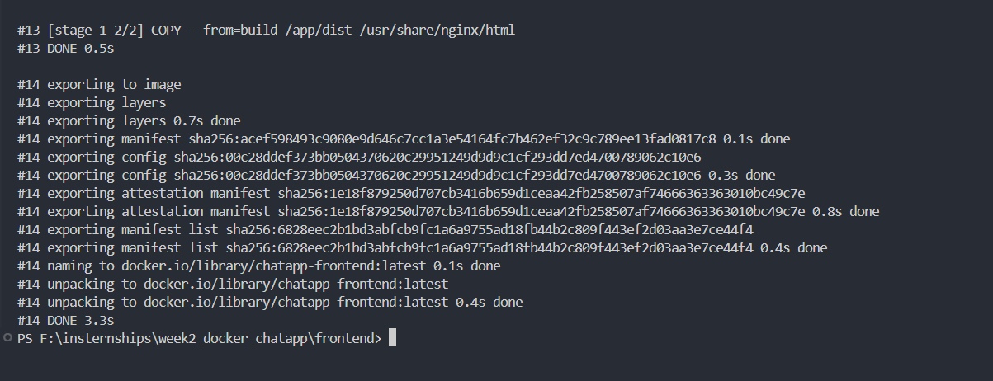
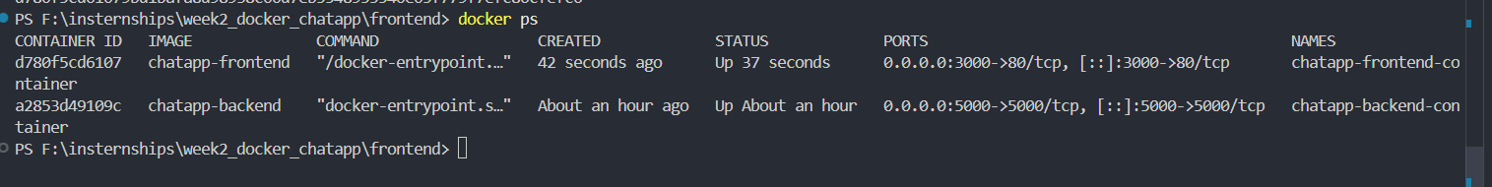

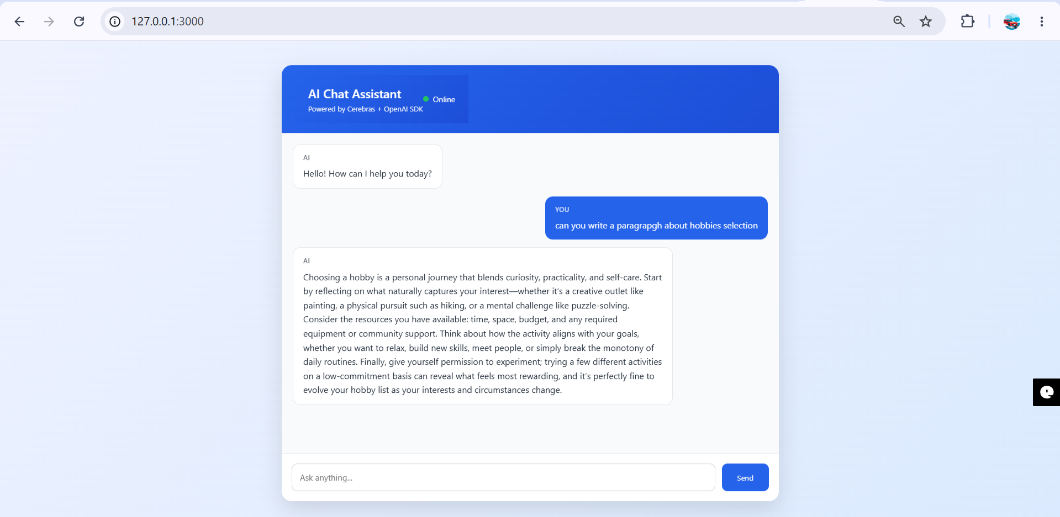
http://127.0.0.1:3000

