TASK 6: ENVIRONMENT VARIABLES IN PRODUCTION
VPS ko API key kaise milegi?
✅ VPS par manually .env banegi.
GitHub Secrets
Ye GitHub Action use karti hai. Ye deployment ke liye hote hain.Application inhe directly use nahi karti.
VPS .env
Ye application use karti hai.
Example
PORT
MONGO_URI
CEREBRAS_API_KEY
JWT_SECRET
BASE_URL
Ye Express app padhti hai.
Production .env
Created manually on VPS.
Never committed to Git.
Never copied into Docker image.


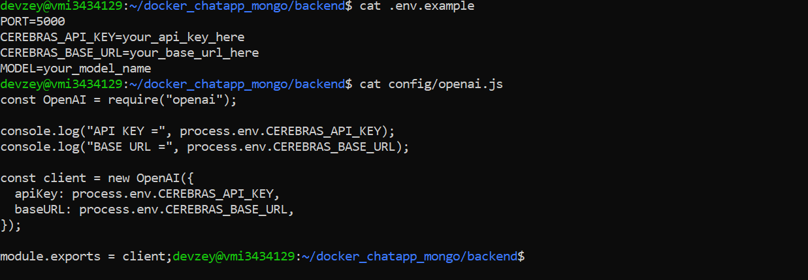
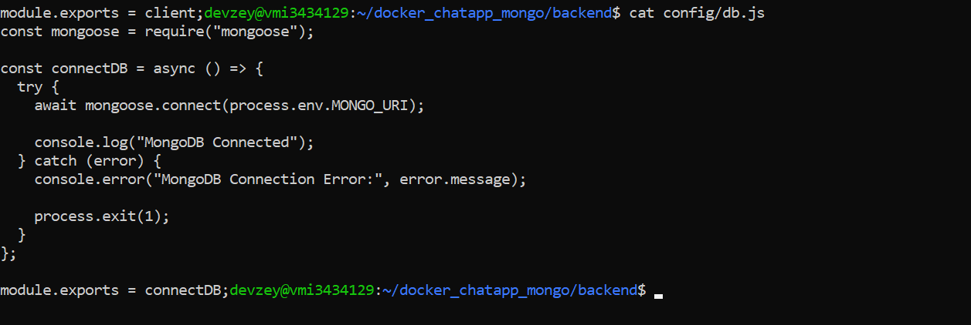
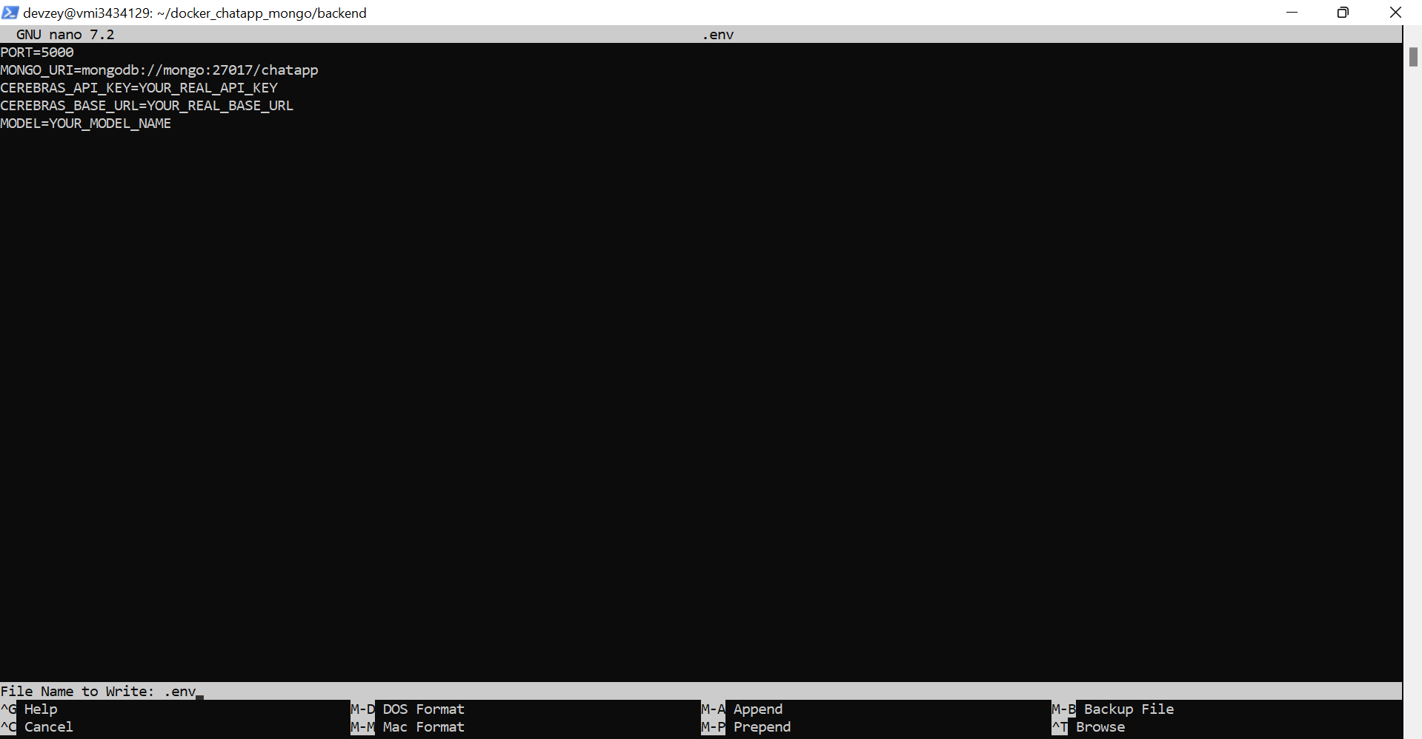

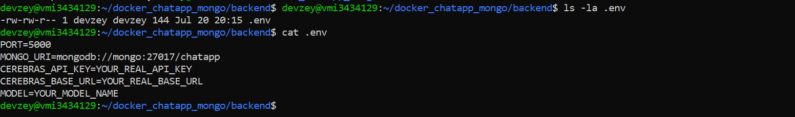
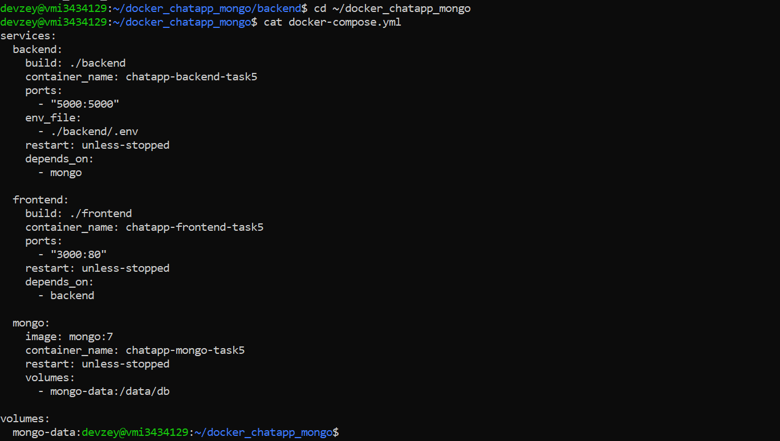

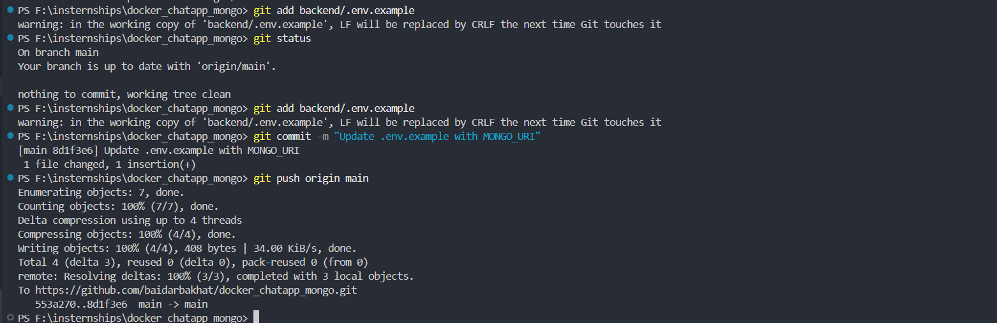
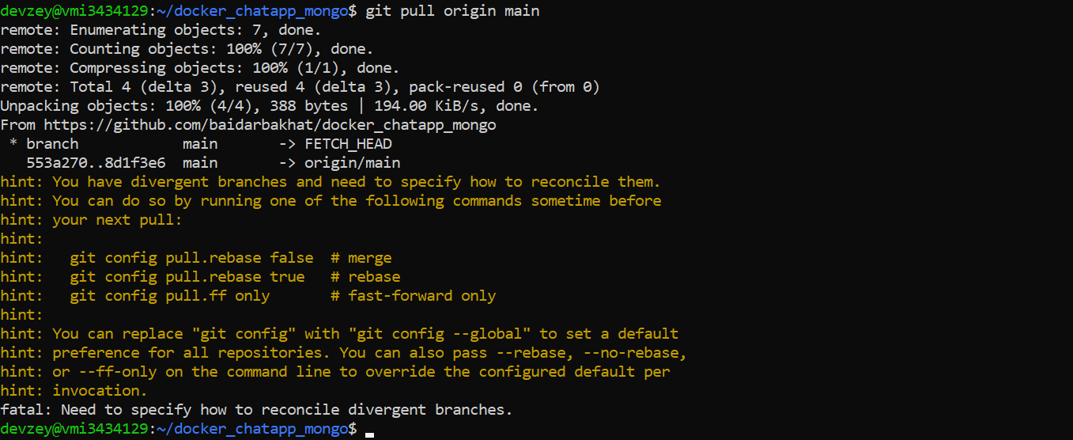

Production .env
- Created directly on VPS.
- Never pushed to GitHub.
- Ignored using .gitignore.
- Stores runtime secrets (API keys, DB URI).
GitHub Secrets
- Stored inside Settings → Secrets and variables → Actions.
- Used by GitHub Actions during deployment.
- Never visible after saving.
- Stores deployment credentials (VPS_HOST, VPS_USER, VPS_SSH_KEY).
Difference
- VPS .env → Application ke runtime secrets.
- GitHub Secrets → Deployment pipeline ke secrets.

