SSL kya secure karta hai?
Ye secure karta hai:
- Chat messages
- Login credentials
- Passwords
- Forms
- API requests
- Personal information
Browser ka padlock matlab:
- ✅ Connection encrypted hai
- ✅ Certificate trusted hai
- ✅ Domain verify hua hai
Certificate Authority (CA)
Certificate khud generate nahi hota.
Ek trusted organization issue karti hai.
Example:
- Let's Encrypt
- DigiCert
- GlobalSign
Certbot kya hai?
Certbot ek command line tool hai.
Ye automatically:
- certificate request karta hai
- domain verify karta hai
- SSL install karta hai
- Nginx configure karta hai
- renew bhi karta hai
Isliye Certbot automation tool hai.
• SSL/TLS: Encrypts communication between browser and server.
• TLS: Modern version of SSL.
• Let's Encrypt: Free Certificate Authority (CA).
• Certbot: Tool to automatically obtain, install, and renew SSL certificates.
• HTTP Port: 80.
• HTTPS Port: 443.
• Certificate Validity: 90 days.
• Renewal: Automatic using the Certbot systemd timer.
• Dry Run: Tests the renewal process without changing the live certificate.

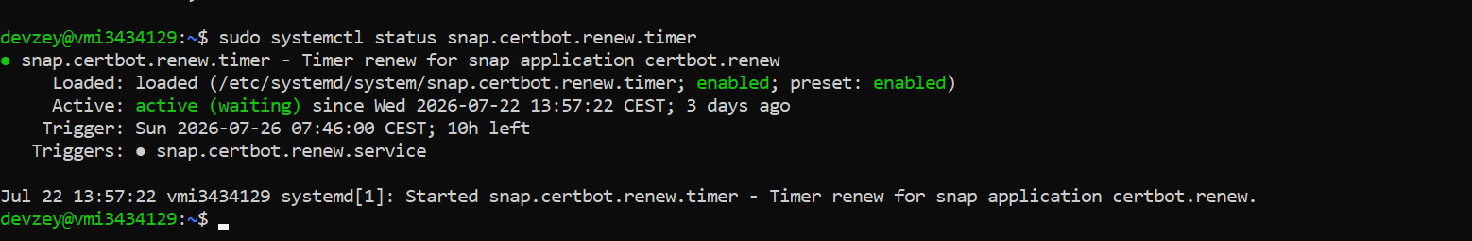

Q1. SSL/TLS kya hai?
Answer: SSL/TLS browser aur server ke darmiyan communication ko encrypt karta hai taake data secure rahe.

Q2. TLS aur SSL mein difference?
Answer: TLS SSL ka modern aur zyada secure version hai. Aaj kal practically TLS use hota hai, lekin log aam tor par "SSL" hi kehte hain.

Q3. Let's Encrypt kya hai?
Answer: Let's Encrypt ek free Certificate Authority (CA) hai jo trusted SSL/TLS certificates issue karti hai.

Q4. Certbot kya hai?
Answer: Certbot ek command-line tool hai jo Let's Encrypt se certificate issue, install aur renew automatically karta hai.

Q5. HTTP aur HTTPS ports?
- HTTP → 80
- HTTPS → 443

Q6. Certificate kitne din ke liye valid hota hai?
90 days

Q7. Dry Run kyun chalate hain?
Renewal process ko test karne ke liye, bina actual certificate renew kiye.

Q8. Auto-renewal kaise hota hai?
System timer (snap.certbot.renew.timer) automatically Certbot ko run karta hai aur expiry se pehle certificate renew kar deta hai.

