AI-Powered Traffic Queue Analysis and Rule Violation
Detection using Video Analytics
Problem Understanding
Urban traffic signals in India face many problems like heavy congestion, signal jumping, and unsafe driving. Most traffic systems still use fixed signal timings and depend on manual traffic police monitoring, which is not effective during peak hours. These systems cannot adjust based on real-time traffic conditions.
Nowadays, many traffic junctions are already monitored using CCTV cameras. By using computer vision and video analysis, traffic movement can be automatically observed to detect vehicle queues and traffic rule violations. This helps in better traffic monitoring and decision-making without the need for constant manual supervision.
The main objectives of the proposed system are:
- To analyze traffic video footage captured at signalized intersections.
- To detect and track different types of vehicles such as cars,bikes,buses, and trucks.
- To estimate queue length and traffic density near traffic signals.
- To identify traffic rule violations such as red signal jumping and unsafe vehicle movement.
- To display traffic analysis results through a simple web-based dashboard.
Input Traffic Video
↓
Vehicle Detection (YOLO)
↓
Multi-Object Tracking
↓
Queue Length & Density Estimation
↓
Violation Detection
↓
Streamlit Dashboard Visualization

Technical Approach :
The proposed system uses computer vision to analyze traffic video footage.
First, a pre-recorded traffic video is uploaded through a streamlit web interface.
The video is processed frame by frame using OpenCV .
Vehicle detection is done using the YOLO deep learning model, which identifies different vehicle types such as cars, two-wheelers, buses, and trucks.
To track vehicles across multiple frames, a centroid-based multi-object tracking method is used. Each vehicle is assigned a unique ID so that its movement can be monitored over time.
Queue length is estimated by counting the number of vehicles present near the traffic signal in a predefined queue region. Queue density is calculated based on the number of vehicles in this area.
Traffic rule violations are detected by defining a virtual stop line. When the signal is red, any vehicle crossing this line is marked as a violation.
As an additional feature, the system records the number plate of vehicles involved in violations for easy identification.
All results, including annotated video output and traffic statistics, are displayed on a single streamlit dashboard.
Dashboard & Visualization : Annotated video output
Real-time metrics : Total vehicles
Queue length
Queue density
Violations

Steamlit-based web interface :

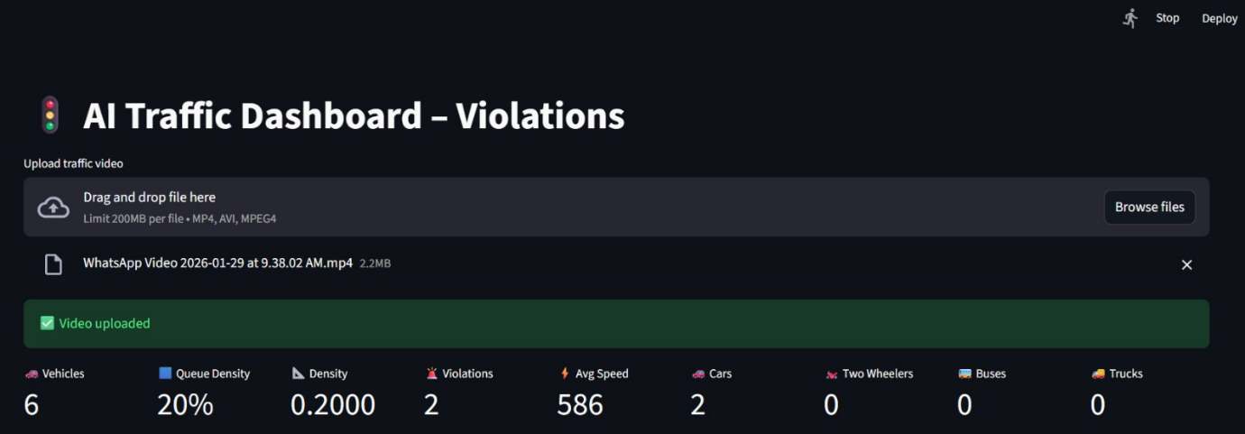

Assigning ID’s to vehicles:

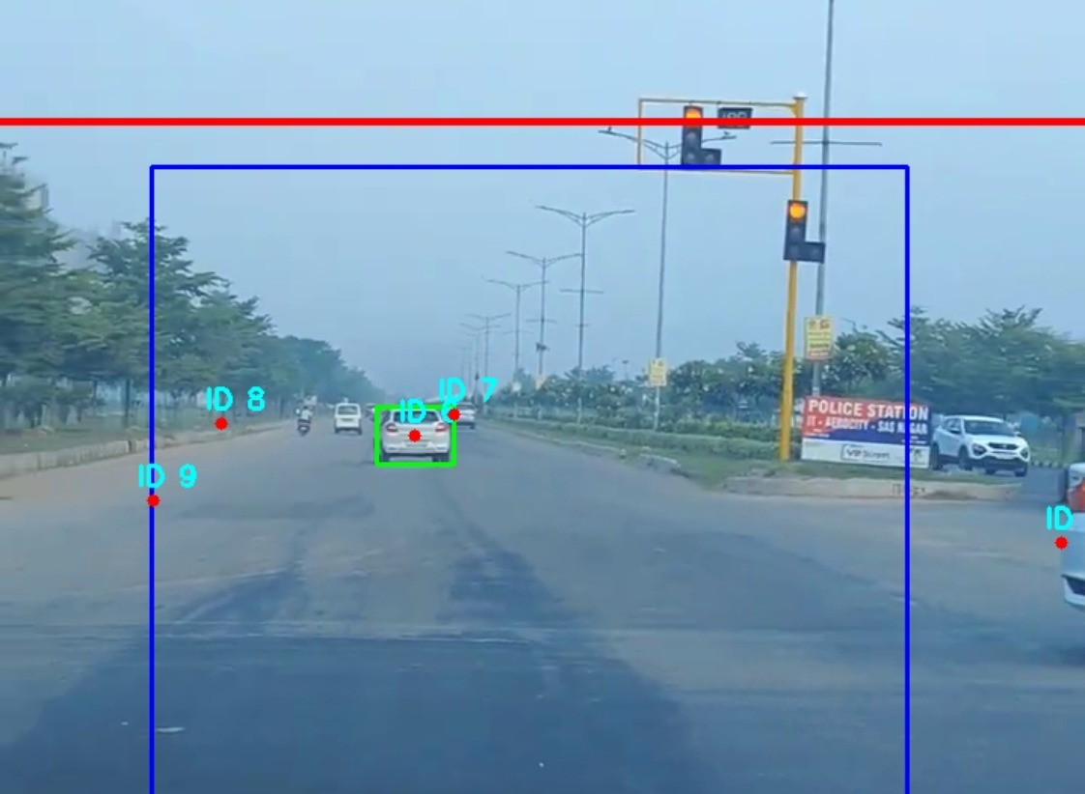

Additional Feature :
Vehicle Number Plate Recognition :
Apart from detecting traffic rule violations, the system also captures the numbers plate of vehicles that violate traffic rules.
When a red signal violation or rash driving is detected, the corresponding vehicle’s number plate is identified and recorded.
This feature helps in easy identification of violating vehicles and can assist traffic authorities in issuing penalties or warnings.

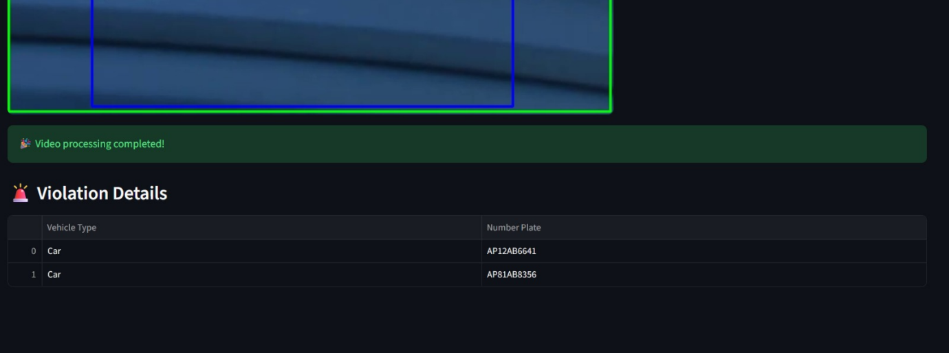

Future Scope :

- Automatic fine generation based on detected violations.
- Integration with government traffic databases.
- Multi-lane queue length estimation.
- Accident detection and alert system.
- Real-time dashboard with live CCTV feed.
- Speed violation detection.
- Emergency vehicle prioritization.

Conclusion :
This project demonstrates how computer vision can be effectively used to analyze traffic behavior and detect rule violations.
The system provides accurate queue analysis and violation detection using video analytics.
With further improvements, this solution can support smarter traffic management in urban environments.

