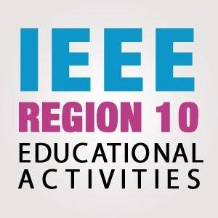

2022 IEEE R10 Educational Activities Call for workshops on TryEngineering & STEM

***Before completing this proposal, please read all the Terms and References at https://ea.ieeer10.org/***

|  |  |  |
| --- | --- | --- |
|  | | |
| Program Title |  | |
| TISP / Try Engineering |  | |
| IEEE Organizational Unit (branch code/Section name/ subsection ) |  | |
| Name of IEEE Organizational Unit Chair |  | |
| IEEE Organizational Unit Counselor (for Student Branch only) |  | |
| Project Leader / Educational Activity Chair of OU Details | | |
| Full Name |  | |
| Email |  | |
| Contact Number with country code |  | |
| IEEE Membership Number |  | |
| Program Team Members & Emails |  | |
| Section Chair Name & Email |  | |
| Executive Summary on proposal (maximum 300 words) | | |
|  | | |
| Introduction and Description of Program (including expenses) | | |
| Proposed budget:   |  |  |  |  | | --- | --- | --- | --- | | No. | Items | Expense description | Proposed Budget ($USD) | | 1. |  |  |  | | 2. |  |  |  | | 3. |  |  |  | | 4. |  |  |  | |  |  | TOTAL |  | | | |
| Alignment with IEEE Goals and Effective Use of IEEE Resources | | |
|  | | |
| Measurement or Assessment of the Educational Outcomes | | |
|  | | |
| Impact of the program to the participants and community (outreach of program/ platform used/ joint event with other OU/ Target audience | | |
|  | | |
| Proposed platform and technology used | | |
|  | | |
| Planning for social media reach | | |
|  | | |
| Innovativeness aspect of the program | | |
|  | | |
| **Prepared by Project Leader:**  Name:  IEEE Membership No:  Signature (e-signature is allowed):  Date: | | **Endorsed by Council/Section/Subsection Chair with the commitment of providing the matching grant**  Name:  IEEE Membership No:  Signature (e-signature is allowed):  Date |

For more details and enquiries, please contact R10 Educational Activities Committee at: region10eab@gmail.com