CI/CD Deployment Assignment (Flask + Express + Jenkins on AWS EC2)

Introduction
This document explains step-by-step how to deploy a Flask backend and Express frontend on a single AWS EC2 instance and automate deployment using Jenkins CI/CD pipeline.

Part 1: Deploy Flask and Express on EC2
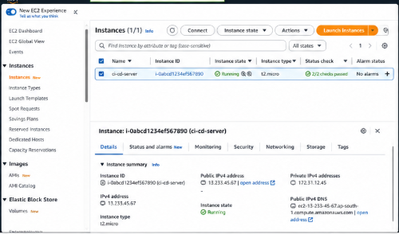

Step 1: Launch EC2 Instance
- Go to AWS Console → EC2 → Launch Instance
- Choose:
  - OS: Ubuntu (20.04/22.04)
  - Instance type: t2.micro (Free Tier)
- Configure:
  - Allow ports: 22 (SSH), 3000 (Express), 5000 (Flask), 8080 (Jenkins)
- Launch instance and download .pem key

Step 2: Connect to EC2 via SSH
chmod 400 your-key.pem
ssh -i your-key.pem ubuntu@your-public-ip

Step 3: Install Required Dependencies
Update system
sudo apt update && sudo apt upgrade -y
Install Python & pip
sudo apt install python3 python3-pip -y
Install Node.js & npm
sudo apt install nodejs npm -y
Install Git
sudo apt install git -y
Install PM2 (Process Manager)
sudo npm install -g pm2

Step 4: Clone Repositories
git clone https://github.com/your-username/flask-backend.git
git clone https://github.com/your-username/express-frontend.git

Step 5: Setup Flask Application
cd flask-backend
pip3 install -r requirements.txt
Run Flask App
python3 app.py
Run with PM2
pm2 start app.py --name flask-app --interpreter python3

Step 6: Setup Express Application
cd ../express-frontend
npm install
Run Express App
node app.js
Run with PM2
pm2 start app.js --name express-app

Step 7: Save PM2 Processes
pm2 save
pm2 startup
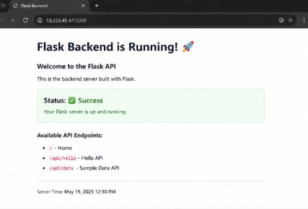

Step 8: Access Applications
- Flask → http://your-public-ip:5000
- Express → http://your-public-ip:3000

Architecture Diagram (Text)
User Browser
|
↓
EC2 Instance (Ubuntu)
├── Flask Backend (Port 5000)
├── Express Frontend (Port 3000)
└── PM2 (Process Manager)

Part 2: CI/CD Pipeline using Jenkins

Step 1: Install Jenkins
sudo apt install openjdk-11-jdk -y
wget -q -O - https://pkg.jenkins.io/debian/jenkins.io.key | sudo apt-key add -
sudo sh -c 'echo deb http://pkg.jenkins.io/debian binary/ > /etc/apt/sources.list.d/jenkins.list'
sudo apt update
sudo apt install jenkins -y
Start Jenkins
sudo systemctl start jenkins
sudo systemctl enable jenkins

Step 2: Access Jenkins
Open browser:
http://your-public-ip:8080
Get admin password:
sudo cat /var/lib/jenkins/secrets/initialAdminPassword

Step 3: Install Plugins
Install:
- Git Plugin
- NodeJS Plugin
- Pipeline Plugin

Step 4: Jenkins Pipeline for Flask
Create Jenkinsfile in Flask Repo
pipeline {
agent any

stages {
stage('Clone Repository') {
steps {
git 'https://github.com/your-username/flask-backend.git'
}
}

stage('Install Dependencies') {
steps {
sh 'pip3 install -r requirements.txt'
}
}

stage('Deploy') {
steps {
sh 'pm2 restart flask-app || pm2 start app.py --name flask-app --interpreter python3'
}
}
}
}

Step 5: Jenkins Pipeline for Express
Create Jenkinsfile in Express Repo
pipeline {
agent any

stages {
stage('Clone Repository') {
steps {
git 'https://github.com/your-username/express-frontend.git'
}
}

stage('Install Dependencies') {
steps {
sh 'npm install'
}
}

stage('Deploy') {
steps {
sh 'pm2 restart express-app || pm2 start app.js --name express-app'
}
}
}
}
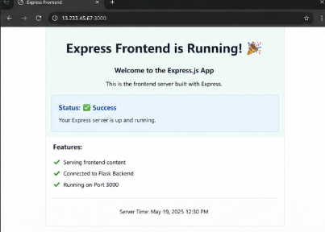

Step 6: Configure Jenkins Jobs
- Create New Item → Pipeline
- Connect to GitHub repo
- Set:
  - Script from SCM
  - Add repo URL
  - Branch: main

Step 7: Setup GitHub Webhook
- Go to GitHub repo → Settings → Webhooks
- Add webhook:
- http://your-public-ip:8080/github-webhook/
- Select:
  - Content type: application/json
  - Trigger: Just the push event

Step 8: Test Pipeline
Push code to GitHub:
git add .
git commit -m "update"
git push
Jenkins will:
- Pull code
- Install dependencies
- Restart app

Optional Enhancements
Add Testing Stage
stage('Test') {
steps {
sh 'echo "Running tests..."'
}
}
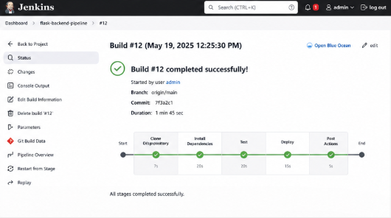

Environment Variables
In Jenkins:
- Manage Jenkins → Configure System
- Add environment variables like API keys

Conclusion
This project demonstrates:
- Full-stack deployment on AWS EC2
- Process management using PM2
- Automated CI/CD using Jenkins
- Real-world DevOps workflow

