Name: saniakumari
Roll No: BIT-24S-039
GitHub link: https://github.com/saniakumari/Python-lab

LAB: 01
Task 1:
Make 2-2 programs of each datatype.
- NUMERIC TYPES:
- Integer:
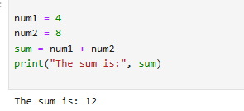
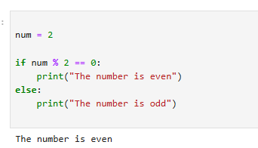
- Float:
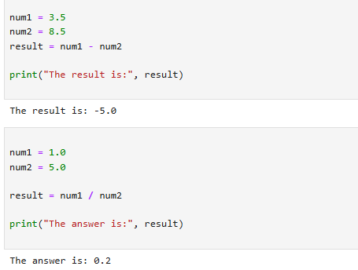

- Complex:
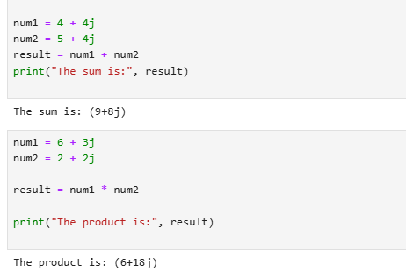

- SEQUENCE TYPES:

- String

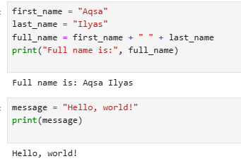
- List:

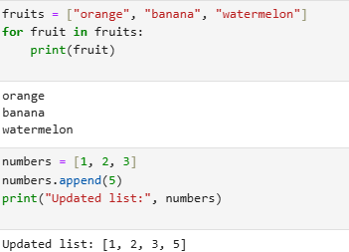

- Tuple:

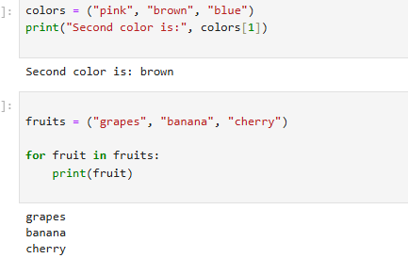

- Range:

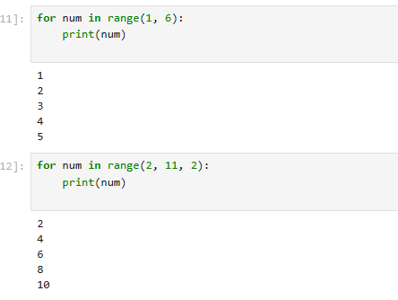

- SET TYPES:

- Set:

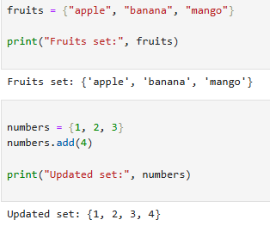
- Frozen set:

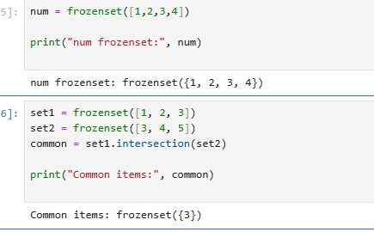

- MAPPING TYPE:

- Dictionary dict:

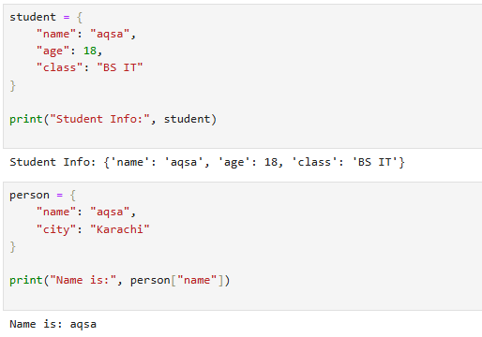

- BOLEAN TYPE:

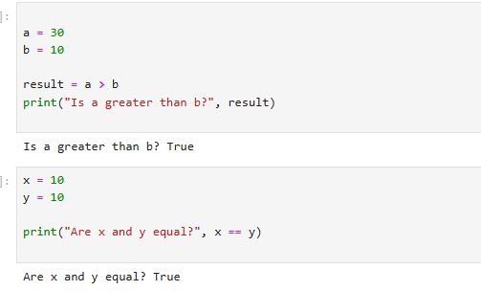

Task 2:

Make up to 5 shapes programs using *
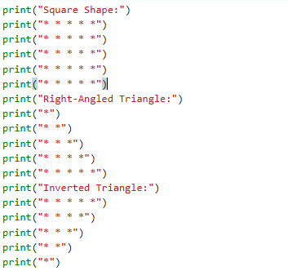

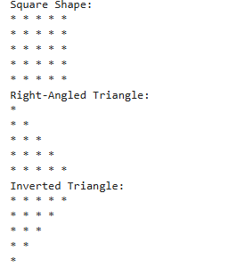

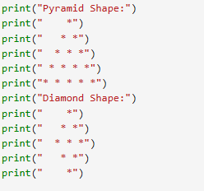

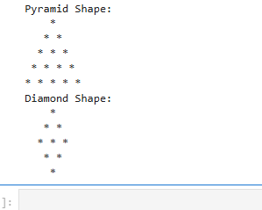

Task 3:

Make same shapes you have made in task 2, using * multiple by number.

Program:

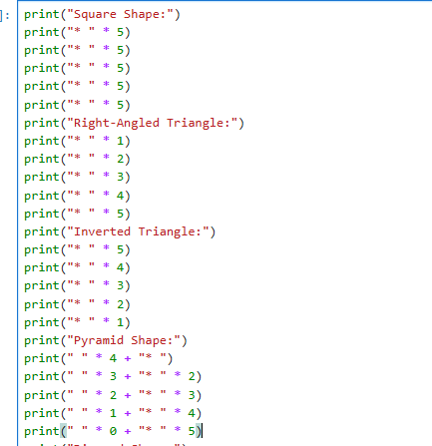

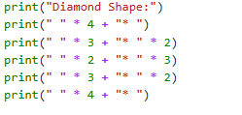
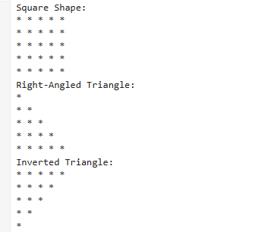
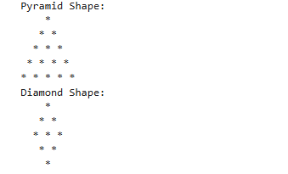

Lab 2:

Task 1:

Print numbers from 1 to 10 using a for loop.

Program:

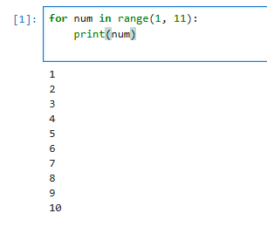

Task 2:

Print all even numbers between 1 and 20 using a while loop.

Program:

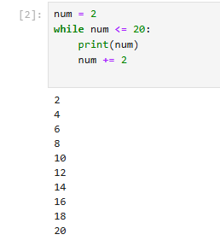

Task 3:

Calculate the sum of numbers from 1 to 100 using a loop.

Program:

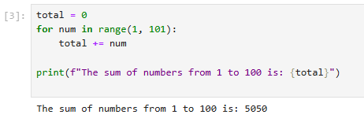
Task 4:

Print the multiplication table of 5 using a loop:

Program:

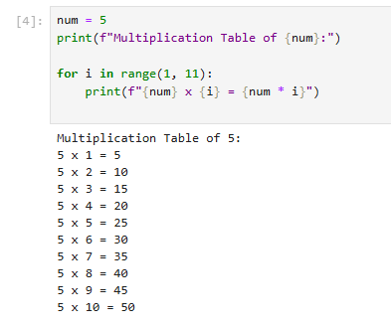

Task 5:

Find the factorial of a given number using a for loop.

Program:

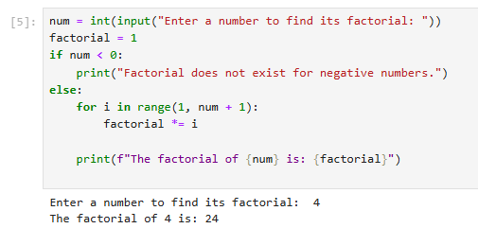
Task 6:

Create a list of numbers and print only the odd numbers using a loop.

Program:

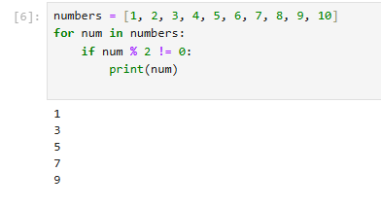

Task 7:

Iterate over a list of fruits and print each item.

Program:

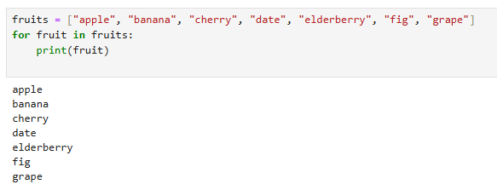

LAB 4:

TASK 01

Write a python program to take 2 numbers as input and perform all arithmetic operations on them.

Program:

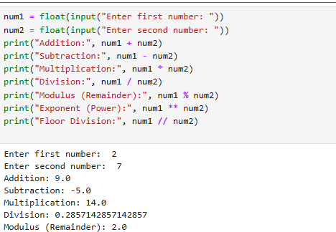

TASK 02

Create a function that takes two numbers and return their sum, difference, product, and quotient.

Program:

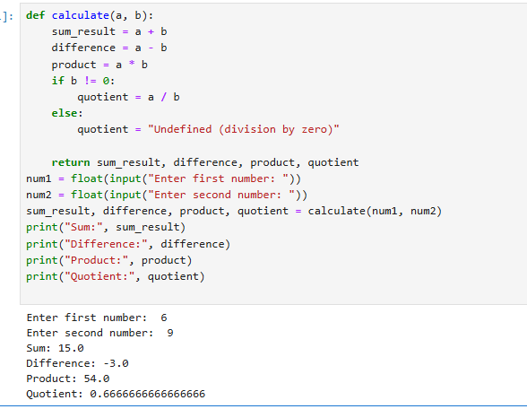

TASK 03

Write a python script to find the remainder when one number is divided by another.

Program:

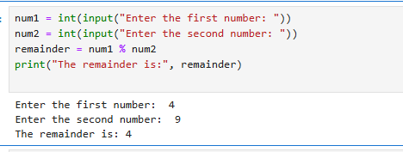

TASK 04

Write a program to calculate the area of a circle using the formula: area=pi*r^2.

Program:

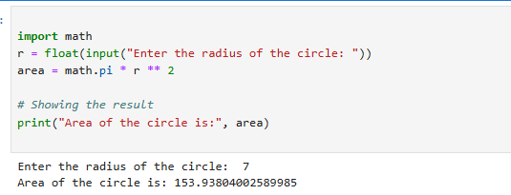

Task 05:

Implement a program that takes a number as input and returns its square and cube using exponentiation.

Program:

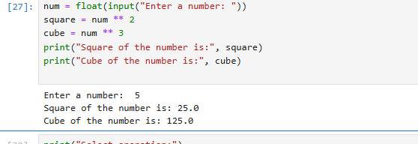

TASK 06:

Create a simple calculator in python that allows the user to choose an operation(addition, subtraction, etc.)and inputs two numbers.

Program:

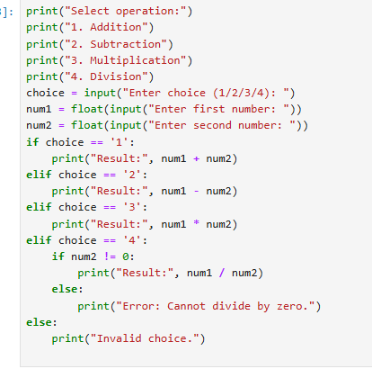
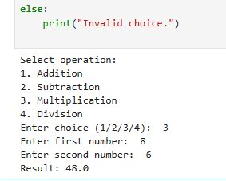

Lab 5:

Task 1:

Basic Task: Write a program that checks if a given number is positive, negative, or zero.

Program:

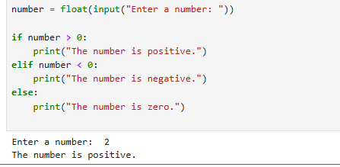

Task 2:

Intermediate Task: Write a program that takes user input and determines whether it's a even or odd.

Program:

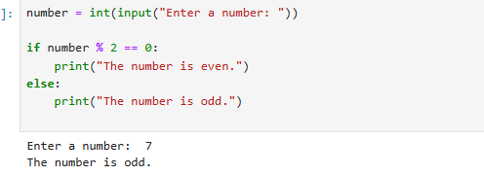

Task 3:

Advanced Task: Create a program that asks user to print:
"Excellent" if marks are above 80
"Good" if marks are between 60 and 80
"Needs Improvement" if marks are below 60

Program:

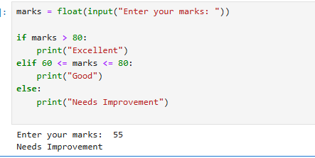

Lab 6:

Task 1:

Basic Task: Write a for loop to print the first 10 natural numbers.

Program:

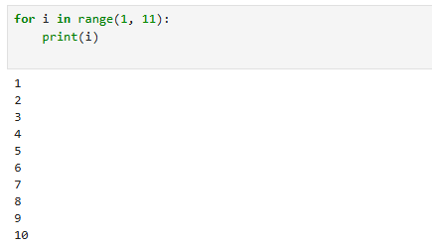

Task 2:

Intermediate Task: Write a while loop that prints numbers from 10 down to 1

Program:

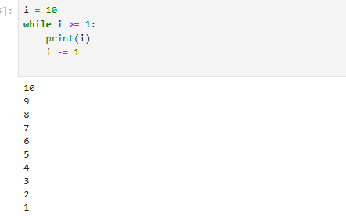

Task 3:

Advanced Task: Create a program that uses a for loop to iterate over a string and count the number of vowels.

Program:

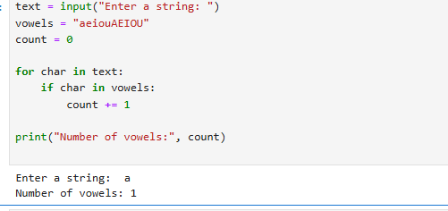

Challenge Task:

Write a program that prints the Fibonacci series up to n terms using a while loop.

Program:

