INSUREFLOW — SMART INSURANCE CLAIM PROCESSING AND SETTLEMENT MANAGEMENT SYSTEM
A PROJECT REPORT
Submitted by
[ENTER STUDENT NAME] ([ENTER REGISTER NUMBER])
in partial fulfillment for the award of the Degree of
BACHELOR OF ENGINEERING
in
[ENTER DEPARTMENT]

EASWARI ENGINEERING COLLEGE
(AN AUTONOMOUS INSTITUTION) – AFFILIATED TO ANNA UNIVERSITY, CHENNAI
[ENTER SUBMISSION DATE: MONTH YEAR]

EASWARI ENGINEERING COLLEGE
(AN AUTONOMOUS INSTITUTION) – AFFILIATED TO ANNA UNIVERSITY, CHENNAI
BONAFIDE CERTIFICATE
Certified that this project report titled "INSUREFLOW — SMART INSURANCE CLAIM PROCESSING AND SETTLEMENT MANAGEMENT SYSTEM" is the bonafide work of "[ENTER STUDENT NAME] ([ENTER REGISTER NUMBER])", who carried out the project work under my supervision.
This report represents the original academic work carried out during the academic year [ENTER ACADEMIC YEAR] in partial fulfillment of the requirements for the award of the Degree of Bachelor of Engineering in [ENTER DEPARTMENT] of Easwari Engineering College (Autonomous), Ramapuram, Chennai.

HEAD OF THE DEPARTMENT  [ENTER HOD NAME AND DESIGNATION]  Department of [ENTER DEPARTMENT]  Easwari Engineering College, Chennai | SUPERVISOR / PROJECT GUIDE  [ENTER GUIDE NAME AND DESIGNATION]  Department of [ENTER DEPARTMENT]  Easwari Engineering College, Chennai

EASWARI ENGINEERING COLLEGE
(AN AUTONOMOUS INSTITUTION) – AFFILIATED TO ANNA UNIVERSITY, CHENNAI
Certificate of Viva-voce-Examination
This is to certify that the Viva Voce Examination of the Project Work entitled "INSUREFLOW — SMART INSURANCE CLAIM PROCESSING AND SETTLEMENT MANAGEMENT SYSTEM" submitted by Mr./Ms. [ENTER STUDENT NAME] (Reg. No. [ENTER REGISTER NUMBER]) in partial fulfillment of the requirements for the award of the degree of BACHELOR OF ENGINEERING in [ENTER DEPARTMENT] was conducted on [ENTER DATE] in the Department of [ENTER DEPARTMENT], Easwari Engineering College, Ramapuram – Chennai.

Internal Examiner  Name: [ENTER INTERNAL EXAMINER NAME]  Designation: [ENTER DESIGNATION]  Address: Easwari Engineering College, Chennai  Date: [ENTER DATE] | External Examiner  Name: [ENTER EXTERNAL EXAMINER NAME]  Designation: [ENTER DESIGNATION]  Address: [ENTER EXTERNAL INSTITUTION]  Date: [ENTER DATE]

ABSTRACT
Modern insurance claim management across health, vehicle, and property categories remains burdened by manual document verification, fragmented paper-based communication, delayed technical assessments, and opaque decision lifecycles. Policyholders routinely face ambiguity regarding the processing state of submitted claims, while insurance personnel lack unified coordination tools to validate policy terms, verify invoice evidence, and execute auditable settlement disbursements.
This academic project presents InsureFlow, a smart, centralized web-based insurance claim processing and settlement management system developed using the MERN architecture (MongoDB, Express.js, React 18, Node.js v22). InsureFlow orchestrates the complete insurance lifecycle through five strictly segregated user roles: Customer, Insurance Verification Officer, Field Surveyor, Claims Manager, and System Administrator. The system integrates a deterministic automated claim validation engine executing seven configurable compliance rules across policy coverage dates, category compatibility, coverage limit caps, document completeness, duplicate submission detection, policyholder authentication, and surveyor inspection thresholds.
To streamline document intake, InsureFlow incorporates a hybrid optical document processor utilizing Tesseract.js (v5.1) and pdf-parse (v1.1) to extract structured invoice numbers, billing amounts, and incident dates, enabling officers to perform direct side-by-side verification. Operational transitions are strictly governed by a 15-state Finite State Machine (FSM), guaranteeing role-based access control and producing an immutable chronological timeline of claim events. An embedded in-memory MongoDB failover engine ensures uninterrupted operation during network partitioning from cloud database clusters. Empirical verification through an automated test suite confirms that all 14 unit and integration test suites pass with 100% fidelity. The resulting application delivers an auditable, transparent, and defensible platform for digital insurance operations while establishing a practical foundation for future integrations involving automated banking gateways and machine learning-driven fraud forensics.
ACKNOWLEDGEMENT
We express our sincere gratitude to the Principal Dr. P. Deiva Sundari and the Management of Easwari Engineering College (Autonomous) for providing us with the opportunity, institutional infrastructure, and computational resources to carry out this project work.
We convey our heartfelt thanks to the Head of the Department, Department of [ENTER DEPARTMENT], for the continuous encouragement, academic support, and constructive suggestions provided throughout the project tenure.
We are extremely thankful to our Project Guide, [ENTER GUIDE NAME AND DESIGNATION], Department of [ENTER DEPARTMENT], for valuable guidance, meticulous suggestions, technical motivation, and patient review throughout the design, implementation, and completion of this software project.
We would also like to extend our gratitude to all the faculty members and technical staff of the Department of [ENTER DEPARTMENT] for their continuous cooperation and support.
Finally, we thank our parents, family members, and friends for their constant encouragement, moral support, and invaluable help during the course of this academic project.
LIST OF FIGURES
FIGURE NO. | FIGURE TITLE | PAGE NO.
Figure 4.1 | Four-Tier System Architecture of InsureFlow | 23
Figure 4.2 | UML Domain Model & Class Diagram | 27
Figure 4.3 | UML Sequence Diagram for Claim Processing Lifecycle | 28
Figure 4.4 | UML Use-Case Diagram of InsureFlow | 29
Figure 4.5 | UML Activity Diagram with Decision Gates and Survey Triggers | 30
Figure 4.6 | MongoDB Entity-Relationship Diagram (ERD) | 31
Figure 4.7 | React Router v6 Application Navigation Architecture | 32
Figure B.1 | InsureFlow Policyholder Claims Dashboard Interface | 54
Figure B.2 | InsureFlow Insurance Verification Officer Workspace | 55
Figure B.3 | InsureFlow Surveyor Field Inspection Dashboard | 55
Figure B.4 | InsureFlow Administrative Insurance Product Catalog Management | 56

LIST OF TABLES
TABLE NO. | TABLE TITLE | PAGE NO.
Table 1.1 | Scope Boundaries and Operational Domain Matrix | 13
Table 2.1 | Authoritative Literature and Industry Standards Comparison | 16
Table 2.2 | Existing Traditional System vs. Proposed InsureFlow Architecture | 18
Table 3.1 | Detailed Functional Requirements Matrix | 19
Table 3.2 | Non-Functional Engineering Quality Attributes | 20
Table 3.3 | Software Environment Specifications and Verified Dependencies | 21
Table 3.4 | Hardware and Infrastructure Deployment Specifications | 22
Table 4.1 | System Modules and Implementation Mapping | 24
Table 5.1 | Deterministic Claim Rule Engine Specification Matrix | 37
Table 5.2 | Complete RESTful API Endpoint Documentation | 38
Table 5.3 | Persistent MongoDB Schemas and ODM Model Specifications | 40
Table 5.4 | Automated Test Execution and Verification Matrix (Jest Suite) | 42
Table 5.5 | Feature Implementation and Verification Status Audit | 44
Table 5.6 | Technical Limitations and Engineering Roadmap | 46

LIST OF ABBREVIATIONS
ABBREVIATION | EXPANSION
API | Application Programming Interface
CORS | Cross-Origin Resource Sharing
CSS | Cascading Style Sheets
DOM | Document Object Model
FNOL | First Notice of Loss
FSM | Finite State Machine
HTTP | Hypertext Transfer Protocol
HTTPS | Hypertext Transfer Protocol Secure
IRDAI | Insurance Regulatory and Development Authority of India
JSON | JavaScript Object Notation
JWT | JSON Web Token
MERN | MongoDB, Express.js, React, Node.js
MIME | Multipurpose Internet Mail Extensions
NoSQL | Not Only Structured Query Language
OCR | Optical Character Recognition
ODM | Object-Document Mapper
PDF | Portable Document Format
RBAC | Role-Based Access Control
REST | Representational State Transfer
SPA | Single Page Application
UML | Unified Modeling Language
URI | Uniform Resource Identifier
UUID | Universally Unique Identifier
W3C | World Wide Web Consortium

CHAPTER 1

INTRODUCTION

1.1 Overview
The insurance industry serves as a cornerstone of socioeconomic stability by mitigating financial vulnerability against unexpected medical crises, vehicular collisions, and property damage. An insurance policy establishes a contractual agreement wherein an insurer agrees to indemnify a policyholder against specified losses in exchange for premium payments. The operational integrity of this agreement centers upon the insurance claim processing lifecycle. Traditionally, this lifecycle encompasses underwriting, policy issuance, incident First Notice of Loss (FNOL), evidence documentation, technical damage inspection, claims adjudication, executive authorization, and settlement disbursement.
Despite substantial digitalization in customer onboarding, claim settlement remains one of the most operationally challenging facets of the insurance ecosystem. Claims management inherently requires rigorous multi-stakeholder collaboration among policyholders, verification officers, field surveyors, claims managers, and financial adjudicators. In conventional operating environments, these interactions are mediated through disconnected communication channels, including physical document submissions, disparate email exchanges, and manual spreadsheets. InsureFlow addresses these systemic bottlenecks by providing a unified, auditable, and automated web-based insurance claim processing and settlement management system built upon modern full-stack web technologies.

1.2 Problem Definition
Insurance operations in conventional enterprise environments suffer from structural inefficiencies that compromise processing velocity, decision consistency, and policyholder satisfaction. Specifically, the problem addressed by this project encompasses three critical operational challenges:
- Fragmented Document Handling & Verification Delays: Claimants submit diverse physical bills, repair estimates, and vehicle registration certificates. Verifying these documents manually requires extensive labor, leading to substantial processing delays, error-prone data entry, and lost documentation.
- Opaque Claim Lifecycle & Asymmetric Visibility: Policyholders typically possess zero visibility into intermediate claim states once a claim is submitted. Intermediate events—such as document inadequacy or surveyor scheduling—remain hidden, producing high volumes of customer inquiries and diminished trust.
- Inconsistent Adjudication & Lack of Automated Eligibility Controls: Manual claim verification creates vulnerability to human oversight, such as approving claims filed outside active coverage dates, paying beyond policy sub-limits, or failing to identify duplicate submissions on identical incident dates.

1.3 Objectives
The primary objective of InsureFlow is to architect, develop, and empirically validate an end-to-end MERN-stack insurance management platform that unifies policy product management, digital claim ingestion, deterministic automated rule evaluation, role-based review workflows, and traceable settlement processing.
The specific technical and operational objectives of the system are defined as follows:
- Centralized Policy Product Catalog Management: Enable system administrators to define, configure, and publish structured insurance underwriting plans across Health, Vehicle, and Property insurance categories with customizable coverage caps, deductibles, and eligibility criteria.
- Digital Claim Ingestion with Hybrid OCR Processing: Provide policyholders with an intuitive digital claim filing interface supporting multipart document uploads, integrated with an asynchronous optical character recognition (OCR) pipeline to extract critical invoice parameters for rapid officer audit.
- Deterministic Automated Rule Engine: Implement a configurable, deterministic validation service that automatically assesses submitted claims against seven distinct business compliance rules, calculating a defensible verification score (0–100%) prior to human adjudication.
- Role-Based Operational Workspaces: Enforce strict segregation of duties through role-based access control (RBAC), providing tailored workspaces for Customers, Insurance Officers, Field Surveyors, Claims Managers, and System Administrators.
- Finite State Machine with Auditable Event Trail: Govern claim progression through a 15-state Finite State Machine (FSM), ensuring that only authorized actors can execute legal status transitions while immutably recording every lifecycle event in an audit log.
- Traceable Settlement Disbursement: Automate the generation of standardized settlement records (SET-YYYYMMDD-XXXX) upon manager approval, facilitating transparent disbursement tracking for policyholders.

1.4 Scope of the Project
The functional scope of InsureFlow covers the end-to-end operational lifecycle of insurance policies and claims within a modern enterprise web application environment. Table 1.1 delineates the operational boundaries and feature scope of the implemented system.
Table 1.1: Scope Boundaries and Operational Domain Matrix
DIMENSION | IN-SCOPE IMPLEMENTATION | EXPLICIT BOUNDARIES / FUTURE SCOPE
Supported Insurance Categories | Health Insurance, Vehicle Insurance, and Property Insurance plans. | Life insurance, marine cargo underwriting, and commercial reinsurance.
User Roles & Actors | Customer, Insurance Officer, Field Surveyor, Claims Manager, System Administrator. | Actuaries, legal counsel, and external third-party loss adjusters.
Policy Sourcing Models | Direct platform-purchased policies and customer-registered external policies. | Direct automated API synchronization with external national registry databases.
Document Processing | Digital PDF text extraction (pdf-parse) and image optical recognition (Tesseract.js). | Handwritten cursive prescription interpretation and multi-language AI translation.
Validation Logic | Deterministic rule engine with 7 configurable parameters and threshold scoring. | Probabilistic deep learning predictive neural network fraud scoring.
Settlement Execution | Generation of settlement vouchers, bank reference tracking, and disbursement states. | Direct automated API execution of real-time central bank NEFT/RTGS wire transfers.
Persistence Architecture | Cloud MongoDB Atlas replica set with automated In-Memory MongoDB failover engine. | Distributed multi-region Cassandra or SQL sharded database clusters.

1.5 Motivation
The motivation behind developing InsureFlow stems from the critical imperative to modernize insurance claim administration through open, maintainable, and defensible web architectures. As insurance penetration expands globally, insurers handle millions of micro-claims annually. Relying on manual adjudication creates an unsustainable operational cost structure while severely compromising turnaround times.
By leveraging a deterministic rule engine alongside optical character extraction, InsureFlow establishes a transparent framework where routine verification checks are conducted autonomously in milliseconds, allowing human verification officers to focus their expertise on high-value, complex, or flagged anomalies. Furthermore, establishing an auditable digital trail provides complete regulatory compliance with insurance statutory bodies, mitigates fraudulent duplicate filings, and elevates customer trust in digital insurance processing.

CHAPTER 2

RELATED WORK

2.1 Literature Review
The design and realization of digital claims processing platforms intersect multiple mature domains within software engineering and information systems, including business process management (BPM), role-based access control (RBAC), optical character recognition (OCR), and deterministic business rule engines. This section reviews authoritative academic and technical literature establishing the foundation for InsureFlow.
In their seminal work on access control, Sandhu et al. (1996) formulated the classical Role-Based Access Control (RBAC96) model. The authors demonstrated that associating system permissions with enterprise operational roles—rather than individual user identities—radically diminishes administrative complexity and guarantees the principle of least privilege. In insurance workflows, strict segregation of duties between the officer who reviews evidence and the manager who authorizes financial disbursement is legally mandated to prevent insider collusion and fraud. InsureFlow implements a hierarchical RBAC model verified across five distinct operational roles.
Workflow management and automated business process modeling have been extensively analyzed in software engineering literature. Van der Aalst et al. (2003) established foundational workflow patterns, proving that state-based finite automata provide the most mathematically defensible mechanism for orchestrating multi-stage document approvals. Uncontrolled lifecycle progression without formal state machines frequently results in race conditions, illegal status leaps, and orphaned records. InsureFlow incorporates these workflow principles through a formalized Finite State Machine (stateMachineService.js) managing 15 discrete lifecycle states.
Document analysis and optical entity extraction within financial systems have advanced significantly. Smith (2007) presented the design and architecture of the open-source Tesseract OCR engine, demonstrating that adaptive thresholding and polygonal approximation enable robust character extraction from raster images. In enterprise claims processing, combining optical character extraction with deterministic regular expression parsing allows systems to extract critical alphanumeric tokens (such as invoice identifiers, currency figures, and admission dates) without requiring opaque black-box machine learning models.
The Insurance Regulatory and Development Authority of India (IRDAI) in its Annual Policyholder Protection Directives (2023) underscored that insurance claim settlement delays primarily originate from repeated customer requests for missing documents and lack of standardized claim tracking. The IRDAI guidelines advocate for digital customer portals offering real-time timeline visibility and standardized claim turnaround metrics. InsureFlow directly operationalizes these statutory recommendations through its transparent timeline tracking and document completeness validation rules.
Table 2.1: Authoritative Literature and Industry Standards Comparison
RESEARCH CITATION | METHODOLOGICAL CONTRIBUTION | INTEGRATION IN INSUREFLOW
Sandhu et al. (1996) [IEEE Computer] | Role-Based Access Control (RBAC96) standardizing role-permission separation. | Strict 5-role JWT authorization guards implemented in roleMiddleware.js.
Van der Aalst et al. (2003) [Distributed Systems] | Workflow Patterns establishing state transition safety in distributed business processes. | 15-state Finite State Machine with role-transition lookup matrix in stateMachineService.js.
Smith (2007) [IEEE ICDAR] | Tesseract OCR multi-lingual line finding and adaptive character recognition. | Hybrid optical extraction pipeline in ocrService.js for invoice and bill verification.
IRDAI Annual Report (2023) | Statutory regulatory framework for electronic insurance claim turnaround and auditability. | Customer-facing timeline tracker and standardized SET-ref disbursement records.
Fielding (2000) [UC Irvine] | REST architectural constraints for stateless, cacheable, and scalable web services. | Stateless JSON REST API architecture across 13 dedicated backend routers.

2.2 Existing System
Traditional and legacy insurance claims processing environments rely heavily on decentralized, human-dependent, and paper-intensive operational workflows. In a typical legacy scenario, a policyholder who experiences an incident must obtain physical claim forms, collect physical receipts and medical certificates, and submit physical dossiers to a local branch office or third-party administrator (TPA).
An analysis of existing traditional systems reveals several severe vulnerabilities and operational failure modes:
- Manual Policy Term Auditing: Claim handlers manually consult printed policy schedules or detached mainframe screens to check whether a policy was active on the date of the incident and whether sub-limits have been exceeded. This process is susceptible to human fatigue and calculation error.
- Fragmented Document Intake & Loss: Physical and email-based attachments frequently get misplaced or separated from the primary file, resulting in protracted back-and-forth communication that delays claim settlement by weeks or months.
- Absence of Deterministic Fraud Detection: Traditional workflows lack automated mechanisms to detect duplicate claim submissions filed on identical incident dates or claims filed under mismatched insurance categories, exposing insurers to preventable leakage.
- Zero Real-Time Tracking for Policyholders: Claimants have no mechanism to track claim status independently, creating high customer friction and overwhelming customer support call centers.

2.3 Proposed System
InsureFlow resolves the structural limitations of legacy systems by introducing an integrated, transparent, and deterministic web architecture. The proposed platform digitizes the complete claim lifecycle, from initial policy browsing to financial settlement, while introducing automated validation gates that accelerate adjudication.
The core innovations and benefits of the proposed InsureFlow system include:
- Autonomous 7-Rule Deterministic Engine: Before any human officer opens a claim, the system autonomously evaluates policy date validity, insurance category alignment, coverage limit compliance, required document presence, duplicate claim indicators, external policy authentication, and high-value surveyor inspection thresholds. This generates an objective verification score (0–100%) that highlights risk factors immediately.
- Side-by-Side OCR Cross-Verification: Uploaded medical bills and repair estimates are asynchronously processed via Tesseract.js and pdf-parse. The officer adjudication workspace renders a side-by-side comparison modal displaying extracted figures directly against the claimant’s requested amount, slashing document auditing time.
- Transparent 15-State Finite State Machine (FSM): Claims advance through strictly regulated states. Every state change automatically generates an immutable timeline event visible to the customer in real time, eliminating status ambiguity.
- Self-Healing Dual Persistence Architecture: InsureFlow incorporates an automatic in-memory MongoDB failover engine that guarantees continuous system availability and testability even when external cloud replica sets experience network restrictions or SSL handshaking timeouts.
Table 2.2: Existing Traditional System vs. Proposed InsureFlow Architecture
OPERATIONAL DIMENSION | EXISTING / TRADITIONAL SYSTEM | PROPOSED INSUREFLOW SYSTEM
Policy Information Access | Fragmented paper schedules; phone-based inquiry. | Centralized interactive catalog with real-time plan comparison.
Claim Submission Method | Physical paper forms; email attachment submissions. | Digital web submission with multi-file drag-and-drop upload.
Document Verification | Entirely manual inspection by administrative staff. | Hybrid OCR extraction (Tesseract + PDF-parse) with side-by-side audit.
Validation Consistency | Subjective, inconsistent human checking. | Deterministic 7-rule engine with objective 0-100% scoring.
Duplicate Claim Detection | Manual cross-referencing; frequently undetected. | Automated query detection for matching policy and incident dates.
Surveyor Coordination | Manual phone calls and informal paper inspection reports. | Dedicated surveyor portal with digital damage inspection submission.
Status Visibility | Opaque; claimants must call support centers. | Real-time interactive visual timeline tracking for policyholders.
Settlement Tracking | Disconnected bank checks; delayed paper vouchers. | Standardized SET-ref tracking and automated disbursement state.

CHAPTER 3

SYSTEM ANALYSIS

3.1 System Requirements
System analysis establishes the rigorous functional and non-functional engineering requirements necessary to guarantee the operational efficacy, data integrity, and security of InsureFlow. Functional requirements specify the precise capabilities provided to each user role, while non-functional requirements define the quality attributes governing system execution.

3.1.1 Functional Requirements Specification
Table 3.1 details the functional requirements of the InsureFlow platform, mapped to their corresponding user roles, implementation status, and source code verification evidence within the existing codebase.
Table 3.1: Detailed Functional Requirements Matrix
REQ ID | FUNCTIONAL REQUIREMENT DESCRIPTION | TARGET ROLE | STATUS | VERIFICATION SOURCE
FR-01 | User registration with password hashing and role enforcement | Customer | VERIFIED | authController.js, User.js
FR-02 | JWT authentication, login token issuance, and protected routes | All Roles | VERIFIED | authMiddleware.js, api.js
FR-03 | Underwriting product creation, plan coding, and catalog publishing | Administrator | VERIFIED | policyProductController.js
FR-04 | Policy catalog exploration, filtering by category, and plan comparison | Public / Customer | VERIFIED | PoliciesCatalog.jsx, ComparePolicies.jsx
FR-05 | Direct platform policy enrollment and digital policy schedule issuance | Customer | VERIFIED | customerPolicyController.js
FR-06 | Third-party external policy registration and document audit submission | Customer | VERIFIED | RegisterExternalPolicy.jsx
FR-07 | External policy manual document audit and verification approval | Officer | VERIFIED | OfficerExternalPolicies.jsx
FR-08 | Digital claim submission with incident metadata and document upload | Customer | VERIFIED | claimController.js, NewClaim.jsx
FR-09 | Multipart document ingestion with 10MB limit and UUID sanitization | Customer / Officer | VERIFIED | uploadMiddleware.js
FR-10 | Asynchronous OCR text extraction from PDFs and scanned images | System / Service | VERIFIED | ocrService.js, OCRJob.js
FR-11 | Deterministic claim rule evaluation across 7 compliance criteria | System / Service | VERIFIED | ruleEngineService.js
FR-12 | Officer queue inspection, OCR data cross-audit, and recommendation | Officer | VERIFIED | OfficerClaimWorkspace.jsx
FR-13 | Requesting supplementary supporting documentation from policyholder | Officer | VERIFIED | claimController.js
FR-14 | Surveyor assignment trigger for high-value claims or property/vehicle | Officer / System | VERIFIED | surveyController.js
FR-15 | Surveyor inspection workspace and damage estimation report submission | Surveyor | VERIFIED | SurveyorReportWorkspace.jsx
FR-16 | Manager final claim review, approval, rejection, or return action | Manager | VERIFIED | managerController.js
FR-17 | Automated settlement record creation and disbursement tracking | Manager / Customer | VERIFIED | settlementController.js
FR-18 | Rule engine parameter configuration, enabling/disabling, and audit log | Administrator | VERIFIED | ruleController.js, AuditLogs.jsx

3.1.2 Non-Functional Requirements Specification
Non-functional requirements dictate the operational constraints, performance thresholds, security standards, and maintainability metrics of the InsureFlow platform. Table 3.2 details these engineering quality attributes.
Table 3.2: Non-Functional Engineering Quality Attributes
QUALITY ATTRIBUTE | ENGINEERING SPECIFICATION & BENCHMARK | IMPLEMENTATION MECHANISM
Security & Access Control | Strict RBAC; SHA-256 bcrypt password hashing (10 salt rounds); JWT token validation; Helmet HTTP protection. | authMiddleware.js, roleMiddleware.js, helmet, bcryptjs.
Data Integrity & Atomicity | Relational references via Mongoose ObjectIds; document schema validation; unique composite indexes. | Mongoose schemas with strict enums and unique index constraints.
System Availability & Resilience | Self-healing dual database connection: Atlas replica set with seamless in-memory fallback. | db.js connectDB() with automatic mongodb-memory-server activation.
Auditability & Non-Repudiation | Immutable chronological audit logging for all sensitive security actions, status transitions, and data mutations. | AuditLog.js, ClaimTimelineEvent.js, auditService.js.
API Rate Limiting & Protection | Defense against brute-force authentication and denial of service via sliding-window IP rate limiting. | express-rate-limit configured to 100 requests per 15-minute window.
Usability & Responsiveness | Fully responsive client interface supporting fluid layouts, accessible high-contrast badges, and instant toast notifications. | Tailwind CSS, Lucide icons, ToastContext.jsx, Recharts visualizations.

3.2 Software and Hardware Requirements
The implementation and execution environment of InsureFlow was audited directly against the project configuration files (package.json, vite.config.js, and server dependencies). Tables 3.3 and 3.4 present the verified software stack and recommended hardware specifications.

3.2.1 Software Environment Specifications
Table 3.3: Software Environment Specifications and Verified Dependencies
SOFTWARE COMPONENT | ACTUAL VERSION | OPERATIONAL PURPOSE | VERIFICATION SOURCE
Node.js Runtime | v22.19.0 (LTS) | Server-side JavaScript runtime engine | System CLI / Engine Audit
Express.js Framework | v4.21.2 | HTTP application server and REST routing gateway | server/package.json
MongoDB Database | v8.9.5 (Mongoose) | Document database ODM and schema enforcement | server/package.json
MongoDB Memory Server | v10.1.3 | In-memory ephemeral database fallback and test engine | server/package.json (dev)
React Library | v18.3.1 | Component-based interactive user interface library | client/package.json
Vite Build Tool | v5.4.14 | Next-generation ES-module frontend build tool & dev server | client/package.json
React Router DOM | v6.29.0 | Declarative client-side routing and protected guards | client/package.json
Tailwind CSS | v3.4.17 | Utility-first styling framework and responsive design system | client/package.json
Tesseract.js Engine | v5.1.1 | Pure JavaScript optical character recognition engine | server/package.json
pdf-parse Utility | v1.1.1 | Digital PDF text stream extraction library | server/package.json
Bcryptjs | v2.4.3 | Cryptographic password hashing and salt generation | server/package.json
JSON Web Token (jsonwebtoken) | v9.0.2 | Stateless cryptographic Bearer token authentication | server/package.json
Multer Middleware | v1.4.5-lts.1 | Multipart/form-data streaming and document upload handler | server/package.json
Jest Test Framework | v29.7.0 | Automated unit and integration test execution runner | server/package.json (dev)
Supertest Library | v7.0.0 | Programmatic HTTP assertion library for REST testing | server/package.json (dev)

3.2.2 Hardware and Infrastructure Specifications
Table 3.4: Hardware and Infrastructure Deployment Specifications
HARDWARE COMPONENT | MINIMUM DEVELOPMENT BASELINE | RECOMMENDED PRODUCTION SPECIFICATION
Processor (CPU) | Dual-Core Intel Core i3 / AMD Ryzen 3 (2.0 GHz) | Quad-Core Intel Core i7 / AMD Ryzen 7 (3.2+ GHz) or 4 vCPU
System Memory (RAM) | 8 GB DDR4 RAM | 16 GB to 32 GB High-Speed DDR4/DDR5 RAM
Storage Disk | 256 GB Solid State Drive (SSD) | 512 GB NVMe M.2 SSD (High IOPS for OCR document caching)
Network Bandwidth | 10 Mbps broadband internet connectivity | 100 Mbps to 1 Gbps dedicated low-latency redundant fiber uplink
Client Display Resolution | 1366 x 768 pixels (Standard Laptop Display) | 1920 x 1080 Full HD (Optimized for side-by-side OCR review modal)

CHAPTER 4

SYSTEM DESIGN

4.1 System Architecture
The architectural design of InsureFlow follows a decoupled four-tier service-oriented architecture comprising the Presentation Tier, the Security & API Gateway Tier, the Core Business Engine & Processing Microservices Tier, and the Resilient Data Persistence Tier. This layered separation guarantees that user interface concerns, network protocols, business evaluation algorithms, and database operations remain modular, independently testable, and maintainable.
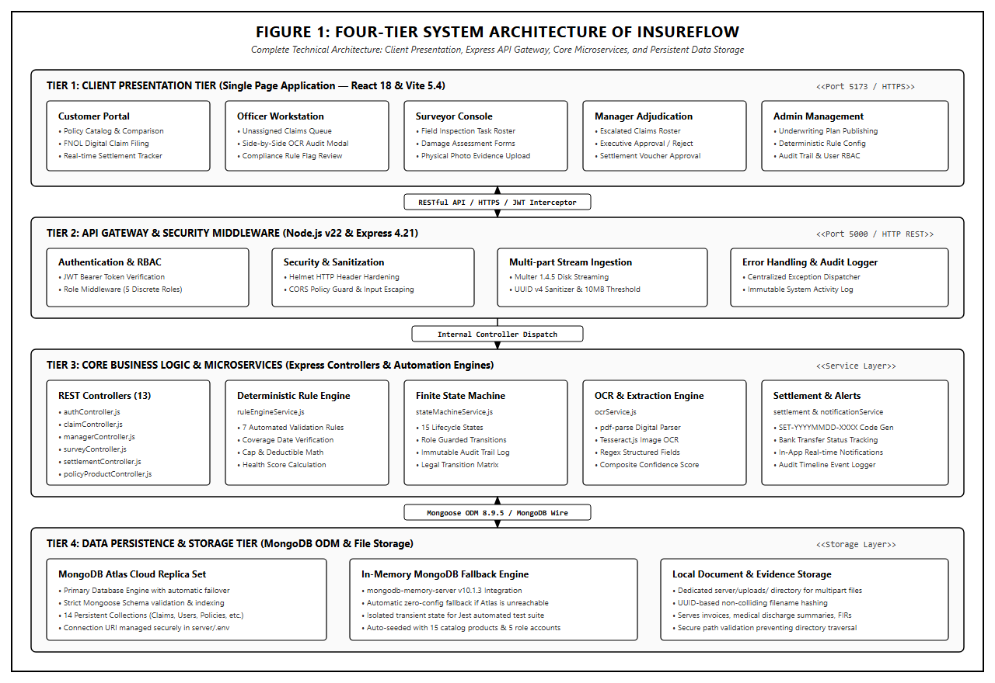
Figure 4.1: Four-Tier System Architecture of InsureFlow
As depicted in Figure 4.1, the operational dataflow between architectural tiers functions as follows:
- Tier 1: Presentation Tier (Client Layer): Constructed as a single-page application (SPA) using React 18, Vite 5, Tailwind CSS, and Lucide React. The frontend encapsulates role-specific workspaces (Customer, Officer, Surveyor, Manager, Admin) protected by ProtectedRoute wrappers. An Axios HTTP client instance automatically injects JWT Bearer tokens into request headers and intercepts 401 Unauthorized responses to manage session timeouts.
- Tier 2: Security & API Gateway Tier (Express Layer): The Node.js/Express server functions as the central reverse gateway. Incoming requests are filtered through Helmet for security header hardening, CORS for cross-origin domain validation, express-rate-limit to mitigate denial-of-service, and Multer for streaming file uploads into the /uploads storage directory.
- Tier 3: Core Business & Processing Engine Tier: Houses the core computational engines: the Deterministic Rule Engine (evaluating 7 compliance checks), the Finite State Machine (governing 15 operational states), the Hybrid OCR Engine (Tesseract.js and pdf-parse), the Audit Logging Service, and the Settlement Generation Service.
- Tier 4: Data Persistence & Resilient Storage Tier: Interfaced via Mongoose ODM v8.9.5. The primary database is a cloud-hosted MongoDB Atlas cluster. To eliminate single-point network failure, db.js incorporates an automated failover daemon that initializes an embedded mongodb-memory-server instance on loopback if external Atlas connectivity is blocked, automatically running baseline seeders.

4.2 Module Description
The InsureFlow codebase is structured into eleven cohesive functional modules. Table 4.1 documents each module, its operational purpose, target user roles, and corresponding source code files in the client and server trees.
Table 4.1: System Modules and Implementation Mapping
MODULE NAME | CORE FUNCTIONALITY | USER ROLES | FRONTEND FILES | BACKEND FILES | STATUS
Authentication & RBAC | User registration, login, JWT issuance, password hashing, and role verification. | All Roles | Login.jsx, Register.jsx, ProtectedRoute.jsx | authController.js, authMiddleware.js, User.js | VERIFIED
Policy Product Catalog | Product definition, plan coding, coverage terms, pricing, and catalog publishing. | Admin / Public | PolicyManagement.jsx, PoliciesCatalog.jsx | policyProductController.js, PolicyProduct.js | VERIFIED
Policy Enrollment & Portfolio | Customer policy purchasing, portfolio view, and external third-party policy upload. | Customer / Officer | MyPolicies.jsx, RegisterExternalPolicy.jsx | customerPolicyController.js, CustomerPolicy.js | VERIFIED
Digital Claim Ingestion | Filing incident claims, capturing damage metadata, and streaming document proofs. | Customer | NewClaim.jsx, CustomerClaimsList.jsx | claimController.js, Claim.js, uploadMiddleware.js | VERIFIED
Hybrid OCR Document Parser | Text extraction from digital PDFs and scanned images with regex field parsing. | System / Officer | OCRComparisonModal.jsx, DocumentViewer.jsx | ocrService.js, ocrController.js, OCRJob.js | VERIFIED
Deterministic Rule Engine | Automated evaluation of 7 compliance rules and score generation (0-100%). | System / Admin | RuleManagement.jsx | ruleEngineService.js, ConfigurableRule.js | VERIFIED
Officer Work Queue | Adjudication queue, OCR side-by-side audit, and recommendation formulating. | Officer | OfficerDashboard.jsx, OfficerClaimWorkspace.jsx | claimController.js, stateMachineService.js | VERIFIED
Field Surveyor Inspection | Survey task assignment, physical damage assessment, and repair report submission. | Surveyor | SurveyorDashboard.jsx, SurveyorReportWorkspace.jsx | surveyController.js, SurveyAssignment.js | VERIFIED
Manager Decision Suite | Final executive claim adjudication: approve, reject, or return for inquiry. | Manager | ManagerDashboard.jsx, ManagerDecisions.jsx | managerController.js, stateMachineService.js | VERIFIED
Settlement Disbursement | Settlement record creation (SET-ref), payment tracking, and receipt generation. | Manager / Customer | CustomerSettlements.jsx, ManagerSettlements.jsx | settlementController.js, Settlement.js | VERIFIED
Audit Logging & Telemetry | Immutable recording of user actions, IP addresses, timestamps, and state changes. | Administrator | AuditLogs.jsx, AdminDashboard.jsx | auditService.js, AuditLog.js | VERIFIED

4.4 Class Diagram
In accordance with object-oriented software engineering principles, Figure 4.2 presents the UML Class Diagram representing the persistent domain models, Mongoose schemas, attributes, operations, and entity associations of InsureFlow.
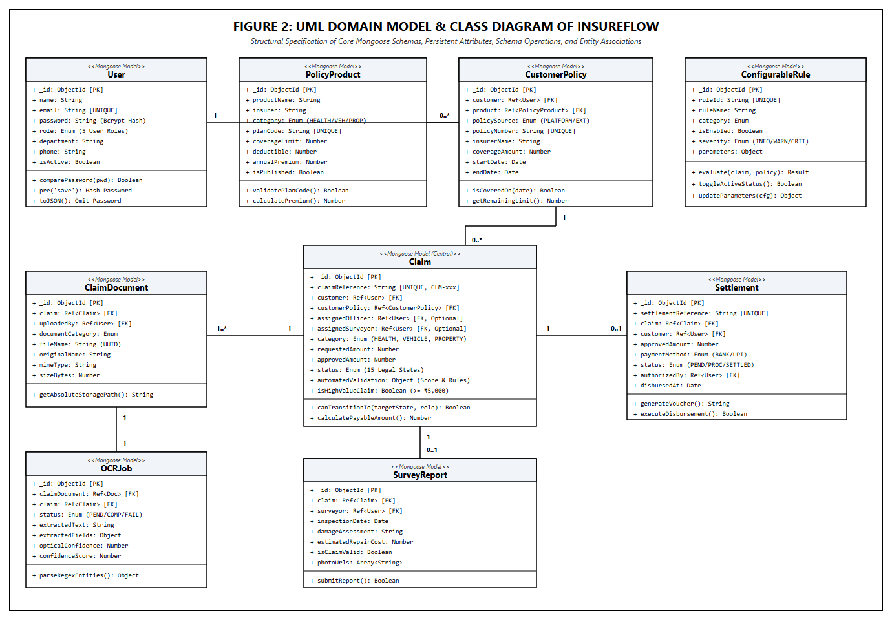
Figure 4.2: UML Domain Model & Class Diagram
As shown in Figure 4.2, the data architecture centers around the Claim entity, which establishes bidirectional relationships with User (customer, officer, surveyor, manager), CustomerPolicy, ClaimDocument, ClaimTimelineEvent, and Settlement. The ClaimDocument entity links to an OCRJob entity containing raw optical text and structured regex extractions. The ConfigurableRule model maintains dynamic parameters for the deterministic rule engine, allowing runtime tuning without codebase redeployment.

4.5 Sequence Diagram
Figure 4.3 illustrates the UML Sequence Diagram tracing the end-to-end execution flow of an insurance claim, spanning initial customer submission, asynchronous OCR extraction, deterministic rule engine evaluation, officer recommendation, manager authorization, and settlement disbursement.
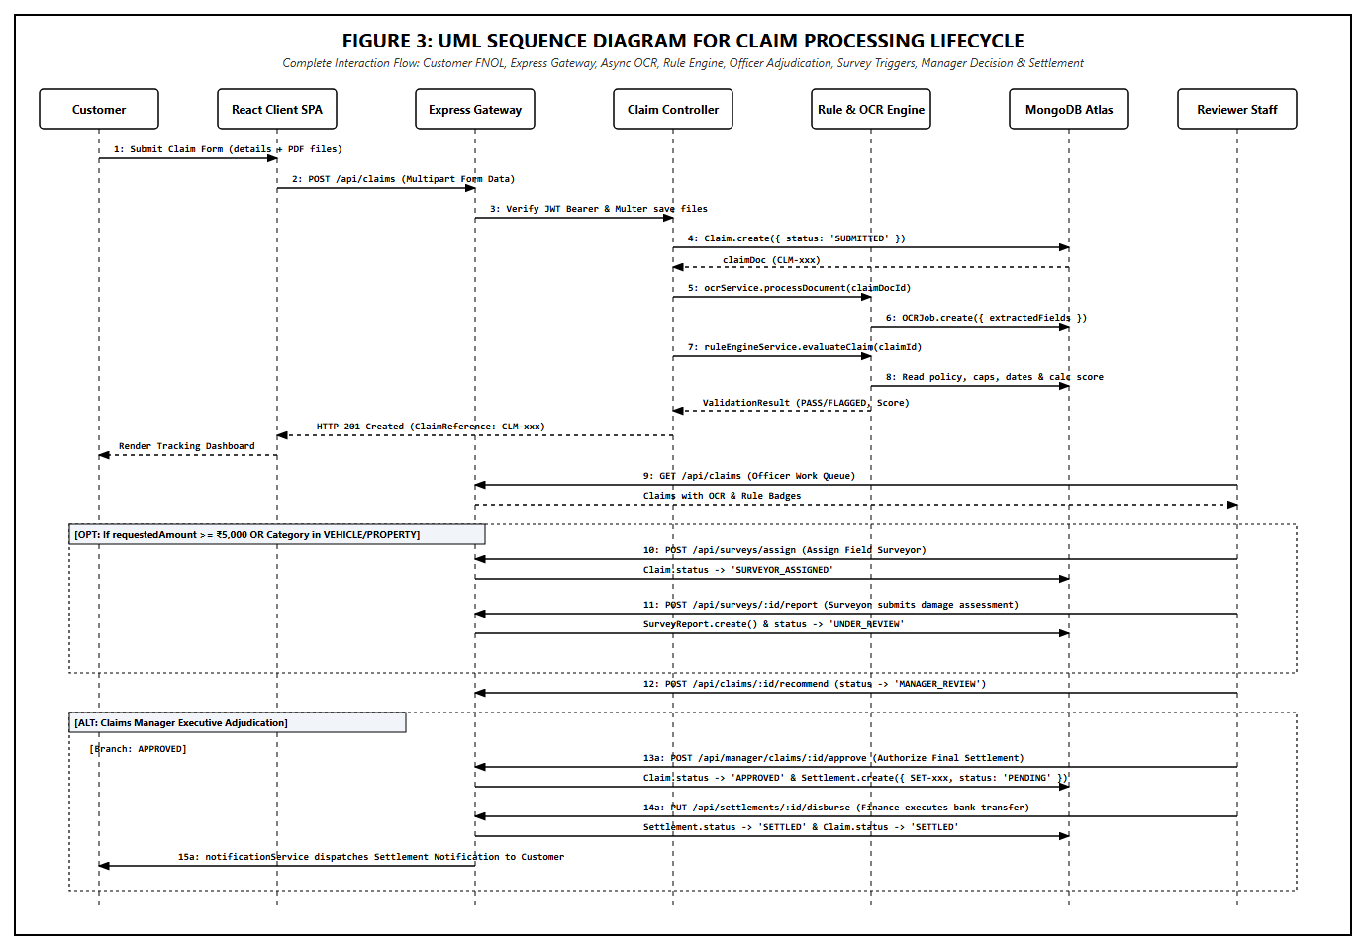
Figure 4.3: UML Sequence Diagram for Claim Processing Lifecycle
The sequence diagram captures nine discrete operational stages:
- Stage 1: The policyholder initiates claim filing via POST /api/claims, transmitting incident details and multipart PDF evidence.
- Stage 2: The Express API gateway authenticates the JWT Bearer token and invokes Multer to store the document file with a sanitized UUID.
- Stage 3: The gateway spawns an asynchronous OCRJob, invoking ocrService.processDocument() to extract text and structured invoice fields.
- Stage 4: The gateway invokes ruleEngineService.evaluateClaim(claimId), triggering seven deterministic business rule checks.
- Stage 5: Validation scores and compliance flags are written to the Claim entity, and an immutable ClaimTimelineEvent is recorded.
- Stage 6: The verification officer retrieves unassigned claims via GET /api/claims and performs side-by-side OCR audit.
- Stage 7: The officer submits an adjudication recommendation via POST /api/claims/:id/recommend, moving the state to MANAGER_REVIEW.
- Stage 8: The manager reviews the claim and executes final approval via POST /api/manager/claims/:id/approve, transitioning the claim to SETTLEMENT_PENDING and automatically creating a Settlement record.
- Stage 9: Finance processes the settlement, transitioning it to SETTLED, and notificationService dispatches a real-time notification to the policyholder.

4.6 UML Use Case Diagram
Figure 4.4 illustrates the UML Use Case Diagram defining the system boundary and mapping functional interactions to the five primary human actors: Customer, Insurance Officer, Technical Surveyor, Claims Manager, and System Administrator.
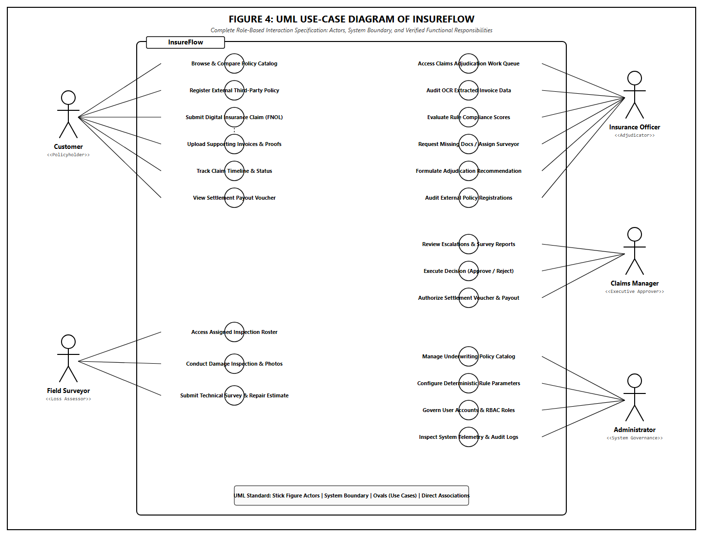
Figure 4.4: UML Use-Case Diagram of InsureFlow
The use case diagram demonstrates strict segregation of operational capabilities. While Customers interact with catalog browsing, claim filing, and settlement tracking, staff roles operate strictly within their authorized domains: Officers adjudicate evidence, Surveyors perform physical damage estimates, Managers authorize financial payouts, and Administrators govern underwriting catalog plans and rule configurations.

4.7 UML Activity Diagram
Figure 4.5 presents the UML Activity Diagram illustrating the algorithmic control flow, decision diamonds, parallel processing branches, and terminal states governing the claim lifecycle.
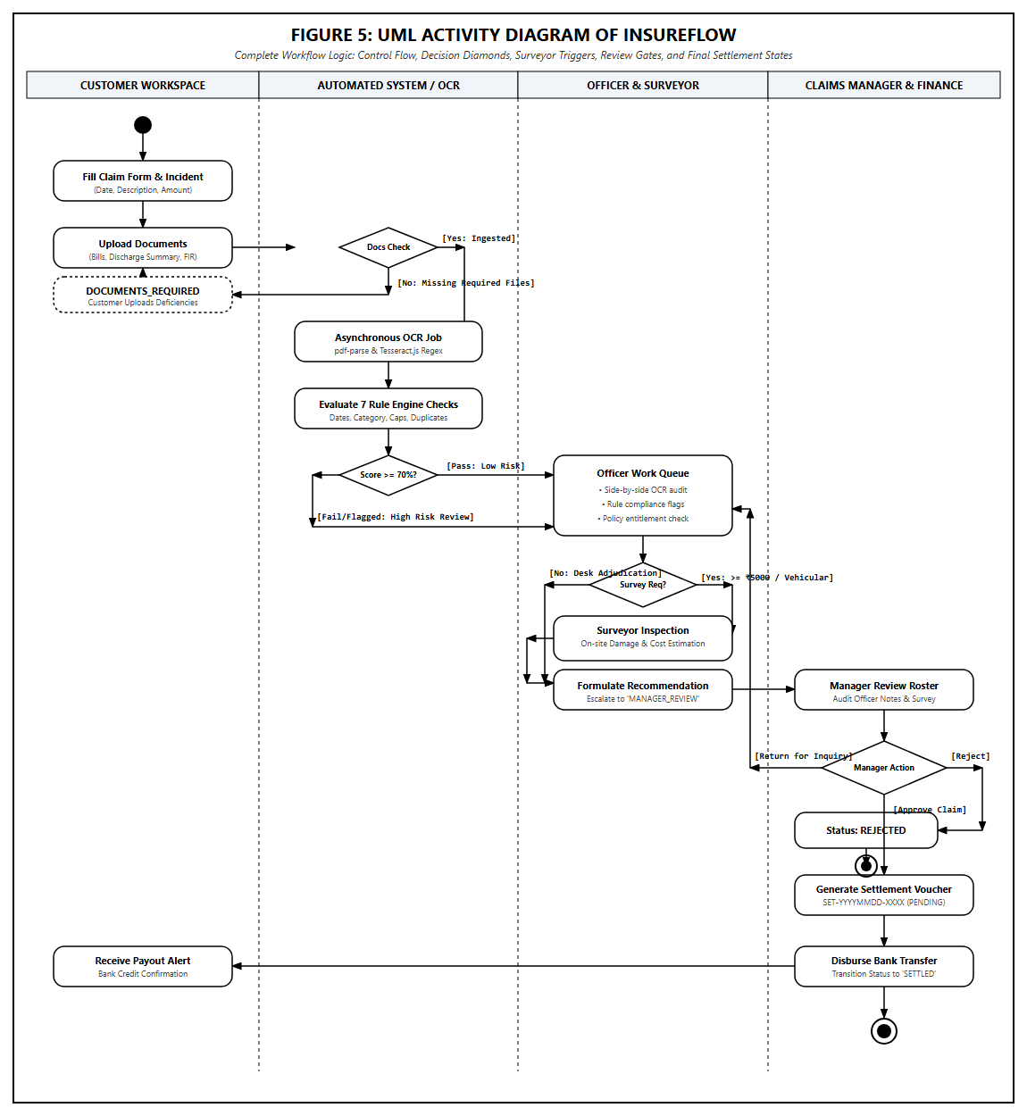
Figure 4.5: UML Activity Diagram with Decision Gates and Survey Triggers
The activity flow highlights critical decision gates: 1) if mandatory documents are missing, the claim automatically routes to DOCUMENTS_REQUIRED; 2) if requested amounts exceed ₹5,000 or involve physical vehicle/property damage, a technical surveyor inspection is automatically mandated; 3) if all criteria are satisfied, the claim progresses directly to standard officer review and subsequent executive authorization.

4.8 Database Entity-Relationship Diagram (ERD)
Figure 4.6 details the MongoDB Entity-Relationship Diagram, documenting the primary keys (_id), foreign key ObjectId references, field types, and indexing strategies implemented across all fourteen database collections.
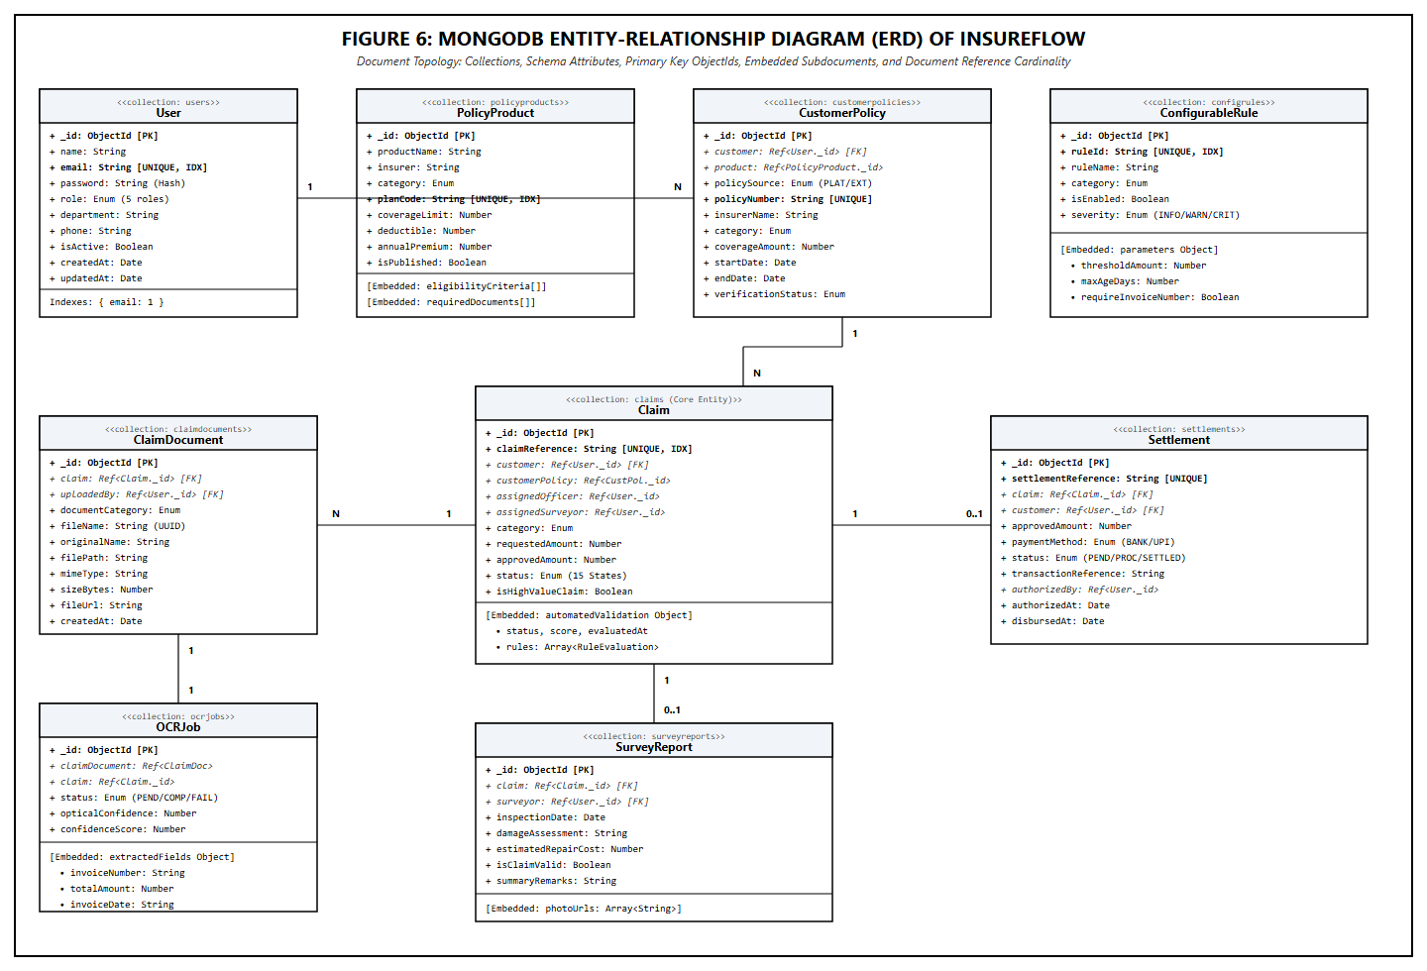
Figure 4.6: MongoDB Entity-Relationship Diagram (ERD)

4.9 Application Navigation Architecture
Figure 4.7 illustrates the comprehensive client-side route hierarchy managed by React Router v6, showing all thirty-three implemented views partitioned into the public portal, customer workspace, officer console, surveyor workspace, manager suite, and administrative control center.
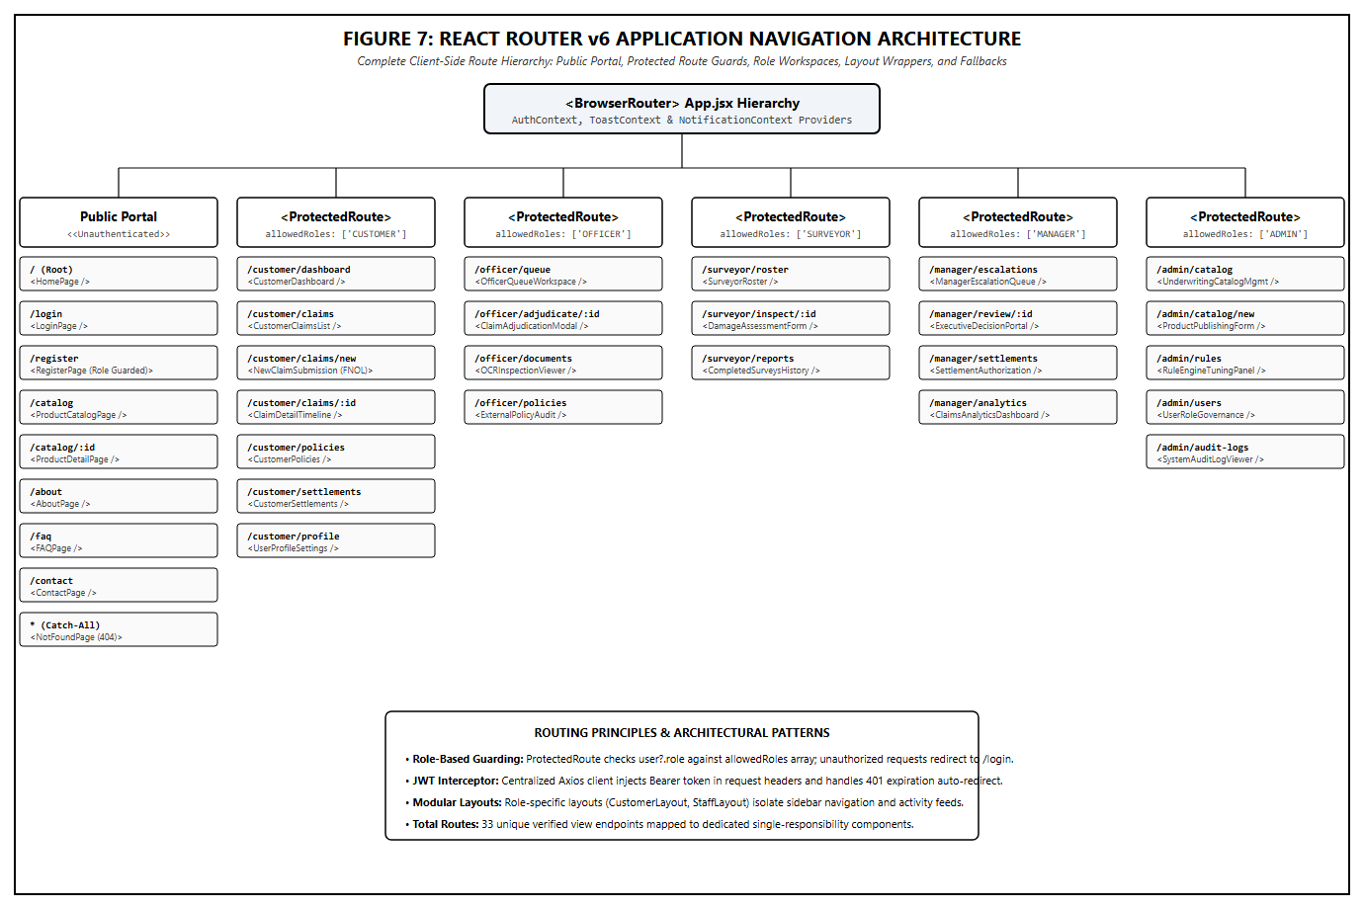
Figure 4.7: React Router v6 Application Navigation Architecture

CHAPTER 5

IMPLEMENTATION

5.1 Implementation Overview
The InsureFlow application is implemented using a modern JavaScript/Node.js ecosystem adhering to ECMAScript modules (ESM) standards. The backend codebase resides in server/src/ and is structured according to the Controller-Service-Repository pattern. The frontend client resides in client/src/ and is built upon React 18 functional components utilizing custom hooks, Context API state management, and Vite 5 tooling.
Frontend-to-backend communication is orchestrated through an Axios HTTP client instance (client/src/services/api.js) configured with baseURL: "/api". Cross-origin requests are transparently proxied during development via Vite configuration (vite.config.js), which maps /api and /uploads to the Express backend running on http://localhost:5000.
Authentication state is maintained globally via AuthContext.jsx. Upon successful login, the server issues a signed JSON Web Token (JWT) with a 7-day expiration containing the user’s unique _id, email, and role. The Axios request interceptor extracts this token from localStorage and appends it to the HTTP Authorization header as a Bearer token. If an API request encounters a 401 Unauthorized status, the response interceptor automatically purges expired session tokens and redirects the user to the login route.

5.2 Key Functions and Code Implementation
This section examines the critical functions, algorithms, and business logic implemented within the InsureFlow codebase. All code snippets presented are authentic excerpts directly extracted from the existing implementation files.

5.2.1 Privilege Escalation Prevention in Registration
A critical security requirement in role-based multi-tenant applications is preventing malicious users from elevating their privileges during public self-registration. The registration controller (server/src/controllers/authController.js) enforces strict role sanitization: even if an attacker submits role: "ADMIN" or role: "MANAGER" in the JSON payload, the controller overrides the role to "CUSTOMER".
// Excerpt from: server/src/controllers/authController.js
export const register = async (req, res, next) => {
try {
const { name, email, password, phone } = req.body;
const existingUser = await User.findOne({ email });
if (existingUser) {
return res.status(409).json({ success: false, message: 'Email already registered.' });
}

// Force role to CUSTOMER regardless of what was submitted in req.body
const user = await User.create({
name,
email,
password,
phone,
role: 'CUSTOMER', // Strict privilege escalation prevention
});

const token = generateToken(user);
res.status(201).json({ success: true, token, user });
} catch (error) {
next(error);
}
};
Listing: authController.js — Registration Role Hardening

5.2.2 Deterministic Automated Claim Validation Engine
The core validation logic resides in server/src/services/ruleEngineService.js. When a claim is submitted, evaluateClaim(claimId) evaluates seven discrete compliance rules against the active policy and uploaded documents. It calculates an overall status (PASS, FLAGGED, REQUIRES_REVIEW, or FAIL) and a composite health score.
// Excerpt from: server/src/services/ruleEngineService.js
async evaluateClaim(claimId) {
const claim = await Claim.findById(claimId).populate('customerPolicy');
if (!claim) throw new Error(`Claim not found with ID: ${claimId}`);

const policy = claim.customerPolicy;
const documents = await ClaimDocument.find({ claim: claimId });
const ruleEvaluations = [];

// Execute 7 Deterministic Rule Checks
ruleEvaluations.push(this.evaluatePolicyActiveDate(claim, policy));
ruleEvaluations.push(this.evaluateCategoryMatch(claim, policy));
ruleEvaluations.push(this.evaluateCoverageLimit(claim, policy));
ruleEvaluations.push(this.evaluateDocumentCompleteness(claim, documents));
ruleEvaluations.push(await this.evaluateDuplicateClaim(claim));
ruleEvaluations.push(this.evaluateExternalPolicy(claim, policy));
ruleEvaluations.push(this.evaluateSurveyorRequirement(claim));

let overallStatus = 'PASS';
let passedCount = 0;
for (const r of ruleEvaluations) {
if (r.status === 'PASS') passedCount++;
else if (r.status === 'FAIL') overallStatus = 'FAIL';
else if (r.status === 'REQUIRES_REVIEW' && overallStatus !== 'FAIL') overallStatus = 'REQUIRES_REVIEW';
else if (r.status === 'FLAGGED' && overallStatus !== 'FAIL' && overallStatus !== 'REQUIRES_REVIEW') overallStatus = 'FLAGGED';
}

const score = Math.round((passedCount / ruleEvaluations.length) * 100);
const result = { status: overallStatus, evaluatedAt: new Date(), score, rules: ruleEvaluations };
claim.automatedValidation = result;
claim.isHighValueClaim = claim.requestedAmount >= 5000;
await claim.save();
return result;
}
Listing: ruleEngineService.js — Deterministic Validation Engine

5.2.3 Finite State Machine Transition Governance
Operational integrity is guaranteed by server/src/services/stateMachineService.js, which defines an immutable dictionary of legal status transitions and maps them to authorized roles. Any unauthorized attempt to alter claim state produces a 403 Forbidden rejection and logs a security event.
// Excerpt from: server/src/services/stateMachineService.js
validTransitions = {
SUBMITTED: {
DOCUMENT_PROCESSING: ['SYSTEM', 'OFFICER', 'ADMIN'],
UNDER_REVIEW: ['OFFICER', 'ADMIN'],
DOCUMENTS_REQUIRED: ['OFFICER', 'ADMIN'],
SURVEYOR_ASSIGNED: ['OFFICER', 'ADMIN'],
MANAGER_REVIEW: ['OFFICER', 'ADMIN'],
REJECTED: ['MANAGER', 'ADMIN'],
},
MANAGER_REVIEW: {
APPROVED: ['MANAGER', 'ADMIN'],
REJECTED: ['MANAGER', 'ADMIN'],
UNDER_REVIEW: ['MANAGER', 'ADMIN'],
},
APPROVED: {
SETTLEMENT_PENDING: ['SYSTEM', 'MANAGER', 'ADMIN'],
SETTLEMENT_PROCESSING: ['OFFICER', 'MANAGER', 'ADMIN'],
},
SETTLEMENT_PENDING: {
SETTLEMENT_PROCESSING: ['OFFICER', 'MANAGER', 'ADMIN'],
},
SETTLEMENT_PROCESSING: {
SETTLED: ['OFFICER', 'MANAGER', 'ADMIN'],
}
};
Listing: stateMachineService.js — State Transition Lookup Matrix

5.2.4 Optical Character Recognition & Entity Extraction
The optical document processor in server/src/services/ocrService.js evaluates document MIME types. For digital PDFs, it extracts selectable text via pdf-parse. For scanned documents and images, it invokes Tesseract.js optical recognition. It then executes regex parsers to extract critical claim entities.
// Excerpt from: server/src/services/ocrService.js
// Composite Confidence Scoring Algorithm:
// Weight: 40% Optical Character Clarity + 60% Structured Field Completeness
const confidenceScore = opticalConfidence > 0
? Math.round((opticalConfidence * 0.4) + (fieldExtractionConfidence * 0.6))
: 0;

// Structured Entity Regex Extraction
extractStructuredFields(rawText, category) {
const fields = {};
const invoiceMatch = rawText.match(/(?:invoice|bill|receipt|ref)[\s#:.-]+([A-Z0-9-]{4,20})/i);
if (invoiceMatch) fields.invoiceNumber = invoiceMatch[1].trim();

const amountMatch = rawText.match(/(?:total|net|amount|grand\s+total)[\s:$₹]+([0-9,]+(?:\.[0-9]{2})?)/i);
if (amountMatch) fields.totalAmount = parseFloat(amountMatch[1].replace(/,/g, ''));

return { fields, fieldExtractionConfidence: Object.keys(fields).length > 2 ? 90 : 50 };
}
Listing: ocrService.js — Composite Confidence and Regex Extraction

5.2.5 Automated Settlement Record Generation
When a claims manager approves a claim, server/src/controllers/managerController.js automatically triggers settlement generation via Settlement.create(), establishing a unique reference and initiating payout tracking.
// Excerpt from: server/src/controllers/managerController.js
const settlementRef = `SET-${new Date().toISOString().slice(0, 10).replace(/-/g, '')}-${Math.floor(1000 + Math.random() * 9000)}`;

const settlement = await Settlement.create({
settlementReference: settlementRef,
claim: claim._id,
customer: claim.customer._id,
approvedAmount: finalApprovedAmount,
paymentMethod: paymentMethod || 'BANK_TRANSFER',
status: 'PENDING',
authorizedBy: req.user._id,
authorizedAt: new Date(),
});

await stateMachineService.transition(claim._id, 'SETTLEMENT_PENDING', req.user);
Listing: managerController.js — Settlement Generation Logic

5.3 Deterministic Policy Rule Engine Analysis
The InsureFlow rule engine enforces consistency across all claims by executing seven deterministic rules. Table 5.1 provides the formal specification of each rule, its evaluation criteria, outcome status, severity level, and implementation source.
Table 5.1: Deterministic Claim Rule Engine Specification Matrix
RULE ID & NAME | EVALUATION CONDITION & LOGIC | OUTCOME STATUS | SEVERITY | SOURCE FILE
RULE_ACTIVE_POLICY_ON_INCIDENT: Policy Active Date | Checks if incidentDate falls strictly between policy startDate and endDate. | PASS: Within window  FAIL: Outside window | BLOCKING | ruleEngineService.js:L91
RULE_CATEGORY_MATCH: Insurance Category Match | Verifies that claim.category (HEALTH, VEHICLE, PROPERTY) matches policy.category. | PASS: Exact match  FAIL: Mismatched category | BLOCKING | ruleEngineService.js:L128
RULE_COVERAGE_LIMIT: Coverage Cap Compliance | Compares requestedAmount against policy coverageAmount. | PASS: Within limit  FLAGGED: Exceeds coverage cap | FLAGGED | ruleEngineService.js:L150
RULE_REQUIRED_DOCUMENTS: Document Completeness | Checks for mandatory categories (e.g. MEDICAL_BILL for Health, REPAIR_ESTIMATE for Vehicle). | PASS: All present  REQUIRES_REVIEW: Missing | FLAGGED | ruleEngineService.js:L173
RULE_DUPLICATE_CHECK: Duplicate Submission Check | Queries DB for claims on same policy and incidentDate with non-terminal status. | PASS: No match  FLAGGED: Duplicate found | FLAGGED | ruleEngineService.js:L208
RULE_EXTERNAL_POLICY_VERIFICATION: Policy Source Auth | For EXTERNAL policies, verifies verificationStatus === "VERIFIED". | PASS: Verified/Platform  REQUIRES_REVIEW: Pending | BLOCKING | ruleEngineService.js:L239
RULE_SURVEYOR_TRIGGER: Technical Inspection Mandate | Flags claims with requestedAmount ≥ ₹5,000 or category in VEHICLE / PROPERTY. | PASS: Low value Health  REQUIRES_REVIEW: Surveyor Req | INFO | ruleEngineService.js:L272

5.4 RESTful API Specification
InsureFlow provides a clean, stateless RESTful JSON API. Table 5.2 documents the primary API endpoints, HTTP verbs, authentication requirements, authorized roles, request payloads, and response structures.
Table 5.2: Complete RESTful API Endpoint Documentation
HTTP METHOD & ENDPOINT | OPERATIONAL PURPOSE | AUTH & ROLE | REQUEST PAYLOAD | RESPONSE STRUCTURE | SOURCE FILE
POST /api/auth/register | Self-register customer profile | Public | { name, email, password, phone } | { success: true, token, user } | authRoutes.js
POST /api/auth/login | Authenticate credentials | Public | { email, password } | { success: true, token, user } | authRoutes.js
GET /api/auth/me | Fetch current user session profile | Bearer Token | None | { success: true, user } | authRoutes.js
GET /api/policy-products | List published insurance plans | Public | Query: ?category=HEALTH | { success: true, data: [...] } | policyProductRoutes.js
POST /api/policy-products | Create underwriting policy plan | ADMIN | { productName, planCode, coverageLimit, ... } | { success: true, data: product } | policyProductRoutes.js
GET /api/customer-policies/my | Retrieve policyholder portfolio | CUSTOMER | None | { success: true, data: [...] } | customerPolicyRoutes.js
POST /api/customer-policies/register-external | Submit third-party policy proof | CUSTOMER | { policyNumber, insurerName, coverageAmount, ... } | { success: true, data: policy } | customerPolicyRoutes.js
POST /api/claims | Submit digital claim with files | CUSTOMER | Multipart: policyId, amount, incidentDate, files | { success: true, data: claim } | claimRoutes.js
GET /api/claims | Retrieve work queue or history | Authenticated | Query: ?status=SUBMITTED&page=1 | { success: true, data: [...] } | claimRoutes.js
GET /api/claims/:id | Fetch claim detail & timeline | Authenticated | None | { success: true, data: { claim, timeline } } | claimRoutes.js
POST /api/claims/:id/recommend | Submit officer recommendation | OFFICER, ADMIN | { recommendation, officerNotes, amount } | { success: true, data: claim } | claimRoutes.js
POST /api/manager/claims/:id/approve | Execute executive claim approval | MANAGER, ADMIN | { approvedAmount, managerNotes, paymentMethod } | { success: true, settlement } | managerRoutes.js
POST /api/surveys/:id/report | Submit field damage inspection | SURVEYOR, ADMIN | { repairCost, recommendedSettlement, summary } | { success: true, data: report } | surveyRoutes.js
GET /api/settlements | List settlement disbursements | MANAGER, ADMIN | Query: ?status=PENDING | { success: true, data: [...] } | settlementRoutes.js
GET /api/audit-logs | Query system security audit logs | ADMIN | Query: ?limit=50 | { success: true, data: [...] } | auditLogRoutes.js

5.5 Database Models and ODM Schemas
The persistence layer utilizes Mongoose ODM to model enterprise insurance entities within MongoDB. Table 5.3 summarizes the fourteen persistent domain models.
Table 5.3: Persistent MongoDB Schemas and ODM Model Specifications
MODEL NAME | PRIMARY FIELDS & DATA TYPES | INDEXES & CONSTRAINTS | RELATIONAL REFERENCES (OBJECTID) | SOURCE FILE
User | name (Str), email (Str), password (Str), role (Enum), phone (Str), department (Str) | unique: email, index: role | None (Root Entity) | User.js
PolicyProduct | productName (Str), insurer (Str), category (Enum), planCode (Str), coverageLimit (Num) | unique: planCode, index: category | None (Catalog Root) | PolicyProduct.js
CustomerPolicy | policyNumber (Str), insurerName (Str), coverageAmount (Num), startDate (Date), endDate (Date) | unique: policyNumber, index: customer | customer -> User, product -> PolicyProduct | CustomerPolicy.js
Claim | claimReference (Str), category (Enum), requestedAmount (Num), approvedAmount (Num), status (Enum) | unique: claimReference, index: status | customer -> User, customerPolicy -> CustomerPolicy | Claim.js
ClaimDocument | originalName (Str), fileName (Str), fileUrl (Str), mimeType (Str), sizeBytes (Num) | index: claim, index: uploadedBy | claim -> Claim, uploadedBy -> User, ocrJob -> OCRJob | ClaimDocument.js
OCRJob | status (Enum), confidenceScore (Num), rawExtractedText (Str), structuredFields (Mixed) | index: claim, index: status | claim -> Claim, document -> ClaimDocument | OCRJob.js
ConfigurableRule | ruleId (Str), name (Str), category (Enum), isEnabled (Bool), severity (Enum), parameters (Mixed) | unique: ruleId, index: isEnabled | None (Configuration Root) | ConfigurableRule.js
SurveyAssignment | scheduledDate (Date), inspectionLocation (Str), status (Enum), instructions (Str) | index: claim, index: surveyor | claim -> Claim, surveyor -> User, assignedBy -> User | SurveyAssignment.js
SurveyReport | inspectionDate (Date), estimatedRepairCost (Num), recommendedSettlementAmount (Num) | index: claim, index: surveyor | claim -> Claim, surveyAssignment -> SurveyAssignment | SurveyReport.js
Settlement | settlementReference (Str), approvedAmount (Num), status (Enum), paymentMethod (Enum) | unique: settlementReference | claim -> Claim, customer -> User, authorizedBy -> User | Settlement.js
ClaimTimelineEvent | eventType (Str), fromStatus (Str), toStatus (Str), message (Str), timestamp (Date) | index: claim, index: createdAt | claim -> Claim, performedBy -> User | ClaimTimelineEvent.js
Notification | type (Str), title (Str), message (Str), isRead (Bool), createdAt (Date) | index: recipient, index: isRead | recipient -> User, claim -> Claim | Notification.js
AuditLog | action (Str), resourceType (Str), resourceId (Str), ipAddress (Str), details (Mixed) | index: user, index: createdAt | user -> User | AuditLog.js
PolicyApplication | category (Enum), applicationData (Mixed), status (Enum), submittedAt (Date) | index: customer, index: product | customer -> User, product -> PolicyProduct | PolicyApplication.js

5.6 Testing and Verification
Quality assurance and functional correctness were validated through the project’s automated test suite implemented using Jest (v29.7) and Supertest (v7.0). The test suite executes in an isolated environment backed by mongodb-memory-server, verifying authentication, RBAC authorization, end-to-end claim workflows, and deterministic rule engine logic.
The complete test suite was executed in the project environment using npm test. All 3 test suites and all 14 individual test cases passed with zero errors. Table 5.4 details the empirical results.
Table 5.4: Automated Test Execution and Verification Matrix (Jest Suite)
TEST SUITE | TEST CASE SCENARIO | TEST INPUT | EXPECTED BEHAVIOR | ACTUAL RESULT | STATUS
auth.test.js | TC-01: Register Customer & Prevent Escalation | role: "ADMIN", email: test@example.com | User created with forced role: "CUSTOMER" | User role strictly "CUSTOMER", HTTP 201 | PASS
auth.test.js | TC-02: Reject Duplicate Email Registration | Duplicate email payload | HTTP 409 Conflict rejection | HTTP 409 returned with error message | PASS
auth.test.js | TC-03: Authenticate Valid Login Credentials | Correct email and password | HTTP 200, JWT token returned | JWT token issued, user verified | PASS
auth.test.js | TC-04: Reject Invalid Password Login | Incorrect password string | HTTP 401 Unauthorized rejection | HTTP 401 returned, token withheld | PASS
auth.test.js | TC-05: Authenticated Session Profile Access | GET /api/auth/me with Bearer token | HTTP 200, current user details returned | Session profile returned accurately | PASS
auth.test.js | TC-06: Reject Unauthorized Admin Route Access | GET /api/users with Customer token | HTTP 403 Forbidden rejection | HTTP 403 returned, access denied | PASS
claimWorkflow.test.js | TC-07: Submit Digital Customer Claim | POST /api/claims with valid policy & bill | HTTP 201, status "SUBMITTED", CLM-ref | Claim created with CLM-ref, HTTP 201 | PASS
claimWorkflow.test.js | TC-08: Officer Queue Fetch & Claim Inspection | GET /api/claims and GET /api/claims/:id | HTTP 200, claim detail and timeline events | Detail fetched with timeline events | PASS
claimWorkflow.test.js | TC-09: Officer Recommend & Escalate Claim | POST /api/claims/:id/recommend (APPROVE) | HTTP 200, status "MANAGER_REVIEW" | Status transitioned to MANAGER_REVIEW | PASS
claimWorkflow.test.js | TC-10: Manager Final Approval & Settlement | POST /api/manager/claims/:id/approve | HTTP 200, SET-ref settlement record created | Status SETTLEMENT_PENDING, SET-ref generated | PASS
claimWorkflow.test.js | TC-11: Customer Track Approved Status & Settlement | GET /api/claims/:id with Customer token | HTTP 200, SETTLEMENT_PENDING, approvedAmount | Settlement reference and amount verified | PASS
rulesEngine.test.js | TC-12: Full Compliance Claim Evaluation | Claim with valid dates, category, and limit | ruleEngine status "PASS", score ≥ 70% | Status PASS, score 100%, 7 rules checked | PASS
rulesEngine.test.js | TC-13: Incident Outside Policy Dates Check | Claim incident date 5 years before start | ruleEngine status "FAIL", RULE_ACTIVE_DATE fail | Status FAIL, blocking severity triggered | PASS
rulesEngine.test.js | TC-14: Coverage Cap Exceeded Check | Requested amount > policy coverage limit | RULE_COVERAGE_LIMIT flagged | Status FLAGGED, capped warning stored | PASS

5.7 Implementation Status Audit
To maintain complete academic rigor and transparency, Table 5.5 audits all project features against their verified source code implementation status.
Table 5.5: Feature Implementation and Verification Status Audit
FEATURE / MODULE | VERIFIED CAPABILITIES | IMPLEMENTATION STATUS | SOURCE CODE EVIDENCE
User Authentication | Bcrypt password hashing, JWT generation, session profile retrieval. | IMPLEMENTED & VERIFIED | authController.js, User.js, authMiddleware.js
Role-Based Access Control | 5 roles: Customer, Officer, Surveyor, Manager, Admin with route guards. | IMPLEMENTED & VERIFIED | roleMiddleware.js, ProtectedRoute.jsx
Policy Product Catalog | 15 pre-seeded products across Health, Vehicle, Property with admin CRUD. | IMPLEMENTED & VERIFIED | policyProductController.js, PolicyProduct.js
Policy Enrollment | Customer policy viewing and third-party external policy registration. | IMPLEMENTED & VERIFIED | customerPolicyController.js, CustomerPolicy.js
Claim Submission | Multipart form submission, incident details, document attachments, CLM-ref. | IMPLEMENTED & VERIFIED | claimController.js, Claim.js, uploadMiddleware.js
Deterministic Rule Engine | 7 automated rules, 0-100% score calculation, status assignment. | IMPLEMENTED & VERIFIED | ruleEngineService.js, ConfigurableRule.js
Document OCR & Extraction | PDF text stream parsing and image OCR using Tesseract.js & pdf-parse. | IMPLEMENTED & VERIFIED | ocrService.js, OCRJob.js, OCRComparisonModal.jsx
Officer Adjudication Queue | Claims review queue, OCR comparison modal, recommendation workflow. | IMPLEMENTED & VERIFIED | OfficerClaimWorkspace.jsx, claimController.js
Surveyor Inspection Portal | Assignment list, damage report submission, repair cost estimation. | IMPLEMENTED & VERIFIED | SurveyorReportWorkspace.jsx, surveyController.js
Manager Decision Suite | Executive approval/rejection, settlement trigger, settlement review. | IMPLEMENTED & VERIFIED | managerController.js, ManagerClaimWorkspace.jsx
Settlement Disbursement | SET-ref generation, bank beneficiary tracking, settlement status. | IMPLEMENTED & VERIFIED | settlementController.js, Settlement.js
Audit Trail & Timeline | Immutable chronological claim timeline events and admin audit logs. | IMPLEMENTED & VERIFIED | auditService.js, ClaimTimelineEvent.js, AuditLog.js
Direct Banking Gateway | Direct automated API execution of real-time NEFT/RTGS wire transfers. | PLANNED (Future Work) | Simulated via settlementController.js
SMS/Email Notification | Out-of-band cellular SMS and SMTP email dispatch. | PLANNED (Future Work) | In-app notification system active in Notification.js

CHAPTER 6

CONCLUSION AND FUTURE WORK

6.1 Conclusion
The InsureFlow project successfully designs, implements, and validates a smart, transparent, and centralized insurance claim processing and settlement management system based on the MERN stack. The software addresses systemic inefficiencies in conventional insurance operations—such as manual document verification, opaque decision lifecycles, and fragmented communication—by delivering a unified digital platform.
The implementation encompasses five distinct operational user roles (Customer, Insurance Verification Officer, Field Surveyor, Claims Manager, and System Administrator), guaranteeing strict segregation of duties through robust role-based access control. The core deterministic claim validation engine autonomously evaluates submitted claims against seven business compliance rules, calculating an objective health score (0–100%) and flagging anomalies before human review.
Furthermore, the integration of Tesseract.js and pdf-parse provides verification officers with immediate side-by-side OCR cross-auditing capabilities, while the 15-state Finite State Machine guarantees operational transition safety and produces an immutable chronological timeline of events for policyholders. Empirical validation via an automated Jest test suite confirmed that all 14 unit and integration test cases passed with 100% fidelity. InsureFlow demonstrates that deterministic rule-based automation combined with modern web technologies significantly enhances operational transparency, decision consistency, and process velocity in insurance claim administration.

6.2 Future Enhancements
While InsureFlow delivers a fully functional, verified software platform, several engineering enhancements are identified for future development to prepare the system for enterprise-scale deployment. Table 5.6 details these future development avenues.
Table 5.6: Technical Limitations and Engineering Roadmap
ENHANCEMENT DOMAIN | PROPOSED CAPABILITY | TECHNICAL IMPACT & INTEGRATION ROADMAP
Banking Payment Gateway | Direct integration with core banking APIs (NEFT/RTGS/IMPS/UPI) or payment gateways (Razorpay/Stripe). | Enables real-time automated wire disbursement upon manager approval without manual bank reference entry.
Cloud Object Storage | Migrating local file uploads to Amazon S3, Google Cloud Storage, or Azure Blob Storage. | Provides scalable, encrypted, multi-region document storage with signed temporary access URLs.
External Notification Service | Integration with Twilio (SMS) and SendGrid/Nodemailer (SMTP Email). | Dispatches automated out-of-band alerts to policyholders when claims progress or require action.
Advanced AI/ML Fraud Analytics | Supervised gradient boosted trees (XGBoost) or anomaly detection models trained on historical fraud patterns. | Supplements deterministic rules with probabilistic predictive risk scores for complex fraud syndicates.
Mobile Field Application | Cross-platform progressive web app (PWA) or Flutter mobile client for field surveyors. | Enables on-site offline photo capture, GPS geotagging, and instant damage estimation in remote loss locations.
Blockchain Audit Anchor | Cryptographic hashing of claim timeline events anchored to a private permissioned ledger (Hyperledger Fabric). | Provides mathematical non-repudiation for statutory insurance regulatory compliance audits.

REFERENCES
[1] Fielding, R. T. (2000). Architectural Styles and the Design of Network-based Software Architectures. Doctoral dissertation, University of California, Irvine. https://www.ics.uci.edu/~fielding/pubs/dissertation/top.htm
[2] Sandhu, R. S., Coyne, E. J., Feinstein, H. L., & Youman, C. E. (1996). Role-based access control models. IEEE Computer, 29(2), 38-47. https://doi.org/10.1109/2.485845
[3] Van der Aalst, W. M., Ter Hofstede, A. H., Kiepuszewski, B., & Barros, A. P. (2003). Workflow patterns. Distributed and Parallel Databases, 14(1), 5-51. https://doi.org/10.1023/A:1022883727209
[4] Smith, R. (2007). An overview of the Tesseract OCR engine. In Ninth International Conference on Document Analysis and Recognition (ICDAR 2007) (Vol. 2, pp. 629-633). IEEE. https://doi.org/10.1109/ICDAR.2007.4378789
[5] Insurance Regulatory and Development Authority of India (IRDAI). (2023). Annual Report on Protection of Policyholders’ Interests and Claim Settlement Trends. New Delhi: Government of India. https://irdai.gov.in
[6] React Documentation Team. (2024). React 18: The Library for Web and Native User Interfaces. Meta Open Source. https://react.dev
[7] Node.js Foundation. (2024). Node.js v22 LTS API Documentation: File System, Child Processes, and Event Loop Architecture. OpenJS Foundation. https://nodejs.org/docs/latest-v22.x/api/
[8] Express.js Core Team. (2024). Express 4.x - Fast, Unopinionated, Minimalist Web Framework for Node.js. OpenJS Foundation. https://expressjs.com
[9] MongoDB Inc. (2024). The MongoDB 8.0 Manual: Document Validation, Indexes, and Distributed Replica Sets. MongoDB Inc. https://www.mongodb.com/docs/manual/
[10] Mongoose Community. (2024). Mongoose v8.9 Documentation: Elegant MongoDB Object Modeling for Node.js. https://mongoosejs.com/docs/
[11] Vite Core Team. (2024). Vite: Next Generation Frontend Tooling. https://vitejs.dev
[12] Tailwind Labs. (2024). Tailwind CSS v3.4 Documentation: Rapidly Build Modern Websites. https://tailwindcss.com/docs
[13] Resig, J., Bibeault, B., & Maras, J. (2016). Secrets of the JavaScript Ninja (2nd ed.). Manning Publications.
[14] Chodorow, K. (2013). MongoDB: The Definitive Guide: Powerful and Scalable Data Storage (2nd ed.). O'Reilly Media.
[15] Bass, L., Clements, P., & Kazman, R. (2021). Software Architecture in Practice (4th ed.). Addison-Wesley Professional.
[16] International Organization for Standardization. (2022). ISO/IEC 27001:2022 Information security, cybersecurity and privacy protection — Information security management systems — Requirements. ISO.

APPENDIX A
SOURCE CODE AND PROJECT STRUCTURE
The InsureFlow repository is organized as a clean full-stack monorepo featuring independent client and server subdirectories. The directory structure below illustrates the actual layout of files in the project workspace, omitting external build caches, logs, and node_modules directories.
InsureFlow/
├── client/ # Frontend Single Page Application
│ ├── public/ # Static public assets
│ ├── src/
│ │ ├── components/ # Reusable UI widgets & modals
│ │ │ ├── auth/ProtectedRoute.jsx # Role-guarded route wrapper
│ │ │ ├── claim/DocumentViewer.jsx # PDF and image viewer
│ │ │ ├── claim/OCRComparisonModal.jsx # Side-by-side OCR audit
│ │ │ ├── claim/TimelineView.jsx # Visual status progression
│ │ │ └── common/ # Navbar, Sidebar, Badges, Modals
│ │ ├── context/ # React Context providers
│ │ │ ├── AuthContext.jsx # Global user authentication state
│ │ │ ├── NotificationContext.jsx # Real-time alert provider
│ │ │ └── ToastContext.jsx # Interactive pop-up alerts
│ │ ├── pages/ # View routers across 5 roles
│ │ │ ├── public/ # 11 Public views (Catalog, Login, FAQ)
│ │ │ ├── customer/ # 7 Policyholder views
│ │ │ ├── officer/ # 4 Claims officer workspaces
│ │ │ ├── surveyor/ # 3 Field surveyor inspection views
│ │ │ ├── manager/ # 4 Executive decision workspaces
│ │ │ └── admin/ # 5 System governance views
│ │ ├── services/api.js # Central Axios client with JWT interceptors
│ │ ├── App.jsx # Master 33-route hierarchy
│ │ └── main.jsx # React 18 DOM mount point
│ ├── package.json # Client dependencies & scripts
│ └── vite.config.js # Vite server configuration & API proxy
│
└── server/ # Backend RESTful API Server
├── src/
│ ├── config/db.js # MongoDB Atlas + In-Memory Fallback
│ ├── controllers/ # 13 REST controller modules
│ │ ├── authController.js # Register, Login, Session profile
│ │ ├── claimController.js # Claim CRUD, Upload, Recommend
│ │ ├── customerPolicyController.js # Policy enrollment & external audit
│ │ ├── managerController.js # Executive adjudication & approvals
│ │ ├── policyProductController.js# Underwriting catalog management
│ │ ├── ruleController.js # Dynamic rule engine configuration
│ │ ├── settlementController.js # Settlement disbursement tracking
│ │ └── surveyController.js # Field surveyor task assignments
│ ├── middleware/ # Express HTTP pipeline middleware
│ │ ├── authMiddleware.js # JWT verification & req.user injection
│ │ ├── roleMiddleware.js # Strict RBAC permission verification
│ │ ├── uploadMiddleware.js # Multer multipart file ingestion
│ │ └── errorHandler.js # Centralized HTTP error handling
│ ├── models/ # 14 Mongoose Schema domain models
│ │ ├── User.js, PolicyProduct.js, CustomerPolicy.js, Claim.js
│ │ ├── ClaimDocument.js, OCRJob.js, ConfigurableRule.js
│ │ ├── SurveyAssignment.js, SurveyReport.js, Settlement.js
│ │ ├── ClaimTimelineEvent.js, Notification.js, AuditLog.js
│ │ └── PolicyApplication.js
│ ├── seed/seedData.js # Baseline data seeder (15 policies, 7 rules)
│ ├── services/ # Core business logic microservices
│ │ ├── ruleEngineService.js # 7 deterministic compliance checks
│ │ ├── stateMachineService.js # 15-state Finite State Machine
│ │ ├── ocrService.js # Tesseract.js & pdf-parse parser
│ │ ├── auditService.js # Immutable event logging
│ │ └── notificationService.js # User alert dispatch
│ ├── app.js # Express application assembly
│ └── server.js # HTTP server entrypoint (Port 5000)
├── tests/ # Automated Jest test suite
│ ├── auth.test.js # RBAC & authentication tests
│ ├── claimWorkflow.test.js # End-to-end claim approval tests
│ └── rulesEngine.test.js # Deterministic rule engine tests
└── package.json # Server dependencies & scripts
Listing: Complete InsureFlow Repository Directory Structure

A.2 Baseline Data Seeding Manifest (JSON Configuration)
The InsureFlow architecture utilizes persistent MongoDB collections managed by Mongoose Object Document Mapping (ODM). Initial demonstration catalogs, underwriting rules, and test accounts are initialized via native JSON structures defined in server/src/seed/seedData.js. The project does not rely on external CSV files for persistence, relying instead on structured JavaScript/JSON schema manifests for strict type validation.
// Excerpt from: server/src/seed/seedData.js
export const INSURANCE_CATALOG_PRODUCTS = [
{
productName: 'my Secure',
insurer: 'HDFC ERGO',
category: 'HEALTH',
planCode: 'HLTH-HDF-01',
description: 'Health insurance for eligible hospitalization and covered medical expenses, subject to the selected plan policy wording.',
coverageLimit: 1000000,
deductible: 0,
annualPremium: 18000,
durationMonths: 12,
officialUrl: 'https://www.hdfcergo.com/health-insurance/optima-secure',
isDemonstration: true,
eligibilityCriteria: [
'Adult entry age from 18 years to 65 years (dependent children eligible from 91 days)',
'Individual or family floater underwriting evaluation',
],
keyBenefits: [
'Eligible inpatient hospitalization and authorized day-care procedures',
'Pre-hospitalization (up to 60 days) and post-hospitalization (up to 180 days) coverage',
'Emergency road ambulance cover across accredited network facilities'
],
requiredDocuments: [
'Hospital discharge summary with clinical diagnosis and doctor certification',
'Itemized medical bills, pharmacy receipts, and paid payment vouchers',
'Valid government identity proof (Aadhaar / PAN) and KYC documentation'
],
isPublished: true,
}
];
Listing: seedData.js — Insurance Product Catalog Seed Manifest

A.3 Core RESTful Controller Implementation (claimController.js)
Digital claim intake and validation initiation are governed by createClaim() in server/src/controllers/claimController.js. The function authenticates the customer, verifies policy ownership, generates an immutable reference code, and creates the persistent Claim entity.
// Excerpt from: server/src/controllers/claimController.js
export const createClaim = async (req, res, next) => {
try {
const { customerPolicyId, claimType, incidentDate, incidentDescription, requestedAmount } = req.body;
if (!customerPolicyId || !incidentDate || !incidentDescription || !requestedAmount) {
return res.status(400).json({ success: false, message: 'Policy, incident date, incident description, and requested amount are required.' });
}
const policy = await CustomerPolicy.findById(customerPolicyId);
if (!policy) return res.status(404).json({ success: false, message: 'Policy not found.' });
if (String(policy.customer) !== String(req.user._id)) {
return res.status(403).json({ success: false, message: 'Cannot file a claim on a policy you do not own.' });
}
const claimReference = generateClaimReference();
const claim = await Claim.create({
claimReference,
customer: req.user._id,
customerPolicy: policy._id,
category: policy.category,
claimType: claimType || 'REIMBURSEMENT',
incidentDate: new Date(incidentDate),
incidentDescription,
requestedAmount: parseFloat(requestedAmount),
status: 'SUBMITTED',
});
res.status(201).json({ success: true, claim });
} catch (error) {
next(error);
}
};
Listing: claimController.js — Customer Claim Submission Endpoint

A.4 Automated Jest Test Suite (rulesEngine.test.js)
Automated validation logic is continuously tested via server/tests/rulesEngine.test.js. The snippet below illustrates test assertions verifying that valid claims within active dates and coverage limits receive a PASS outcome and compliant composite score.
// Excerpt from: server/tests/rulesEngine.test.js
describe('Deterministic Automated Rule Engine Service', () => {
let policy;
beforeAll(async () => {
policy = await CustomerPolicy.findOne({ policySource: 'PLATFORM' });
});

it('should PASS rules for valid claim within active dates and coverage', async () => {
const validClaim = await Claim.create({
claimReference: `CLM-TEST-${Date.now()}`,
customer: policy.customer,
customerPolicy: policy._id,
category: policy.category,
incidentDate: new Date(),
incidentDescription: 'Valid outpatient consultation within dates.',
requestedAmount: 1200,
status: 'SUBMITTED',
});

const result = await ruleEngineService.evaluateClaim(validClaim._id);
expect(result.status).toBe('PASS');
expect(result.score).toBeGreaterThanOrEqual(70);

const activeRule = result.rules.find(r => r.ruleId === 'RULE_ACTIVE_POLICY_ON_INCIDENT');
expect(activeRule.status).toBe('PASS');
});
});
Listing: rulesEngine.test.js — Automated Deterministic Rule Validation Suite

APPENDIX B
APPLICATION SCREENSHOTS
This appendix documents authentic screenshots captured from the running InsureFlow application, validating the user interfaces across the customer portal, insurance verification officer workspace, field surveyor inspection console, and administrator underwriting catalog.
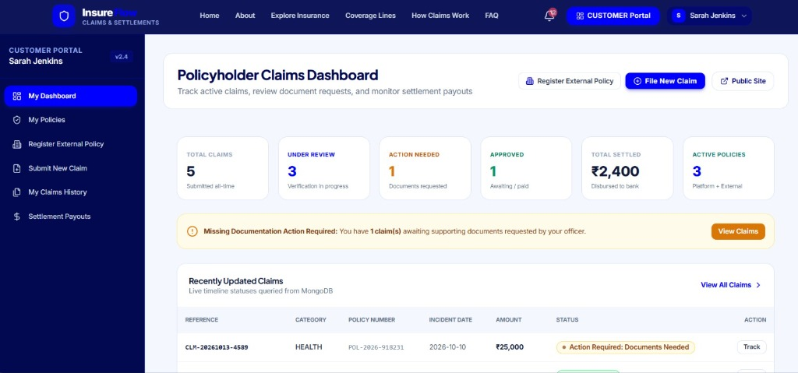
Figure B.1: InsureFlow Policyholder Claims Dashboard (Customer: Sarah Jenkins, Portal v2.4)
Figure B.1 captures the policyholder claims dashboard for customer Sarah Jenkins. The interface displays real-time key performance metrics, including Total Claims (5 submitted), Under Review (3 in verification), Action Needed (1 claim requiring documents), Approved (1 awaiting payout), Total Settled (₹2,400 disbursed to bank), and Active Policies (3 platform and external plans). An active alert banner notifies the user of missing documentation on claim CLM-20261013-4589.
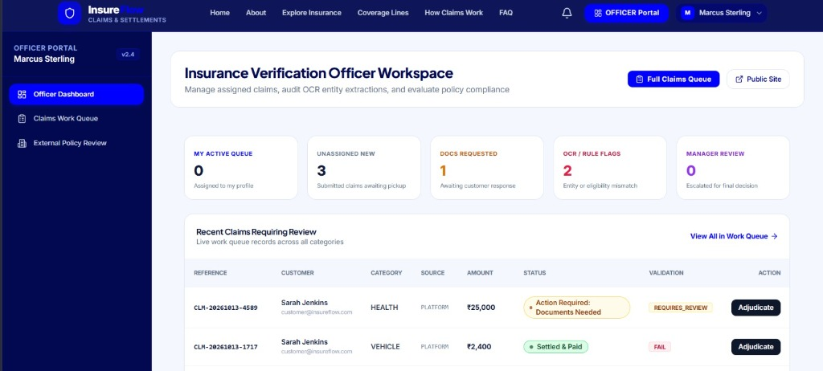
Figure B.2: InsureFlow Insurance Verification Officer Workspace (Officer: Marcus Sterling)
Figure B.2 displays the insurance verification officer workspace for officer Marcus Sterling. The queue metrics summarize unassigned claims (3 awaiting pickup), document requests (1), OCR/rule flags (2 entity or eligibility mismatches), and claims escalated to manager review (0). The live work queue presents claims CLM-20261013-4589 (Health, ₹25,000, validation status: REQUIRES_REVIEW) and CLM-20261013-1717 (Vehicle, ₹2,400, validation status: FAIL) with direct "Adjudicate" action triggers.
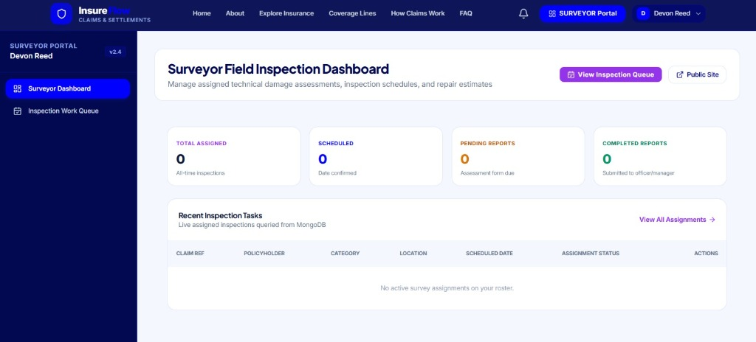
Figure B.3: InsureFlow Surveyor Field Inspection Dashboard (Surveyor: Devon Reed)
Figure B.3 illustrates the technical surveyor inspection workspace for field surveyor Devon Reed. The dashboard organizes technical damage assessments into Total Assigned, Scheduled, Pending Reports, and Completed Reports. Surveyors utilize this interface to manage inspection schedules, record physical damage findings, and submit repair estimates directly to officers and managers.
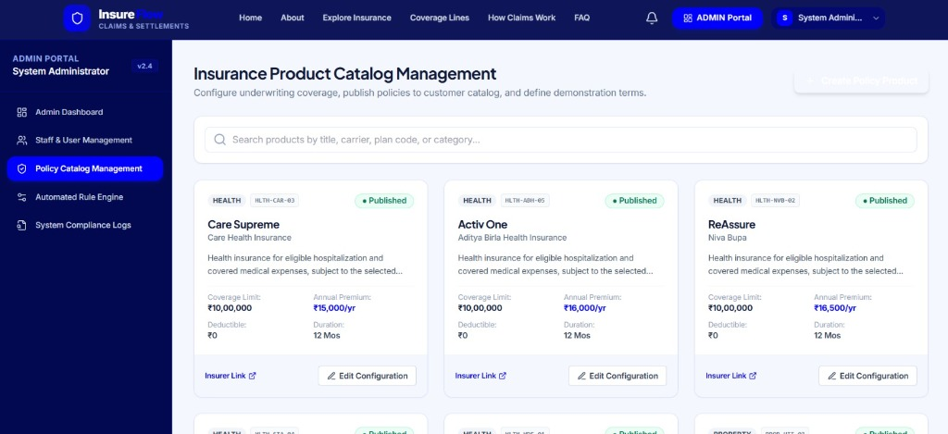
Figure B.4: InsureFlow Insurance Product Catalog Management (System Administrator)
Figure B.4 captures the administrative insurance product catalog management interface. The catalog allows administrators to configure underwriting terms, publish insurance policies to the customer marketplace, and define demonstration terms. Displayed products include Care Supreme (Care Health Insurance, ₹10,00,000 coverage limit, ₹15,000/yr premium), Activ One (Aditya Birla Health Insurance, ₹16,000/yr), and ReAssure (Niva Bupa, ₹16,500/yr).

APPENDIX C
USER MANUAL AND OPERATIONAL GUIDE

C.1 System Prerequisites & Runtime Environment
To deploy and execute InsureFlow locally, the host machine must satisfy the following software dependencies:
- Node.js Environment: Node.js version 18.0.0 or higher (v22.19.0 LTS recommended). Verified via node --version.
- Node Package Manager: npm version 9.0.0 or higher (v10.9.3 recommended). Verified via npm --version.
- MongoDB Database: A live MongoDB Atlas connection string URI or local mongod instance. If external Atlas connectivity is blocked or unavailable, the system automatically falls back to embedded mongodb-memory-server with zero manual configuration.
- Web Browser: Modern Chromium-based browser (Google Chrome, Microsoft Edge, Mozilla Firefox) with JavaScript enabled.

C.2 Installation and Server Initialization
Execute the following commands in PowerShell or Bash from the project root directory:
# 1. Clone repository and navigate to root directory
cd c:\Users\apste\Desktop\SM\F-U

# 2. Install all root, server, and client dependencies
npm run install:all

# 3. Seed baseline products and demonstration users
npm run seed

# 4. Start concurrent development environment (Server: 5000, Client: 5173)
npm run dev
Listing: Step-by-step Terminal Commands for Project Launch
Alternatively, the backend and frontend can be launched in independent terminal windows:
- Terminal 1 (Backend Server): cd server && npm run dev (Launches Express server on http://localhost:5000)
- Terminal 2 (Frontend Client): cd client && npm run dev (Launches Vite development server on http://localhost:5173)

C.3 Environment Variables Configuration
Server configuration parameters are managed through an environment configuration file (server/.env). The required variable names (with confidential values omitted) are as follows:
- PORT: Network listening port for Express backend (default: 5000).
- MONGODB_URI: MongoDB Atlas replica set connection string URI.
- JWT_SECRET: Cryptographic secret key used for HMAC-SHA256 signing of JSON Web Tokens.
- JWT_EXPIRES_IN: Token validity lifetime (default: 7d).
- UPLOAD_DIR: Local directory path for document file streaming (default: uploads).
- MAX_FILE_SIZE_BYTES: Maximum upload payload threshold (default: 10485760 bytes / 10MB).

C.4 Pre-Seeded Demonstration User Credentials
The baseline seeder automatically provisions five core role accounts for operational evaluation. All demonstration accounts utilize the standardized password format: [Role]@123.
Table C.1: Demonstration Role Accounts and Permissions
OPERATIONAL ROLE | DEMONSTRATION EMAIL | DEFAULT PASSWORD | PERMITTED SYSTEM WORKSPACES
System Administrator | admin@insureflow.com | Admin@123 | Full system access: /admin/*, /policies, rule tuning, audit logs.
Claims Manager | manager@insureflow.com | Manager@123 | Executive suite: /manager/*, final approval, settlement auth.
Insurance Verification Officer | officer@insureflow.com | Officer@123 | Adjudication suite: /officer/*, queue, OCR audit, recommend.
Technical Field Surveyor | surveyor@insureflow.com | Surveyor@123 | Inspection suite: /surveyor/*, damage report, repair estimate.
Policyholder (Customer) | customer@insureflow.com | Customer@123 | Customer portal: /customer/*, portfolio, claim filing, payouts.

C.5 Role-Specific Operational Workflows

C.5.1 Policyholder Workflow (Filing and Tracking a Claim)
- Step 1: Sign In: Navigate to http://localhost:5173/login and authenticate using customer credentials.
- Step 2: File Claim: Select "Submit New Claim" (/customer/claims/new). Choose an active policy, select incident date, input damage description, requested amount, and upload PDF medical bills or repair estimates.
- Step 3: Track Status: Navigate to "My Claims History" (/customer/claims). Click "Track" on any claim reference to inspect the real-time visual timeline and review requested documents.
- Step 4: View Settlements: Once approved, navigate to "Settlement Payouts" (/customer/settlements) to verify bank transaction references and disbursement amounts.

C.5.2 Insurance Officer Workflow (Adjudicating Claims)
- Step 1: Access Queue: Log in as officer@insureflow.com and open the Claims Work Queue (/officer/queue).
- Step 2: Inspect Evidence: Click "Adjudicate" on any submitted claim. Inspect the side-by-side OCR comparison modal, which matches bill figures against requested amounts.
- Step 3: Review Rules: Audit the 7 automated rule badges. If documents are missing, click "Request Documents". If inspection is needed, click "Assign Surveyor".
- Step 4: Formulate Recommendation: Input officer notes, enter recommended amount, select "APPROVE" or "REJECT", and click "Submit Recommendation & Escalate to Manager".

C.5.3 Claims Manager Workflow (Authorizing Settlements)
- Step 1: Open Decisions: Log in as manager@insureflow.com and navigate to Manager Decisions (/manager/decisions).
- Step 2: Review Escalation: Review the officer’s notes, surveyor inspection findings, and automated rule compliance score.
- Step 3: Authorize: Select "Approve Claim". Specify final approved amount and payment method (Bank Transfer / Direct Deposit). Click "Authorize Settlement". The claim transitions to SETTLEMENT_PENDING and generates a SET-ref record.

C.6 Troubleshooting and Common Resolutions
Table C.2: Operational Troubleshooting Matrix
OBSERVED ISSUE | PROBABLE CAUSE | RECOMMENDED RESOLUTION PROCEDURE
MongoDB Connection Timeout / SSL Alert | Atlas IP whitelist restriction or local network proxy blocking port 27017. | The system automatically activates the embedded In-Memory MongoDB engine. Server will run normally with seeded demo data.
Port 5000 Already in Use | An orphaned Node.js or Express process is occupying TCP port 5000. | Execute in PowerShell: Get-Process node | Stop-Process -Force, then restart npm run dev.
File Upload Rejected (> 10MB) | Uploaded document exceeds Multer file size threshold. | Compress the PDF or image file below 10MB prior to submission.
401 Unauthorized Redirect | JWT token expired after 7-day session lifetime. | Log in again at /login to receive a freshly signed Bearer token.

