EXERCISE 1 OF MONGO DB

**INSERT DOCUMENTS**

show dbs

admin 0.000GB

config 0.000GB

local 0.000GB

mongo_practice 0.000GB

> use mongo_practice

switched to db mongo_practice

> db.movies.find.pretty()

uncaught exception: TypeError: db.movies.find.pretty is not a function :

@(shell):1:1

> db.movies.find()

{ "_id" : ObjectId("6104fa96e9faf8b7ac9daae4"), "title" : "fight club", "writer" : "Chuck Palahniuko", "year" : 1999, "actors" : [ "Brad Pitt", "Edward Norton" ] }

{ "_id" : ObjectId("6104fb13e9faf8b7ac9daae5"), "title" : "pulp fiction", "writer" : "Quentin Tarantino", "year" : 1994, "actors" : [ "John Travolta", "Uma Thurman" ] }

{ "_id" : ObjectId("6104fb7ae9faf8b7ac9daae6"), "title" : "inglorious basterds", "writer" : "Quentin Tarantino", "year" : 2009, "actors" : [ "Brad Pitt", "Diane Kruger", "Eli Roth" ] }

{ "_id" : ObjectId("6104fc63e9faf8b7ac9daae7"), "title" : "The Hobbit:An unexpected Journey", "writer" : "J.R.R. Tolkein", "year" : 2012, "franchise" : "The Hobbit" }

> db.movies.find().pretty()

{

"_id" : ObjectId("6104fa96e9faf8b7ac9daae4"),

"title" : "fight club",

"writer" : "Chuck Palahniuko",

"year" : 1999,

"actors" : [

"Brad Pitt",

"Edward Norton"

]

}

{

"_id" : ObjectId("6104fb13e9faf8b7ac9daae5"),

"title" : "pulp fiction",

"writer" : "Quentin Tarantino",

"year" : 1994,

"actors" : [

"John Travolta",

"Uma Thurman"

]

}

{

"_id" : ObjectId("6104fb7ae9faf8b7ac9daae6"),

"title" : "inglorious basterds",

"writer" : "Quentin Tarantino",

"year" : 2009,

"actors" : [

"Brad Pitt",

"Diane Kruger",

"Eli Roth"

]

}

{

"_id" : ObjectId("6104fc63e9faf8b7ac9daae7"),

"title" : "The Hobbit:An unexpected Journey",

"writer" : "J.R.R. Tolkein",

"year" : 2012,

"franchise" : "The Hobbit"

}

> db.movies.insert({title:"The Hobbit:The Desolation of Smaug", writer:"J.R.R. Tolkein", year:2013, franchise:"The Hobbit"})

WriteResult({ "nInserted" : 1 })

> db.movies.insert({title:"The Hobbit:The Battle of five Armies", writer:"J.R.R. Tolkein", year:2012, franchise:"The Hobbit", synopsis:"Biblo and company are forced to engage in a war against an array of combatants and keep the lonely Mountain from falling into the hands of a rising darkness"})

WriteResult({ "nInserted" : 1 })

> db.movies.insert({title:"Pee Wee Herman's Big Adventure"})

WriteResult({ "nInserted" : 1 })

> db.movies.insert({title:"Avatar"})

WriteResult({ "nInserted" : 1 })

**GET ALL DOCUMENT’S**

db.movies.find().pretty()

{

"_id" : ObjectId("6104fa96e9faf8b7ac9daae4"),

"title" : "fight club",

"writer" : "Chuck Palahniuko",

"year" : 1999,

"actors" : [

"Brad Pitt",

"Edward Norton"

]

}

{

"_id" : ObjectId("6104fb13e9faf8b7ac9daae5"),

"title" : "pulp fiction",

"writer" : "Quentin Tarantino",

"year" : 1994,

"actors" : [

"John Travolta",

"Uma Thurman"

]

}

{

"_id" : ObjectId("6104fb7ae9faf8b7ac9daae6"),

"title" : "inglorious basterds",

"writer" : "Quentin Tarantino",

"year" : 2009,

"actors" : [

"Brad Pitt",

"Diane Kruger",

"Eli Roth"

]

}

{

"_id" : ObjectId("6104fc63e9faf8b7ac9daae7"),

"title" : "The Hobbit:An unexpected Journey",

"writer" : "J.R.R. Tolkein",

"year" : 2012,

"franchise" : "The Hobbit"

}

{

"_id" : ObjectId("6105493820ea11fa5a5dd067"),

"title" : "The Hobbit:The Desolation of Smaug",

"writer" : "J.R.R. Tolkein",

"year" : 2013,

"franchise" : "The Hobbit"

}

{

"_id" : ObjectId("610549df20ea11fa5a5dd068"),

"title" : "The Hobbit:The Battle of five Armies",

"writer" : "J.R.R. Tolkein",

"year" : 2012,

"franchise" : "The Hobbit",

"synopsis" : "Biblo and company are forced to engage in a war against an array of combatants and keep the lonely Mountain from falling into the hands of a rising darkness"

}

{

"_id" : ObjectId("61054a1320ea11fa5a5dd069"),

"title" : "Pee Wee Herman's Big Adventure"

}

{ "_id" : ObjectId("61054a1f20ea11fa5a5dd06a"), "title" : "Avatar" }

db.movies.find({writer:"Quentin Tarantino"}).pretty()

{

"_id" : ObjectId("6104fb13e9faf8b7ac9daae5"),

"title" : "pulp fiction",

"writer" : "Quentin Tarantino",

"year" : 1994,

"actors" : [

"John Travolta",

"Uma Thurman"

]

}

{

"_id" : ObjectId("6104fb7ae9faf8b7ac9daae6"),

"title" : "inglorious basterds",

"writer" : "Quentin Tarantino",

"year" : 2009,

"actors" : [

"Brad Pitt",

"Diane Kruger",

"Eli Roth"

]

db.movies.find({actors:{$in:["Brad Pitt"]}}).pretty()

{

"_id" : ObjectId("6104fa96e9faf8b7ac9daae4"),

"title" : "fight club",

"writer" : "Chuck Palahniuko",

"year" : 1999,

"actors" : [

"Brad Pitt",

"Edward Norton"

]

}

{

"_id" : ObjectId("6104fb7ae9faf8b7ac9daae6"),

"title" : "inglorious basterds",

"writer" : "Quentin Tarantino",

"year" : 2009,

"actors" : [

"Brad Pitt",

"Diane Kruger",

"Eli Roth"

]

}

db.movies.find({franchise:"The Hobbit"}).pretty()

{

"_id" : ObjectId("6104fc63e9faf8b7ac9daae7"),

"title" : "The Hobbit:An unexpected Journey",

"writer" : "J.R.R. Tolkein",

"year" : 2012,

"franchise" : "The Hobbit"

}

{

"_id" : ObjectId("6105493820ea11fa5a5dd067"),

"title" : "The Hobbit:The Desolation of Smaug",

"writer" : "J.R.R. Tolkein",

"year" : 2013,

"franchise" : "The Hobbit"

}

{

"_id" : ObjectId("610549df20ea11fa5a5dd068"),

"title" : "The Hobbit:The Battle of five Armies",

"writer" : "J.R.R. Tolkein",

"year" : 2012,

"franchise" : "The Hobbit",

"synopsis" : "Biblo and company are forced to engage in a war against an array of combatants and keep the lonely Mountain from falling into the hands of a rising darkness"

db.movies.find({year:{$lt:2000}}).pretty()

{

"_id" : ObjectId("6104fa96e9faf8b7ac9daae4"),

"title" : "fight club",

"writer" : "Chuck Palahniuko",

"year" : 1999,

"actors" : [

"Brad Pitt",

"Edward Norton"

]

}

{

"_id" : ObjectId("6104fb13e9faf8b7ac9daae5"),

"title" : "pulp fiction",

"writer" : "Quentin Tarantino",

"year" : 1994,

"actors" : [

"John Travolta",

"Uma Thurman"

]

}

db.movies.find({$or:[{year:{$lt:2000}},{year:{$gt:2010}}]}).pretty()

{

"_id" : ObjectId("6104fa96e9faf8b7ac9daae4"),

"title" : "fight club",

"writer" : "Chuck Palahniuko",

"year" : 1999,

"actors" : [

"Brad Pitt",

"Edward Norton"

]

}

{

"_id" : ObjectId("6104fb13e9faf8b7ac9daae5"),

"title" : "pulp fiction",

"writer" : "Quentin Tarantino",

"year" : 1994,

"actors" : [

"John Travolta",

"Uma Thurman"

]

}

{

"_id" : ObjectId("6104fc63e9faf8b7ac9daae7"),

"title" : "The Hobbit:An unexpected Journey",

"writer" : "J.R.R. Tolkein",

"year" : 2012,

"franchise" : "The Hobbit"

}

{

"_id" : ObjectId("6105493820ea11fa5a5dd067"),

"title" : "The Hobbit:The Desolation of Smaug",

"writer" : "J.R.R. Tolkein",

"year" : 2013,

"franchise" : "The Hobbit"

}

{

"_id" : ObjectId("610549df20ea11fa5a5dd068"),

"title" : "The Hobbit:The Battle of five Armies",

"writer" : "J.R.R. Tolkein",

"year" : 2012,

"franchise" : "The Hobbit",

"synopsis" : "Biblo and company are forced to engage in a war against an array of combatants and keep the lonely Mountain from falling into the hands of a rising darkness"

}

db.movies.update({title:"The Hobbit:An Unexpected Journey"},{$set:{synopsis:"A reluctant hobbit Biblo Baggins sets out to the lonely Mountain with a sprinted group of dwarves to reclaim their mountain home- and the gold within it -from the dragon smaug"}})

WriteResult({ "nMatched" : 0, "nUpserted" : 0, "nModified" : 0 })

> db.movies.update({title:"The Hobbit:The Desolation of Smaug"},{$set:{synopsis:"The dwarves along with biblo baggins and gandalf the grey, continue their quest to reclaim Erebor their homesland from SmaugBiblo Baggins is in possession of a mysterious and magical ring"}})

WriteResult({ "nMatched" : 1, "nUpserted" : 0, "nModified" : 1 })

db.movies.update({title:"pulp fiction"},{$set:{actors:["Samuel L Jackson"]}})

WriteResult({ "nMatched" : 1, "nUpserted" : 0, "nModified" : 1 })

db.movies.find().pretty()

{

"_id" : ObjectId("6104fa96e9faf8b7ac9daae4"),

"title" : "fight club",

"writer" : "Chuck Palahniuko",

"year" : 1999,

"actors" : [

"Brad Pitt",

"Edward Norton"

]

}

{

"_id" : ObjectId("6104fb13e9faf8b7ac9daae5"),

"title" : "pulp fiction",

"writer" : "Quentin Tarantino",

"year" : 1994,

"actors" : [

"Samuel L Jackson"

]

}

{

"_id" : ObjectId("6104fb7ae9faf8b7ac9daae6"),

"title" : "inglorious basterds",

"writer" : "Quentin Tarantino",

"year" : 2009,

"actors" : [

"Brad Pitt",

"Diane Kruger",

"Eli Roth"

]

}

{

"_id" : ObjectId("6104fc63e9faf8b7ac9daae7"),

"title" : "The Hobbit:An unexpected Journey",

"writer" : "J.R.R. Tolkein",

"year" : 2012,

"franchise" : "The Hobbit",

"synopsis" : "A reluctant hobbit Biblo Baggins sets out to the lonely Mountain with a sprinted group of dwarves to reclaim their mountain home- and the gold within it -from the dragon smaug"

}

{

"_id" : ObjectId("6105493820ea11fa5a5dd067"),

"title" : "The Hobbit:The Desolation of Smaug",

"writer" : "J.R.R. Tolkein",

"year" : 2013,

"franchise" : "The Hobbit",

"synopsis" : "The dwarves along with biblo baggins and gandalf the grey, continue their quest to reclaim Erebor their homesland from SmaugBiblo Baggins is in possession of a mysterious and magical ring"

}

{

"_id" : ObjectId("610549df20ea11fa5a5dd068"),

"title" : "The Hobbit:The Battle of five Armies",

"writer" : "J.R.R. Tolkein",

"year" : 2012,

"franchise" : "The Hobbit",

"synopsis" : "Biblo and company are forced to engage in a war against an array of combatants and keep the lonely Mountain from falling into the hands of a rising darkness"

}

{

"_id" : ObjectId("61054a1320ea11fa5a5dd069"),

"title" : "Pee Wee Herman's Big Adventure"

}

{ "_id" : ObjectId("61054a1f20ea11fa5a5dd06a"), "title" : "Avatar" }

(i-search)`':

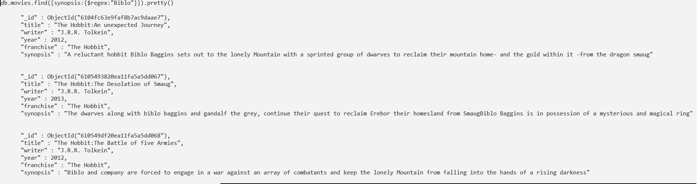



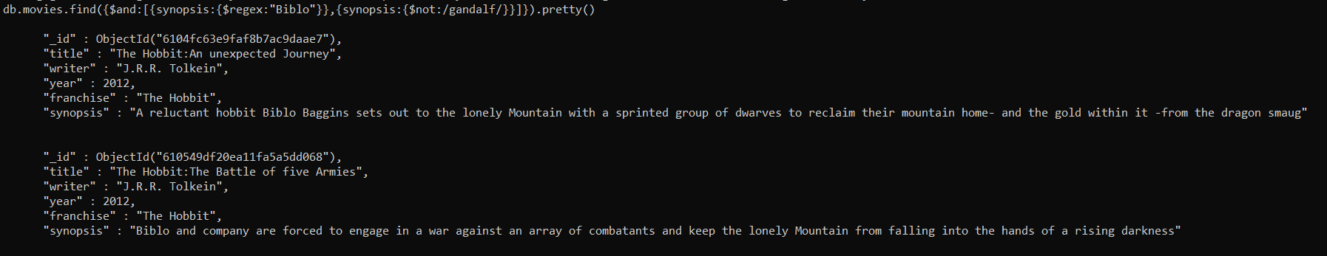

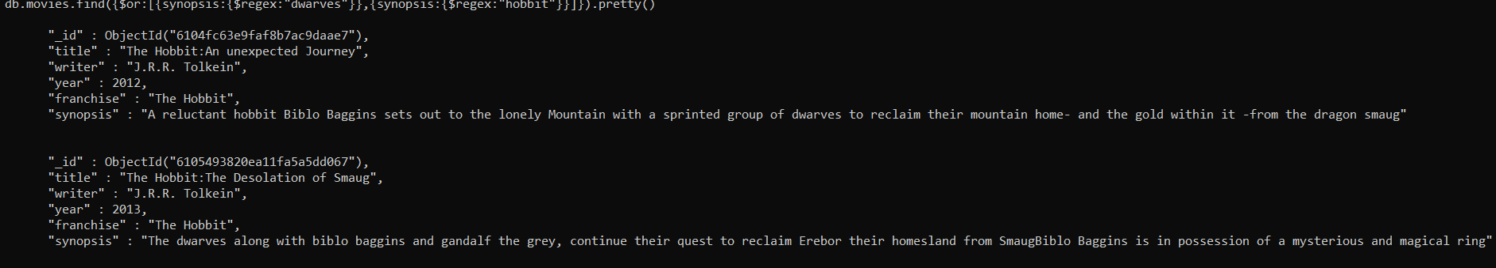

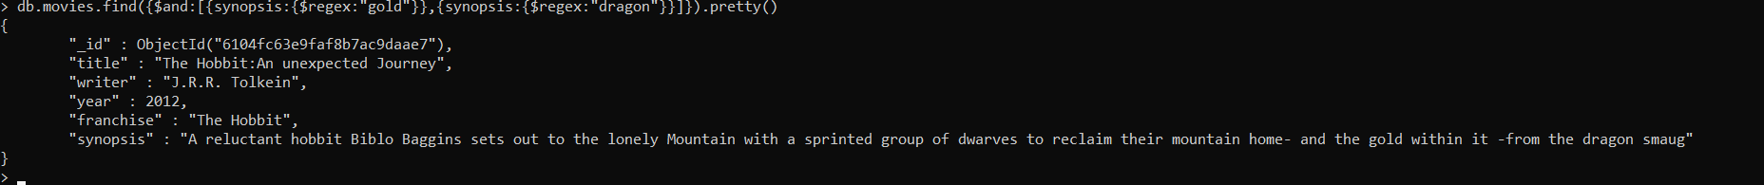

db.movies.remove({title:"Pee Wee Herman's Big Adventure"})

WriteResult({ "nRemoved" : 1 })

> db.movies.find().pretty()

{

"_id" : ObjectId("6104fa96e9faf8b7ac9daae4"),

"title" : "fight club",

"writer" : "Chuck Palahniuko",

"year" : 1999,

"actors" : [

"Brad Pitt",

"Edward Norton"

]

}

{

"_id" : ObjectId("6104fb13e9faf8b7ac9daae5"),

"title" : "pulp fiction",

"writer" : "Quentin Tarantino",

"year" : 1994,

"actors" : [

"Samuel L Jackson"

]

}

{

"_id" : ObjectId("6104fb7ae9faf8b7ac9daae6"),

"title" : "inglorious basterds",

"writer" : "Quentin Tarantino",

"year" : 2009,

"actors" : [

"Brad Pitt",

"Diane Kruger",

"Eli Roth"

]

}

{

"_id" : ObjectId("6104fc63e9faf8b7ac9daae7"),

"title" : "The Hobbit:An unexpected Journey",

"writer" : "J.R.R. Tolkein",

"year" : 2012,

"franchise" : "The Hobbit",

"synopsis" : "A reluctant hobbit Biblo Baggins sets out to the lonely Mountain with a sprinted group of dwarves to reclaim their mountain home- and the gold within it -from the dragon smaug"

}

{

"_id" : ObjectId("6105493820ea11fa5a5dd067"),

"title" : "The Hobbit:The Desolation of Smaug",

"writer" : "J.R.R. Tolkein",

"year" : 2013,

"franchise" : "The Hobbit",

"synopsis" : "The dwarves along with biblo baggins and gandalf the grey, continue their quest to reclaim Erebor their homesland from SmaugBiblo Baggins is in possession of a mysterious and magical ring"

}

{

"_id" : ObjectId("610549df20ea11fa5a5dd068"),

"title" : "The Hobbit:The Battle of five Armies",

"writer" : "J.R.R. Tolkein",

"year" : 2012,

"franchise" : "The Hobbit",

"synopsis" : "Biblo and company are forced to engage in a war against an array of combatants and keep the lonely Mountain from falling into the hands of a rising darkness"

}

{ "_id" : ObjectId("61054a1f20ea11fa5a5dd06a"), "title" : "Avatar" }

db.movies.remove({title:"Avatar"})

WriteResult({ "nRemoved" : 1 })

> db.movies.find().pretty()



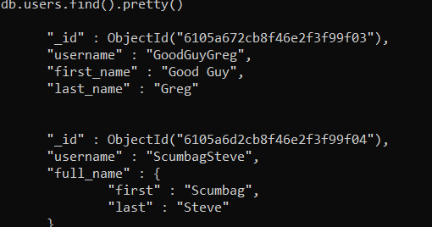

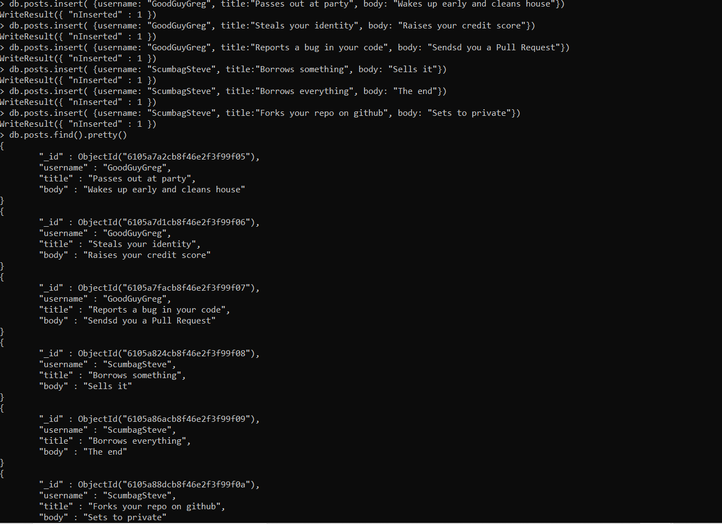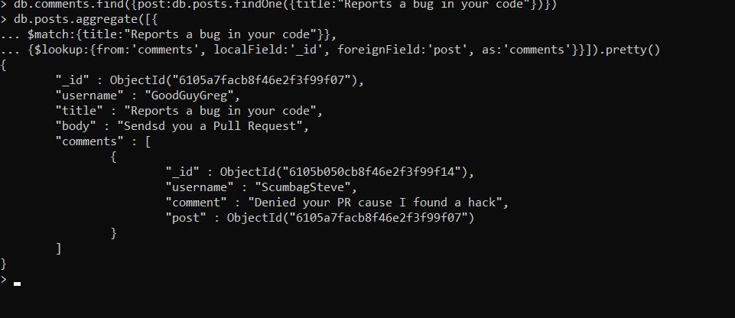

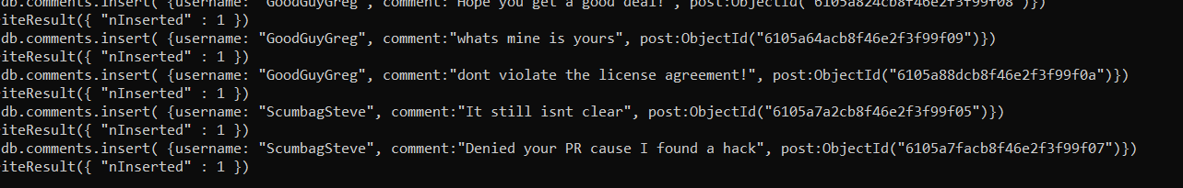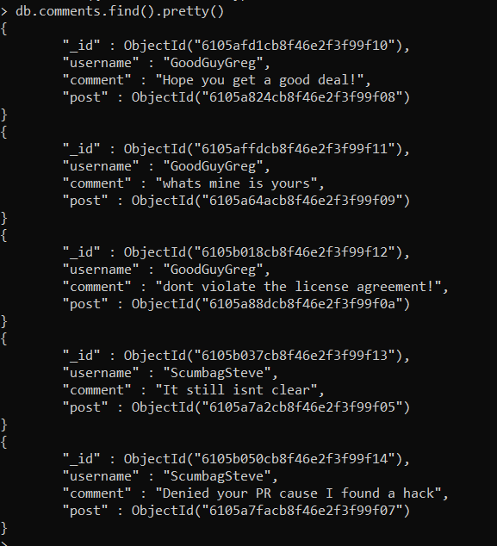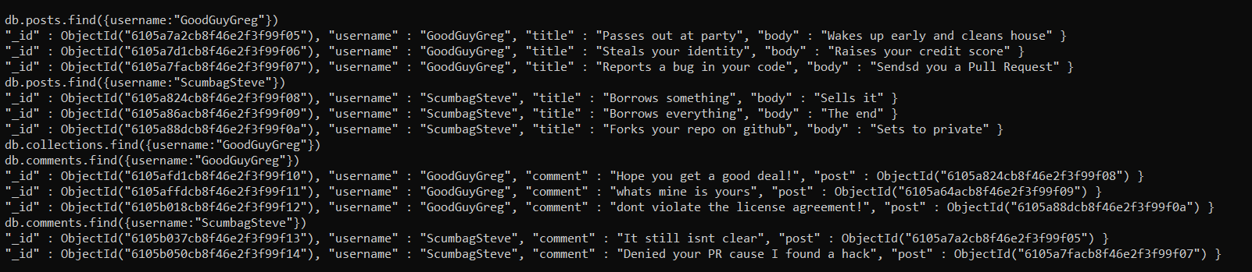

db.posts.aggregate([  
{  
$match: { title: 'Reports a bug in your code' }  
},  
{  
$lookup: {  
from: 'comments',  
localField: '_id',  
foreignField: 'post',  
as: 'comments'  
}  
}  
]).pretty();