ASSIGNMENT 2

ATLANTA POPULATION

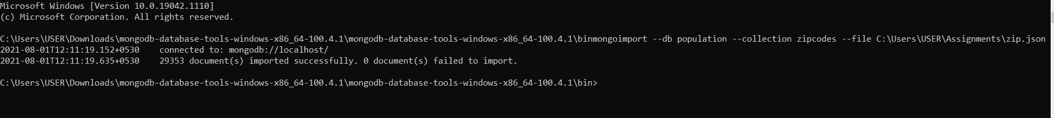

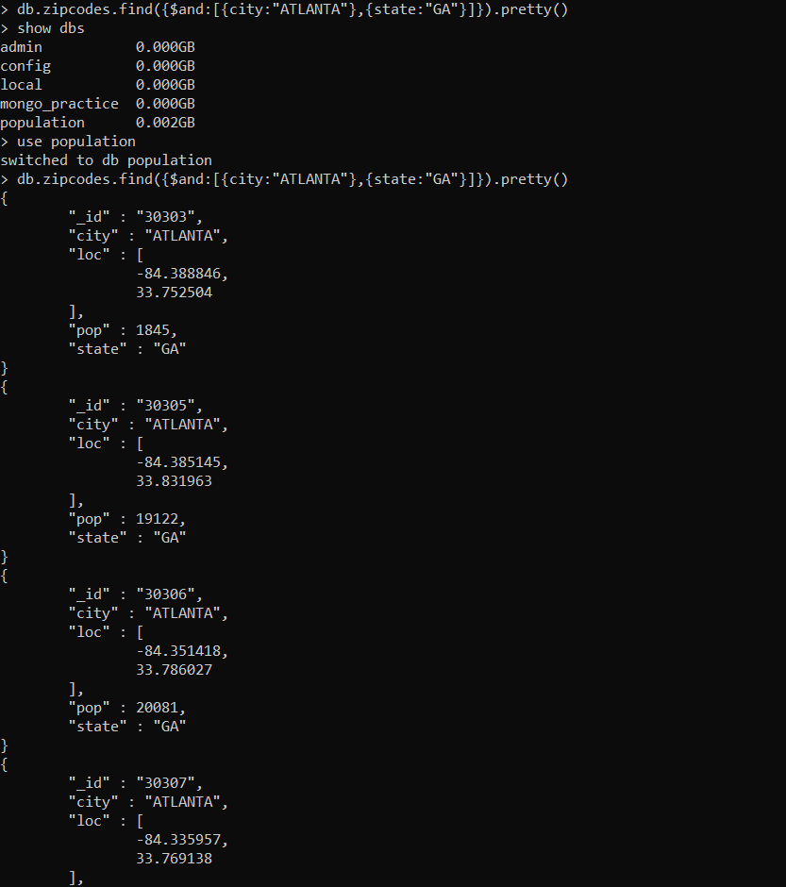

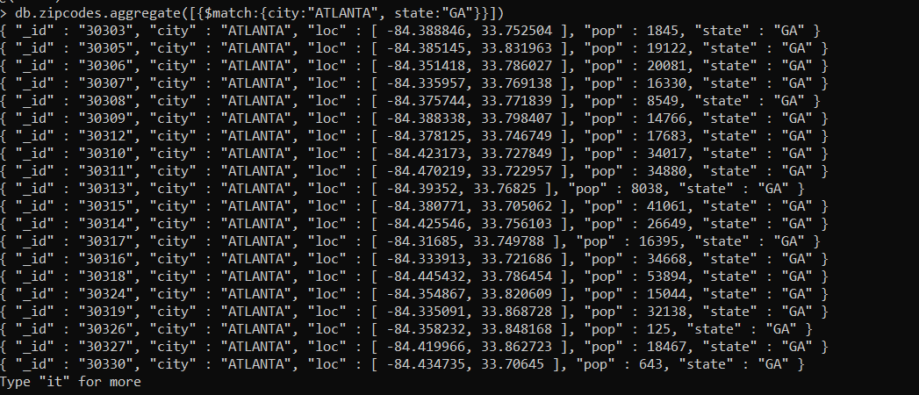



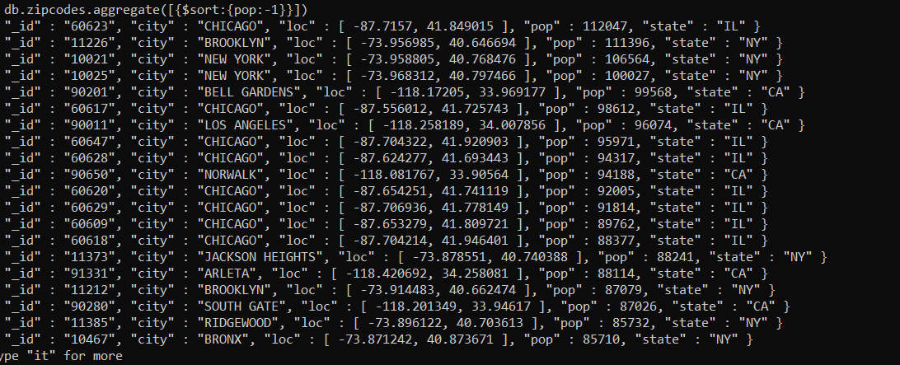

**POPULATION BY STATE**

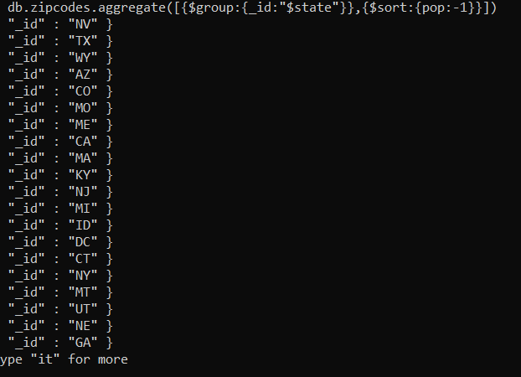

1. db.zipcodes.aggregate({$match:{city:"ATLANTA"}},{$group:{_id:'$city',zips:{$sum:1}}})

{ "_id" : "ATLANTA", "zips" : 41 }

db.zipcodes.aggregate({$match:{city:"ATLANTA"}},{$group:{_id:'$city',Population:{$sum:'$pop'}}})

{ "_id" : "ATLANTA", "Population" : 630046 }

db.zipcodes.aggregate({$group:{_id:'$state',Population:{$sum:'$pop'}}})

{ "_id" : "NV", "Population" : 1201833 }

{ "_id" : "TX", "Population" : 16984601 }

{ "_id" : "WY", "Population" : 453528 }

{ "_id" : "AZ", "Population" : 3665228 }

{ "_id" : "CO", "Population" : 3293755 }

{ "_id" : "MO", "Population" : 5110648 }

{ "_id" : "ME", "Population" : 1226648 }

{ "_id" : "CA", "Population" : 29754890 }

{ "_id" : "MA", "Population" : 6016425 }

{ "_id" : "KY", "Population" : 3675484 }

{ "_id" : "NJ", "Population" : 7730188 }

{ "_id" : "MI", "Population" : 9295297 }

{ "_id" : "ID", "Population" : 1006749 }

{ "_id" : "DC", "Population" : 606900 }

{ "_id" : "CT", "Population" : 3287116 }

{ "_id" : "NY", "Population" : 17990402 }

{ "_id" : "MT", "Population" : 798948 }

{ "_id" : "UT", "Population" : 1722850 }

{ "_id" : "NE", "Population" : 1578139 }

{ "_id" : "GA", "Population" : 6478216 }

Type "it" for more

1. db.zipcodes.aggregate({$group:{_id:{state:"$state"},population:{$sum:'$pop'}}},{$sort:{population:-1}},{$limit:3})

{ "_id" : { "state" : "CA" }, "population" : 29754890 }

{ "_id" : { "state" : "NY" }, "population" : 17990402 }

{ "_id" : { "state" : "TX" }, "population" : 16984601 }

**POPULATION BY CITY**

1. db.zipcodes.aggregate({$group:{_id:{city:'$city',state:"$state"},population:{$sum:'$pop'}}})

{ "_id" : { "city" : "SAINT PETERS", "state" : "MO" }, "population" : 43133 }

{ "_id" : { "city" : "PRICHARD", "state" : "WV" }, "population" : 1215 }

{ "_id" : { "city" : "RANCHITA", "state" : "CA" }, "population" : 389 }

{ "_id" : { "city" : "DARDANELLE", "state" : "AR" }, "population" : 8281 }

{ "_id" : { "city" : "TRIDELL", "state" : "UT" }, "population" : 363 }

{ "_id" : { "city" : "TURTLE CREEK", "state" : "PA" }, "population" : 8157 }

{ "_id" : { "city" : "HOUSTON", "state" : "PA" }, "population" : 6060 }

{ "_id" : { "city" : "MALONE", "state" : "TX" }, "population" : 491 }

{ "_id" : { "city" : "ROUND MOUNTAIN", "state" : "NV" }, "population" : 1302 }

{ "_id" : { "city" : "ROSSFORD", "state" : "OH" }, "population" : 5861 }

{ "_id" : { "city" : "SAN MARTIN", "state" : "CA" }, "population" : 5563 }

{ "_id" : { "city" : "FAIRBANKS", "state" : "AK" }, "population" : 31379 }

{ "_id" : { "city" : "SOUTH SHORE", "state" : "SD" }, "population" : 487 }

{ "_id" : { "city" : "HOSSTON", "state" : "LA" }, "population" : 766 }

{ "_id" : { "city" : "PEMBERTON", "state" : "MN" }, "population" : 880 }

{ "_id" : { "city" : "HOPE", "state" : "RI" }, "population" : 3653 }

{ "_id" : { "city" : "COATS", "state" : "NC" }, "population" : 4437 }

{ "_id" : { "city" : "PECK", "state" : "KS" }, "population" : 1023 }

{ "_id" : { "city" : "FORT BENTON", "state" : "MT" }, "population" : 2795 }

{ "_id" : { "city" : "LAWRENCE", "state" : "NE" }, "population" : 594 }

Type "it" for more

1. db.zipcodes.aggregate({$group:{_id:{city:"$city",state:"$state"},population:{$sum:'$pop'}}},{$sort:{population:-1}})

{ "_id" : { "city" : "CHICAGO", "state" : "IL" }, "population" : 2452177 }

{ "_id" : { "city" : "BROOKLYN", "state" : "NY" }, "population" : 2300504 }

{ "_id" : { "city" : "LOS ANGELES", "state" : "CA" }, "population" : 2102295 }

{ "_id" : { "city" : "HOUSTON", "state" : "TX" }, "population" : 2095918 }

{ "_id" : { "city" : "PHILADELPHIA", "state" : "PA" }, "population" : 1610956 }

{ "_id" : { "city" : "NEW YORK", "state" : "NY" }, "population" : 1476790 }

{ "_id" : { "city" : "BRONX", "state" : "NY" }, "population" : 1209548 }

{ "_id" : { "city" : "SAN DIEGO", "state" : "CA" }, "population" : 1049298 }

{ "_id" : { "city" : "DETROIT", "state" : "MI" }, "population" : 963243 }

{ "_id" : { "city" : "DALLAS", "state" : "TX" }, "population" : 940191 }

{ "_id" : { "city" : "PHOENIX", "state" : "AZ" }, "population" : 890853 }

{ "_id" : { "city" : "MIAMI", "state" : "FL" }, "population" : 825232 }

{ "_id" : { "city" : "SAN JOSE", "state" : "CA" }, "population" : 816653 }

{ "_id" : { "city" : "SAN ANTONIO", "state" : "TX" }, "population" : 811792 }

{ "_id" : { "city" : "BALTIMORE", "state" : "MD" }, "population" : 733081 }

{ "_id" : { "city" : "SAN FRANCISCO", "state" : "CA" }, "population" : 723993 }

{ "_id" : { "city" : "MEMPHIS", "state" : "TN" }, "population" : 632837 }

{ "_id" : { "city" : "SACRAMENTO", "state" : "CA" }, "population" : 628279 }

{ "_id" : { "city" : "JACKSONVILLE", "state" : "FL" }, "population" : 610160 }

{ "_id" : { "city" : "ATLANTA", "state" : "GA" }, "population" : 609591 }

Type "it" for more

1. db.zipcodes.aggregate({$group:{_id:{city:"$city"},population:{$sum:'$pop'}}},{$sort:{population:-1}},{$limit:3})

{ "_id" : { "city" : "CHICAGO" }, "population" : 2452177 }

{ "_id" : { "city" : "BROOKLYN" }, "population" : 2341387 }

{ "_id" : { "city" : "HOUSTON" }, "population" : 2123053 }

1. db.zipcodes.aggregate({$match:{state:"TX"}},{$group:{_id:'$city',Population:{$sum:'$pop'}}},{$sort:{Population:-1}},{$limit:3})

{ "_id" : "HOUSTON", "Population" : 2095918 }

{ "_id" : "DALLAS", "Population" : 940191 }

{ "_id" : "SAN ANTONIO", "Population" : 811792 }

db.zipcodes.aggregate( [

... { $group: { _id: { state: "$state", city: "$city" }, pop: { $sum: "$pop" } } },

... { $group: { _id: "$_id.state", avgCityPop: { $avg: "$pop" } } }

... ] )

{ "_id" : "NV", "avgCityPop" : 18209.590909090908 }

{ "_id" : "TX", "avgCityPop" : 13775.02108678021 }

{ "_id" : "WY", "avgCityPop" : 3384.5373134328356 }

{ "_id" : "AZ", "avgCityPop" : 20591.16853932584 }

{ "_id" : "CO", "avgCityPop" : 9981.075757575758 }

{ "_id" : "MO", "avgCityPop" : 5672.195338512764 }

{ "_id" : "ME", "avgCityPop" : 3006.4901960784314 }

{ "_id" : "CA", "avgCityPop" : 27756.42723880597 }

{ "_id" : "MA", "avgCityPop" : 14855.37037037037 }

{ "_id" : "KY", "avgCityPop" : 4767.164721141375 }

{ "_id" : "NJ", "avgCityPop" : 15775.89387755102 }

{ "_id" : "MI", "avgCityPop" : 12087.512353706112 }

{ "_id" : "ID", "avgCityPop" : 4320.811158798283 }

{ "_id" : "DC", "avgCityPop" : 303450 }

{ "_id" : "CT", "avgCityPop" : 14674.625 }

{ "_id" : "MT", "avgCityPop" : 2593.987012987013 }

{ "_id" : "NY", "avgCityPop" : 13131.680291970803 }

{ "_id" : "UT", "avgCityPop" : 9518.508287292818 }

{ "_id" : "NE", "avgCityPop" : 3034.882692307692 }

{ "_id" : "GA", "avgCityPop" : 11547.62210338681 }

Type "it" for more

**BONUS 1**

db.zipcodes.aggregate([{$sort:{avgCityPop:-1}},{$limit:3}])

{ "_id" : "01026", "city" : "CUMMINGTON", "loc" : [ -72.905767, 42.435296 ], "pop" : 1484, "state" : "MA" }

{ "_id" : "01013", "city" : "CHICOPEE", "loc" : [ -72.607962, 42.162046 ], "pop" : 23396, "state" : "MA" }

{ "_id" : "01011", "city" : "CHESTER", "loc" : [ -72.988761, 42.279421 ], "pop" : 1688, "state" : "MA" }

**BONUS 2**

db.zipcodes.aggregate( [{ $group: { _id: { state: "$state", city: "$city" }, pop: { $sum: "$pop" } } }, { $group: { _id: "$_id.state", avgCityPop: { $avg: "$pop" } } },{$sort:{avgCityPop:-1}},{$limit:3}] )

{ "_id" : "DC", "avgCityPop" : 303450 }

{ "_id" : "CA", "avgCityPop" : 27756.42723880597 }

{ "_id" : "FL", "avgCityPop" : 27400.958963282937 }