**EXERCISE 3 OF MONGODB COMPLEX QUERIES**

C:\Users\USER\Downloads\mongodb-database-tools-windows-x86_64-100.4.1\mongodb-database-tools-windows-x86_64-100.4.1\bin>mongoimport --db restaurants --collection addresses--file C:\Users\USER\Assignments\restaurants.json

2021-08-02T01:08:39.731+0530 connected to: mongodb://localhost/

2021-08-02T01:08:39.834+0530 3772 document(s) imported successfully. 0 document(s) failed to import.

**EXERCISE QNS**

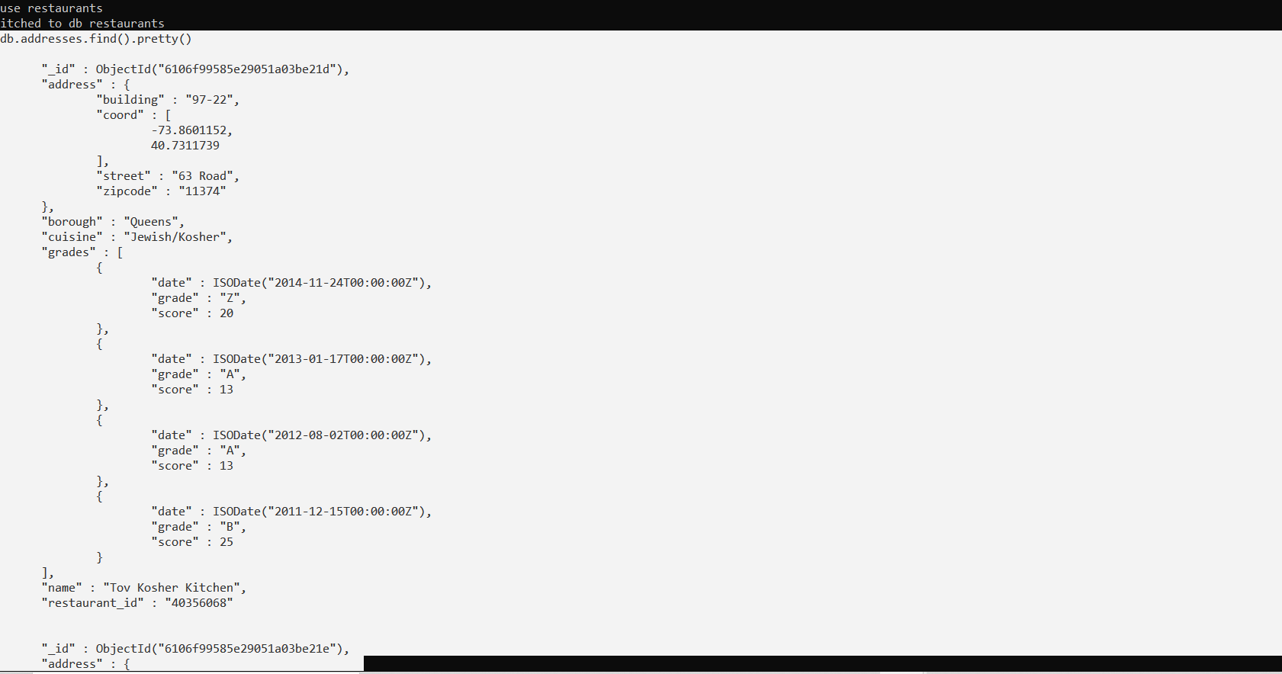

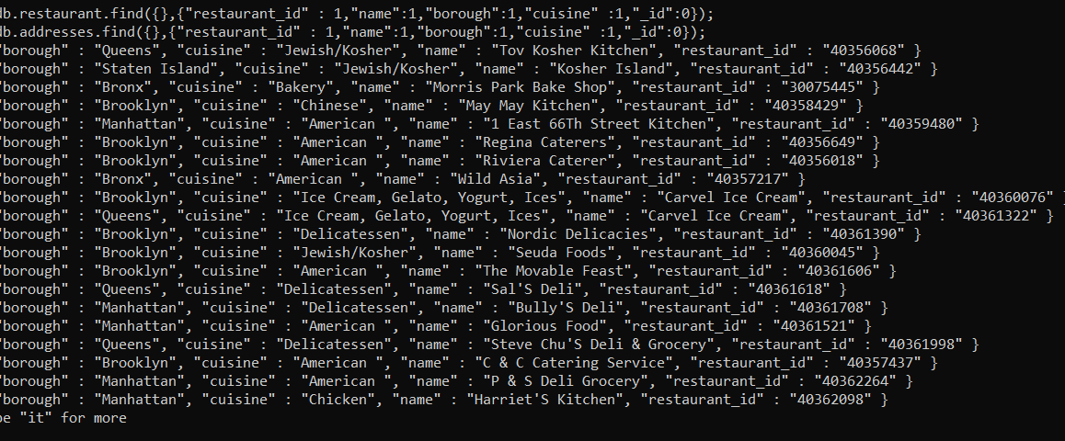

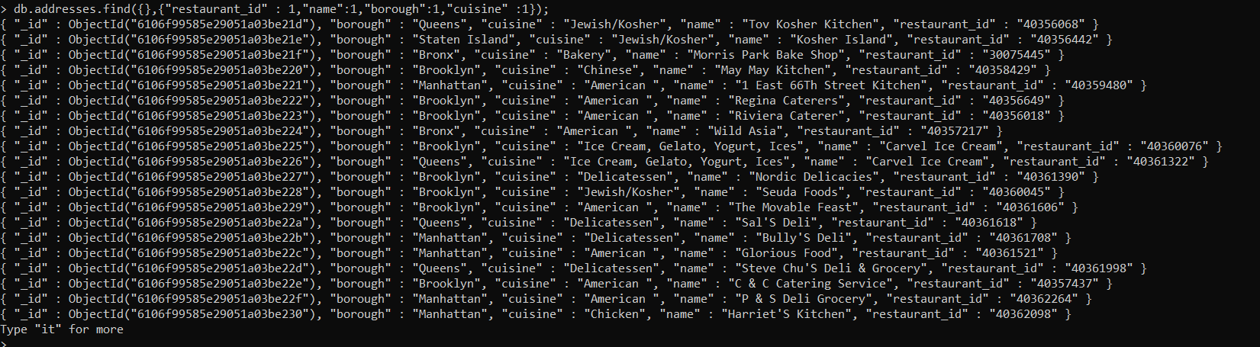

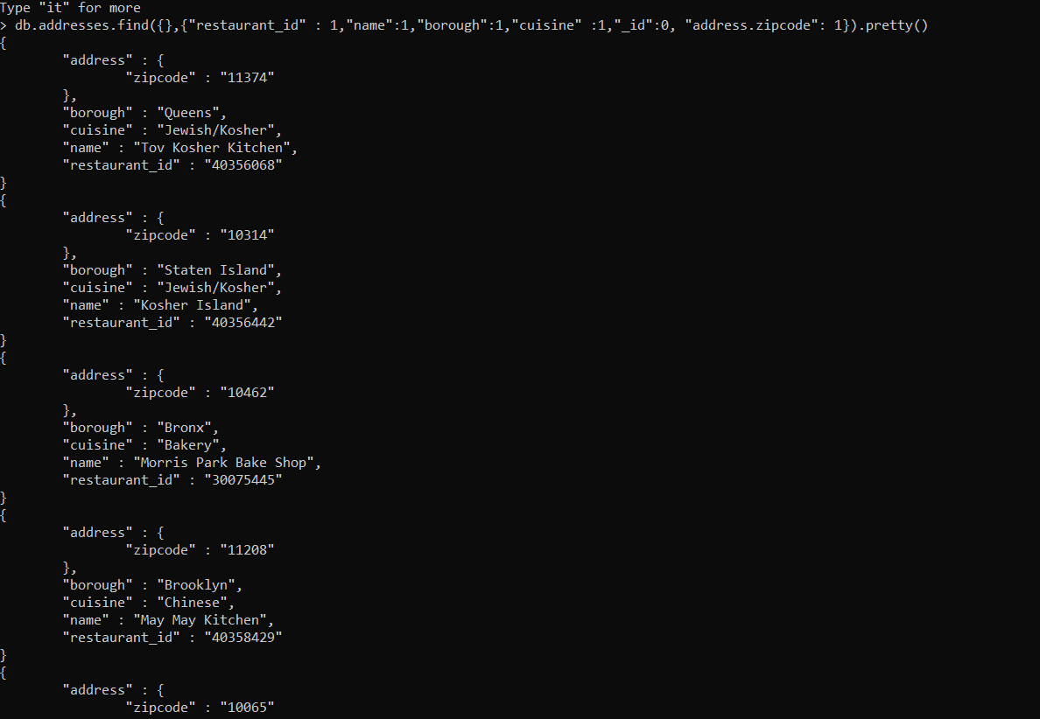

db.addresses.find({"borough": "Bronx"}).pretty()

{

"_id" : ObjectId("6106f99585e29051a03be21f"),

"address" : {

"building" : "1007",

"coord" : [

-73.856077,

40.848447

],

"street" : "Morris Park Ave",

"zipcode" : "10462"

},

"borough" : "Bronx",

"cuisine" : "Bakery",

"grades" : [

{

"date" : ISODate("2014-03-03T00:00:00Z"),

"grade" : "A",

"score" : 2

},

{

"date" : ISODate("2013-09-11T00:00:00Z"),

"grade" : "A",

"score" : 6

},

{

"date" : ISODate("2013-01-24T00:00:00Z"),

"grade" : "A",

"score" : 10

},

{

"date" : ISODate("2011-11-23T00:00:00Z"),

"grade" : "A",

"score" : 9

},

{

"date" : ISODate("2011-03-10T00:00:00Z"),

"grade" : "B",

"score" : 14

}

],

"name" : "Morris Park Bake Shop",

"restaurant_id" : "30075445"

}

{

"_id" : ObjectId("6106f99585e29051a03be224"),

"address" : {

"building" : "2300",

"coord" : [

-73.8786113,

40.8502883

],

"street" : "Southern Boulevard",

"zipcode" : "10460"

},

"borough" : "Bronx",

"cuisine" : "American ",

"grades" : [

{

"date" : ISODate("2014-05-28T00:00:00Z"),

"grade" : "A",

"score" : 11

},

{

"date" : ISODate("2013-06-19T00:00:00Z"),

"grade" : "A",

"score" : 4

},

{

"date" : ISODate("2012-06-15T00:00:00Z"),

"grade" : "A",

"score" : 3

}

],

"name" : "Wild Asia",

"restaurant_id" : "40357217"

}

db.addresses.find({borough: "Bronx"}).limit(5).pretty()

{

"_id" : ObjectId("6106f99585e29051a03be21f"),

"address" : {

"building" : "1007",

"coord" : [

-73.856077,

40.848447

],

"street" : "Morris Park Ave",

"zipcode" : "10462"

},

"borough" : "Bronx",

"cuisine" : "Bakery",

"grades" : [

{

"date" : ISODate("2014-03-03T00:00:00Z"),

"grade" : "A",

"score" : 2

},

{

"date" : ISODate("2013-09-11T00:00:00Z"),

"grade" : "A",

"score" : 6

},

{

"date" : ISODate("2013-01-24T00:00:00Z"),

"grade" : "A",

"score" : 10

},

{

"date" : ISODate("2011-11-23T00:00:00Z"),

"grade" : "A",

"score" : 9

},

{

"date" : ISODate("2011-03-10T00:00:00Z"),

"grade" : "B",

"score" : 14

db.addresses.find({borough: "Bronx"}).skip(5).limit(5).pretty()

db.addresses.find({grades : { $elemMatch:{"score":{$gt : 90}}}}).pretty()

db.addresses.find({grades : { $elemMatch:{"score":{$gt : 80, $lt:100}}}});

{ "_id" : ObjectId("6106f99585e29051a03be41e"), "address" : { "building" : "345", "coord" : [ -73.9864626, 40.7266739 ], "street" : "East 6 Street", "zipcode" : "10003" }, "borough" : "Manhattan", "cuisine" : "Indian", "grades" : [ { "date" : ISODate("2014-09-15T00:00:00Z"), "grade" : "A", "score" : 5 }, { "date" : ISODate("2014-01-14T00:00:00Z"), "grade" : "A", "score" : 8 }, { "date" : ISODate("2013-05-30T00:00:00Z"), "grade" : "A", "score" : 12 }, { "date" : ISODate("2013-04-24T00:00:00Z"), "grade" : "P", "score" : 2 }, { "date" : ISODate("2012-10-01T00:00:00Z"), "grade" : "A", "score" : 9 }, { "date" : ISODate("2012-04-06T00:00:00Z"), "grade" : "C", "score" : 92 }, { "date" : ISODate("2011-11-03T00:00:00Z"), "grade" : "C", "score" : 41 } ], "name" : "Gandhi", "restaurant_id" : "40381295" }

{ "_id" : ObjectId("6106f99585e29051a03be57d"), "address" : { "building" : "130", "coord" : [ -73.984758, 40.7457939 ], "street" : "Madison Avenue", "zipcode" : "10016" }, "borough" : "Manhattan", "cuisine" : "Pizza/Italian", "grades" : [ { "date" : ISODate("2014-12-24T00:00:00Z"), "grade" : "Z", "score" : 31 }, { "date" : ISODate("2014-06-17T00:00:00Z"), "grade" : "C", "score" : 98 }, { "date" : ISODate("2013-12-12T00:00:00Z"), "grade" : "C", "score" : 32 }, { "date" : ISODate("2013-05-22T00:00:00Z"), "grade" : "B", "score" : 21 }, { "date" : ISODate("2012-05-02T00:00:00Z"), "grade" : "A", "score" : 11 } ], "name" : "Bella Napoli", "restaurant_id" : "40393488" }

{ "_id" : ObjectId("6106f99685e29051a03bede8"), "address" : { "building" : "", "coord" : [ -74.0163793, 40.7167671 ], "street" : "Hudson River", "zipcode" : "10282" }, "borough" : "Manhattan", "cuisine" : "American ", "grades" : [ { "date" : ISODate("2014-06-27T00:00:00Z"), "grade" : "C", "score" : 89 }, { "date" : ISODate("2013-06-06T00:00:00Z"), "grade" : "A", "score" : 6 }, { "date" : ISODate("2012-06-19T00:00:00Z"), "grade" : "A", "score" : 13 } ], "name" : "West 79Th Street Boat Basin Cafe", "restaurant_id" : "40756344" }

db.addresses.find({"address.coord" : {$lt : -95.754168}});

{ "_id" : ObjectId("6106f99685e29051a03be863"), "address" : { "building" : "3707", "coord" : [ -101.8945214, 33.5197474 ], "street" : "82 Street", "zipcode" : "11372" }, "borough" : "Queens", "cuisine" : "American ", "grades" : [ { "date" : ISODate("2014-06-04T00:00:00Z"), "grade" : "A", "score" : 12 }, { "date" : ISODate("2013-11-07T00:00:00Z"), "grade" : "B", "score" : 19 }, { "date" : ISODate("2013-05-17T00:00:00Z"), "grade" : "A", "score" : 11 }, { "date" : ISODate("2012-08-29T00:00:00Z"), "grade" : "A", "score" : 11 }, { "date" : ISODate("2012-04-03T00:00:00Z"), "grade" : "A", "score" : 12 }, { "date" : ISODate("2011-11-16T00:00:00Z"), "grade" : "A", "score" : 7 } ], "name" : "Burger King", "restaurant_id" : "40534067" }

1. db.addresses.find(

{$and:

[

{"cuisine" : {$ne :"American "}},

{"grades.score" : {$gt : 70}},

{"address.coord" : {$lt : -65.754168}}

]

}

);

1. db.addresses.find(

{

"cuisine" : {$ne : "American "},

"grades.score" :{$gt: 70},

"address.coord" : {$lt : -65.754168}

}

);

1. db.addresses.find({$and:[{"cuisine" : {$ne :"American "}},{"grades.grade" : "A"},{"borough" : {$ne :"Brooklyn "}}]}).sort({"cuisine":-1}).pretty()

13.

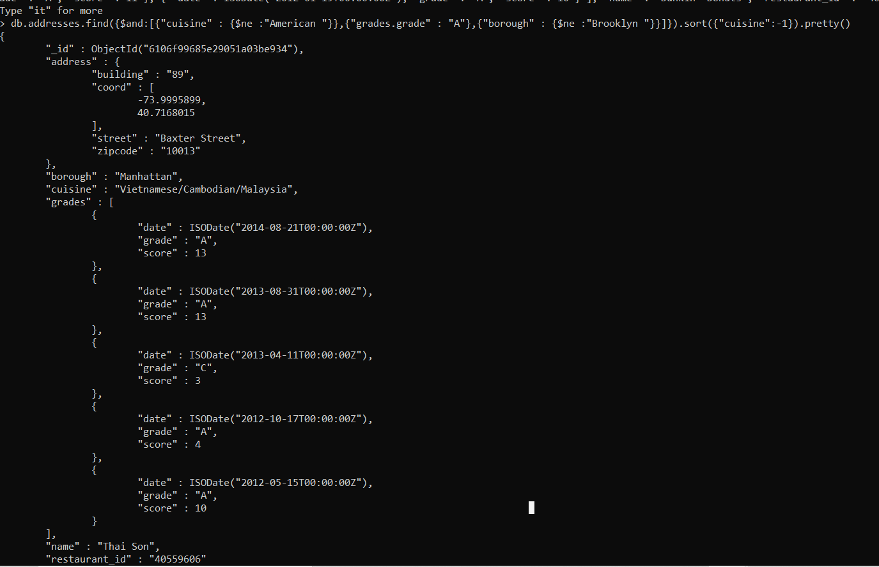

14.

db.addresses.find( {name: /^Wil/}, { "restaurant_id" : 1, "name":1,"borough":1, "cuisine" :1 } )

{ "_id" : ObjectId("6106f99585e29051a03be224"), "borough" : "Bronx", "cuisine" : "American ", "name" : "Wild Asia", "restaurant_id" : "40357217" }

{ "_id" : ObjectId("6106f99585e29051a03be23e"), "borough" : "Brooklyn", "cuisine" : "Delicatessen", "name" : "Wilken'S Fine Food", "restaurant_id" : "40356483" }

{ "_id" : ObjectId("6106f99685e29051a03bf02e"), "borough" : "Bronx", "cuisine" : "Pizza", "name" : "Wilbel Pizza", "restaurant_id" : "40871979" }

15.

db.addresses.find( {name: /ces$/}, { "restaurant_id" : 1, "name":1,"borough":1, "cuisine" :1 } )

{ "_id" : ObjectId("6106f99685e29051a03be6ae"), "borough" : "Manhattan", "cuisine" : "American ", "name" : "Pieces", "restaurant_id" : "40399910" }

{ "_id" : ObjectId("6106f99685e29051a03be770"), "borough" : "Queens", "cuisine" : "American ", "name" : "S.M.R Restaurant Services", "restaurant_id" : "40403857" }

{ "_id" : ObjectId("6106f99685e29051a03be775"), "borough" : "Manhattan", "cuisine" : "American ", "name" : "Good Shepherd Services", "restaurant_id" : "40403989" }

{ "_id" : ObjectId("6106f99685e29051a03bec20"), "borough" : "Queens", "cuisine" : "Ice Cream, Gelato, Yogurt, Ices", "name" : "The Ice Box-Ralph'S Famous Italian Ices", "restaurant_id" : "40690899" }

{ "_id" : ObjectId("6106f99685e29051a03bee2b"), "borough" : "Brooklyn", "cuisine" : "Jewish/Kosher", "name" : "Alices", "restaurant_id" : "40782042" }

{ "_id" : ObjectId("6106f99685e29051a03bf046"), "borough" : "Manhattan", "cuisine" : "American ", "name" : "Re: Sources", "restaurant_id" : "40876068" }

16.

db.addresses.find( {name: /.*Reg*./}, { "restaurant_id" : 1, "name":1,"borough":1, "cuisine" :1 } )

{ "_id" : ObjectId("6106f99585e29051a03be222"), "borough" : "Brooklyn", "cuisine" : "American ", "name" : "Regina Caterers", "restaurant_id" : "40356649" }

{ "_id" : ObjectId("6106f99585e29051a03be234"), "borough" : "Queens", "cuisine" : "Chinese", "name" : "Ho Mei Restaurant", "restaurant_id" : "40362432" }

{ "_id" : ObjectId("6106f99585e29051a03be237"), "borough" : "Brooklyn", "cuisine" : "Caribbean", "name" : "Shashemene Int'L Restaura", "restaurant_id" : "40362869" }

{ "_id" : ObjectId("6106f99585e29051a03be238"), "borough" : "Manhattan", "cuisine" : "Irish", "name" : "Dj Reynolds Pub And Restaurant", "restaurant_id" : "30191841" }

{ "_id" : ObjectId("6106f99585e29051a03be259"), "borough" : "Manhattan", "cuisine" : "American ", "name" : "Palm Restaurant", "restaurant_id" : "40364355" }

{ "_id" : ObjectId("6106f99585e29051a03be25a"), "borough" : "Manhattan", "cuisine" : "American ", "name" : "Old Town Bar & Restaurant", "restaurant_id" : "40364389" }

{ "_id" : ObjectId("6106f99585e29051a03be25b"), "borough" : "Manhattan", "cuisine" : "Italian", "name" : "Isle Of Capri Resturant", "restaurant_id" : "40364373" }

{ "_id" : ObjectId("6106f99585e29051a03be260"), "borough" : "Manhattan", "cuisine" : "Latin (Cuban, Dominican, Puerto Rican, South & Central American)", "name" : "Seville Restaurant", "restaurant_id" : "40364439" }

{ "_id" : ObjectId("6106f99585e29051a03be263"), "borough" : "Queens", "cuisine" : "Jewish/Kosher", "name" : "Ben-Best Deli & Restaurant", "restaurant_id" : "40364529" }

{ "_id" : ObjectId("6106f99585e29051a03be268"), "borough" : "Manhattan", "cuisine" : "Italian", "name" : "Marchis Restaurant", "restaurant_id" : "40364668" }

{ "_id" : ObjectId("6106f99585e29051a03be26f"), "borough" : "Queens", "cuisine" : "Pizza/Italian", "name" : "New Park Pizzeria & Restaurant", "restaurant_id" : "40364744" }

{ "_id" : ObjectId("6106f99585e29051a03be278"), "borough" : "Manhattan", "cuisine" : "Italian", "name" : "Forlinis Restaurant", "restaurant_id" : "40365098" }

{ "_id" : ObjectId("6106f99585e29051a03be279"), "borough" : "Manhattan", "cuisine" : "Irish", "name" : "Dorrian'S Red Hand Restaurant", "restaurant_id" : "40365239" }

{ "_id" : ObjectId("6106f99585e29051a03be27f"), "borough" : "Manhattan", "cuisine" : "American ", "name" : "Keats Restaurant", "restaurant_id" : "40365288" }

{ "_id" : ObjectId("6106f99585e29051a03be287"), "borough" : "Manhattan", "cuisine" : "Spanish", "name" : "Spain Restaurant & Bar", "restaurant_id" : "40365472" }

{ "_id" : ObjectId("6106f99585e29051a03be288"), "borough" : "Manhattan", "cuisine" : "American ", "name" : "Reynold'S Bar", "restaurant_id" : "40365423" }

{ "_id" : ObjectId("6106f99585e29051a03be28d"), "borough" : "Manhattan", "cuisine" : "Italian", "name" : "V & T Restaurant", "restaurant_id" : "40365577" }

{ "_id" : ObjectId("6106f99585e29051a03be28e"), "borough" : "Brooklyn", "cuisine" : "American ", "name" : "Reben Luncheonette", "restaurant_id" : "40365546" }

{ "_id" : ObjectId("6106f99585e29051a03be291"), "borough" : "Queens", "cuisine" : "Chinese", "name" : "King Yum Restaurant", "restaurant_id" : "40365592" }

{ "_id" : ObjectId("6106f99585e29051a03be292"), "borough" : "Queens", "cuisine" : "American ", "name" : "Jahn'S Restaurant", "restaurant_id" : "40365627" }

17.

db.addresses.find( {borough:"Bronx",$or:[{cuisine:"Chinese"}, {cuisine:"American"}]})

{ "_id" : ObjectId("6106f99585e29051a03be240"), "address" : { "building" : "1236", "coord" : [ -73.8893654, 40.81376179999999 ], "street" : "238 Spofford Ave", "zipcode" : "10474" }, "borough" : "Bronx", "cuisine" : "Chinese", "grades" : [ { "date" : ISODate("2013-12-30T00:00:00Z"), "grade" : "A", "score" : 8 }, { "date" : ISODate("2013-01-08T00:00:00Z"), "grade" : "A", "score" : 10 }, { "date" : ISODate("2012-06-12T00:00:00Z"), "grade" : "B", "score" : 15 } ], "name" : "Happy Garden", "restaurant_id" : "40363289" }

{ "_id" : ObjectId("6106f99585e29051a03be252"), "address" : { "building" : "277", "coord" : [ -73.8941893, 40.8634684 ], "street" : "East Kingsbridge Road", "zipcode" : "10458" }, "borough" : "Bronx", "cuisine" : "Chinese", "grades" : [ { "date" : ISODate("2014-03-03T00:00:00Z"), "grade" : "A", "score" : 10 }, { "date" : ISODate("2013-09-26T00:00:00Z"), "grade" : "A", "score" : 10 }, { "date" : ISODate("2013-03-19T00:00:00Z"), "grade" : "A", "score" : 10 }, { "date" : ISODate("2012-08-29T00:00:00Z"), "grade" : "A", "score" : 11 }, { "date" : ISODate("2011-08-17T00:00:00Z"), "grade" : "A", "score" : 13 } ], "name" : "Happy Garden", "restaurant_id" : "40364296" }

{ "_id" : ObjectId("6106f99685e29051a03be7cc"), "address" : { "building" : "2459", "coord" : [ -73.8929629, 40.8601605 ], "street" : "Webster Avenue", "zipcode" : "10458" }, "borough" : "Bronx", "cuisine" : "Chinese", "grades" : [ { "date" : ISODate("2014-12-23T00:00:00Z"), "grade" : "A", "score" : 7 }, { "date" : ISODate("2014-01-07T00:00:00Z"), "grade" : "A", "score" : 8 }, { "date" : ISODate("2012-12-28T00:00:00Z"), "grade" : "A", "score" : 11 }, { "date" : ISODate("2012-07-18T00:00:00Z"), "grade" : "A", "score" : 13 } ], "name" : "China Wok Ii", "restaurant_id" : "40510328" }

{ "_id" : ObjectId("6106f99685e29051a03be854"), "address" : { "building" : "2102", "coord" : [ -73.82609699999999, 40.8687177 ], "street" : "Bartow Ave", "zipcode" : "10475" }, "borough" : "Bronx", "cuisine" : "Chinese", "grades" : [ { "date" : ISODate("2014-08-04T00:00:00Z"), "grade" : "A", "score" : 7 }, { "date" : ISODate("2014-02-21T00:00:00Z"), "grade" : "A", "score" : 4 }, { "date" : ISODate("2013-05-30T00:00:00Z"), "grade" : "B", "score" : 17 }, { "date" : ISODate("2012-04-13T00:00:00Z"), "grade" : "A", "score" : 12 } ], "name" : "Dragon City", "restaurant_id" : "40529203" }

{ "_id" : ObjectId("6106f99685e29051a03be902"), "address" : { "building" : "3511", "coord" : [ -73.9100876, 40.8860444 ], "street" : "Johnson Avenue", "zipcode" : "10463" }, "borough" : "Bronx", "cuisine" : "Chinese", "grades" : [ { "date" : ISODate("2014-07-02T00:00:00Z"), "grade" : "A", "score" : 5 }, { "date" : ISODate("2013-11-06T00:00:00Z"), "grade" : "A", "score" : 8 }, { "date" : ISODate("2013-03-29T00:00:00Z"), "grade" : "B", "score" : 17 }, { "date" : ISODate("2012-06-20T00:00:00Z"), "grade" : "B", "score" : 27 } ], "name" : "Hunan Balcony", "restaurant_id" : "40551996" }

{ "_id" : ObjectId("6106f99685e29051a03be905"), "address" : { "building" : "732", "coord" : [ -73.883128, 40.85353 ], "street" : "East 187 Street", "zipcode" : "10458" }, "borough" : "Bronx", "cuisine" : "Chinese", "grades" : [ { "date" : ISODate("2014-11-07T00:00:00Z"), "grade" : "A", "score" : 9 }, { "date" : ISODate("2014-05-15T00:00:00Z"), "grade" : "A", "score" : 7 }, { "date" : ISODate("2013-11-18T00:00:00Z"), "grade" : "A", "score" : 7 }, { "date" : ISODate("2013-06-10T00:00:00Z"), "grade" : "A", "score" : 12 }, { "date" : ISODate("2012-09-17T00:00:00Z"), "grade" : "B", "score" : 19 } ], "name" : "Great Wall Restaurant", "restaurant_id" : "40552226" }

18.

db.addresses.find( {"borough":{$in:["Staten Island","Queens","Bronx" ,"Brooklyn"]}}, { "restaurant_id" : 1, "name":1,"borough":1, "cuisine" :1 } )

{ "_id" : ObjectId("6106f99585e29051a03be21d"), "borough" : "Queens", "cuisine" : "Jewish/Kosher", "name" : "Tov Kosher Kitchen", "restaurant_id" : "40356068" }

{ "_id" : ObjectId("6106f99585e29051a03be21e"), "borough" : "Staten Island", "cuisine" : "Jewish/Kosher", "name" : "Kosher Island", "restaurant_id" : "40356442" }

{ "_id" : ObjectId("6106f99585e29051a03be21f"), "borough" : "Bronx", "cuisine" : "Bakery", "name" : "Morris Park Bake Shop", "restaurant_id" : "30075445" }

{ "_id" : ObjectId("6106f99585e29051a03be220"), "borough" : "Brooklyn", "cuisine" : "Chinese", "name" : "May May Kitchen", "restaurant_id" : "40358429" }

{ "_id" : ObjectId("6106f99585e29051a03be222"), "borough" : "Brooklyn", "cuisine" : "American ", "name" : "Regina Caterers", "restaurant_id" : "40356649" }

{ "_id" : ObjectId("6106f99585e29051a03be223"), "borough" : "Brooklyn", "cuisine" : "American ", "name" : "Riviera Caterer", "restaurant_id" : "40356018" }

{ "_id" : ObjectId("6106f99585e29051a03be224"), "borough" : "Bronx", "cuisine" : "American ", "name" : "Wild Asia", "restaurant_id" : "40357217" }

{ "_id" : ObjectId("6106f99585e29051a03be225"), "borough" : "Brooklyn", "cuisine" : "Ice Cream, Gelato, Yogurt, Ices", "name" : "Carvel Ice Cream", "restaurant_id" : "40360076" }

{ "_id" : ObjectId("6106f99585e29051a03be226"), "borough" : "Queens", "cuisine" : "Ice Cream, Gelato, Yogurt, Ices", "name" : "Carvel Ice Cream", "restaurant_id" : "40361322" }

{ "_id" : ObjectId("6106f99585e29051a03be227"), "borough" : "Brooklyn", "cuisine" : "Delicatessen", "name" : "Nordic Delicacies", "restaurant_id" : "40361390" }

{ "_id" : ObjectId("6106f99585e29051a03be228"), "borough" : "Brooklyn", "cuisine" : "Jewish/Kosher", "name" : "Seuda Foods", "restaurant_id" : "40360045" }

{ "_id" : ObjectId("6106f99585e29051a03be229"), "borough" : "Brooklyn", "cuisine" : "American ", "name" : "The Movable Feast", "restaurant_id" : "40361606" }

{ "_id" : ObjectId("6106f99585e29051a03be22a"), "borough" : "Queens", "cuisine" : "Delicatessen", "name" : "Sal'S Deli", "restaurant_id" : "40361618" }

{ "_id" : ObjectId("6106f99585e29051a03be22d"), "borough" : "Queens", "cuisine" : "Delicatessen", "name" : "Steve Chu'S Deli & Grocery", "restaurant_id" : "40361998" }

{ "_id" : ObjectId("6106f99585e29051a03be22e"), "borough" : "Brooklyn", "cuisine" : "American ", "name" : "C & C Catering Service", "restaurant_id" : "40357437" }

{ "_id" : ObjectId("6106f99585e29051a03be231"), "borough" : "Brooklyn", "cuisine" : "Ice Cream, Gelato, Yogurt, Ices", "name" : "Taste The Tropics Ice Cream", "restaurant_id" : "40356731" }

{ "_id" : ObjectId("6106f99585e29051a03be232"), "borough" : "Queens", "cuisine" : "American ", "name" : "Brunos On The Boulevard", "restaurant_id" : "40356151" }

{ "_id" : ObjectId("6106f99585e29051a03be233"), "borough" : "Brooklyn", "cuisine" : "Hamburgers", "name" : "Wendy'S", "restaurant_id" : "30112340" }

{ "_id" : ObjectId("6106f99585e29051a03be234"), "borough" : "Queens", "cuisine" : "Chinese", "name" : "Ho Mei Restaurant", "restaurant_id" : "40362432" }

{ "_id" : ObjectId("6106f99585e29051a03be236"), "borough" : "Brooklyn", "cuisine" : "Hamburgers", "name" : "White Castle", "restaurant_id" : "40362344" }

19.

db.addresses.find( {"borough":{$nin:["Staten Island","Queens","Bronx" ,"Brooklyn"]}}, { "restaurant_id" : 1, "name":1,"borough":1, "cuisine" :1 } )

{ "_id" : ObjectId("6106f99585e29051a03be221"), "borough" : "Manhattan", "cuisine" : "American ", "name" : "1 East 66Th Street Kitchen", "restaurant_id" : "40359480" }

{ "_id" : ObjectId("6106f99585e29051a03be22b"), "borough" : "Manhattan", "cuisine" : "Delicatessen", "name" : "Bully'S Deli", "restaurant_id" : "40361708" }

{ "_id" : ObjectId("6106f99585e29051a03be22c"), "borough" : "Manhattan", "cuisine" : "American ", "name" : "Glorious Food", "restaurant_id" : "40361521" }

{ "_id" : ObjectId("6106f99585e29051a03be22f"), "borough" : "Manhattan", "cuisine" : "American ", "name" : "P & S Deli Grocery", "restaurant_id" : "40362264" }

{ "_id" : ObjectId("6106f99585e29051a03be230"), "borough" : "Manhattan", "cuisine" : "Chicken", "name" : "Harriet'S Kitchen", "restaurant_id" : "40362098" }

{ "_id" : ObjectId("6106f99585e29051a03be235"), "borough" : "Manhattan", "cuisine" : "American ", "name" : "Angelika Film Center", "restaurant_id" : "40362274" }

{ "_id" : ObjectId("6106f99585e29051a03be238"), "borough" : "Manhattan", "cuisine" : "Irish", "name" : "Dj Reynolds Pub And Restaurant", "restaurant_id" : "30191841" }

{ "_id" : ObjectId("6106f99585e29051a03be239"), "borough" : "Manhattan", "cuisine" : "Turkish", "name" : "The Country Cafe", "restaurant_id" : "40362715" }

{ "_id" : ObjectId("6106f99585e29051a03be23b"), "borough" : "Manhattan", "cuisine" : "American ", "name" : "Downtown Deli", "restaurant_id" : "40363021" }

{ "_id" : ObjectId("6106f99585e29051a03be23f"), "borough" : "Manhattan", "cuisine" : "American ", "name" : "Cafe Metro", "restaurant_id" : "40363298" }

{ "_id" : ObjectId("6106f99585e29051a03be242"), "borough" : "Manhattan", "cuisine" : "Sandwiches/Salads/Mixed Buffet", "name" : "Lexler Deli", "restaurant_id" : "40363426" }

{ "_id" : ObjectId("6106f99585e29051a03be244"), "borough" : "Manhattan", "cuisine" : "Bakery", "name" : "Olive'S", "restaurant_id" : "40363151" }

{ "_id" : ObjectId("6106f99585e29051a03be245"), "borough" : "Manhattan", "cuisine" : "Continental", "name" : "Lorenzo & Maria'S", "restaurant_id" : "40363630" }

{ "_id" : ObjectId("6106f99585e29051a03be249"), "borough" : "Manhattan", "cuisine" : "Pizza", "name" : "Domino'S Pizza", "restaurant_id" : "40363644" }

{ "_id" : ObjectId("6106f99585e29051a03be24a"), "borough" : "Manhattan", "cuisine" : "American ", "name" : "Berkely", "restaurant_id" : "40363685" }

{ "_id" : ObjectId("6106f99585e29051a03be24b"), "borough" : "Manhattan", "cuisine" : "Pizza", "name" : "Domino'S Pizza", "restaurant_id" : "40363945" }

{ "_id" : ObjectId("6106f99585e29051a03be24c"), "borough" : "Manhattan", "cuisine" : "American ", "name" : "Spoon Bread Catering", "restaurant_id" : "40364179" }

{ "_id" : ObjectId("6106f99585e29051a03be254"), "borough" : "Manhattan", "cuisine" : "Chicken", "name" : "Texas Rotisserie", "restaurant_id" : "40364304" }

{ "_id" : ObjectId("6106f99585e29051a03be256"), "borough" : "Manhattan", "cuisine" : "American ", "name" : "21 Club", "restaurant_id" : "40364362" }

{ "_id" : ObjectId("6106f99585e29051a03be259"), "borough" : "Manhattan", "cuisine" : "American ", "name" : "Palm Restaurant", "restaurant_id" : "40364355" }

20.

db.addresses.find( {"grades.score":{$lte:10}}, { "restaurant_id" : 1, "name":1,"borough":1, "cuisine" :1 } )

{ "_id" : ObjectId("6106f99585e29051a03be21e"), "borough" : "Staten Island", "cuisine" : "Jewish/Kosher", "name" : "Kosher Island", "restaurant_id" : "40356442" }

{ "_id" : ObjectId("6106f99585e29051a03be21f"), "borough" : "Bronx", "cuisine" : "Bakery", "name" : "Morris Park Bake Shop", "restaurant_id" : "30075445" }

{ "_id" : ObjectId("6106f99585e29051a03be220"), "borough" : "Brooklyn", "cuisine" : "Chinese", "name" : "May May Kitchen", "restaurant_id" : "40358429" }

{ "_id" : ObjectId("6106f99585e29051a03be221"), "borough" : "Manhattan", "cuisine" : "American ", "name" : "1 East 66Th Street Kitchen", "restaurant_id" : "40359480" }

{ "_id" : ObjectId("6106f99585e29051a03be222"), "borough" : "Brooklyn", "cuisine" : "American ", "name" : "Regina Caterers", "restaurant_id" : "40356649" }

{ "_id" : ObjectId("6106f99585e29051a03be223"), "borough" : "Brooklyn", "cuisine" : "American ", "name" : "Riviera Caterer", "restaurant_id" : "40356018" }

{ "_id" : ObjectId("6106f99585e29051a03be224"), "borough" : "Bronx", "cuisine" : "American ", "name" : "Wild Asia", "restaurant_id" : "40357217" }

{ "_id" : ObjectId("6106f99585e29051a03be225"), "borough" : "Brooklyn", "cuisine" : "Ice Cream, Gelato, Yogurt, Ices", "name" : "Carvel Ice Cream", "restaurant_id" : "40360076" }

{ "_id" : ObjectId("6106f99585e29051a03be226"), "borough" : "Queens", "cuisine" : "Ice Cream, Gelato, Yogurt, Ices", "name" : "Carvel Ice Cream", "restaurant_id" : "40361322" }

{ "_id" : ObjectId("6106f99585e29051a03be227"), "borough" : "Brooklyn", "cuisine" : "Delicatessen", "name" : "Nordic Delicacies", "restaurant_id" : "40361390" }

{ "_id" : ObjectId("6106f99585e29051a03be228"), "borough" : "Brooklyn", "cuisine" : "Jewish/Kosher", "name" : "Seuda Foods", "restaurant_id" : "40360045" }

{ "_id" : ObjectId("6106f99585e29051a03be229"), "borough" : "Brooklyn", "cuisine" : "American ", "name" : "The Movable Feast", "restaurant_id" : "40361606" }

{ "_id" : ObjectId("6106f99585e29051a03be22a"), "borough" : "Queens", "cuisine" : "Delicatessen", "name" : "Sal'S Deli", "restaurant_id" : "40361618" }

{ "_id" : ObjectId("6106f99585e29051a03be22b"), "borough" : "Manhattan", "cuisine" : "Delicatessen", "name" : "Bully'S Deli", "restaurant_id" : "40361708" }

{ "_id" : ObjectId("6106f99585e29051a03be22c"), "borough" : "Manhattan", "cuisine" : "American ", "name" : "Glorious Food", "restaurant_id" : "40361521" }

{ "_id" : ObjectId("6106f99585e29051a03be22d"), "borough" : "Queens", "cuisine" : "Delicatessen", "name" : "Steve Chu'S Deli & Grocery", "restaurant_id" : "40361998" }

{ "_id" : ObjectId("6106f99585e29051a03be22e"), "borough" : "Brooklyn", "cuisine" : "American ", "name" : "C & C Catering Service", "restaurant_id" : "40357437" }

{ "_id" : ObjectId("6106f99585e29051a03be22f"), "borough" : "Manhattan", "cuisine" : "American ", "name" : "P & S Deli Grocery", "restaurant_id" : "40362264" }

{ "_id" : ObjectId("6106f99585e29051a03be230"), "borough" : "Manhattan", "cuisine" : "Chicken", "name" : "Harriet'S Kitchen", "restaurant_id" : "40362098" }

{ "_id" : ObjectId("6106f99585e29051a03be231"), "borough" : "Brooklyn", "cuisine" : "Ice Cream, Gelato, Yogurt, Ices", "name" : "Taste The Tropics Ice Cream", "restaurant_id" : "40356731" }

Type "it" for more

21.

db.addresses.find({$or:[{name:"/^Wil/"}, {$and:[{"cuisine":{$ne:"American"}},{"cuisine":{$ne:"Chinese"}}]}]}, { "restaurant_id" : 1, "name":1,"borough":1, "cuisine" :1 } )

{ "_id" : ObjectId("6106f99585e29051a03be21d"), "borough" : "Queens", "cuisine" : "Jewish/Kosher", "name" : "Tov Kosher Kitchen", "restaurant_id" : "40356068" }

{ "_id" : ObjectId("6106f99585e29051a03be21e"), "borough" : "Staten Island", "cuisine" : "Jewish/Kosher", "name" : "Kosher Island", "restaurant_id" : "40356442" }

{ "_id" : ObjectId("6106f99585e29051a03be21f"), "borough" : "Bronx", "cuisine" : "Bakery", "name" : "Morris Park Bake Shop", "restaurant_id" : "30075445" }

{ "_id" : ObjectId("6106f99585e29051a03be221"), "borough" : "Manhattan", "cuisine" : "American ", "name" : "1 East 66Th Street Kitchen", "restaurant_id" : "40359480" }

{ "_id" : ObjectId("6106f99585e29051a03be222"), "borough" : "Brooklyn", "cuisine" : "American ", "name" : "Regina Caterers", "restaurant_id" : "40356649" }

{ "_id" : ObjectId("6106f99585e29051a03be223"), "borough" : "Brooklyn", "cuisine" : "American ", "name" : "Riviera Caterer", "restaurant_id" : "40356018" }

{ "_id" : ObjectId("6106f99585e29051a03be224"), "borough" : "Bronx", "cuisine" : "American ", "name" : "Wild Asia", "restaurant_id" : "40357217" }

{ "_id" : ObjectId("6106f99585e29051a03be225"), "borough" : "Brooklyn", "cuisine" : "Ice Cream, Gelato, Yogurt, Ices", "name" : "Carvel Ice Cream", "restaurant_id" : "40360076" }

{ "_id" : ObjectId("6106f99585e29051a03be226"), "borough" : "Queens", "cuisine" : "Ice Cream, Gelato, Yogurt, Ices", "name" : "Carvel Ice Cream", "restaurant_id" : "40361322" }

{ "_id" : ObjectId("6106f99585e29051a03be227"), "borough" : "Brooklyn", "cuisine" : "Delicatessen", "name" : "Nordic Delicacies", "restaurant_id" : "40361390" }

{ "_id" : ObjectId("6106f99585e29051a03be228"), "borough" : "Brooklyn", "cuisine" : "Jewish/Kosher", "name" : "Seuda Foods", "restaurant_id" : "40360045" }

{ "_id" : ObjectId("6106f99585e29051a03be229"), "borough" : "Brooklyn", "cuisine" : "American ", "name" : "The Movable Feast", "restaurant_id" : "40361606" }

{ "_id" : ObjectId("6106f99585e29051a03be22a"), "borough" : "Queens", "cuisine" : "Delicatessen", "name" : "Sal'S Deli", "restaurant_id" : "40361618" }

{ "_id" : ObjectId("6106f99585e29051a03be22b"), "borough" : "Manhattan", "cuisine" : "Delicatessen", "name" : "Bully'S Deli", "restaurant_id" : "40361708" }

{ "_id" : ObjectId("6106f99585e29051a03be22c"), "borough" : "Manhattan", "cuisine" : "American ", "name" : "Glorious Food", "restaurant_id" : "40361521" }

{ "_id" : ObjectId("6106f99585e29051a03be22d"), "borough" : "Queens", "cuisine" : "Delicatessen", "name" : "Steve Chu'S Deli & Grocery", "restaurant_id" : "40361998" }

{ "_id" : ObjectId("6106f99585e29051a03be22e"), "borough" : "Brooklyn", "cuisine" : "American ", "name" : "C & C Catering Service", "restaurant_id" : "40357437" }

{ "_id" : ObjectId("6106f99585e29051a03be22f"), "borough" : "Manhattan", "cuisine" : "American ", "name" : "P & S Deli Grocery", "restaurant_id" : "40362264" }

{ "_id" : ObjectId("6106f99585e29051a03be230"), "borough" : "Manhattan", "cuisine" : "Chicken", "name" : "Harriet'S Kitchen", "restaurant_id" : "40362098" }

{ "_id" : ObjectId("6106f99585e29051a03be231"), "borough" : "Brooklyn", "cuisine" : "Ice Cream, Gelato, Yogurt, Ices", "name" : "Taste The Tropics Ice Cream", "restaurant_id" : "40356731" }

Type "it" for more

22.

db.addresses.find(

... {

... "grades.date": ISODate("2014-08-11T00:00:00Z"),

... "grades.grade":"A" ,

... "grades.score" : 11

... },

... {"restaurant_id" : 1,"name":1,"grades":1}

... );

{ "_id" : ObjectId("6106f99585e29051a03be29a"), "grades" : [ { "date" : ISODate("2014-08-11T00:00:00Z"), "grade" : "A", "score" : 13 }, { "date" : ISODate("2013-07-22T00:00:00Z"), "grade" : "A", "score" : 9 }, { "date" : ISODate("2013-03-14T00:00:00Z"), "grade" : "A", "score" : 12 }, { "date" : ISODate("2012-07-02T00:00:00Z"), "grade" : "A", "score" : 11 }, { "date" : ISODate("2012-02-02T00:00:00Z"), "grade" : "A", "score" : 10 }, { "date" : ISODate("2011-08-24T00:00:00Z"), "grade" : "A", "score" : 11 } ], "name" : "Neary'S Pub", "restaurant_id" : "40365871" }

{ "_id" : ObjectId("6106f99585e29051a03be377"), "grades" : [ { "date" : ISODate("2014-08-11T00:00:00Z"), "grade" : "A", "score" : 11 }, { "date" : ISODate("2013-12-10T00:00:00Z"), "grade" : "A", "score" : 9 }, { "date" : ISODate("2013-06-10T00:00:00Z"), "grade" : "A", "score" : 12 }, { "date" : ISODate("2012-06-08T00:00:00Z"), "grade" : "A", "score" : 13 }, { "date" : ISODate("2012-01-25T00:00:00Z"), "grade" : "A", "score" : 8 }, { "date" : ISODate("2011-09-13T00:00:00Z"), "grade" : "A", "score" : 12 } ], "name" : "Don Filippo Restaurant", "restaurant_id" : "40372417" }

{ "_id" : ObjectId("6106f99685e29051a03be638"), "grades" : [ { "date" : ISODate("2014-08-11T00:00:00Z"), "grade" : "A", "score" : 6 }, { "date" : ISODate("2013-08-29T00:00:00Z"), "grade" : "A", "score" : 12 }, { "date" : ISODate("2013-04-25T00:00:00Z"), "grade" : "C", "score" : 2 }, { "date" : ISODate("2012-10-23T00:00:00Z"), "grade" : "A", "score" : 13 }, { "date" : ISODate("2012-04-16T00:00:00Z"), "grade" : "A", "score" : 11 }, { "date" : ISODate("2011-11-15T00:00:00Z"), "grade" : "A", "score" : 12 } ], "name" : "Mustang Sally'S Restaurant", "restaurant_id" : "40397374" }

{ "_id" : ObjectId("6106f99685e29051a03be846"), "grades" : [ { "date" : ISODate("2015-01-12T00:00:00Z"), "grade" : "A", "score" : 10 }, { "date" : ISODate("2014-08-11T00:00:00Z"), "grade" : "A", "score" : 9 }, { "date" : ISODate("2014-01-14T00:00:00Z"), "grade" : "A", "score" : 13 }, { "date" : ISODate("2013-02-07T00:00:00Z"), "grade" : "A", "score" : 10 }, { "date" : ISODate("2012-04-30T00:00:00Z"), "grade" : "A", "score" : 11 } ], "name" : "Club Macanudo (Cigar Bar)", "restaurant_id" : "40526406" }

{ "_id" : ObjectId("6106f99685e29051a03be93c"), "grades" : [ { "date" : ISODate("2014-08-11T00:00:00Z"), "grade" : "A", "score" : 8 }, { "date" : ISODate("2014-01-09T00:00:00Z"), "grade" : "B", "score" : 27 }, { "date" : ISODate("2013-06-11T00:00:00Z"), "grade" : "A", "score" : 4 }, { "date" : ISODate("2012-10-09T00:00:00Z"), "grade" : "B", "score" : 19 }, { "date" : ISODate("2012-05-10T00:00:00Z"), "grade" : "A", "score" : 11 }, { "date" : ISODate("2011-11-23T00:00:00Z"), "grade" : "A", "score" : 9 } ], "name" : "Marino'S Pizza & Restaurant", "restaurant_id" : "40560917" }

{ "_id" : ObjectId("6106f99685e29051a03beae6"), "grades" : [ { "date" : ISODate("2015-01-05T00:00:00Z"), "grade" : "A", "score" : 9 }, { "date" : ISODate("2014-08-11T00:00:00Z"), "grade" : "A", "score" : 10 }, { "date" : ISODate("2014-03-04T00:00:00Z"), "grade" : "B", "score" : 22 }, { "date" : ISODate("2013-09-13T00:00:00Z"), "grade" : "A", "score" : 5 }, { "date" : ISODate("2013-01-16T00:00:00Z"), "grade" : "A", "score" : 11 } ], "name" : "Gene'S Coffee Shop", "restaurant_id" : "40614916" }

{ "_id" : ObjectId("6106f99685e29051a03bec52"), "grades" : [ { "date" : ISODate("2014-08-11T00:00:00Z"), "grade" : "A", "score" : 10 }, { "date" : ISODate("2014-02-20T00:00:00Z"), "grade" : "A", "score" : 7 }, { "date" : ISODate("2013-08-29T00:00:00Z"), "grade" : "A", "score" : 7 }, { "date" : ISODate("2013-03-29T00:00:00Z"), "grade" : "A", "score" : 10 }, { "date" : ISODate("2012-03-07T00:00:00Z"), "grade" : "A", "score" : 12 }, { "date" : ISODate("2011-11-18T00:00:00Z"), "grade" : "A", "score" : 11 }, { "date" : ISODate("2011-10-12T00:00:00Z"), "grade" : "P", "score" : 4 } ], "name" : "Union Cafe Restaurant", "restaurant_id" : "40698823" }

{ "_id" : ObjectId("6106f99685e29051a03bf0bc"), "grades" : [ { "date" : ISODate("2014-08-11T00:00:00Z"), "grade" : "A", "score" : 10 }, { "date" : ISODate("2013-08-28T00:00:00Z"), "grade" : "A", "score" : 9 }, { "date" : ISODate("2012-09-05T00:00:00Z"), "grade" : "A", "score" : 11 }, { "date" : ISODate("2011-08-25T00:00:00Z"), "grade" : "A", "score" : 7 } ], "name" : "Jojo'S Pizza", "restaurant_id" : "40892913" }

23.

db.addresses.find({"grades.1.date": ISODate("2014-08-11T00:00:00Z"),"grades.1.grade":"A" ,"grades.1.score" : 9},{"restaurant_id" : 1,"name":1,"grades":1});

{ "_id" : ObjectId("6106f99685e29051a03be846"), "grades" : [ { "date" : ISODate("2015-01-12T00:00:00Z"), "grade" : "A", "score" : 10 }, { "date" : ISODate("2014-08-11T00:00:00Z"), "grade" : "A", "score" : 9 }, { "date" : ISODate("2014-01-14T00:00:00Z"), "grade" : "A", "score" : 13 }, { "date" : ISODate("2013-02-07T00:00:00Z"), "grade" : "A", "score" : 10 }, { "date" : ISODate("2012-04-30T00:00:00Z"), "grade" : "A", "score" : 11 } ], "name" : "Club Macanudo (Cigar Bar)", "restaurant_id" : "40526406" }

24.

db.addresses.find({"address.coord.1":{$gt:42, $lte:52}},{"restaurant_id" : 1,"name":1,"coord":1});

{ "_id" : ObjectId("6106f99585e29051a03be4ba"), "name" : "T.G.I. Friday'S", "restaurant_id" : "40387990" }

{ "_id" : ObjectId("6106f99585e29051a03be4eb"), "name" : "T.G.I. Fridays", "restaurant_id" : "40388936" }

{ "_id" : ObjectId("6106f99685e29051a03be745"), "name" : "Di Luvio'S Deli", "restaurant_id" : "40402284" }

{ "_id" : ObjectId("6106f99685e29051a03be97f"), "name" : "La Caridad 78", "restaurant_id" : "40568285" }

{ "_id" : ObjectId("6106f99685e29051a03bf04b"), "name" : "Bijan'S", "restaurant_id" : "40876618" }

{ "_id" : ObjectId("6106f99685e29051a03bf060"), "name" : "Hyatt, Ny Central/Room Service", "restaurant_id" : "40879243" }

{ "_id" : ObjectId("6106f99685e29051a03bf075"), "name" : "Sports Center At Chelsea Piers (Sushi Bar)", "restaurant_id" : "40882356" }

25.

db.addresses.find().sort({"name":1})

26.

db.addresses.find().sort({"name":-1})

27.

db.addresses.find().sort({"cuisine":1,"borough":-1})

28

db.addresses.find({"address.street": {$exists:true}});

29

db.addresses.find({"address.coord": {$type:1}})

30

db.addresses.find({ "grades.score": { $mod : [7, 0]}},{"restaurant_id" :1, "name":1, "grades": 1})

31

db.addresses.find(

{ name :

{ $regex : "mon.*", $options: "i" }

},

{

"name":1,

"borough":1,

"address.coord":1,

"cuisine" :1

}

);

db.addresses.find({ name : /.*mon.*/}, {"name":1,"borough":1, "address.coord":1, "cuisine" :1});

32

db.addresses.find(

{ name :

{ $regex : /^Mad/i, }

},

{

"name":1,

"borough":1,

"address.coord":1,

"cuisine" :1

}

);

db.addresses.find({ name : /^Mad/}, {"name":1,"borough":1, "address.coord":1, "cuisine" :1});

{ "_id" : ObjectId("6106f99685e29051a03be762"), "address" : { "coord" : [ -73.9860597, 40.7431194 ] }, "borough" : "Manhattan", "cuisine" : "American ", "name" : "Madison Square" }

{ "_id" : ObjectId("6106f99685e29051a03be826"), "address" : { "coord" : [ -73.98302199999999, 40.742313 ] }, "borough" : "Manhattan", "cuisine" : "Indian", "name" : "Madras Mahal" }

{ "_id" : ObjectId("6106f99685e29051a03bead8"), "address" : { "coord" : [ -74.000002, 40.72735 ] }, "borough" : "Manhattan", "cuisine" : "American ", "name" : "Madame X" }

{ "_id" : ObjectId("6106f99685e29051a03beb87"), "address" : { "coord" : [ -73.98171959999999, 40.7499406 ] }, "borough" : "Manhattan", "cuisine" : "French", "name" : "Madison Bistro" }

{ "_id" : ObjectId("6106f99685e29051a03bec0a"), "address" : { "coord" : [ -73.9717845, 40.6897199 ] }, "borough" : "Brooklyn", "cuisine" : "African", "name" : "Madiba" }

{ "_id" : ObjectId("6106f99685e29051a03bef14"), "address" : { "coord" : [ -73.9040753, 40.9069011 ] }, "borough" : "Bronx", "cuisine" : "Italian", "name" : "Madison'S" }

{ "_id" : ObjectId("6106f99685e29051a03bef91"), "address" : { "coord" : [ -73.9886598, 40.7565811 ] }, "borough" : "Manhattan", "cuisine" : "Hotdogs", "name" : "Madame Tussaud'S" }

{ "_id" : ObjectId("6106f99685e29051a03befc8"), "address" : { "coord" : [ -73.95623719999999, 40.7761697 ] }, "borough" : "Manhattan", "cuisine" : "American ", "name" : "Mad River Bar & Grille" }

>