UI/UX Design and Wireframe Development
BengalWeave: Apparel & Textiles E-Commerce Website
Junior Web Developer Internship | Week 2 Task | Sania Shamim
Item | Detail
Project | BengalWeave, an online store from Kolkata selling apparel, home textiles and fabrics by the metre, including Bengal handloom (tant, jamdani)
Builds on | Week 1 Strategic Web Blueprint (objectives, personas, user journeys, sitemap, functionalities)
Deliverables in this document | Wireframes for the Home page, Product Listing page, Product Detail page and Checkout flow (Cart, Address, Delivery & Payment, Confirmation), with desktop and mobile views, annotated diagrams and a written design explanation
Fidelity | Digital mid-fidelity wireframes: real layout, real copy and the Week 1 colour palette, with grey image placeholders
Author | Sania Shamim, BCA (2nd year), Aliah University, Kolkata

Contents at a glance
1. Introduction and Objective
2. Review of the Week 1 Blueprint: elements the UI must include
3. Design Foundations: colour, typography, layout grid and components
4. Wireframe 1: Home Page
5. Wireframe 2: Product Listing Page
6. Wireframe 3: Product Detail Page
7. Wireframe 4: Checkout Flow
8. Navigation Flow
9. Usability Best Practices
10. Accessibility and Inclusive Design
11. Responsive Behaviour
12. Validation Plan
13. Traceability: Week 1 to Week 2, and Task Requirement Checklist
14. Conclusion and Next Steps

1. Introduction and Objective
Week 1 defined what BengalWeave should achieve, who it is for and which features it needs. Week 2 turns that strategy into how the website will look and behave. The objective is to translate the blueprint into wireframes for the four most important parts of an e-commerce journey (Home, Product Listing, Product Detail and Checkout) and to explain every layout, colour, typography and navigation decision.

1.1 Design principles
Five principles, taken directly from the Week 1 objectives and personas, guide every wireframe:
- Clarity: one primary action per screen (shown in terracotta), a clear heading and a predictable layout.
- Trust: free-shipping limit, cash on delivery, returns policy and secure-payment cues are visible before the customer has to ask.
- Discoverability: navigation, search and filters mirror the Week 1 sitemap so any product is reachable in three clicks or fewer.
- Fabric confidence: because customers cannot touch fabric online, the design uses large zoomable images, fabric close-ups, material details and photo reviews.
- Inclusivity and speed: mobile-first, accessible (WCAG 2.1 AA targets) and light enough to load quickly on mobile data.

1.2 Why the UX of the buying journey matters (evidence)
The Baymard Institute, which has compiled 49 studies on online shopping-cart abandonment, reports an average abandonment rate of about 70%. It also estimates that fixing checkout usability problems alone could raise conversion by about 35% for an average large e-commerce site. Common reasons customers leave include unexpected extra costs, being forced to create an account, a long or complicated checkout, and not trusting the site with payment details. Each of these is addressed directly in the checkout wireframes in Section 7 (all costs shown up-front, guest checkout, a short three-step flow and visible security cues). Mobile abandonment is reported to be higher than desktop, which is why the mobile views are designed first.
Source: Baymard Institute, "Cart Abandonment Rate Statistics" (baymard.com/lists/cart-abandonment-rate).

1.3 Method followed (task key steps)
- Reviewed the Week 1 blueprint and listed the elements that must appear in the interface (Section 2).
- Defined the visual system (colours, type, grid, components) so all pages stay consistent (Section 3).
- Created digital wireframes for Home, Listing, Product Detail and Checkout, in desktop and mobile versions (Sections 4 to 7).
- Wrote a numbered annotation and rationale for every wireframe: component placement, navigation and expected user interaction.
- Mapped navigation flows and persona walkthroughs (Section 8).
- Discussed usability and accessibility practices (Sections 9 to 11) and a validation plan (Section 12).
- Compiled everything in this document with annotated diagrams (red numbered markers match the tables beneath each figure).

2. Review of the Week 1 Blueprint: Elements the UI Must Include
The table below lists the key Week 1 findings and shows exactly where each one appears in the Week 2 interface.
Week 1 element | What it demands from the UI | Where it appears
Brand: warm, earthy, trustworthy | Cream, indigo and terracotta palette; clean serif and sans-serif type; plenty of white space | Section 3; all wireframes
Fabric close-ups and material stories | Zoomable gallery, fabric close-up thumbnail, "Fabric & Care" tab, artisan story block | Home (9); Product Detail (2, 10)
Easy discovery (categories, search, filters) | Mega menu, prominent search bar, filter sidebar, sorting, breadcrumbs | Home (2, 3); Listing (1 to 5)
Lower cart abandonment | Guest checkout, three-step flow, free-shipping progress bar, order summary at every step | Cart (2); Checkout (all)
Higher order value | Free-shipping threshold, "Complete the look", bundles, coupon field | Cart (2, 4); Product Detail (12)
Engagement | Reviews with photos, wishlist, newsletter with first-order discount, blog and artisan stories | Product Detail (11); Home (9, 10)
Trust in the Indian market | COD, UPI, 7-day returns, clear delivery estimate and pincode check | Announcement bar; Product Detail (8, 9); Payment (3, 4)
Persona: Zoya (22, mobile, price/size conscious) | Filters by size and price, clear returns, fast mobile layout, UPI | Listing (4); Mobile views
Persona: Imran (38, time-poor parent) | Saved addresses, quick login, transparent price, reviews, fabric care details | Address (2); Product Detail (4, 10, 11)
Persona: Rukhsar (45, tailor / boutique owner) | Zoom, swatch ordering, metre-based quantity, bulk price | Product Detail (2, 6); Cart line item (fabric by metre)
Sitemap | Primary navigation and footer reproduce the Week 1 page structure | Home (3, 10); Navigation flow (Section 8)

3. Design Foundations
A small, consistent design system keeps all pages coherent and makes later development faster, because every colour, font size and component is defined once.

3.1 Colour scheme
The palette comes from the Week 1 branding objective (cream, indigo, terracotta), inspired by indigo-dyed cloth, terracotta temple art of Bengal and undyed handloom cotton. Contrast ratios were calculated against WCAG 2.1.
Swatch | Name / hex | Used for | Reason for choice | Contrast
 | Cream  #FAF5EC | Page background | Warm, paper-like base; reduces glare compared with pure white | Base
 | Indigo  #25356B | Headings, header strip, primary navigation, secondary buttons | Trust and craftsmanship; 10.7:1 on cream, 11.7:1 with white text | 10.7:1
 | Terracotta  #B8512F | Primary call-to-action (Add to cart, Checkout, Place order), price, sale tags | Warm and energetic; draws the eye to the one main action per screen; 4.9:1 with white text | 4.9:1
 | Charcoal  #2B2724 | Body text | Softer than pure black yet highly readable | 13.6:1
 | Sage green  #4F7352 | Success, free shipping, in stock, sustainability cues | Natural, calming; used only for positive feedback | 5.4:1
 | Sand  #E9DFCC | Borders, cards, trust strip background | Separates content without heavy lines | Decorative
 | Warm grey  #6B645A | Secondary text (breadcrumbs, captions) | Meets AA on cream; used instead of lighter greys | 5.4:1
 | Error red  #B3261E | Form errors and remove actions | Universal warning colour; always paired with text or icon | 6.5:1
Colour usage rule (60-30-10): about 60% cream and white space, 30% indigo (text, header, footer), 10% terracotta (action colour). Because terracotta is reserved for actions and prices, shoppers learn quickly that "orange-red means I can click this to buy".

3.2 Typography
Role | Typeface | Size (desktop / mobile) | Reason
Display and headings | Playfair Display (serif), bold | 32-40 px / 26-30 px | Editorial, heritage feel that matches handloom and craft; used sparingly for page titles, hero text and section headings
Body and UI text | Poppins or Inter (sans-serif), regular | 16 px / 16 px | Clean and highly legible on small screens; 16 px prevents zoom-on-focus on phones
Buttons and labels | Same sans-serif, semi-bold, uppercase for main CTA | 14-16 px | Clear affordance; consistent weight signals interactivity
Prices | Sans-serif semi-bold, terracotta | 18-24 px | Prices must be scannable at a glance; old price struck through in grey
Captions and helper text | Sans-serif regular, warm grey | 12-14 px | Secondary information stays quiet but readable
Line height is 1.5 for body text, line length is kept to roughly 60 to 75 characters in text blocks, and a maximum of two typefaces is used to keep pages fast and visually calm. Headings follow a clear scale (H1 40, H2 28, H3 20 px) so structure is obvious both visually and to screen readers.

3.3 Layout grid, spacing and breakpoints
- Grid: 12 columns on desktop (1200 px max container, 24 px gutters), 8 columns on tablet, 4 columns on mobile (16 px margins).
- Spacing: an 8-point scale (8, 16, 24, 32, 48, 64 px) so margins and padding are consistent everywhere.
- Touch targets: at least 44 x 44 px for buttons, swatches and icons on mobile.
- Visual hierarchy: the eye is led from image, to title, to price, to the single terracotta button.

3.4 Reusable components
Component | Specification
Primary button | Terracotta fill, white bold text, 8 px radius, 48-56 px height; used once per section for the main action (Add to cart, Proceed to checkout, Place order)
Secondary button | White fill, indigo 2 px outline and text (Our story, Quick view, Apply coupon)
Input field | White, 1 px grey-sand border, visible label above, helper text below, 2 px indigo focus ring, red border with message on error
Product card | Image (4:5 ratio), SALE/NEW tag, wishlist heart, name, price (old price struck through), rating, colour swatches
Selection chips | Size, length and filter chips; selected state is filled indigo with white text (colour plus shape change, never colour alone)
Badges and tags | Terracotta SALE, sage NEW, text label always present
Feedback messages | Sage success banner, red inline error, indigo information strip
Stepper | Four-step progress indicator: Cart, Address, Delivery & Payment, Confirmation; completed steps show a tick

4. Wireframe 1: Home Page
Purpose: introduce the BengalWeave brand within seconds, build trust, and send each shopper (Zoya, Imran or Rukhsar) quickly towards the right category or a featured product.
Figure 1 on the next page shows the desktop home page. Red numbers match the annotation table in section 4.2.

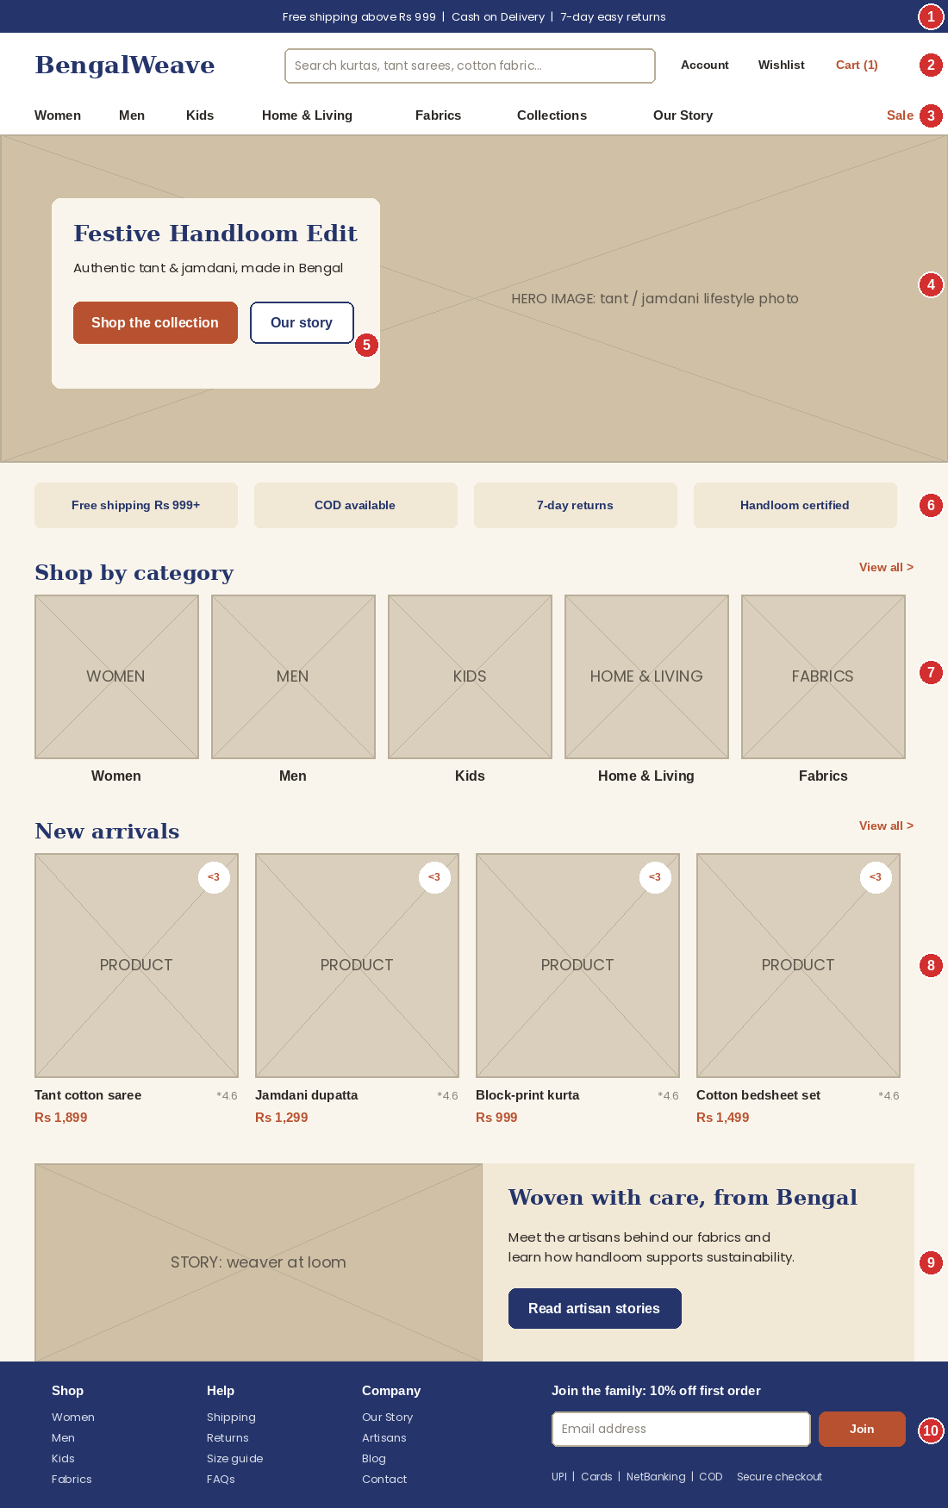
Figure 1: Home page wireframe (desktop, 1100 px wide)

4.1 Layout choices
The page follows a single-column vertical flow with full-width bands. Content is ordered by user intent: trust and orientation (announcement bar, header, navigation), inspiration (hero banner), browse (categories), buy (new arrivals), belong (brand story) and stay (newsletter and footer). Generous white space and an alternating image/text rhythm give the textile photography room to breathe. Only one hero message is shown instead of an auto-rotating carousel, because rotating banners hide content, are hard for keyboard and screen-reader users, and are often missed by shoppers.

4.2 Annotated elements
No. | Element | Design explanation (placement, purpose, interaction)
1 | Announcement bar | Thin indigo strip above the header with the three promises that matter most in the Indian market: free shipping above Rs 999, cash on delivery and 7-day returns (identified in Week 1 as the biggest trust factors). It is repeated on every page, so the policy is known before the shopper reaches checkout.
2 | Header: logo, search, account, wishlist, cart | The serif BengalWeave wordmark sits top-left (always links to Home). A wide, centred search bar with example text invites searching because Week 1 identified search as a core discovery tool. Account, Wishlist and Cart (with item count in terracotta) sit top-right, where users expect them. The header becomes a compact sticky bar on scroll so search and cart are always one tap away.
3 | Primary navigation | Eight items copied from the Week 1 sitemap: Women, Men, Kids, Home & Living, Fabrics, Collections, Our Story and Sale. "Sale" is separated on the right in terracotta so it is visible but does not crowd the categories. On hover, each category opens a mega menu (sub-categories such as Ethnic Wear, Sarees, Cotton, Handloom, plus one promotional image). Keeping the menu to eight labels respects short-term memory limits.
4 | Hero banner | Full-width lifestyle photograph of the featured collection (for example the Festive Handloom Edit) with a cream text card placed over a plain area of the image so the text has high contrast. It sets the brand mood and promotes the seasonal collection mentioned in Week 1.
5 | Hero call-to-action buttons | One primary terracotta button ("Shop the collection") and one secondary outlined button ("Our story"). The clear primary/secondary difference follows the principle of one dominant action, and Our Story supports the brand-storytelling objective.
6 | Trust strip | Four short reassurance tiles (free shipping, COD, returns, handloom certified) directly below the hero. They answer typical doubts at the moment the user decides whether to keep scrolling.
7 | Shop by category | Five large image tiles for Women, Men, Kids, Home & Living and Fabrics. They give a second route into the catalogue for visual browsers, and each tile is a big, easy-to-tap target. This serves all three personas in one click: Zoya (Women), Imran (Home & Living) and Rukhsar (Fabrics).
8 | New arrivals | Four product cards in a row with image, name, price, rating and a wishlist heart. "View all" links to the full New Arrivals collection. Showing real products on the home page lets customers start shopping without opening a menu, supporting the sales objective.
9 | Brand story block | A split image and text band (weaver at the loom) with a link to Artisan Stories. This is the main differentiator against large marketplaces identified in the Week 1 competitor gap analysis, and it supports the sustainability message.
10 | Footer and newsletter | Four-column footer reproducing the Week 1 sitemap groups (Shop, Help, Company), a newsletter box offering 10% off the first order, and payment and security cues. The footer is indigo to anchor the page and give a strong closing.

4.3 Colour, typography and navigation on this page
- Colour: cream background with indigo headings; terracotta appears only on the primary CTA, prices, cart count and Sale link, so the user's eye is guided to action points.
- Typography: serif headings ("Festive Handloom Edit", "Shop by category") for heritage character; sans-serif for navigation, product names and buttons for legibility.
- Navigation flow: Home leads to Category Listing (menu or category tiles), to Search Results (search bar), to Product Detail (new arrivals), or to Our Story (brand block). The logo always returns to Home.
- Expected interaction: the shopper scans the hero, uses either menu or category tile, and reaches a product page in two clicks.

4.4 Home page: mobile view
Mobile is designed first because most shoppers in this category use phones. The layout becomes a single column with thumb-friendly controls.
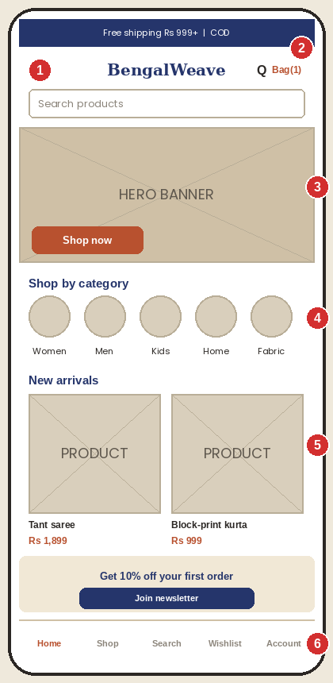
Figure 2: Home page wireframe (mobile, 390 px wide)
No. | Element | Design explanation (placement, purpose, interaction)
1 | Hamburger menu and logo | The menu icon opens a full-height drawer containing the same eight categories as an accordion (tap to reveal sub-categories). The logo stays centred.
2 | Search and bag | A search icon and bag with count remain in the top bar; a full-width search field sits directly below so search is always visible.
3 | Hero banner with CTA | A shorter hero image keeps the first product section above the fold; the Shop now button is at least 44 px tall.
4 | Category circles | Horizontally scrollable round icons for the five categories, positioned in the natural thumb zone.
5 | Product grid | Two columns of product cards. Two columns balance image size and the number of products visible on a small screen.
6 | Bottom tab bar | Home, Shop, Search, Wishlist and Account in a fixed bar at the bottom, within easy reach of the thumb. It is the mobile equivalent of the desktop primary navigation.

5. Wireframe 2: Product Listing Page
Purpose: help shoppers narrow a large catalogue (for example, 248 ethnic-wear products) to a few suitable items quickly. Week 1 flagged that "a wide catalogue becomes hard to use without strong discovery tools", so filters, sorting and a clear product grid are the heart of this page.
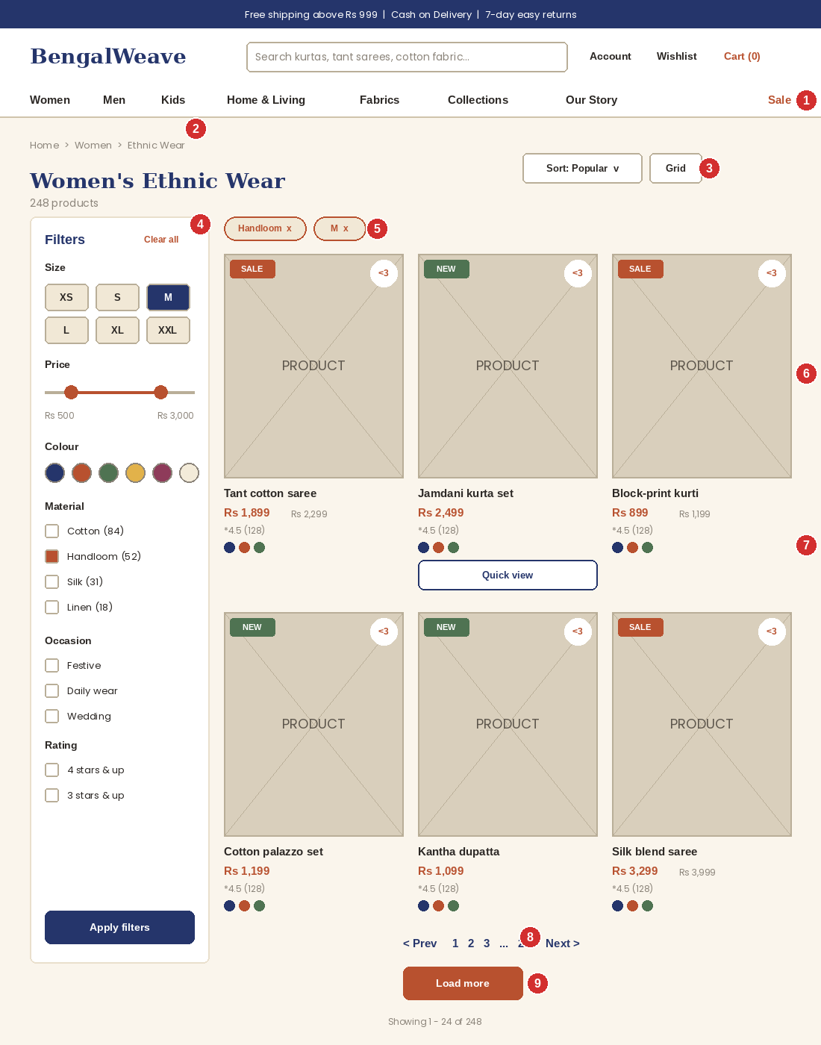
Figure 3: Product listing page wireframe (desktop): Women > Ethnic Wear

5.1 Layout choices
A two-zone layout is used: a fixed-width filter sidebar on the left (about 25%) and a three-column product grid on the right (about 75%). The left sidebar matches the reading direction of users and is the convention shoppers know from other fashion sites, which reduces the learning effort. A three-column grid keeps each product image large enough to judge fabric and pattern while showing nine items without much scrolling. Equal card sizes and consistent spacing create a calm rhythm that makes comparison easy.

5.2 Annotated elements
No. | Element | Design explanation (placement, purpose, interaction)
1 | Persistent header and mega menu | The same header and navigation as the home page, so the user never feels lost. The current category (Women) is highlighted.
2 | Breadcrumbs | Home > Women > Ethnic Wear shows location and lets users jump back one or two levels with a single click. It reduces dependence on the browser back button.
3 | Sort and view controls | "Sort by" dropdown (Popularity, New arrivals, Price low to high, Price high to low, Rating) and a grid/list toggle, placed top-right above the products where shoppers expect them. The result count (248 products) gives feedback about the size of the catalogue.
4 | Filter sidebar | Filter groups taken from Week 1: Size (chips), Price (range slider with values), Colour (swatches), Material (checkboxes with counts, including Handloom), Occasion and Rating. Counts in brackets stop users choosing filters that give zero results. Filters apply instantly on desktop; on mobile they open as a bottom sheet with an Apply button showing the number of results.
5 | Active filter chips | Selected filters (Handloom, M) are shown as removable terracotta-outlined chips above the grid, with a "Clear all" link in the sidebar. The user always sees what is currently filtered and can undo it with one tap.
6 | Product card | Image with SALE or NEW tag and wishlist heart; below it the name, price (sale price in terracotta with the old price struck through), rating with review count. The most decision-relevant details are visible without opening the product.
7 | Colour swatches and quick view | Small swatches under the price show available colours. On hover a Quick View button appears so users can check sizes and add to cart without leaving the list. On touch devices quick view is replaced by tapping the card.
8 | Pagination | Numbered pagination with Previous and Next, and a summary "Showing 1 to 24 of 248". Numbered pages let users return to a position they remember and keep the footer reachable.
9 | Load more button | A "Load more" option is offered as an alternative (default on mobile) so shoppers can continue without a page reload while the footer is still reachable, avoiding the problems of infinite scroll.

5.3 Colour, typography and interaction
- Colour: selected filters use indigo fill (size M) and terracotta (Handloom) so the active state is clear; sale prices and tags are terracotta; the sidebar is white on a cream page so it reads as a separate control panel.
- Typography: page title in serif; filter headings in semi-bold sans-serif; product names 15 to 16 px semi-bold; prices bold. Text on cards is kept to three lines (name, price, rating) to avoid clutter.
- Navigation: card (image or name) leads to the Product Detail page; the heart saves to Wishlist without leaving the page; breadcrumbs and sub-category links move up or sideways.
- Empty state: when filters return no results, the page shows a friendly message, the active filters and a "Clear filters" button, plus popular products, so the shopper never reaches a dead end.

6. Wireframe 3: Product Detail Page
Purpose: give shoppers everything they need to buy with confidence. Because customers cannot touch fabric online, this page invests most in visuals, fabric information, size/length guidance, delivery clarity and social proof, which are the barriers identified in Week 1 for all three personas.
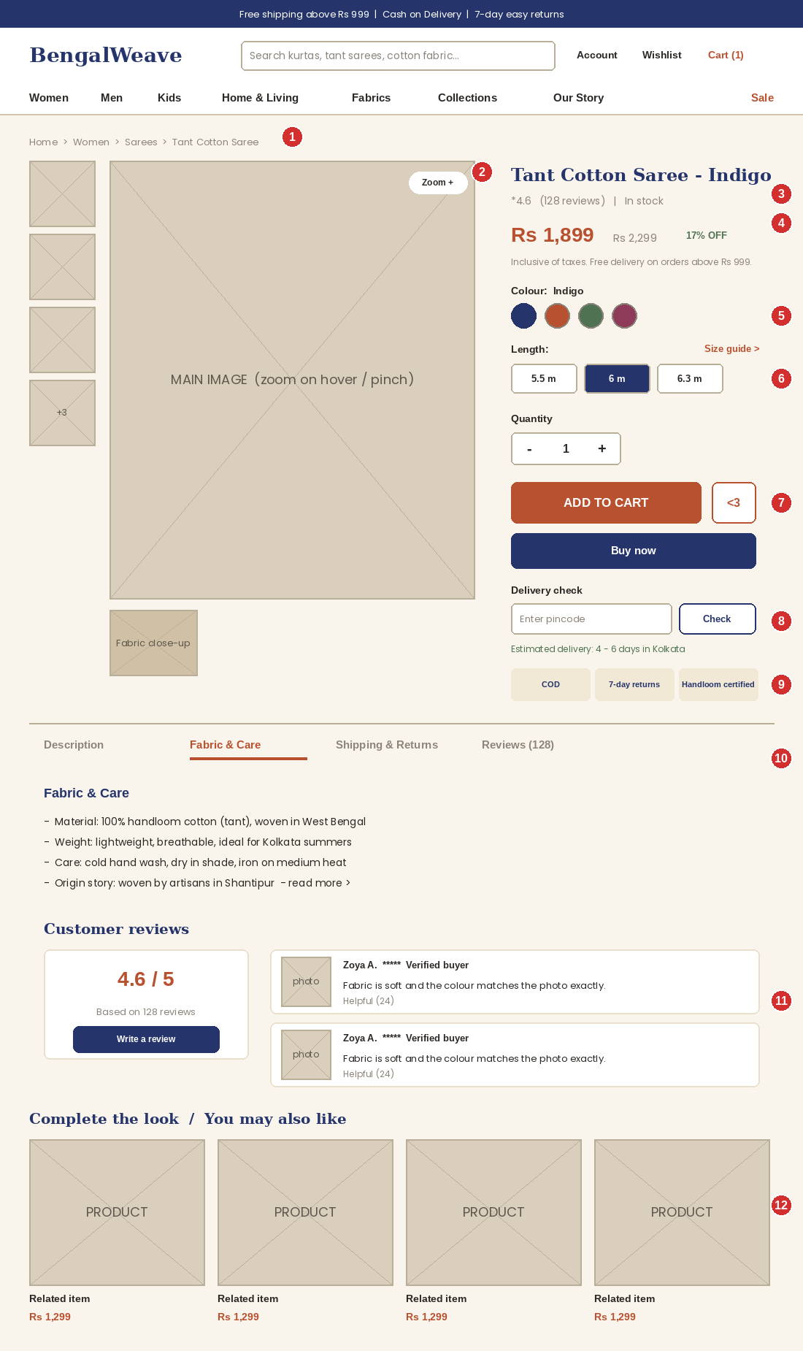
Figure 4: Product detail page wireframe (desktop): Tant Cotton Saree

6.1 Layout choices
A two-column above-the-fold layout places the image gallery on the left (about 55%) and the buying panel on the right (about 45%). Image and decision tools are visible together, so the user can look at the product while choosing options. The buying panel follows the natural order of a purchase decision: what is it, how much, which colour, which size, add to cart, when will it arrive, can I trust it. Below the fold, tabs, reviews and related products support deeper research without crowding the first screen. The Add to cart button is the largest and only terracotta element in the panel.

6.2 Annotated elements
No. | Element | Design explanation (placement, purpose, interaction)
1 | Breadcrumbs | Home > Women > Sarees > Tant Cotton Saree. Shows the product's place in the sitemap and offers quick return to the Sarees listing.
2 | Image gallery with zoom | A vertical thumbnail strip, a large main image with hover zoom (pinch-zoom on mobile), and a dedicated fabric close-up image. This answers Rukhsar's need to "check colour and texture closely" and the Week 1 objective of showing fabric close-ups. A "+3" thumbnail indicates more images.
3 | Product title, rating, stock | Serif product name, star rating with review count (linking to the Reviews tab) and a green "In stock" message. The stock status removes uncertainty before the user invests effort.
4 | Price block | Current price in large terracotta type, old price struck through and discount label, with "Inclusive of taxes. Free delivery above Rs 999". This is Imran's key requirement: transparent pricing with no surprise delivery charges.
5 | Colour swatches | Round swatches show the real colours; the selected swatch has a thicker indigo ring and the colour name is written beside the label, so colour is never communicated by colour alone. Selecting a swatch changes the main image.
6 | Length / size selector and size guide | Selection chips (5.5 m, 6 m, 6.3 m for sarees; XS to XXL for garments) with a "Size guide" link opening a side panel. Week 1 identified sizing as the main reason shoppers hesitate on apparel. For fabric products this block becomes a metre-based quantity input with a bulk-discount table, supporting Rukhsar's exact-length ordering.
7 | Add to cart, wishlist, Buy now | A wide terracotta ADD TO CART button, an outlined heart button to save to wishlist, and a secondary indigo Buy now. If the user has not chosen a size or length, an inline message appears beside the missing option instead of a generic alert. After adding, a mini-cart slides in with a Checkout button, while the user stays on the page.
8 | Delivery check | A pincode field with a Check button shows the estimated delivery date and whether COD is available. This removes a major uncertainty for Indian shoppers before they reach the cart.
9 | Trust badges | COD, 7-day returns and Handloom certified in a compact row under the buy buttons, repeating Week 1 trust points where the decision is made.
10 | Information tabs | Description, Fabric & Care, Shipping & Returns and Reviews. The Fabric & Care tab holds material, weight, care instructions and the artisan origin story, meeting the Week 1 requirement for "detailed fabric information" and the sustainability message.
11 | Reviews with photos | Rating summary and individual reviews with customer photos and a "Verified buyer" label, plus a Write a review button. Photo reviews are especially useful for checking whether the real colour matches the studio photo (Rukhsar's pain point).
12 | Related products | "Complete the look / You may also like" row to raise average order value, as planned in Week 1.

6.3 Product detail page: mobile view
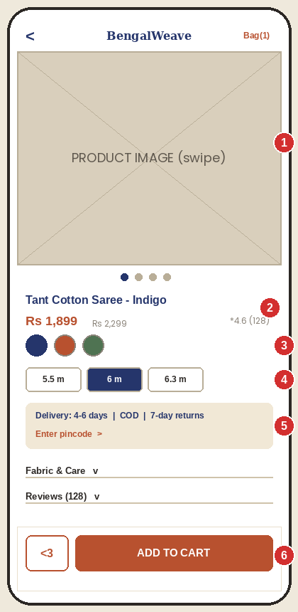
Figure 5: Product detail page wireframe (mobile)
No. | Element | Design explanation (placement, purpose, interaction)
1 | Swipeable gallery | Full-width images with dot indicators; pinch to zoom. Full width gives fabric detail the most space.
2 | Title, price and rating | Compact block directly under the image, so price is visible without scrolling.
3 | Colour swatches | Large 44 px circles for accurate touch.
4 | Size / length chips | Wide chips arranged in one row; the selected chip is filled indigo.
5 | Delivery and trust card | One card combining delivery estimate, COD and returns, with a pincode link.
6 | Sticky action bar | The heart and ADD TO CART button are fixed to the bottom so the main action is always within thumb reach. Information sections below become collapsible accordions to shorten scrolling.

7. Wireframe 4: Checkout Flow
Purpose: convert interest into a completed order with the least possible effort. Week 1 set the goal to "reduce cart abandonment with a short checkout, guest checkout and clear delivery details". The flow has four screens: Cart, Address, Delivery & Payment and Order Confirmation.

7.1 Checkout design principles
- Focused layout: the main navigation, search and footer are removed during checkout and replaced by a slim header with the logo and a "Secure checkout" note, so nothing distracts from completing the order.
- Visible progress: a four-step progress indicator shows where the user is; completed steps show a green tick and can be tapped to go back.
- Guest checkout: no account is required. Account creation is offered after the order is placed.
- No surprises: an order summary stays on the right at every step, with subtotal, shipping, discount, tax and the final total, and the message "No hidden charges".
- Short forms: only seven address fields; city and state are filled automatically from the pincode; inline validation tells users about mistakes as they type.
- Indian payment habits: UPI is shown first and pre-selected as recommended, followed by cards, net banking, wallets and cash on delivery.

7.2 Step 1: Shopping cart
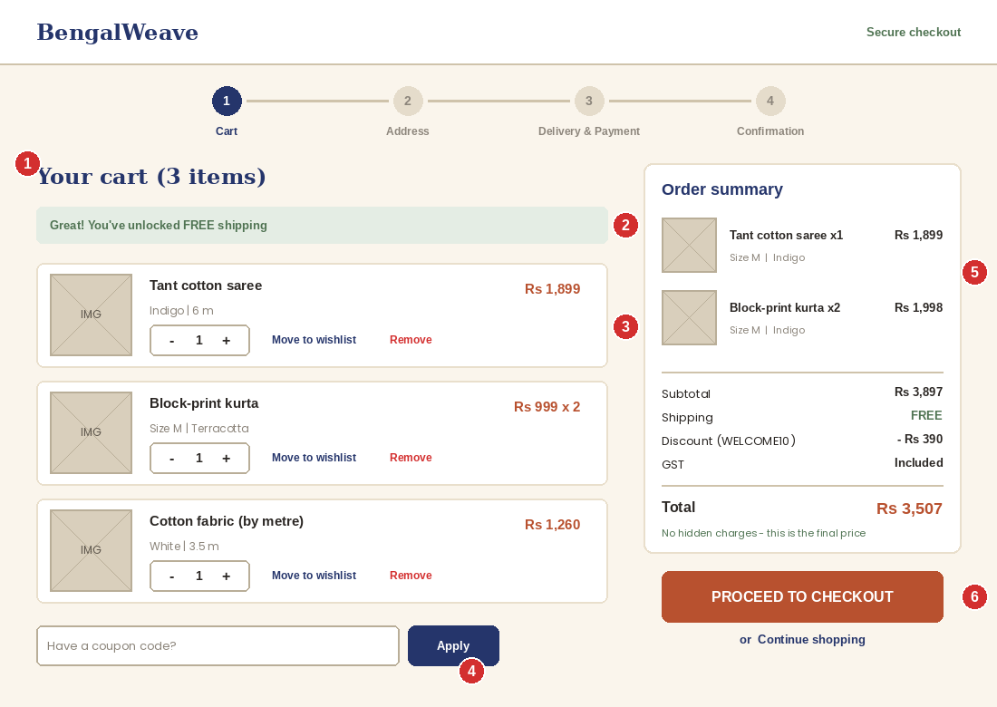
Figure 6: Cart page wireframe (desktop)
No. | Element | Design explanation (placement, purpose, interaction)
1 | Progress stepper | Cart is highlighted as step 1 of 4. The simplified header removes distractions.
2 | Free-shipping progress message | A green banner shows how close the cart is to free shipping (here, already unlocked). Before the threshold it reads, for example, "Add Rs 250 more for free shipping". This raises order value, as planned in Week 1.
3 | Cart line items | Thumbnail, name, variant (colour, size or length in metres), quantity stepper (+ and minus), price, "Move to wishlist" and "Remove". The third item shows fabric sold by the metre (3.5 m), supporting Rukhsar's use case. Removing an item shows an Undo message instead of a confirmation pop-up.
4 | Coupon field | A collapsed-by-default input with an Apply button, placed below the items so it does not distract shoppers without a code. Successful codes update the summary immediately.
5 | Order summary panel | Sticky summary with subtotal, shipping, discount, tax and total, displayed on the right so it is visible while the user edits the cart.
6 | Proceed to checkout | The only terracotta button on the page, full-width inside the summary, plus a quiet "Continue shopping" link.

7.3 Step 2: Delivery address
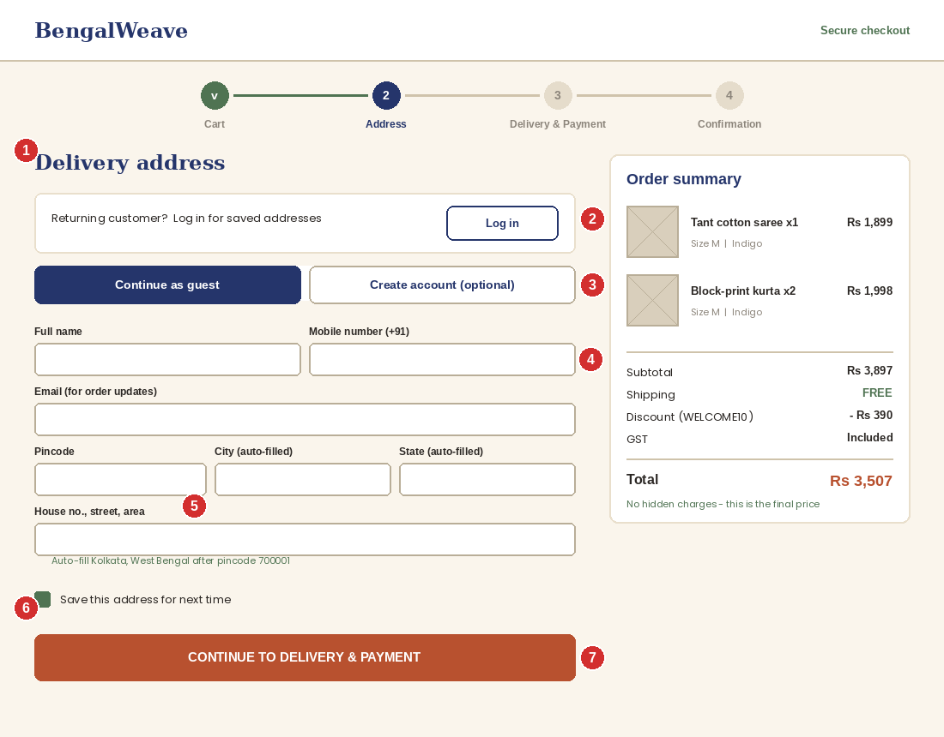
Figure 7: Checkout step 2, delivery address (desktop)
No. | Element | Design explanation (placement, purpose, interaction)
1 | Heading and stepper | Step 2 of 4 is highlighted; Cart shows a green tick.
2 | Returning customer login | A short prompt with a Log in button, so returning users like Imran can load saved addresses. It sits above the form and does not block new users.
3 | Guest or account toggle | "Continue as guest" is pre-selected; "Create account (optional)" is the alternative. Forced registration is a well-known reason for abandonment, so it is avoided.
4 | Contact fields | Full name, mobile number (with +91 prefix) and email for order updates. Labels sit above the fields, they remain visible while typing, and input types open the correct keyboard on mobile.
5 | Pincode with auto-fill | Entering the pincode fills city and state, reducing typing and errors.
6 | Save address checkbox | Lets returning customers skip this step next time.
7 | Continue button | Primary terracotta button labelled "Continue to delivery & payment", which tells the user precisely what happens next.

7.4 Step 3: Delivery and payment
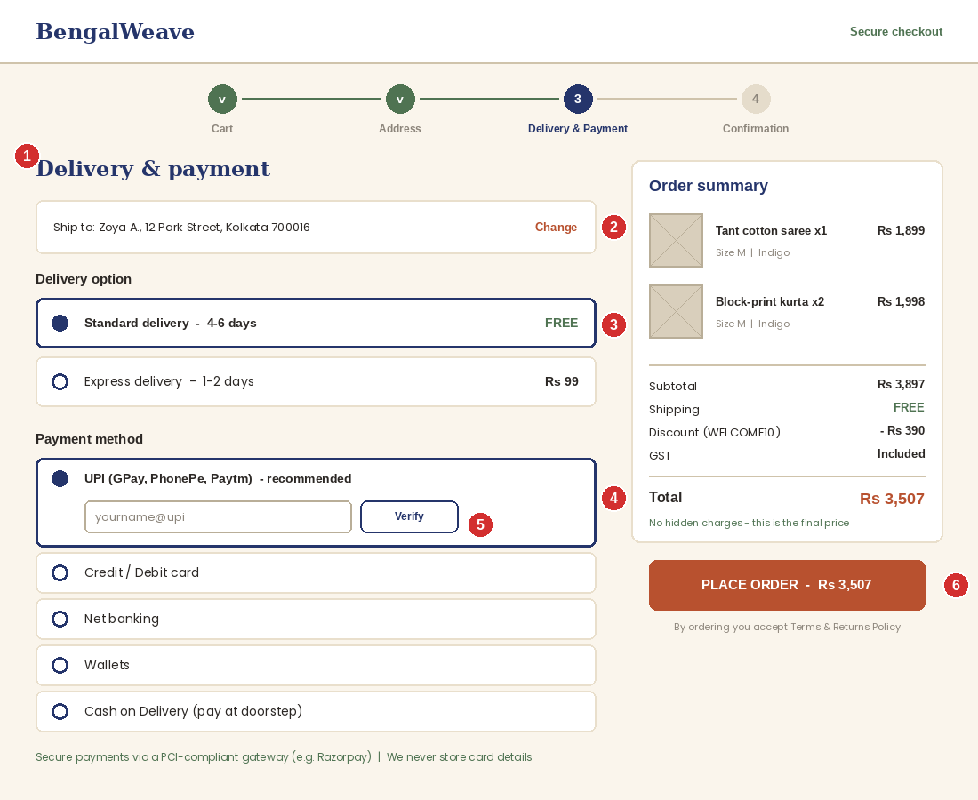
Figure 8: Checkout step 3, delivery and payment (desktop)
No. | Element | Design explanation (placement, purpose, interaction)
1 | Heading and stepper | Step 3 highlighted; Cart and Address show green ticks.
2 | Address recap | The chosen address is displayed with a Change link so it can be corrected without losing progress.
3 | Delivery options | Radio cards for Standard (4 to 6 days, free) and Express (1 to 2 days, Rs 99). Each option shows time and price, and the selected card has a thick indigo border plus filled radio button.
4 | Payment methods | UPI (recommended, pre-selected), Card, Net banking, Wallets and Cash on Delivery shown as large radio cards. Only the selected method expands, keeping the screen short.
5 | UPI field | Inline UPI ID field with a Verify button, giving instant feedback on a wrong ID. Card fields (for the Card option) are validated as the user types.
6 | Place order | Terracotta "PLACE ORDER - Rs 3,507" shows the exact amount on the button, with Terms and Returns Policy text beneath and a security note (secure gateway, no card details stored).

7.5 Step 4: Order confirmation
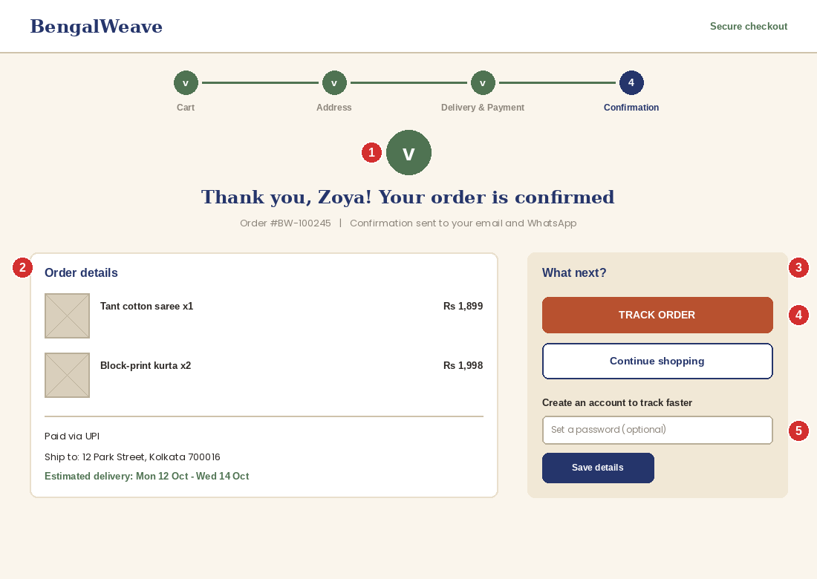
Figure 9: Checkout step 4, order confirmation (desktop)
No. | Element | Design explanation (placement, purpose, interaction)
1 | Success message | Large green tick, a personal thank-you, order number and a note that confirmation was sent by email and WhatsApp. This reassurance closes the flow and fulfils the Week 1 plan for WhatsApp or email updates.
2 | Order details | Items, payment method, delivery address and estimated delivery window, so no one needs to search their email for this information.
3 | What next? panel | A cream panel directs the shopper to the next steps without cluttering the confirmation.
4 | Track order and continue shopping | Terracotta Track Order (primary) and outlined Continue shopping (secondary).
5 | Optional account creation | Because the shopper has already entered their details, one password field is enough to save them: registering after purchase has far lower friction than before purchase.

7.6 Checkout flow: mobile view
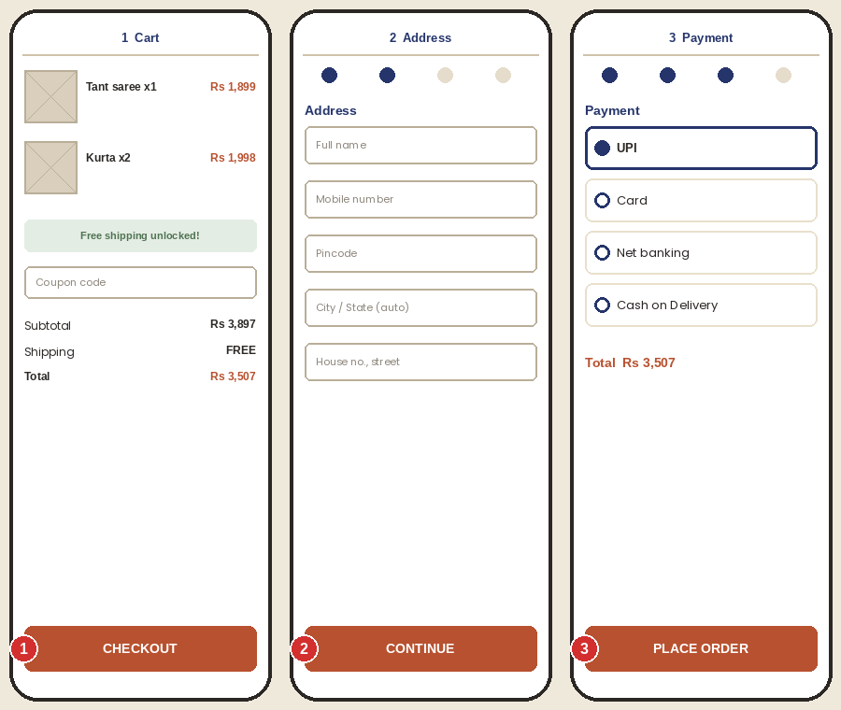
Figure 10: Checkout on mobile: cart, address and payment screens
No. | Element | Design explanation (placement, purpose, interaction)
1 | Cart screen | Items, free-shipping message, coupon and totals; a full-width CHECKOUT button is fixed at the bottom.
2 | Address screen | Four progress dots at the top, single-column fields with large touch targets (at least 44 px) and a fixed Continue button.
3 | Payment screen | UPI first, with large radio rows and a fixed PLACE ORDER button. The total is repeated above the button so users know exactly what they will pay.
On mobile each step is one screen and one task. Fields use the correct keyboard types (numeric for pincode and mobile number), autofill attributes for name and address, and the browser's native UPI app intent where available.

8. Navigation Flow
The diagram shows how users move between the wireframed screens. It follows the Week 1 sitemap, and every screen is reachable in three clicks or fewer from Home.
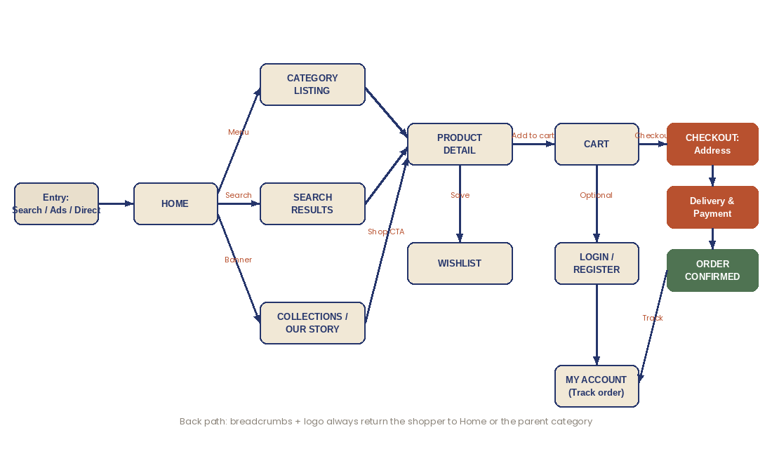
Figure 11: Navigation flow between key screens

8.1 Navigation principles
- Consistent global navigation: logo, search, account, wishlist, cart and the eight-item menu appear in the same position on every browsing page; checkout uses a reduced header.
- Always a way back: breadcrumbs on Listing and Product pages, and the logo returns Home from anywhere.
- Multiple entry routes: menu, search, category tiles, collection banners and related-product rows all lead to the same product pages, so shoppers choose the route that suits them.
- Cart is reachable everywhere: the cart icon always shows the item count; a mini-cart gives a quick preview without leaving the page.
- Mobile equivalents: drawer menu and a bottom tab bar replace the desktop mega menu.

8.2 Persona walkthroughs
Persona | Path through the wireframes | Design features that support the journey
Zoya, 22 (first-time buyer, mobile) | Home (hero) > Women > Listing (filter size M, price) > Product (size guide, reviews) > Cart > Guest checkout > UPI > Confirmation | Hero from Instagram ad; filter chips; size guide; free-shipping bar; guest checkout; UPI first; tracking link
Imran, 38 (returning parent) | Home > Home & Living > search "cotton bedsheet king size" > Product (fabric care, reviews) > Cart > Login > saved address > Payment | Mega menu; search with suggestions; Fabric & Care tab; transparent price; saved address; short checkout
Rukhsar, 45 (bulk fabric buyer) | Home > Fabrics > Listing (material, colour) > Product (zoom, swatch) > metre quantity > Cart > Checkout | Category tile; filters; zoom and close-up; metre-based selector with bulk price; summary shows metres

9. Usability Best Practices
The wireframes were checked against Nielsen's ten usability heuristics, a standard framework for evaluating interfaces.
Heuristic | How the BengalWeave design applies it
1. Visibility of system status | Progress stepper, cart count, free-shipping progress bar, active filter chips, loading skeletons and success messages
2. Match with the real world | Familiar words (Bag/Cart, Wishlist), Indian context (pincode, UPI, COD, saree lengths in metres), shop-style categories
3. User control and freedom | Undo after removing an item, Clear all filters, Change address link, breadcrumbs, back to previous step without data loss
4. Consistency and standards | Same header, button styles and card layout on all pages; terracotta always means the main action; icons follow common conventions
5. Error prevention | Pincode auto-fill, UPI verification, disabled filter options with zero results, unavailable sizes shown as crossed out
6. Recognition rather than recall | Selected options displayed beside labels, order summary on every step, recent searches, saved addresses
7. Flexibility and efficiency | Guest and account checkout, quick view, keyboard-accessible controls, saved addresses and payment preference for returning users
8. Aesthetic and minimalist design | One primary action per screen, generous white space, limited colours, no auto-rotating banners, short checkout forms
9. Help users recognise and recover from errors | Inline messages in plain language next to the field, for example "Please enter a 6-digit pincode", with a red outline and an icon
10. Help and documentation | Size guide, FAQs, delivery estimate checker, return policy summary on product pages, WhatsApp and email support in the footer

10. Accessibility and Inclusive Design
An inclusive platform serves more customers (including older users, people with low vision, motor impairments or slow connections) and is also better for everyone else. The design targets WCAG 2.1 Level AA and is organised around the four POUR principles.
Principle | Design practice | Where applied
Perceivable | Text contrast of at least 4.5:1 (see Section 3.1); colour never the only signal (selected states also change border, fill or show a tick); alt text for every product image and fabric close-up; captions or text alternatives for any video; text resizable to 200% without loss | Palette, swatches, chips, gallery, tags
Operable | Fully keyboard-navigable with a visible 2 px focus ring; logical tab order; touch targets of 44 px or larger; skip-to-content link; no auto-rotating content; no time limits in checkout; adequate spacing between tap targets | Header, filters, checkout, mobile bars
Understandable | Plain language; visible labels above inputs (placeholders are never used as labels); inline, specific error messages; consistent navigation; predictable behaviour; language attribute set | Forms, errors, navigation
Robust | Semantic HTML (header, nav, main, footer, headings in order), ARIA labels for icon-only buttons (cart, wishlist, search), ARIA live regions for cart updates and filter result counts, form fields linked to labels | Cart, filters, buttons, all templates

Additional inclusive practices
- Performance for low bandwidth: lazy-loaded, compressed WebP images, a mobile-first stylesheet and a target of under about three seconds to load on a mid-range phone.
- Reduced motion: animations (mini-cart slide, image zoom) respect the "reduce motion" device setting.
- Language readiness: layouts leave extra room in buttons and menus so Bengali or Hindi labels can be added later without breaking the design.
- Payment and trust accessibility: payment options use text labels with logos, and every error is read out by screen readers.

Contrast check of key colour pairs
Combination | Use | Ratio | Result
Charcoal on cream | Body text | 13.6:1 | Passes AAA
Indigo on cream | Headings, links | 10.7:1 | Passes AAA
White on indigo | Header strip, secondary buttons | 11.7:1 | Passes AAA
White on terracotta | Primary buttons | 4.9:1 | Passes AA
Terracotta on cream | Prices, sale text | 4.5:1 | Passes AA
White on sage | Success tags | 5.4:1 | Passes AA
Warm grey on cream | Secondary text | 5.4:1 | Passes AA

11. Responsive Behaviour
Breakpoint | Typical device | Layout adaptation
Mobile: up to 599 px | Phones | Single column; drawer menu and bottom tab bar; 2-column product grid; filters in a bottom sheet; sticky Add to cart and Checkout bars; accordions for product details
Tablet: 600 to 1023 px | Tablets, small laptops | 8-column grid; 3-column product grid; collapsible filter panel; two-column product page when space allows
Desktop: 1024 px and up | Laptops, monitors | Full 12-column layout; mega menu; left filter sidebar; 3 to 4 column product grid; sticky order summary in checkout

12. Validation Plan
Before development starts, the wireframes should be tested with five to eight people from the target segments (students, parents and tailors) using a clickable prototype of these screens. Suggested tasks and success measures:
Task | Persona | Success measure
Find a size M handloom kurti under Rs 1,500 on the Women page | Zoya | Completed in under 60 seconds with at most 4 clicks
Find the washing instructions for a bedsheet and check delivery to pincode 700016 | Imran | Locates Fabric & Care and delivery check without help
Order 3.5 metres of white cotton fabric and a swatch | Rukhsar | Selects metres correctly; finds bulk price
Place an order as a guest using UPI | All | Completes checkout in under 3 minutes with no errors; no one looks for an account requirement
Return to Home from a product page and find the Return Policy | All | Uses logo or breadcrumb and footer; completes in under 30 seconds
The measures recorded would be task success rate, time on task, errors and a short satisfaction rating (for example, a 1 to 5 ease-of-use score). Findings will be used to refine the layouts before visual design and coding.

13. Traceability and Task Requirement Checklist

13.1 Task requirements and where they are met
Week 2 requirement | Where it is covered in this document
Detailed wireframes for the main pages of the website | Sections 4 to 7 (Figures 1 to 10)
Home page wireframe | Section 4 (desktop and mobile)
Product listing page wireframe | Section 5
Product detail page wireframe | Section 6 (desktop and mobile)
Checkout flow wireframe | Section 7: Cart, Address, Delivery & Payment, Confirmation, mobile checkout
Layout choices explanation | Subsections "Layout choices" in Sections 4, 5, 6 and the checkout principles in 7.1
Colour scheme explanation | Section 3.1 plus colour notes on each page
Typographic decisions explanation | Section 3.2 plus typography notes on each page
Navigation flow explanation | Section 8 and navigation notes in each page section
Review of the Week 1 blueprint and key UI elements | Section 2
Descriptions of component placement, navigation and user interaction | Numbered annotation tables under every wireframe
Usability and accessibility best practices | Sections 9, 10 and 11
Annotated diagrams and detailed design explanation in one document | Whole document; red numbered markers match the tables
Alignment with the Week 1 branding strategy | Sections 2 and 3

13.2 Week 1 objectives and the Week 2 design response
Week 1 objective | Week 2 design response
Branding: trustworthy, modern, earthy palette | Cream, indigo and terracotta system; serif and sans-serif pairing; artisan story block
Sales: easy to find products | Search bar, mega menu, filter sidebar, sort, active filter chips, quick view
Sales: reduce cart abandonment | Guest checkout, 3-step flow, 7 form fields, all costs in the order summary, UPI and COD
Sales: raise average order value | Free-shipping progress bar, "Complete the look", coupon, bulk fabric pricing
Engagement: reviews, wishlist, newsletter, blog, tracking | Photo reviews, wishlist hearts, newsletter in footer, Our Story and blog in navigation, Track Order on confirmation
Technology: HTML, CSS, JavaScript or React | Components and spacing are defined so each can become a reusable React component in the build phase

14. Conclusion and Next Steps
This document turns the Week 1 blueprint into concrete, tested-in-principle interface designs. The Home page builds trust and routes shoppers quickly; the Listing page makes a large catalogue manageable; the Product page replaces touching the fabric with detailed visuals and information; and the Checkout flow removes the common causes of abandonment. A single colour and type system keeps the experience consistent, and accessibility and responsive behaviour are part of the design from the start.
Next steps (development phase):
- Convert the wireframes to high-fidelity designs and a clickable prototype, then run the validation plan in Section 12.
- Build the reusable components (header, product card, filters, stepper, form fields) in HTML, CSS and JavaScript or React, starting with the Home page and product listing.
- Add the backend (Node.js, database) for products, cart, users and orders, followed by payment-gateway integration.

Project references
- Week 1 Strategic Web Blueprint (Sania_Week1_Web_Blueprint.docx)
- GitHub project: https://github.com/saniashamim98311-cyber/apparel-web-blueprint
- Baymard Institute, cart abandonment statistics: baymard.com/lists/cart-abandonment-rate
- Web Content Accessibility Guidelines (WCAG) 2.1, W3C; Nielsen Norman Group, 10 Usability Heuristics for User Interface Design

