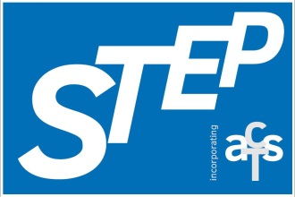

**Scottish Teachers for Enhancing Practice**

**(incorporating the Association of Chartered Teachers Scotland)**

Charity Number: SCO41390

**National Education Conference**

**Saturday 2nd March 2024**

**Stirling Court Hotel**

**BOOKING FORM**

**Name (please print) ……………………………………………………………….**

**School/Place of Work: ……… ……………………………………………………**

**Email address (work):…… ……………………………………………………….**

**Email address (personal):……… ………………………………………………..**

**Local authority: ………………………………………………………………………**

**GTCS number: ………………………………………………………………………..**

**Special dietary requirements/allergies: ……… ……………………………**

**Please tick below to indicate that you give consent to keep your contact details on file in order to contact you regarding future STEP events.**

**Yes ( ) No ( )**

**I am a probationer teacher YES/NO** *please delete as appropriate*

The conference fee is **£50.00**, payable by BACS to STEP –

**Sort Code 80-22-60, Account Number 12858861**.

Please give your full name and GTCS number (where applicable) as the reference in the BACS payment details e.g. John Brown, GTCS No 10000.

**WORKSHOP CHOICES**

**Session A - Morning**

***First choice Second choice***

**Session B - Morning**

***First choice Second choice***

**Session C - Afternoon**

***First choice Second choice***

**Please feel free to stay behind after the conference and attend the STEP AGM. Refreshments and a snack will be provided.**

|  |  |
| --- | --- |
|  | **Yes / No** |
| STEP AGM after the conference |  |

**Cancellation Policy:**

* Notification of cancellation must be received via email by 21st February to [conference@steachersep.org.uk](mailto:conference@steachersep.org.uk). Please make sure you receive acknowledgement of this from the conference organiser if you cancel.
* Cancellation will incur an administrative charge of 30% of the registration fee (£15).
* After 21st February, there will be no refunds.
* Refunds will not be given for no-shows at the conference.
* If you book and your institute is paying for your attendance and you subsequently cancel after 21st February, your institute will still be required to make payment in full.

**Please email this form to:**

**conference@steachersep.org.uk**

**no later than 21st February 2024**