Universal Asynchronous Receiver Transmitter (UART)

Made by :-

Sanidhya Narayan Singh

Summary

Li-Fi technology is an efficient data communication mechanism involving visible light as a medium of transmission. The main ideology behind this technological innovation is that visible light illuminated by a light emitting diode (LED) is methodically amplitude modulated at the transmission end by rapid switching of LED lights at a speed not perceptible to human eye, whereas at the receiving end, photodiodes detect the modulated light and demodulates it to binary form by synchronized receiver circuits. It consists of a light source, line-of-sight (LOS) propagation medium, and a light detector. Information (streaming content), in the form of digital or analogue signals, is input to electronic circuitry that modulates the light source. The source output passes through an optical system (to control the emitted radiation, e.g., to ensure that the transmitter is eye safe) into the free space. The received signal comes through an optical system (e.g., an optical filter that rejects optical noise, a lens system or concentrator that focuses light on the detector), passes through the photo diode (PD), and the resulting photo-current is amplified before the signal processing electronics transforms it back to the received data stream. In this way, data communication is successfully achieved. Unlike Wi-Fi, the technology uses visible light spectrum instead of the increasingly congested radio frequency (RF) spectrum. Similarly to Wi-Fi, this technology allows connection of different web-enabled devices such as computers, smart TVs, smart phones, etc. to internet; provides the inter-connection of Wi-Fi enabled things such as refrigerators, watches, cameras, etc. in Internet of Things (IoT); and makes off-loading from cellular networks possible, addressing this way capacity needs for mobile broadband connections. In addition, Li-Fi has a huge amount of visible light spectrum that is unregulated and does not require licenses. It has to be ensured, however, that Li-Fi systems do not present any health hazards and that they are properly installed so as not to create any electromagnetic interference.

Introduction

Considering any situation, be it using wireless internet in public malls, contending for bandwidths at workshops and seminars or even engaging in home Wi-Fi networks, there is always a growing frustration when slow speeds of internet hampers and decelerates our work. This condition is engendered due to a substantial number of devices competing for a place in a comparatively smaller bandwidth of Radio Spectrum. An acclaimed German physicist, Dr Harald Haas came up with an effective solution to counter the ever increasing problem.

He introduced a much faster data transfer approach using visible light as a medium, which he termed as “Data through illumination”. This is a wireless communication technique wherein visible light is used instead of radio waves. Various innovative aspects to optimize the communication have been initiated. This visible light communication method is extremely vital considering the ever increasing population and hence the exponential rise in use of gadgets employing wireless networks. Hence, this innovation caters to the huge demand of a considerably narrow bandwidth of radio waves in the optical spectrum.

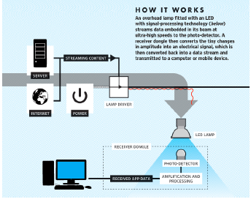

A typical indoor Li-Fi system link is illustrated in above figure. It consists of a light source, line-of-sight (LOS) propagation medium, and a light detector. Information (streaming content), in the form of digital or analogue signals, is input to electronic circuitry that modulates the light source. The source output passes through an optical system (to control the emitted radiation, e.g., to ensure that the transmitter is eye safe) into the free space. The received signal comes through an optical system (e.g., an optical filter that rejects optical noise, a lens system or concentrator that focuses light on the detector), passes through the photo diode (PD), and the resulting photo-current is amplified before the signal processing electronics transforms it back to the received data stream.

For most indoor applications, light emitting diodes (LEDs) are the favoured light sources due to the relaxed safety regulations, low cost, and energy efficiency. They are replacing incandescent bulbs as the primary source of illumination in residential and public environments and by as early as 2018, the majority of new energy-efficient lighting installations are expected to be LED-based. For higher speeds or longer distances, laser diodes appear to be a better choice. The brightness of LEDs can be modulated at a high rate, which enables the combination of both illumination and wireless communication. LEDs emit incoherent light that has different wavelengths and phase (unlike the coherent light of laser diodes), hence, simple and low-cost Intensity Modulation (IM) is performed, where the transmitted signal is modulated into the instantaneous optical power of the LED. Since IM changes instantaneous power of the LED, Direct Detection (DD) is the only feasible demodulation method that converts the incident optical signal power into a proportional current. The setup is far simpler and less expensive than coherent detection chains used in RF, where a local oscillator is used to extract the base-band signal from the carrier. Modulation frequencies are kept high enough to avoid flicker in the emitted light, so that the modulation is imperceptible by human eye.

There are generally two types of photo detectors that can be used in Li-Fi systems: PIN photo diodes and Avalanche photo diodes (APDs). Although the APD have a higher gain, the PIN PDs have been predominantly used due to high temperature tolerance, lower cost, performing better in scenarios where the receiver gets flooded with relatively high intensity light.

In order to provide internet access, an uplink from the device to the network needs also to be ensured in addition to the downlink, which will allow the device to request, modify, and upload information. LED-PD pairs need to be placed on both ends of the wireless communication link to provide this functionality.

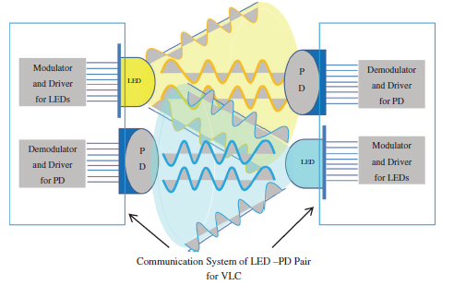

History

LI-FI, a Visible Light Communication technology was developed by a team of scientists including Dr. Gordon Povey, Professor Harald Hass and Dr. Mostafa Afgani at the University of Edinburgh. Harald Haas, a professor at the University of Edinburgh who began his research in the field in 2004, gave a debut demonstration of what he called a Li-Fi prototype at the TED Global conference in Edinburgh on 12th July 2011. He used a table lamp with an LED bulb to transmit a video of blooming flowers that was then projected onto a screen behind him. The technology truly began during the 1990's in countries like Germany, Korea, and Japan where they discovered LED's could be retrofitted to send information. Harald Haas continues to wow the world with the potential to use light for communication.



The general term visible light communication (VLC), whose history dates back to the 1880s, includes any use of the visible light portion of the electromagnetic spectrum to transmit information. The D-Light project at Edinburgh's Institute for Digital Communications was funded from January 2010 to January 2012. Haas promoted this technology in his 2011 TED talk and helped start a company to market it. “Pure Li-Fi”, formerly “pure VLC”, is an original equipment manufacturer (OEM) firm set up to commercialize Li-Fi products for integration with existing LED - lighting systems. In October 2011, companies and industry groups formed the Li-Fi consortium, to promote high-speed optical wireless systems and to overcome the limited amount of radio-based wireless spectrum available by exploiting a completely different part of the electromagnetic spectrum.

Working

Li-Fi is typically implemented using white LED light bulbs at the downlink transmitter which normally used for illumination only by applying a constant current. The LEDs can be switched on and off very quickly which gives nice opportunity for data transfer in the form of Binary code. Hence, by fast and subtle variations of the current, the optical output can be made to vary at extremely high speeds. This very property of optical current is used in Li-Fi setup.The operational procedure is very simple, if the LED is on, you transmit a digital 1, if it’s off you transmit a 0. Hence it is possible to encode the data into the LED’s by using a controller ,we just have to vary at which LED’s flicker depending on the data we want to encode to give different strings of 0’s and 1’s. Visible light has 10,000 times as broad a spectrum as the radio frequencies which Wi-Fi uses, allowing for much more bandwidth, once tapped. Light bulbs are made to flicker at extremely high speed that human eye can’t detect,this is accomplished by the flickering of LED light bulbs to create binary code (on = 1, off = 0), and is done at higher rates than the human eye can’t detect.



Advantages of LI-FI

* Issues regarding Radio Spectrum –

Radio spectrum is congested but the demand for wireless data double every year. Radio spectrum has various problems. First one is Capacity , Radiowaves are expensive and has less bandwidth as compared to other spectrums. Second it isn’t very efficient. Millions of base stations consume large amount of energy for transmitting the radio waves and to cool the base station cabins. Third is availability, it is only available within a range of base stations. And the last one is Security, it is less secure as the waves and data can pass through various things like walls. So to overcome these problems, we move to the other possible spectrum which is the Visible Light Spectrum as other spectrums like Gamma and Ultraviolent rays are harmful to human beings. Here RF means Radio Frequency.

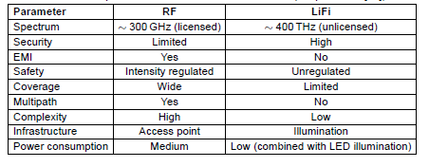

* Visible Light spectrum has 10,000 times as broad a spectrum as the radio frequencies which is being used in various technologies like Wi-Fi. Thus LI-FI has way more bandwidth than WI-FI and provides much greater speed than it. UK researches say that using a micro-LED light bulb they have achieved a data transmission speed of **10Gbps** using LI-FI.

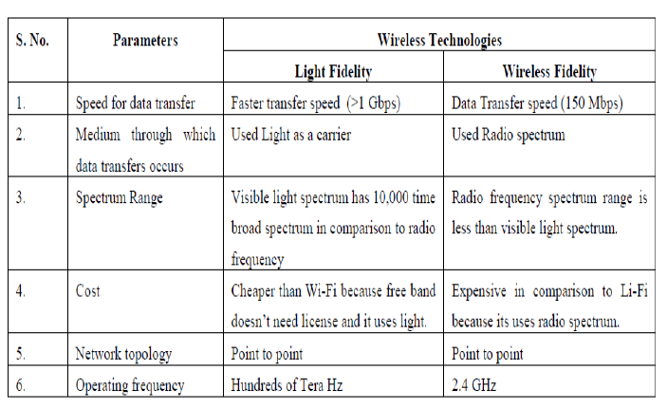

* The more money we spend on lighting in our house/office/school, the more speed we will get in transferring of data. As LI-FI works using the visible light as a medium, more the number of lights, greater the speed. This way we don’t have to spend extra money just to get higher speed.
* Security –

Since Li-Fi makes use of visible light spectrum, it cannot penetrate through optically opaque objects like walls making it difficult for unauthorised access unlike present Wi-Fi which could be accessed from beyond walls and making it vulnerable to unauthorised access.

Components Used

* Software used –

We have used Arduino Complier version 1.8.2. Arduino is an open source computer hardware and software company, project and user community that designs and manufactures single board microcontrollers and microcontroller kits for building digital devices and interactive objects that can sense and control objects in the physical and digital world. Arduino board designs use a variety of microprocessors and controllers. The boards are equipped with sets of digital and analog input/output (I/O) pins that may be interfaced to various expansion boards or breadboards and other circuits.

* Hardware used –

We have used the following components :-

1. Arduino (2)
2. Red LED (1)
3. White LED (1)
4. Table Lamp (1) [5 Watt]
5. Light Dependent Resistor[3]
6. Connecting Wires
7. Breadboard
8. AUX cable
9. Laptop (2)

We are using 2 laptops to demonstrate the LI-FI working model. If a person enters any character, be it any digit or alphabet or any special character, our code is first converting the character into its ASCII value, which is in the form of binary bits and we use give that sequence of bits to the led/lamp, here ‘1’ means the led/lamp is on and ‘0’ means that it is off. And we have connected Light Dependent Resistors near the light source which will detect the bit sequence and then at the other end, our code will decode the bit sequence, which is the ASCII into its respective character. And we will receive the character sent by the transmitter.

Applications of LI-FI in real life

* Avoid street Accidents –

Li-Fi sensors can be implanted in street lights, possible sending your car info about road conditions other warnings**.** One of the smartest application of LIFI is sensors can be implanted in street lights, possible sending your car info about road conditions, warning you about the guy you can’t see speeding towards the intersection, or instantly transmitting his plate number to the cops when he does.

Sensors implanted in front and rear bumpers could receive data transmitted from rear lights of other car: Sensors implanted in front and rear bumpers could receive data transmitted from rear lights of the car just veered into your lane while you were texting. Both drivers are warned (or may be the car takes over) and the accident is averted.

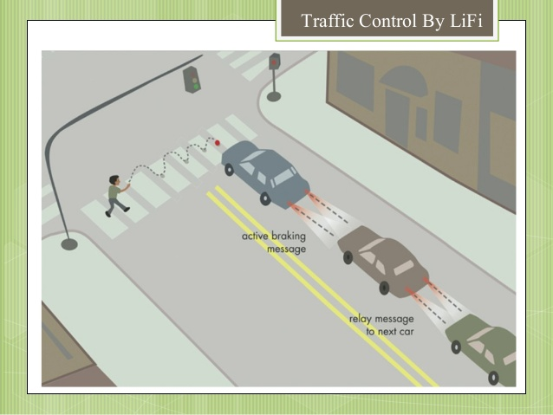 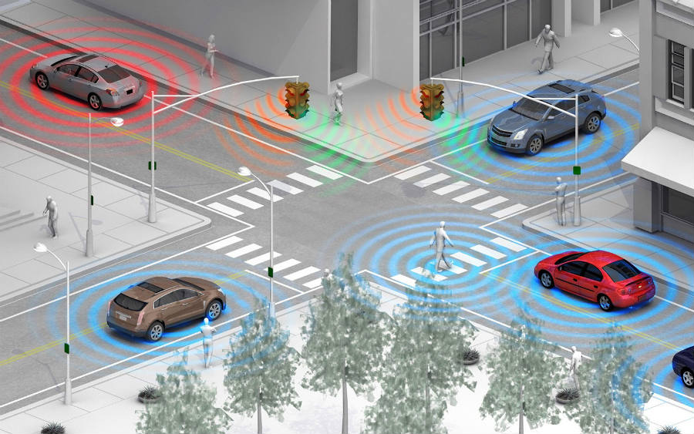

* Hospitals –

Places where Wi-Fi isn’t allowed due to radiation concerns:LIFI can be used in operating rooms where Wi-Fi isn’t allowed due to radiation concerns.

In invasive bio medical instruments:It may also be used in invasive bio medical instruments where it’s not safe to use other radio frequencies.

* Airplanes –

Whenever we travel through airways we face the problem in communication media, because the whole airways communication are performed on the basis of radio waves. To overcome this drawback on radio waves, li-fi is introduced.

Applications of LI-FI in real life

* Underwater –

Li-Fi can even work underwater were Wi-Fi fails completely, thereby throwing open endless opportunities for military/navigation operations.



* Product Retailing –

High speed web access through lighting in malls a customer can passively gather data about reviews and pricing of any product on display**:** With high speed web access through lighting in malls a customer can passively gather data about reviews and pricing and ultimately walk out the door with the item they might otherwise paused at for a moment.

Service of secure high speed connection to simulate your experience researching and purchasing at home:Not only is Li-Fi able to make the process less intrusive than say, QR codes, but it provides you the service of secure high speed connection to simulate your experience researching and purchasing at home.



Applications of LI-FI in real life

* Offices –

Alternative to Optical Fibres**:** A common problem within offices is that they can’t afford fiber optic cable yet they require high speed internet. Li-Fi cheaply solves the office Internet woes and adds a layer of security to boot.

We can get even 100 Mbps connections without any hassle.

Li-Fi can also be used in Encoded Transmissions.Thus securing the data transmission.

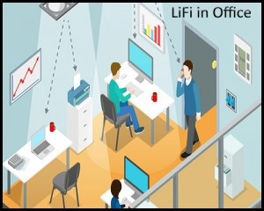

* Lecture Halls/Seminars –

Downloading notes from blogs of respective teachers:Often we encounter teachers telling us to download lecture notes from their blog in my time. With LIFI the notes could be downloaded by the students in the hall itself, so that they could follow along as the lecture progressed.

Interactive classroom with interconnected devices:Imagine how interactive the classroom could be with real-time interconnectivity between 500 devices.

Sharing questions not only with teachers but the entire class:Sharing questions with not only the teacher but the entire class, and no one need be left behind.

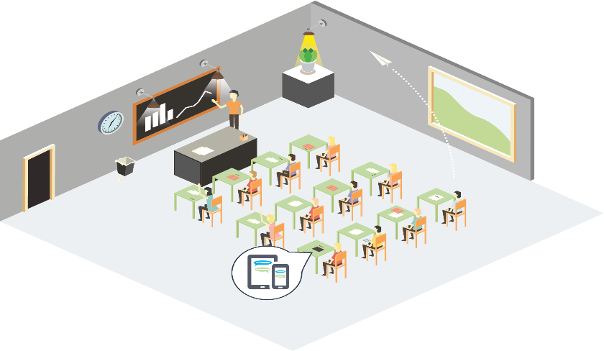

Applications of LI-FI in real life

* Street Lights –

We can get News Updates .

Updates about Natural Calamity:It could keep us informed & save lives. Emergency Communication in Subway stations and tunnels, and other common dead zones:With Li-Fi, if there’s light, one can be online. Subway stations and tunnels, common dead zones for most emergency communications, pose no obstruction.

Cheap high-speed Web access to every street corner:In times less stressing cities could opt to provide cheap high-speed Web access to every street corner.

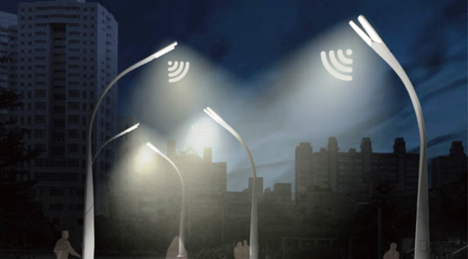

* Smart Museums –

Deliver much more information on pieces in their collection than those tiny cards they paste:Li-Fi could enable a museum to deliver much more information on pieces in their collection than those tiny cards they paste to the walls could ever dream of.

Learn about the artist’s history, listen to an audio tour, peruse recent auctions of their work, etc:It would be possible to learn about the artist’s history, listen to an audio tour, peruse recent auctions of their work.



Applications of LI-FI in real life

* Blind Indoor Navigation System –

Indoor navigation is convenient for everyone, and it is especially indispensable for the visually impaired. We proposed such a navigation system for the visually impaired as shown in Figure. LED lights emit visible light with location data and embedded system or smartphone with a visible light receiver receives the data. The embedded system or smartphone calculates the optimal path to a designation and speaks to the visually impaired through a headphone.



Observations

We have observed that when we use the Red LED for the transmission of data , we have to place the Light Dependent Resistor near the light source. But in the case of White LED, the sensor can be placed farther as compared to the Red LED. And in case of the Table Lamp, the sensor can be placed anywhere as long as even a single ray of light falls on it. This is because the table lamp has a White LED bulb, which contains several small LEDs. And the light coming out of the bulb is dispersed and scattered, it reaches far more distance than a single source of light. And when we are transmitting any audio signal, we are receiving the digital pattern of the audio that is it’s the binary sequence of the audio, and when we pass that output to an Analogue to Digital Converter, we will get the analogue output of that pattern which is the audio itself.

Limitations

* Light can't pass through objects.
* Interferences from external light sources like sun light, normal bulbs, and opaque materials in the path of transmission will cause interruption in the communication.
* High installation cost of the Visible Light Communication systems.
* Uplink**:** Providing an efficient uplink scheme for LiFi (from photo diode to LED luminaire) has been challenging, as LiFi with illumination has predominantly broadcast characteristics. A visible light uplink would be inefficient for portable devices which run on low power and may also be considered inconvenient or unpleasant. To address this challenge, use of other types of communication has been proposed and investigated, where RF or infrared can be used for transmitting uplink data. Utilizing different technologies for uplink and downlink, however, gives rise to HetNets that impose additional practical challenges such as complex network management and reliable data recovery.
* LED Modulation Bandwidth**:** The data rate of the Li-Fi link is limited by the modulation bandwidth of high brightness LEDs used in light fixtures and lamps. Due to the power-bandwidth trade-off of LEDs and the various parasitic impedances in the LED packaging, signals modulated at high frequencies are strongly attenuated. If the entire white spectrum is used at detection, the modulation bandwidth is limited to *_* 2.5 MHz. Blue filtering enhances the modulation bandwidth up to 20 MHz. High data rates over such a limited bandwidth can only be achieved by exploiting high Signal-to-Noise Ratios (SNRs) with high-order modulation techniques; using arrays of smaller, less powerful LEDs (with lower internal parasitic impedances); or using Wavelength Division Multiplex (WDM) to transmit independent data streams on differently colored LEDs that combine to make white light.
* Coverage/Shadowing/Mobility**:** The transmission distance of visible light sources is limited and requires LOS for best SNR conditions to achieve high data rates. With an object or human blocking the Line Of Sight, the observed optical power degrades resulting in severe data rate reductions. User mobility thus introduces novel issues for LiFi as the SNR varies dramatically when the user moves within the cell. This effect may be minimized by distributing lighting sources so that high SNR is maintained throughout the cell .
* Lights Off Mode**:** LiFi applications based on LED lighting are more attractive in environments where the lights are always switched on, for instance, in industrial settings, public transport, or medical areas. Some low data rate transmission can be achieved by making the light emitted to be low enough so that human eyes perceive it as being switched off. Integration of infrared LED chips into future LED luminaires would allow for continuous data flows when the lights are switched off.

Conclusion

This technology stands out with perfection, where data transfer is fast, efficient and significantly provides high level of security. Presently, Li-Fi technology is in its rudimentary stages. However with some developments and optimizations, the future scope of this reliable technology looks promising.

References

[1] H. Haas and N. Serafimovski, “LiFi unlocking unprecedented wireless pathways for our digital future,” *IEEE ComSoc Technology News*, Dec. 2016. [Online]. Available:

<http://www.comsoc.org/ctn/does-5g-have-bright-future-light-based-communications-wireless-solutions.html>

[2] Markets and Markets. (2015) Free space optics (FSO) and visible light communication (Li-Fi) market by component, application (smart store, consumer electronics, defense, transportation, aviation, hospital, underwater, and hazardous environment), and by geography - Global forecast to 2020. [Online]. Available: [http://www.marketsandmarkets.com/Market-Reports/visible-lightcommunication- market-946.html](http://www.marketsandmarkets.com/Market-Reports/visible-lightcommunication-%20market-946.html)

[3] pureLiFi. (2016). [Online]. Available: <http://purelifi.com/>

[4] LiFi by Lucibel. (2016). [Online]. Available: <http://www.lucibel.com/lifi-haut-debit/>

[5] SLUX: pursuit of perfection with light. (2017). [Online]. Available: <https://www.slux.guru/>