**Heart Rate Monitor**

* Open Xcode
* Change the Signing property from Genaral pane in the project editor for the target.

**Integration with Firebase:**

* In Firebase, create a project.
* Add bundle identifier of Xcode project in Firebase.
* Add Google-Info.plist from Firebase to Xcode Project
* In order, to have access to libraries of Firebase, make sure cocoa pods are installed.

Visit below link to install cocoa pods:

<https://cocoapods.org/>

* Check that the project contains necessary pods for Firebase and its real-time database.

**Integration with Amazon Dynamo DB**

* Set the SDK for iOS by installing cocoa pods for Amazon Web Service.
* Install pods mentioned in below link in the system.

<http://docs.aws.amazon.com/mobile/sdkforios/developerguide/setup-aws-sdk-for-ios.html>

* Create identity pool in Amazon Cognito Console.
* Create a table in Amazon Dynamo DB console and attach roles and policy by following steps mentioned in below link:

<http://docs.aws.amazon.com/mobile/sdkforios/developerguide/dynamodb-setup-for-ios.html>

* In information property list in Xcode, add value for pool id as well as region as shown below in ‘YourCognitoIdentityPoolId’ and ‘YourCognitoIdentityRegion’

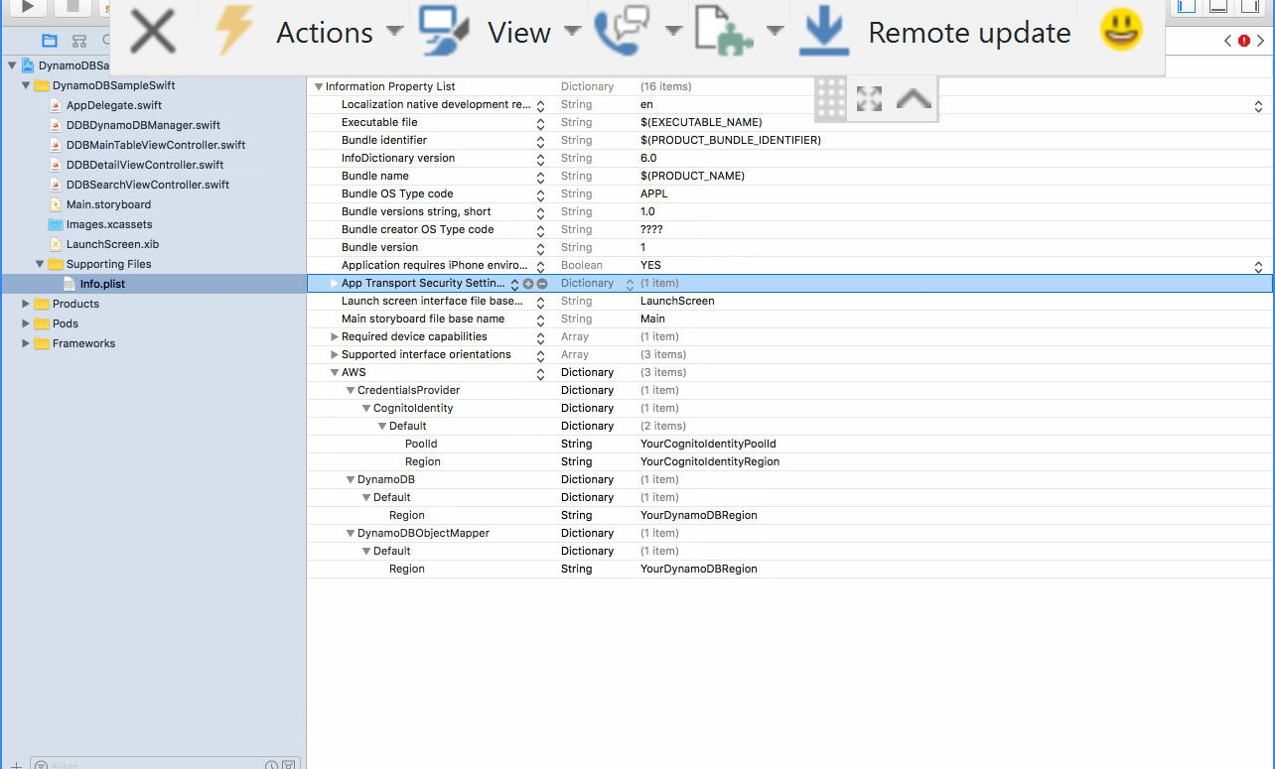

* Import necessary libraries in Application.
* In AppDelegate file of Xcode, mention pool id in the credential provider.
* Compare the name of haskey attribute and range key attribute in the model class with the table created in the Amazon Dynamo DB console.
* Also, change the name in the controller before assigning values those parameters.