**Day-17 Lab (PN: Assign minimum 2 labs. To be done using Jupyter notebook)**

**Assignment: 1.**

**Write a NumPy program to create an array of 10 zeros, 10 ones, and 10 fives.**

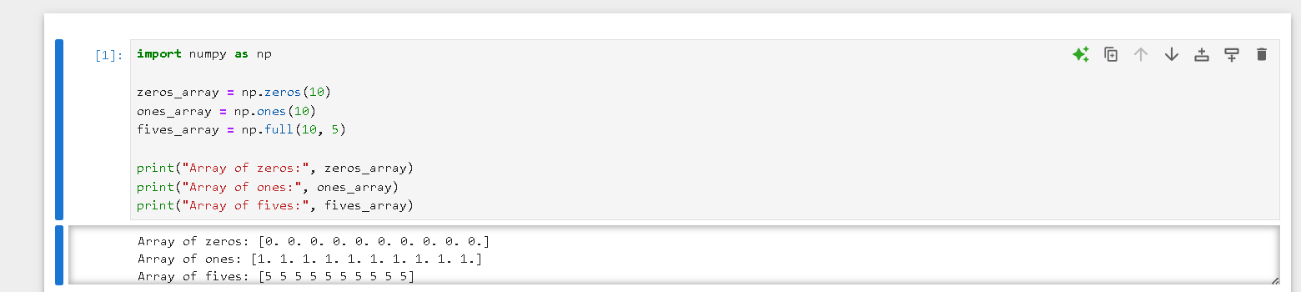

**2. Write a NumPy program to create a 3x3 matrix with values ranging from 2 to 10**

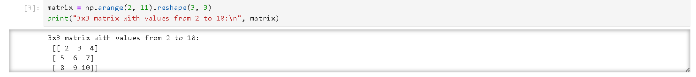

**3. Write a NumPy program to create an array with values ranging from 12 to 38.**



**4. Write a NumPy program to convert a list and tuple into arrays**

