- The Age distribution is slightly right-skewed.

- Most passengers are between 20–40 years old.

 First-class passengers tend to be older on average.

- Third-class passengers show a wider spread in age distribution.

- Higher fares seem to be associated with higher survival.

- Younger passengers are spread across all fare ranges.

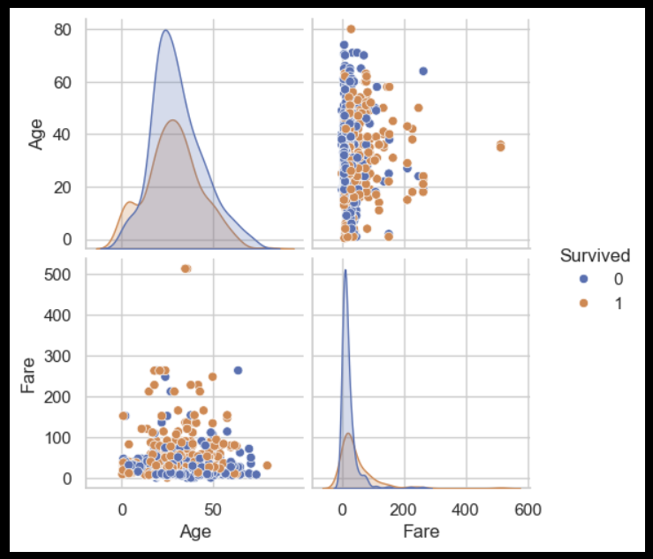

- There is a visible separation in Fare for survivors vs non-survivors.

- Fare has a moderate positive correlation with Survival.

- Pclass has a negative correlation with Survival.

- Females had a much higher survival rate compared to males.