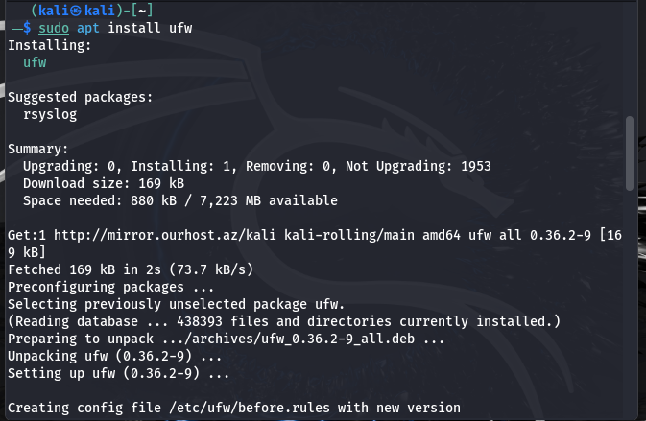

Linux installation of ufw

Enabling ufw and denying telnet

Windows firewall defender

Inbound rules

Outbound rules

Adding the rule to bock port 23 for telnet

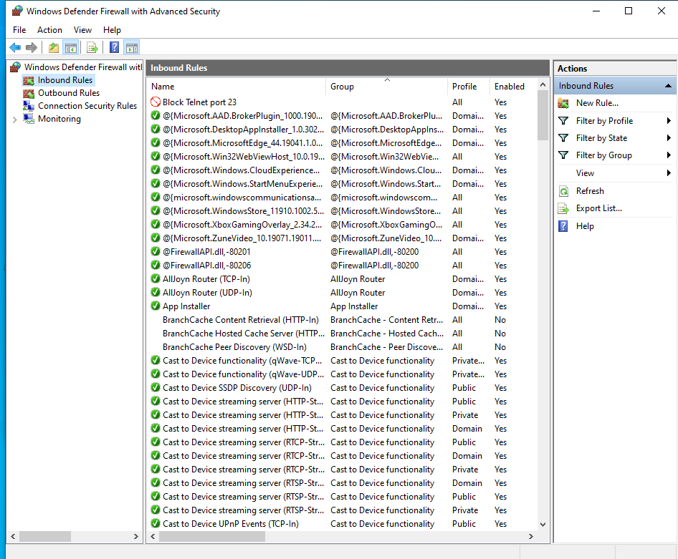

Checking if the rule is working

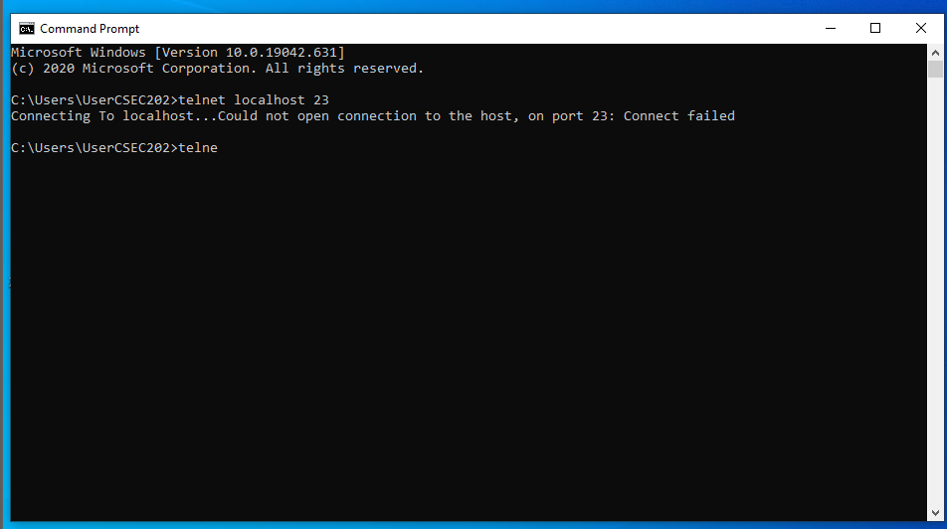

Deleting the rule

