Stegnanography_Tool_Screenshots

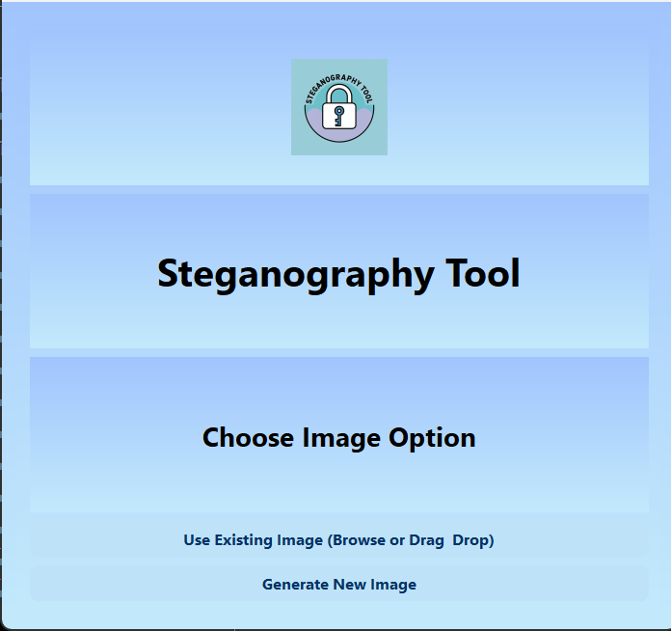

Home screen with options to use existing image or generate a new one

Drag-and-drop support for PNG/BMP images

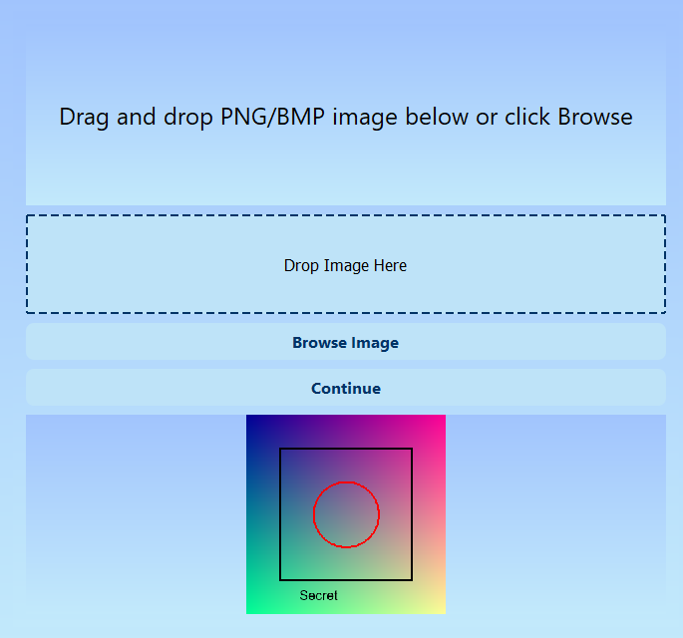

Preview of existing selected image

Encoding and Decoding option with the text box to encode or decode message in the image

After selecting generating image and then choosing one of the given options the same steps as above for encoding or decoding needs to be taken