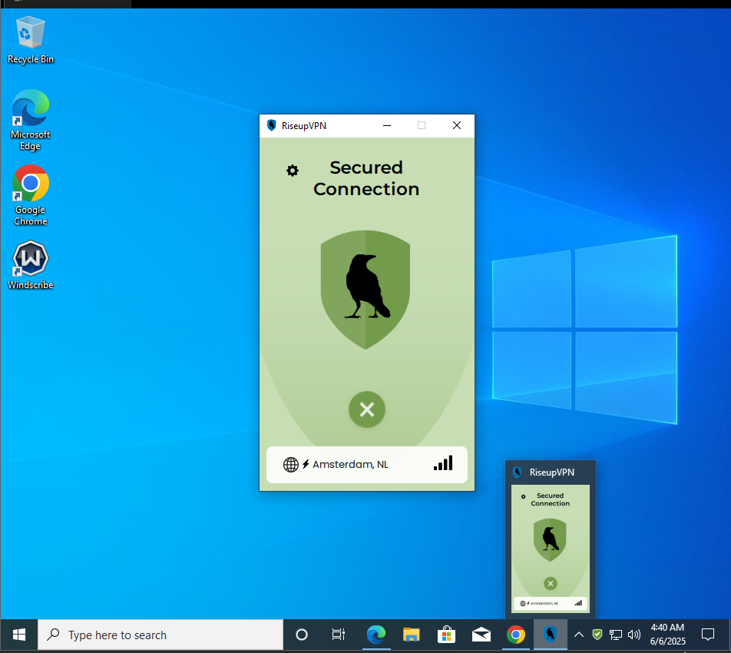

Using riseup vpn

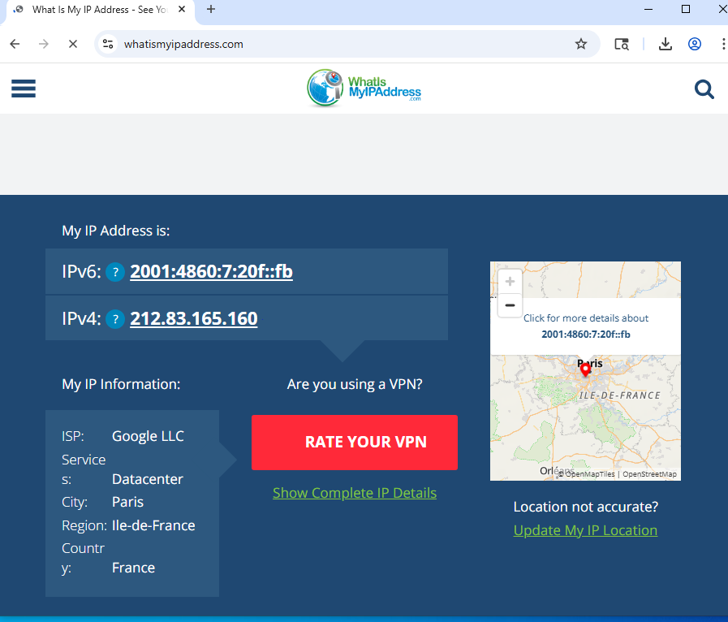

With vpn the ip address recorded

After disconnecting

Without vpn

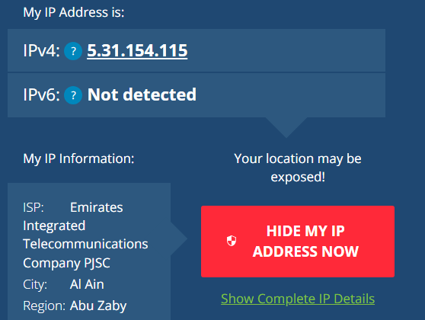

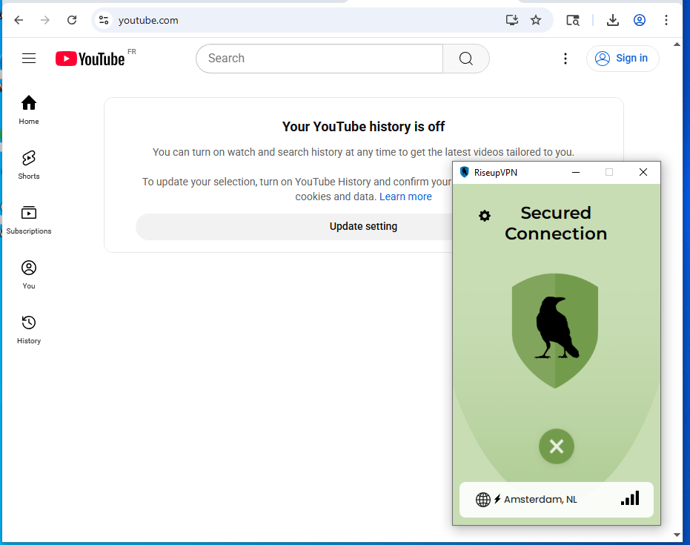

**Test Encrypted Browsing**

* + While connected to Riseup VPN going to Any secure HTTPS site
* This confirms that your traffic is encrypted and routing through a secure server.