DMart Sales & Operational Intelligence
Dashboard

- SANIKA ARUN GIJAYE
BATCH - T340 / DS

DMart Sales & Operational Intelligence Dashboard
The DMart Sales & Operational Intelligence Dashboard project focuses on analyzing retail transactions to monitor sales performance, customer demographics, and operational efficiency. It simplifies insights such as tracking sales trends, category-wise revenue, order status, and state-wise performance.

Built in Power BI, the project integrates interactive visuals and slicers for year, category, age group, and discounts. It helps in identifying growth opportunities, understanding customer behavior, and improving operational decisions through data-driven insights.

Project Aim:

- Sales Performance Tracking: Monitor overall sales trends over time, analyze category-wise contributions, and identify top-performing products and regions.

- Customer Insights: Study customer demographics such as age and gender, along with shopping behavior like browsing time and repeat purchases.

- Product & Discount Analysis: Compare discounted vs. non-discounted product performance, measure their effect on ratings, and evaluate repeat purchase patterns.

- Order & Payment Monitoring: Track order status (delivered, shipped, cancelled, returned) and analyze customer payment preferences such as UPI, Debit, Credit, and COD.

- Operational Efficiency: Evaluate shipping modes, delivery timelines, and cancellation rates to optimize logistics and service quality.

- Revenue & Profitability: Analyze sales distribution across states, profit margins by category, and revenue growth patterns to support strategic decisions.

Objectives :

- Track Overall Sales Trends:
- Visualize sales growth over years to monitor business performance.
- Identify seasonal or yearly fluctuations in revenue.

- Analyze Customer Behavior & Demographics:
- Study website visit duration and its correlation with sales.
- Evaluate customer distribution across gender and age groups.

- Evaluate Product & Category Performance:
- Measure revenue contribution across Local, Branded, and Imported products.
- Highlight best-selling products and categories driving the majority of sales.

- Assess Discount Effectiveness:
- Understand the impact of discounts on customer ratings and repeat purchases.
- Compare revenue and discount contribution across product categories.

- Order & Payment Insights:
- Track order status by category (delivered, cancelled, returned, shipped).
- Analyze customer payment method preferences (UPI, Debit, Credit, COD, etc.).

- Geographical & Regional Sales Performance:
- Identify high-performing states contributing the most revenue.
- Compare state-wise sales to optimize regional strategies.

- Operational Efficiency & Shipping Performance:
- Evaluate average delivery times across shipping modes.
- Track cancellation rate and its impact on operations.

- Decision Support with Interactivity:
- Use slicers for Category, Year, Discount Level, and Customer Segments to enable flexible business exploration.
- Support DMart managers in making data-driven decisions for sales, marketing, and logistics.

Dataset Overview:

Dataset Structure in Power BI:
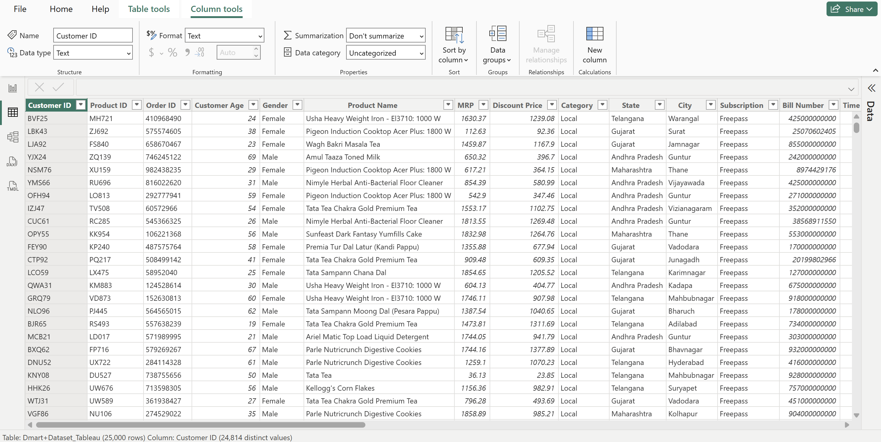

This dashboard provides a comprehensive Sales & Operational Intelligence Report for D-Mart, offering insights across sales, customer behavior, product performance, and operations.

Executive Summary of D-Mart Performance:

- Total Sales Growth: Total sales peaked in 2022 at $5.70M but showed a slight decline in 2023 from the peak, though still higher than 2021 ($5.53M).
- Best-Selling Products: The top-performing product (unlabeled, likely the one with $775.37K$ in sales) significantly leads the pack, with the second-best selling product (labeled 'Pule...' with $808.91K$) having the highest sales visible on the chart, indicating a concentrated revenue stream from a few key items.
- Operational Efficiency: The overall average delivery time across all shipping modes is 6.27 days, with the fastest being Priority at 2.50 days. The Order Cancellation Analysis shows a low cancellation rate of 0.07.
- Payment Method: The predominant payment method accounts for 37.21% of transactions (9K), followed by another category at 28.66% (7K).

Project Scope & Problem Definition:

- Project Objective:
The core objective is to utilize the capabilities of Power BI to process and visualize DMart's historical transaction data⁶. This analysis aims to produce actionable insights that directly improve:
- Sales and Revenue Forecasting.
- Understanding of Customer Behavior.
- Optimization of Pricing Patterns.
- Efficiency of Operational Performance.
- Problem Statement:
D-Mart seeks to upgrade its existing decision-making process by integrating data-driven insights. The specific goals addressed by this dashboard include:
- Analyzing customer purchase patterns.
- Understanding sales trends and product performance.
- Exploring crucial operational metrics, particularly shipping and payment status.

- Dataset Overview:
The analysis is based on a robust dataset containing 25,000+ retail transactions. The key attributes available for analysis are categorized as follows:
- Customer Demographics: Age and Gender.
- Product Info: Category, Brand Type, and Pricing.
- Sales Timeline: Order Date and Delivery Date.
- Marketing: Clicks and Time on Website.
- Operational Data: Payment Mode, Order Status, and Shipping Mode.

Data Analysis Plan & Key Business Questions:

The analysis is divided into four key sections to ensure all strategic areas of the business are covered.
- Sales & Revenue Trends:
This section will establish a baseline for DMart’s financial performance and revenue drivers.
Analysis: How do monthly and yearly sales figures compare?
Focus: Determine the contribution of specific product types (Branded, Local, Imported) to total revenue.
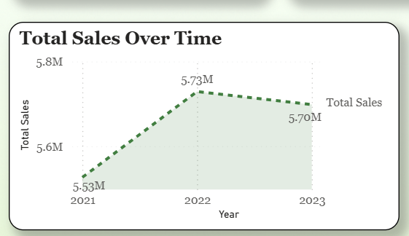

- Customer Demographics & Behavior:
This analysis will define the customer base and quantify the effectiveness of the online presence.
Analysis: What is the distribution of customers by age and gender?
Focus: Quantify how digital engagement (time on the website or number of clicks) affects subsequent purchase behavior.
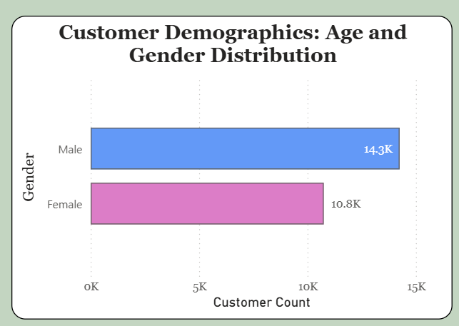

- Product & Pricing Insights:
This section focuses on profitability and the effectiveness of promotional activities²⁷.
Analysis: Identify which products generate the most revenue or are given the highest discounts.
Focus: Test the hypothesis: Are discounted products leading to better ratings and repeat purchases, thereby measuring discount ROI?
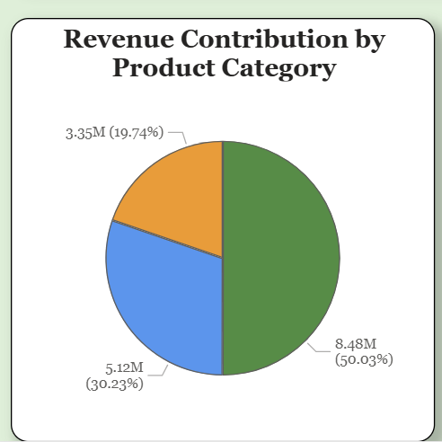

- Operational Performance (Shipping, Payment, Order Status):
This is critical for improving logistics and reducing losses from incomplete orders.
Shipping & Fulfillment: What shipping modes are most common, and how efficient are they in terms of delivery time?
Cancellations: What is the overall order cancellation rate, and what are the probable causes linked to this rate?
Payment & Order Status: What is the breakdown of payment modes (COD, Online)? Are certain product types or payment modes more likely to result in pending or cancelled orders?
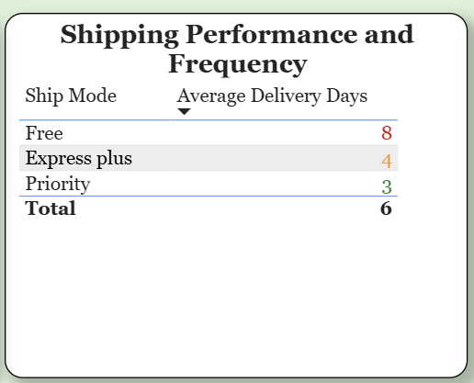

Dashboard Design & Technical Approach:

Analysis Area | Visualizations Used | Purpose
Key Performance Metrics | • KPI Cards (Order Cancellation %, Avg Order Value, Total Sales) | Gives a quick snapshot of business health and important top-level KPIs.
Sales Trends Over Time | • Line Chart (Total Sales Over Time – 2021, 2022, 2023) | Shows sales growth trend, year-over-year comparison, and whether performance is improving.
Best-Selling Products | • Waterfall/Column Combination (Best-Selling Products Overview) | Identifies top-contributing products and highlights cumulative contribution toward total sales.
State-Wise Performance | • Treemap (State-Wise Total Sales) | Helps compare sales performance by state and spot high vs. low revenue regions.
Order Status Analysis | • Stacked Bar Chart (Order Status Breakdown by Product Category) | Shows how each product category performs across order statuses (Delivered, Shipped, Cancelled).
Shipping Efficiency | • Table (Shipping Performance & Frequency – Average Delivery Days) | Highlights efficiency of shipping modes and identifies slow or fast delivery methods.
Product Revenue Contribution | • Pie Chart (Revenue Contribution by Product Category) | Shows which product categories contribute the most to total revenue.
Payment Behavior Analysis | • Donut Chart (Payment Method Breakdown) | Visualizes how customers prefer to pay—Debit, Credit, UPI, COD, etc.
Customer Demographics | • Horizontal Bar Chart (Age & Gender Distribution) | Shows distribution of customers by gender and age groups.
Impact of Discounts | • Clustered Columns (Impact of Discounts on Customer Ratings) | Shows whether discounts influence customer ratings positively or negatively.

Key Findings & Insights :

- Sales Optimization: Clear identification of peak sales cycles and the most lucrative product types (Branded, Local, Imported) to inform inventory management and procurement decisions.
- Targeted Marketing: Precise distribution of customers by age and gender, allowing marketing efforts to be narrowly focused on the most profitable segments.
- Pricing Impact: A quantified relationship between discount depth and subsequent customer behavior (ratings/repeat purchases), providing a guide for promotional budgets.
- Operational Bottlenecks: Identification of the most and least efficient shipping modes and the probable causes of high order cancellation rates.

Proposed Business Recommendations:

Finding/Insight | Data-Backed Business Suggestion
High Cancellation Rate for COD/Specific Products | Implement stricter purchase caps or a small pre-payment requirement for Cash-on-Delivery (COD) for high-value or high-cancellation product categories.
Low Conversion from Website Clicks/Time on Site | Invest in A/B testing on product pages to reduce friction in the conversion funnel, targeting the segments identified as having high engagement but low conversion.
Inefficient Shipping Mode | Review contracts with underperforming logistics partners and reallocate volume to more efficient shipping modes to improve overall delivery timelines.
Discounts Not Leading to Repeat Purchases | Shift discount strategy from blanket price cuts to loyalty-based rewards or bundling complementary products to foster better long-term customer value.

Conclusion:

The DMart Power BI Dashboard successfully transforms 25,000+ transaction data into a cohesive analytical tool. It provides actionable intelligence on sales trends, customer purchasing patterns, pricing effectiveness, and operational efficiency (shipping/cancellation rates). This dashboard empowers DMart to make strategic, data-driven decisions that will ultimately enhance revenue, optimize operations, and improve customer satisfaction.

