

A Digital System Design using Verilog Open ended Project Report on
IMPLEMENTATION OF 3 BIT BINARY TO GRAY USING CMOS AND PSEUDO NMOS LOGIC
in
ELECTRONICS AND COMMUNICATION ENGINEERING
By
1 | Sanika Chougule | USN: 02FE22BEC080
2 | Shraddha Shahpurkar | USN: 02FE22BEC091
3 | Adarsh Kadalikar | USN: 02FE23BEC410
4 | Tejas Khadpe | USN: 02FE23BEC412

UNDER THE GUIDANCE OF
GUIDE NAME HERE



DEPARTMENT OF
ELECTRONICS AND COMMUNICATION ENGINEERING

K. L. E. Dr. M. S. SHESHGIRI
COLLEGE OF ENGINEERING AND TECHNOLOGY,
BELAGAVI– 590008
(2023-24)

Problem statement

Design and implement the 3-bit Binary to Gray code conversion circuit using CMOS logic. Implement the same circuit using pseudo-NMOS logic, which simplifies the design by using fewer transistors but comes with the trade-off of higher static power dissipation. Compare both designs based on power consumption, complexity, and efficiency. Analyze and verify the functionality of both circuits through simulations, ensuring that the outputs correctly reflect the corresponding Gray code values for each binary input.

Introduction
VLSI (Very Large-Scale Integration) design is important for creating small, efficient electronic circuits. This project focuses on designing a 3-bit binary to Gray code converter, a useful circuit in applications like error correction and communication systems, where minimizing errors during data transfer is essential.
The converter is built using two types of logic: CMOS and pseudo-NMOS. CMOS is known for its low power use and high reliability, making it a popular choice for efficient designs. On the other hand, pseudo-NMOS is simpler to design with fewer transistors, but it tends to consume more power when not in use.
This project aims to compare the two designs in terms of power usage and simplicity.
Utilizing the Cadence tool suite, the project involves:
- Developing the schematics for both CMOS and pseudo-NMOS logic styles.
- Conducting transient analysis to verify the correct functionality and response time of the circuit.
- Assessing power consumption to evaluate the energy efficiency of each logic style.
The goal of this study is to analyze the trade-offs between power consumption, design simplicity, and performance, providing insight into the practical considerations of VLSI circuit design in modern electronics

Circuit Diagram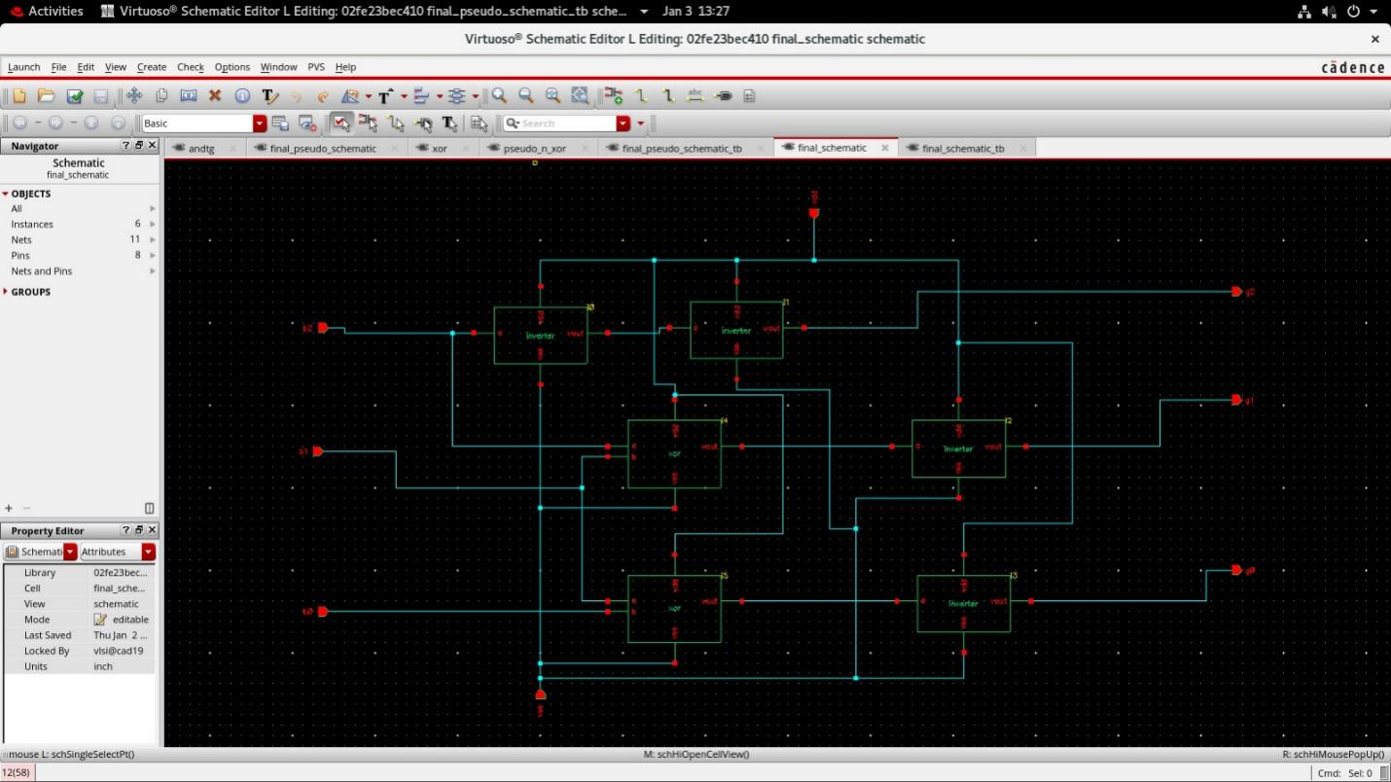

Explanation about Circuit Diagram

The 3-bit Binary to Gray code converter is built using CMOS logic, as shown in the circuit diagram. The circuit has two XOR gates and four inverters, which are the main components that help convert the binary inputs (B2, B1, B0) into the Gray code outputs (G2, G1, G0). Here's how it works:

- XOR gates are used to create the relationships between the binary and Gray code values.
- Inverters are used to flip the signals when needed to complete the logic.

Together, these components generate the correct Gray code outputs from the given binary inputs.

In this project, we created a 3-bit Binary to Gray code converter using CMOS logic. Here's a simpler explanation of how the circuit works:

1) Binary to Gray Code Conversion Logic:
To convert binary numbers to Gray code, we use these simple rules:
- G2 = B2 (Gray output G2 is the same as binary input B2)
- G1 = B2 XOR B1 (Gray output G1 is the XOR of binary inputs B2 and B1)
- G0 = B1 XOR B0 (Gray output G0 is the XOR of binary inputs B1 and B0)

2) CMOS Implementation:
- The XOR gates are built using CMOS logic. In simple terms, these gates use pairs of NMOS and PMOS transistors to create the XOR function. For the NMOS part, two series connections are made (one with A and B', and one with A' and B), and these are connected in parallel. The PMOS transistors do the opposite.
- Inverters (used to flip the signal) are also made using CMOS, where a PMOS and NMOS transistor pair work together to create the inversion.

3) Inputs and Outputs:
- The circuit takes three binary inputs: B2, B1, and B0.
- It gives three corresponding Gray code outputs: G2, G1, and G0.

4) How the Circuit Works:
- G2 is directly connected to B2.
- G1 is created by XORing B2 and B1.
- G0 is created by XORing B1 and B0.
- The circuit’s behavior can be checked using simulations to make sure the Gray code outputs are correct and to measure how much power it uses.

5) Symbol for the Circuit:
The circuit is represented by a symbol in the second diagram. This symbol makes it easier to use the 3-bit Binary to Gray code converter in larger systems. It has three input pins (B2, B1, B0) and three output pins (G2, G1, G0), along with power supply pins (VDD and GND).

This design shows how CMOS logic can effectively perform binary to Gray code conversion.

The 3-bit Binary to Gray code converter is built using pseudo-NMOS logic, as shown in the circuit diagram. The circuit includes two XOR gates and four inverters, which are the main parts that convert the binary inputs (B2, B1, B0) into the Gray code outputs (G2, G1, G0). Here's a simpler explanation of how it works:

1) Binary to Gray Code Conversion Logic:
- G2 = B2 (Gray output G2 is the same as binary input B2).
- G1 = B2 XOR B1 (Gray output G1 is the result of XORing B2 and B1).
- G0 = B1 XOR B0 (Gray output G0 is the result of XORing B1 and B0).
These steps are carried out using pseudo-NMOS XOR gates and direct connections.

2) Pseudo-NMOS Implementation:
- In the XOR gates, a PMOS transistor is always connected to the power supply (VDD), which makes the design simpler and uses fewer transistors. The NMOS transistors are arranged to ensure the correct XOR logic is performed.
- Inverters are created using a PMOS and an NMOS transistor. The PMOS transistor stays on, causing a small continuous current flow, which is a trade-off for a simpler design.

3) Inputs and Outputs:
- The circuit takes three binary inputs: B2, B1, and B0.
- It produces three corresponding Gray code outputs: G2, G1, and G0.

4) Working of the Circuit:
- G2 is directly connected to B2.
- G1 is created by XORing B2 and B1.
- G0 is created by XORing B1 and B0.
The circuit’s performance is confirmed through analysis of how it behaves over time and how much power it consumes.

5) Symbol for Hierarchical Design:
The symbol represents the whole 3-bit binary to Gray code converter. It shows how the internal pseudo-NMOS circuit fits into larger systems, with three input pins (B2, B1, B0), three output pins (G2, G1, G0), and power supply pins (VDD and GND).

This design shows how pseudo-NMOS logic can be used to create the binary to Gray code converter.

Results

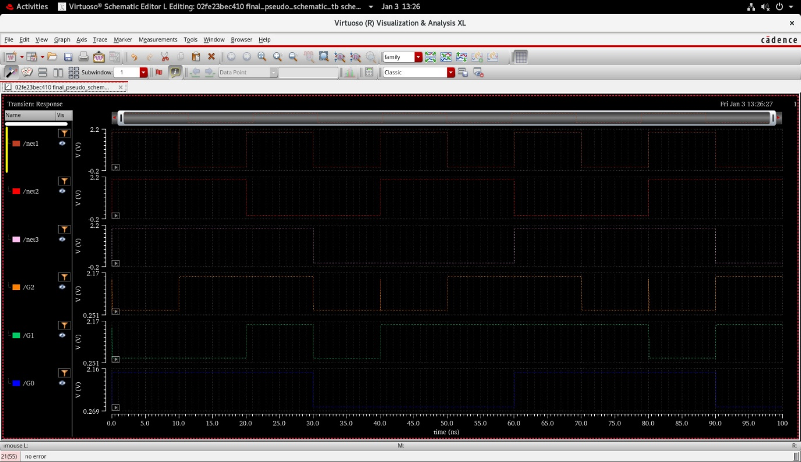

Conclusion

In this project, we designed a 3-bit binary to Gray code converter using both CMOS and pseudo-NMOS logic styles. The CMOS design proved to be more power-efficient and reliable, while the pseudo-NMOS design was simpler but consumed more power. This comparison highlights the trade-offs between power efficiency and design complexity.

