Robot Programming Lab

Name-Sanika Rahate
Registration no-21BRS1084

Lab Assignment 1
1) Communicate a “hello world message” between talker and listner
2) Draw a square using turtle bot

THEORY
The Robot Operating System (ROS) is not an actual operating system, but a framework and set of tools that provide functionality of an operating system on a heterogeneous computer cluster. Its usefulness is not limited to robots, but the majority of tools provided are focused on working with peripheral hardware. ROS is split up in more than 2000 packages, each package providing specialized functionality. The number of tools connected to the framework are probably its biggest power.

Commands
$roscore
Start the talker node by using the following command in another terminal
$rosrun reoscpp_tutorials talker
Now you see the messages printing on the terminal screen.

$rosrun roscpp_tutorials listener
The subscribing begins between the two nodes
output-
1)running roscore command

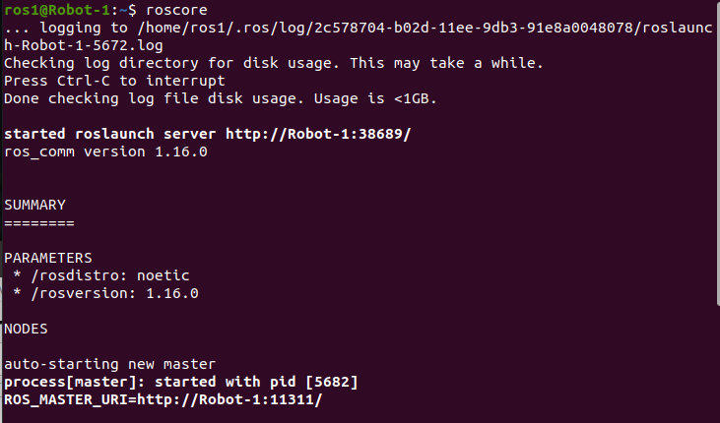

run : rosrun reoscpp_tutorials talker
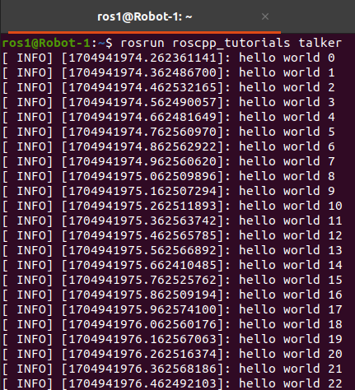

run : rosrun roscpp_tutorials listener
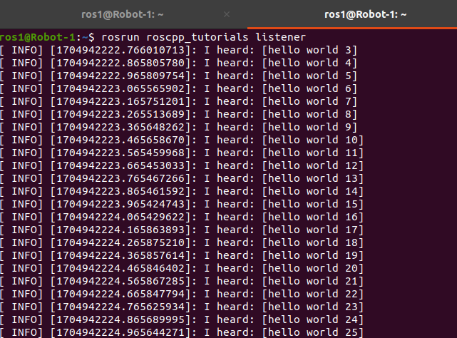

2)Commands:
roscore
rosrun turtlesim turtlesim_node
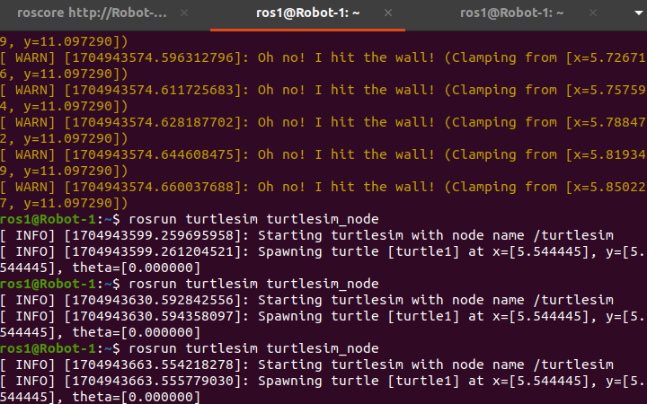

rosrun turtlesim turtle_teleop_key
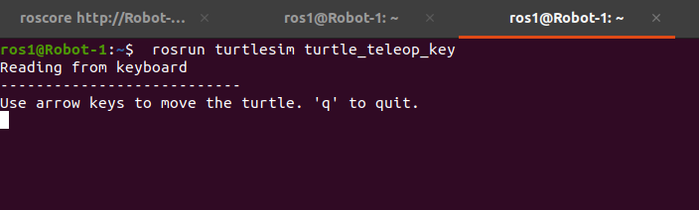

OUTPUT-
