Food Delivery Intelligence: Delivery Performance, Operational Analysis & Predictive Analytics

1. Introduction
Food delivery platforms generate large volumes of operational data every day, including order times, delivery locations, rider details, traffic and weather conditions. Analyzing this data is essential to monitor delivery speed, identify the causes of delays, and manage riders and vehicles efficiently.
This project analyzes 45,584 delivery orders recorded between 11 February 2022 and 6 April 2022 across 22 cities and 1,320 riders. It focuses on delivery performance, traffic and weather impact, rider and vehicle differences, order type, delivery distance and festival effects, and includes a basic regression analysis to explain and predict delivery time.

2. Problem Statement
The delivery operation lacks a centralized system to monitor delivery time and to understand which factors make some deliveries slower than others.
Without structured analysis:
- The share of slow deliveries is not monitored.
- The effect of traffic and weather on delivery time is not quantified.
- The relationship between delivery distance and delivery time is unclear.
- Differences between riders, vehicles and simultaneous deliveries cannot be evaluated.
- Data quality issues such as invalid coordinates and corrupted time values may distort the results.
An interactive dashboard is required to analyze delivery performance and the factors associated with delivery time.

3. Dataset Description
The dataset contains order-level delivery records. Each row represents one delivery order. It has 45,584 rows and 20 columns.
The dataset includes the following key columns:
- Order ID – Unique identifier of each order.
- Rider ID – Identifier of the delivery partner; its prefix also identifies the city (for example, MUM = Mumbai).
- Rider Age and Rider Rating – Age and customer rating (out of 5) of the delivery partner.
- Restaurant and Delivery Latitude / Longitude – Coordinates used to calculate the delivery distance.
- Order Date, Order Time and Pickup Time – When the order was placed and picked up.
- Weather – Weather condition (Sunny, Cloudy, Fog, Windy, Stormy, Sandstorms).
- Traffic – Road traffic density (Low, Medium, High, Jam).
- Vehicle Condition and Vehicle Type – Condition score (0 to 3) and type of vehicle (Motorcycle, Scooter, Electric Scooter, Bicycle).
- Order Type – Snack, Meal, Drinks or Buffet.
- Multiple Deliveries – Number of other deliveries the rider was handling (0 to 3).
- Festival – Whether the order was placed during a festival (Yes / No).
- City – Area type of the order (Metropolitan, Urban or Semi-Urban).
- Time Taken (min) – Delivery time in minutes, which is the target of the analysis (10 to 54 minutes, average 26.3).
This dataset enables analysis of delivery performance, the impact of traffic and weather, and rider and vehicle differences.

4. Tools Used
1. Power BI Desktop
Used as the main tool to build the interactive 6-page dashboard with KPI cards, charts, slicers, navigation buttons and the Key Influencers visual.
2. Power Query Editor
Used for data inspection, cleaning and transformation, including handling missing values, repairing corrupted time values, fixing invalid coordinates, and creating derived columns.
3. DAX
Used to create measures, calculated columns and the date table, including KPIs, share percentages, a simple regression and the prediction column.
4. Haversine Formula
Used to calculate the straight-line distance in kilometres between the restaurant and the delivery location from valid latitude and longitude values.
5. Linear Regression
Used as the statistical technique to measure how much of the variation in delivery time is explained by distance and by nine factors combined.

5. Data cleaning and Preprocessing
Power Query was used to inspect, clean and prepare the data to guarantee data quality and readiness for analysis.
- First, the CSV file was imported into Power BI and the column quality and distribution views were used to inspect the structure, data types and missing values.
- Missing values were stored as the text "NaN", so the automatic type-detection step was removed and "NaN" was replaced with real blanks before the data types were set.
- The columns were renamed to clean names (for example, Delivery_person_Ratings became Rider Rating), and the Order Date was converted to date format using the UK locale (dd-MM-yyyy).
- Invalid coordinates: 3,640 orders (8%) had restaurant coordinates of 0. These were flagged, and distance was left blank for them instead of being calculated.
- Negative restaurant coordinates: 431 orders had a minus sign that placed the restaurant outside India. The sign was corrected with an absolute value and the rows were flagged.
- Distance (km) was calculated with the Haversine formula only for valid coordinates. This gave 41,944 valid distances, ranging from 1.47 km to 20.97 km, with an average of 9.72 km.
- Corrupted time values: 8,195 order or pickup times had been stored by Excel as day fractions (for example, 0.8333 for 20:00), and 880 pickup times read "24:05:00". All formats were converted to minutes after midnight. After the repair, the pickup time minus order time was always between 5 and 15 minutes, confirming the fix.
- Impossible rider records: 91 orders had a rider age of 15 with rating 1.0, or age 50 with rating 6.0 (the scale ends at 5). These were flagged and the invalid age and rating values were blanked.
- "City" column: this column actually contained the area type (Metropolitan, Urban, Semi-Urban), and "Metropolitian" was misspelled. It was renamed to Area Type and corrected. The real city was derived from the rider ID prefix and joined to a city lookup table of 22 cities.
- Missing categories were not guessed. For example, orders with a missing Festival value averaged only 11 minutes against 26 overall, so they were left blank rather than treated as "No".
- To simplify the analysis, the following columns were created:
  - Distance Category – 0-3 km, 3-6 km, 6-10 km and 10+ km.
  - Delivery Performance – Fast (19 minutes or less), Average (20 to 32 minutes) and Slow (more than 32 minutes). The thresholds are the 25th and 75th percentiles of the actual delivery time. This gave 12,509 Fast (27.4%), 21,809 Average (47.8%) and 11,266 Slow (24.7%) deliveries.
  - Rider Age Band, Rider Rating Band, Time Bin (5-minute bands), Time of Day, Delivery Type (Single / Multiple) and sort columns so that charts display in a logical order, for example Low to Jam traffic.
These preprocessing steps ensured valid distance values, consistent time values, reliable rider information and meaningful analytical categories.

6. Power BI Dashboard
After preprocessing, the dataset was loaded into Power BI to develop the Food Delivery Intelligence Dashboard, a 6-page interactive report.
Data Model
The model uses one fact table and two dimensions. Fact Delivery (45,584 rows) holds all orders. Dim City (22 cities) is linked on City Code and Dim Date (11 February to 6 April 2022) is linked on Order Date, both as many-to-one relationships with single-direction filtering.All measures are stored in a separate measures table.
Page 1: Home
The landing page introduces the project with title Food Delivery Intelligence, and Total Orders card showing 45,584. I have added 5 navigation cards (Overview, Delivery, Riders, Traffic and Prediction) which use page-navigation actions to open each analysis page.
Page 2: Overview
KPI Cards – The top section displays key performance indicators:
- Total Deliveries – 45,584 orders.
- Average Delivery Time – 26.3 minutes (minimum 10, maximum 54, median 26).
- Average Distance – 9.7 km.
- Average Rider Rating – 4.64.
- Slow Delivery % – 24.7% of deliveries took more than 32 minutes.
- Multiple Delivery % – shows whether rider had one or more deliveries. 68.4% of orders (with a known value) were handled while the rider had one or more other deliveries.
Visualizations Included
1. Average Delivery Time by City (Bar Chart)
Compares the average delivery time of the 22 cities. All cities fall between 26.0 minutes (Mysore) and 27.0 minutes (Allahabad), so city is not a major factor.
2. Delivery Time Trend (Line Chart)
Shows the average delivery time per day. Daily averages move between about 22.9 and 30.3 minutes with no steady rise or fall.
3. Delivery Time Distribution (Column Chart)
A histogram of delivery time in 5-minute bands. Most deliveries take 15 to 35 minutes, and the busiest band is 25 to 29 minutes with 10,068 orders.
4. Average Time by Area Type (Column Chart)
Urban orders average 23.0 minutes, Metropolitan 27.3 minutes, and the 164 Semi-Urban orders average 49.7 minutes.
5. Deliveries by Traffic (Donut Chart)
Shows the traffic density out of total and deliveries carried out during that particular density traffic : Low 34%, Jam 31%, Medium 24% and High 10% of orders.
6. Order Type Distribution (Donut Chart)
Orders are split almost evenly (about 25% each) between Snack, Meal, Drinks and Buffet.
Page 3: Delivery
This page answers the question "What influences delivery duration?" It shows the cards Fast Delivery %, Average Delivery Time, Multiple Delivery % and Slow Delivery %, plus dynamic insight cards that update with the filters.
1. Average Time by Multiple Deliveries (Column Chart)
Delivery time rises sharply with simultaneous deliveries: 22.9 minutes with none, 26.9 with one, 40.5 with two and 47.8 with three. Orders with two or more simultaneous deliveries are 98% to 100% slow, although only about 5% of orders fall in this group
2. Fast / Average / Slow (Donut Chart)
Comapres delivery performance out. Approx 27.4% of orders where delivered Fast, 47.8% Average 47.8% and 24.7% Slow.
3. Average Time by Order Type (Bar Chart)
Meal 26.4, Snack 26.3, Buffet 26.3 and Drinks 26.2 minutes, which shows that order type has essentially no relationship with delivery time.
4. Average Time by Distance (Line Chart)
Shows the average delivery time for each kilometre of distance. Time rises with distance.
5. Average Time by Distance Category (Column Chart)
Shows distance category and avg time required to deliver order for that particular distance range. Deliveries of 0-3 km take 21.5 minutes, 3-6 km take 22.8, 6-10 km take 24.4 and 10+ km take 29.8 minutes.
Page 4: Riders
This page analyzes delivery partner and vehicle performance with the cards Average Rider Age (29.6), Average Rider Rating (4.64), Total Deliveries and Average Delivery Time.
1. Average Time by Rider Rating (Scatter Chart)
It shows rider rating and avg time of the delivery. Delivery time falls as rating rises. By rating band, riders rated 4.0 or below average 36.1 minutes, 4.1-4.5 average 30.6, 4.6-4.8 average 24.3 and 4.9-5.0 average 24.6 minutes.
2. Average Time by Rider Age (Scatter Chart)
It shows avg time taken for delivery based on the riders age. Riders aged 18-29 average about 23.0 minutes, while riders aged 30 and above average about 29.5 minutes. The pattern is a step at age 30 rather than a smooth rise.
3. Rider Rating Distribution (Column Chart)
It shows that Most deliveries are made by riders rated 4.6 to 4.8 (21,224 orders), followed by 4.9-5.0 (11,036), 4.1-4.5 (8,919) and 4.0 or below (2,406).
4. Average Time by Vehicle Condition (Column Chart)
Here we can see Vehicles in condition 0 average 30.1 minutes, against 24.4 for condition 1 and 24.5 for condition 2.
5. Average Time by Vehicle Type (Bar Chart)
It shows time taken for delivery based on the vehicle type Motorcycle 27.6 minutes (26,429 orders), Scooter 24.5, Electric Scooter 24.5 and Bicycle 26.4 (only 68 orders, so it should not be over-interpreted).
6. Average Time by Multiple Deliveries (Column Chart)
Delivery time rises sharply with simultaneous deliveries: 22.9 minutes with none, 26.9 with one, 40.5 with two and 47.8 with three. Orders with two or more simultaneous deliveries are 98% to 100% slow, although only about 5% of orders fall in this group

Page 5: Traffic
This page answers "How do traffic and weather affect delivery performance?" and includes dynamic insight cards.
1. Average Time by Traffic (Column Chart)
Avg time taken for delivery w.r.t to traffic density. Low traffic averages 21.3 minutes, Medium 26.7, High 27.2 and Jam 31.2 minutes. Jam adds about 9.9 minutes (+47%) compared with Low traffic, and 44% of Jam deliveries are slow against 6% in low traffic.
2. Average Time by Weather (Bar Chart)
Cloudy and Fog are the slowest at 28.9 minutes, followed by Windy 26.1, Sandstorms and Stormy 25.9, while Sunny is the fastest at 21.9 minutes.
3. Festival vs Non-Festival (Column Chart)
Festival orders average 45.5 minutes (896 orders, all slow) against 26.0 minutes on other days. Festival orders also had more simultaneous deliveries, so the two effects overlap.
4. Weather x Traffic Heatmap (Matrix)
Shows the average delivery time for each combination of weather (rows) and traffic (columns) with conditional colour formatting. The worst combinations are Fog with Jam (36.8 minutes) and Cloudy with Jam (36.7 minutes). In Sunny weather, traffic makes little difference (20.2 to 23.4 minutes).
5. Traffic and Weather Distribution (Clustered Bar Charts)
Show the percentage of orders in each traffic and weather category. Each weather type holds about 16% to 17% of orders.
Page 6: Prediction (What Drives Delivery Time?)
This is the most analytical page. It moves from describing patterns to measuring how much of delivery time can be explained and predicted.
1. Regression Cards
- Slope, 0.54 minutes per km
This is the steepness of the trend line. Each extra kilometre is associated with about half a minute more delivery time.
- R², 0.10
This card shows how much of the variation in delivery time distance explains. R² = 0.10 (distance alone): distance explains 10% of the variation. The other 90% comes from other things, such as traffic, simultaneous deliveries, festivals, weather and rider factors.
- Correlation, r = 0.32
Correlation measures how closely two things move together, on a scale from −1 to +1.
- +1 means a perfect upward relationship.
- 0 means no relationship.
- −1 means a perfect downward relationship.
At 0.32, longer distances tend to go with longer delivery times, but the link is only modest. Many short deliveries are slow and many long ones are fast.
2. Distance vs Delivery Time (Scatter Chart)
Shows one point per order with a regression trend line, so the spread around the line is visible.
3. Key Influencers (AI Visual)
Power BI’s Key Influencers visual analyzes delivery time using traffic, weather, multiple deliveries, rider rating, rider age, vehicle type, festival, order type and distance, and ranks the factors that increase delivery time.
4. Actual vs Predicted Sample Orders (Table)
Lists Order ID, actual delivery time and predicted delivery time for individual orders.
5. Actual vs Predicted Average Time by Traffic (Clustered Column Chart)
Compares actual and predicted averages across traffic levels to show how closely the model tracks reality.

STOP
Prediction model. A multiple linear regression with nine factors (distance, traffic, weather, rider age, rider rating, vehicle condition, multiple deliveries, order type and festival) was applied through a DAX calculated column. The coefficients were estimated by least squares on this dataset and entered as constants because Power BI has no built-in multiple-regression function. The model was scored on 41,944 orders with valid distance and gives an R-squared of 0.56, a mean absolute error of 4.9 minutes, and about 90% of predictions within 10 minutes of the actual time. This is a basic regression analysis and not a full machine-learning system.
The factors with the strongest individual association with delivery time (share of variation explained) are:
Factor | Variation explained
Traffic | 18.3%
Time of day | 16.8%
Multiple deliveries | 15.0%
Rider rating | 13.0%
Distance | 10.3%
Festival | 9.7%
Rider age | 9.2%
Area type | 6.4%
Weather | 6.3%
Vehicle condition | 5.5%
City | 0.06%
Order type | 0.01%

Filters and Slicers
Interactive slicers such as Traffic, Weather and Vehicle Type (Overview page) and Area Type (Prediction page) let users dynamically filter the data and analyze specific segments. All charts are cross-filtered, so selecting a bar or a slice updates the other visuals on the page. A sidebar with page-navigation buttons is available on every page.
DAX Measures Used
DAX (Data Analysis Expressions) was used in Power BI to calculate key delivery performance metrics and support interactive analysis.
- Total Deliveries – Counts the rows of the fact table (45,584).
- Average Delivery Time, Minimum and Maximum Delivery Time – Mean, lowest and highest delivery time in minutes.
- Average Distance, Average Rider Rating and Average Rider Age – Averages that ignore blank values.
- Fast Deliveries, Slow Deliveries, Fast Delivery % and Slow Delivery % – Counts and shares of deliveries by the Delivery Performance category.
- Multiple Delivery % – Share of orders where the rider had one or more other deliveries, out of orders with a known value.
- Traffic Share % and Weather Share % – Share of orders in each category of the current selection, calculated with ALLSELECTED.
- Festival Avg Time and Non-Festival Avg Time – Average delivery time on festival and non-festival days.
- Time vs Overall Avg – Difference between a group’s average time and the overall average.
- Correlation Distance-Time, R Squared Distance and Slope (min per km) – A simple regression between distance and delivery time calculated with variables and iterator functions (AVERAGEX, SUMX).
- Predicted Time (calculated column), Avg Predicted Time, Deliveries Scored, Model R2 and Model MAE – The prediction column and the measures that evaluate its accuracy.
- Slowest Traffic Level and Insight measures – Text measures that build dynamic insight sentences, such as the slowest traffic level and its average time, which update with every filter.
These measures enable dynamic KPI calculation and help monitor delivery speed, identify delay drivers and evaluate prediction accuracy.

7. Conclusion
The Food Delivery Intelligence Dashboard provides a structured and data-driven approach to analyze delivery performance. By repairing corrupted time values, handling invalid coordinates, correcting rider records and calculating distance with the Haversine formula, the dashboard ensures reliable operational insights.
The analysis shows that delivery time is not driven by a single factor. Traffic, simultaneous deliveries and festivals are the strongest associations: Jam traffic adds about 10 minutes, two or more simultaneous deliveries raise the average to over 40 minutes, and festival orders average 45.5 minutes. Weather (Fog and Cloudy) and distance add to these effects, while city and order type have almost no relationship with delivery time. Combined, nine factors explain about 56% of delivery time with a typical error of 4.9 minutes.
Based on these findings, the recommendations are:
- Use traffic- and weather-aware delivery time estimates.
- Limit simultaneous deliveries to one extra order per rider.
- Plan extra rider capacity for festival days.
- Review coverage and rider allocation in Semi-Urban areas.
- Review vehicle condition and support for low-rated riders.
Limitations: the data is observational and covers about eight weeks, so the findings show association and not causation; distance is a straight-line value capped at about 21 km; 8% of orders have no valid distance; the rating and vehicle-condition scales are undocumented; and the linear model does not capture interactions such as weather combined with traffic.
Overall, this project demonstrates how data analytics and Power BI can support better decision-making and improve operational efficiency in food delivery.

8. Dashboard Photos

Figure: Home page
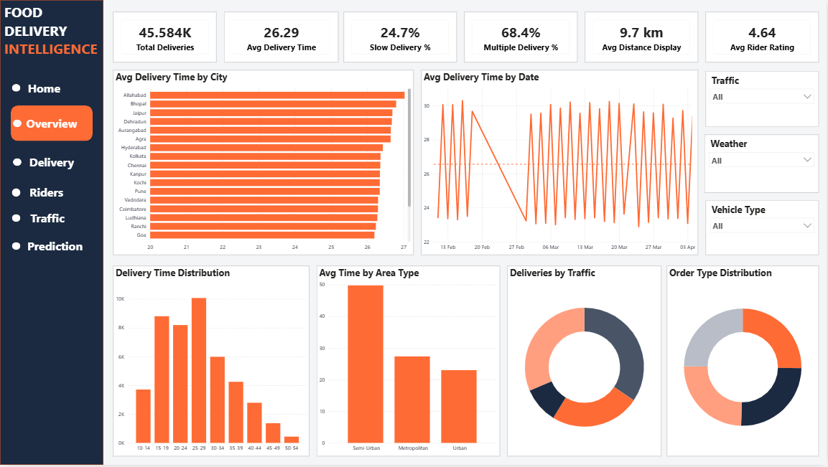
Figure: Overview page

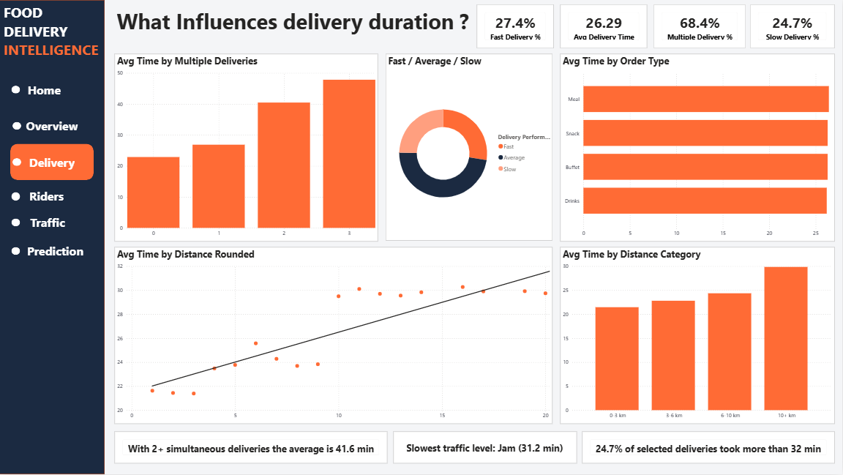
Figure: Delivery page
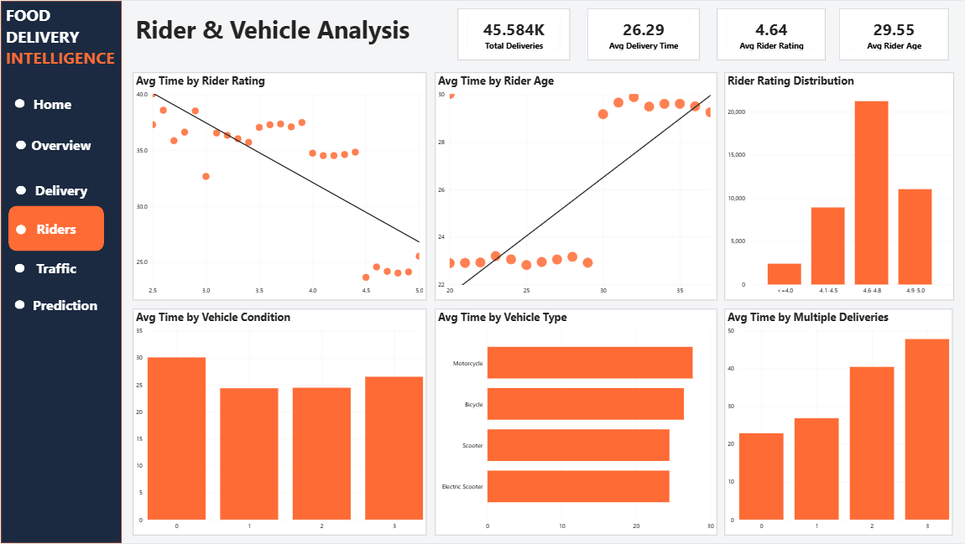
Figure: Riders page

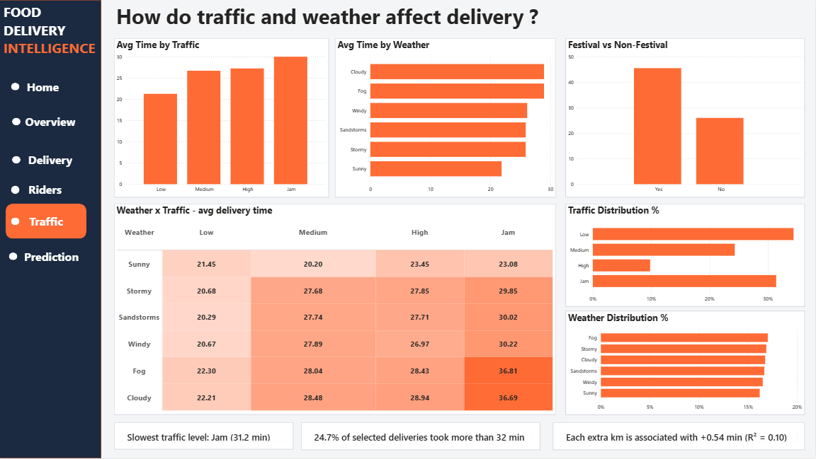
Figure: Traffic page
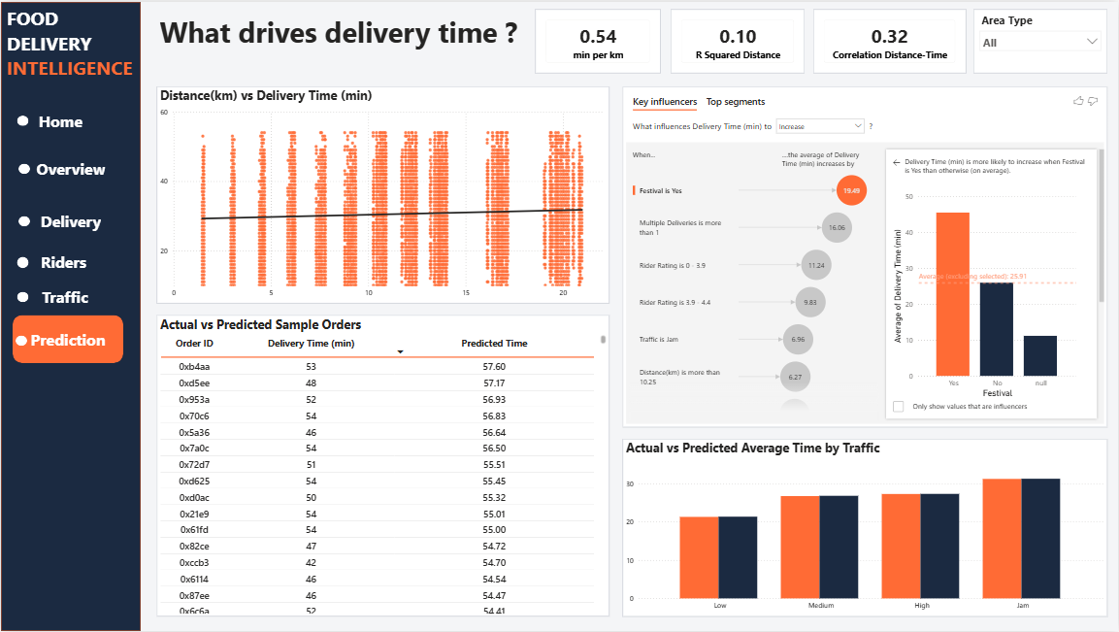
Figure: Prediction page
Submitted By: Sanika Kate
Project LinkedIn link (video demo) : https://lnkd.in/p/dPzmCF7w

