MINOR PROJECT REPORT
Predictive Classification using Random Forest Ensembles
AIML Minor Project 4
Submitted by: Sanika Balaji Bavale
Date: 11 October 2026

Abstract
This project applies Random Forest classification to the Breast Cancer Wisconsin (Diagnostic) benchmark dataset (569 records, 30 numeric predictors). With a stratified 80:20 split, the model achieved accuracy 0.965, malignant precision 1.000, malignant recall 0.905, malignant F1-score 0.950, and ROC-AUC 0.996. This is a coursework experiment, not a medical diagnostic tool.

1. Introduction
Random Forest is an ensemble learning algorithm that combines multiple decision trees and aggregates their predictions. It is suitable for tabular classification and can model nonlinear relationships.

2. Objectives
- Perform exploratory data analysis and examine class imbalance and correlations.
- Handle missing values and prepare data for classification.
- Train RandomForestClassifier using an 80:20 split.
- Evaluate with confusion matrix, precision, recall, F1-score, ROC-AUC, and feature importance.

3. Dataset
The included dataset has 569 rows and 30 numeric predictor features. The target is diagnosis: B (benign) or M (malignant). Class counts are B=357 and M=212. The benchmark is available from Kaggle and UCI. The local CSV is created from scikit-learn's bundled copy of the same benchmark.
Kaggle: https://www.kaggle.com/datasets/uciml/breast-cancer-wisconsin-data
UCI: https://archive.ics.uci.edu/dataset/17/breast+cancer+wisconsin+diagnostic

4. Exploratory Data Analysis
The class distribution is moderately imbalanced. Feature distributions differ across diagnosis groups. The correlation heatmap shows groups of strongly correlated measurements; correlated variables may provide overlapping information.
Figure 1. Class distribution
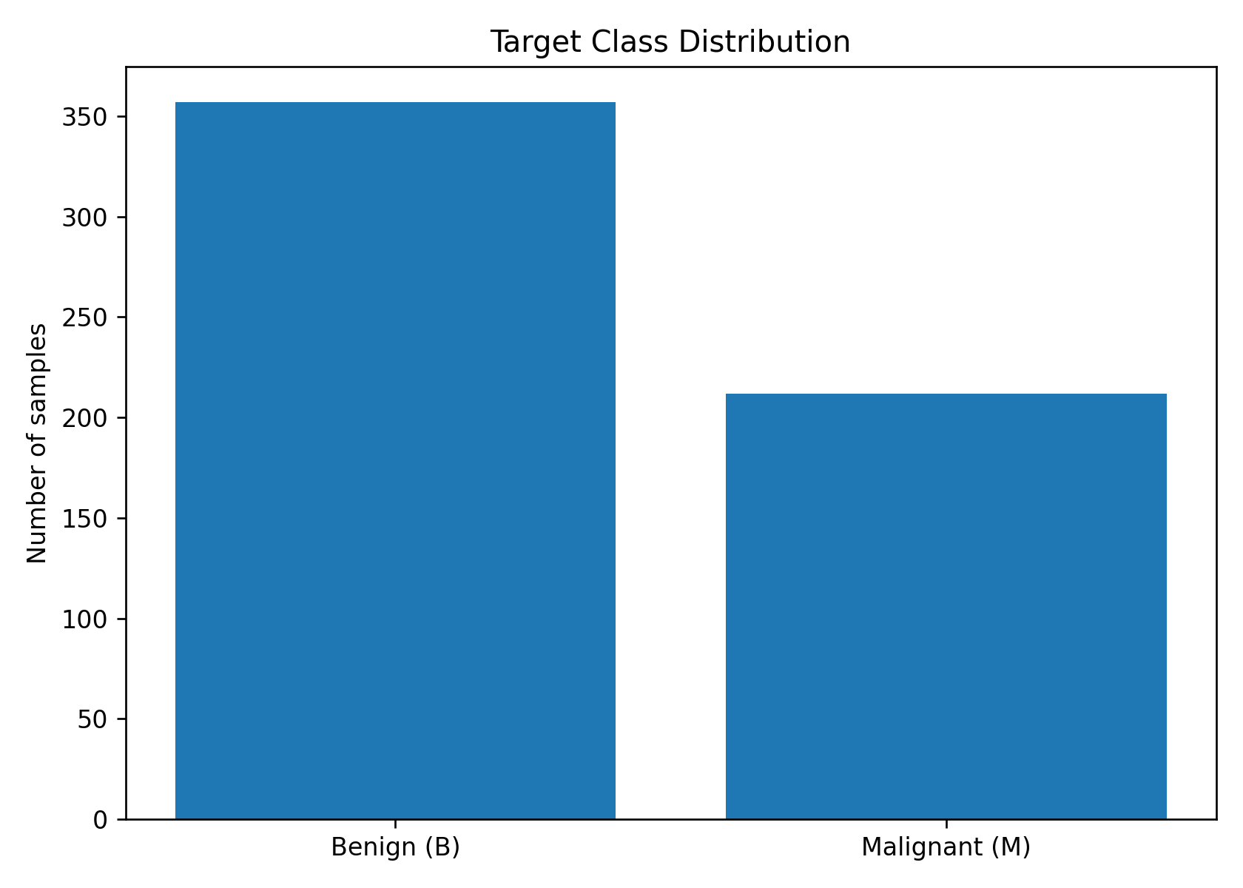
Figure 2. Feature distributions
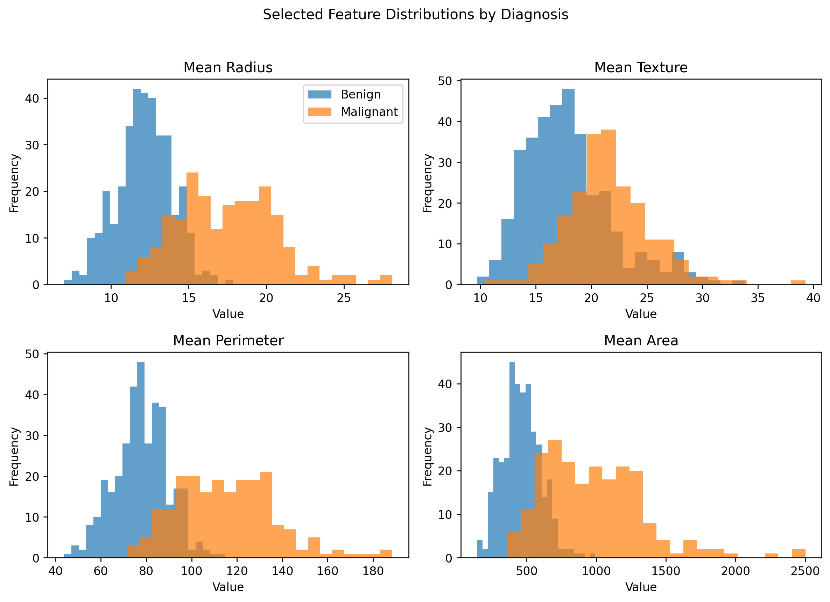
Figure 3. Correlation heatmap
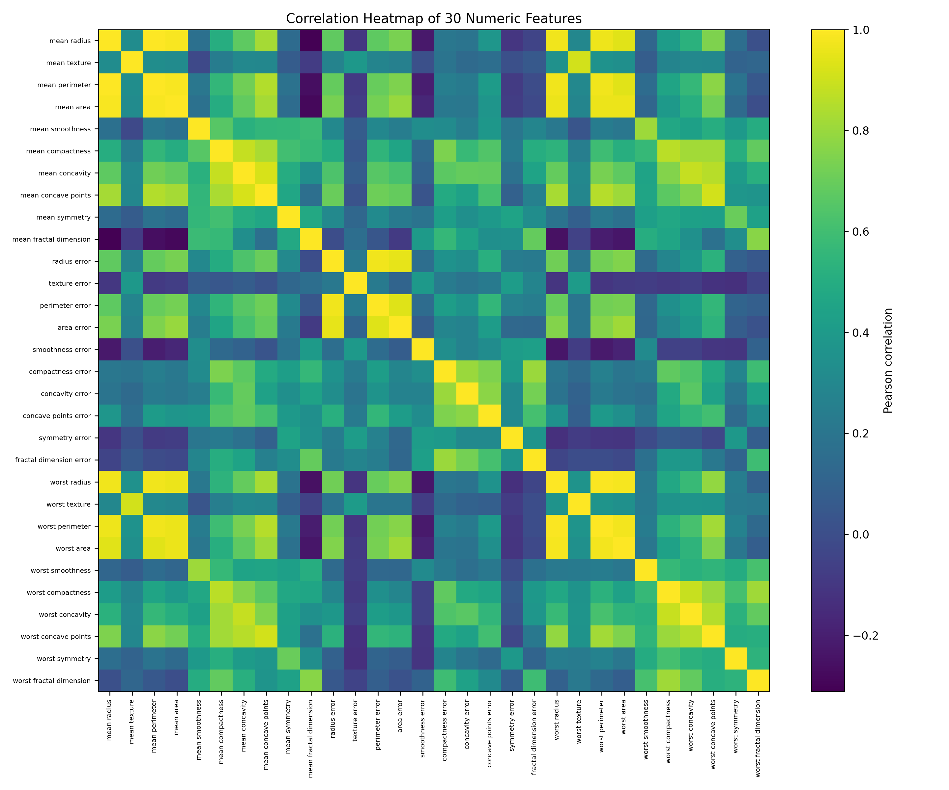

5. Preprocessing
The data is split into 80% training and 20% testing using stratification and random_state=42. Predictor columns are numeric, so predictor encoding is not required. Median imputation is included for robustness, although no missing values are present. Feature scaling is skipped because Random Forest uses tree splits and is not distance-based.

6. Model and Hyperparameters
RandomForestClassifier is configured with n_estimators=200, max_depth=10, class_weight='balanced', and random_state=42. Two hundred trees provide a stable ensemble; limiting depth helps control overfitting; balanced class weights help account for unequal class counts.

7. Results
Metric | Value | Interpretation
Accuracy | 0.965 | 96.5% of the held-out test records were classified correctly.
Precision (malignant) | 1.000 | Of cases predicted malignant, this fraction were actually malignant.
Recall (malignant) | 0.905 | Of all actual malignant cases, this fraction were identified.
F1-score (malignant) | 0.950 | Harmonic mean of malignant precision and recall.
ROC-AUC (malignant) | 0.996 | Discrimination ability across probability thresholds; 1.0 is ideal.
Figure 4. Confusion matrix
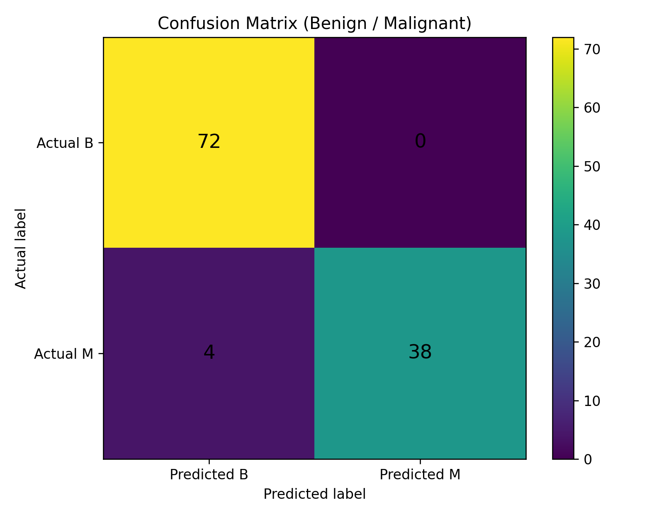
Figure 5. ROC curve
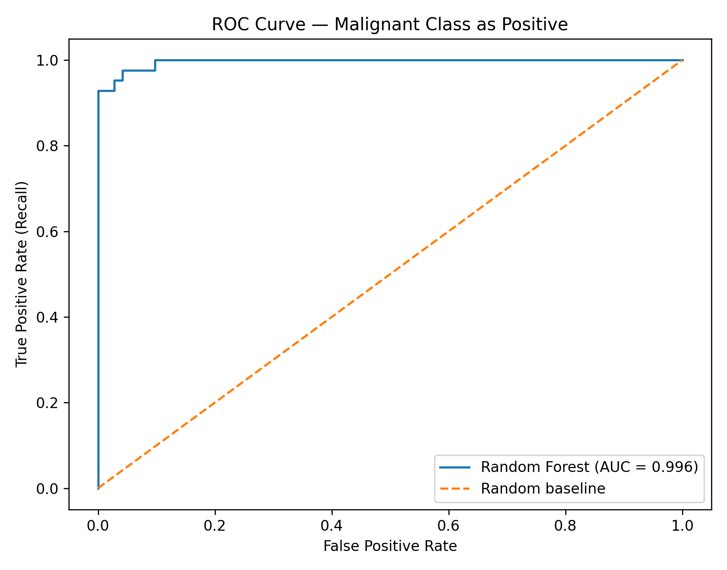
Figure 6. Feature importance
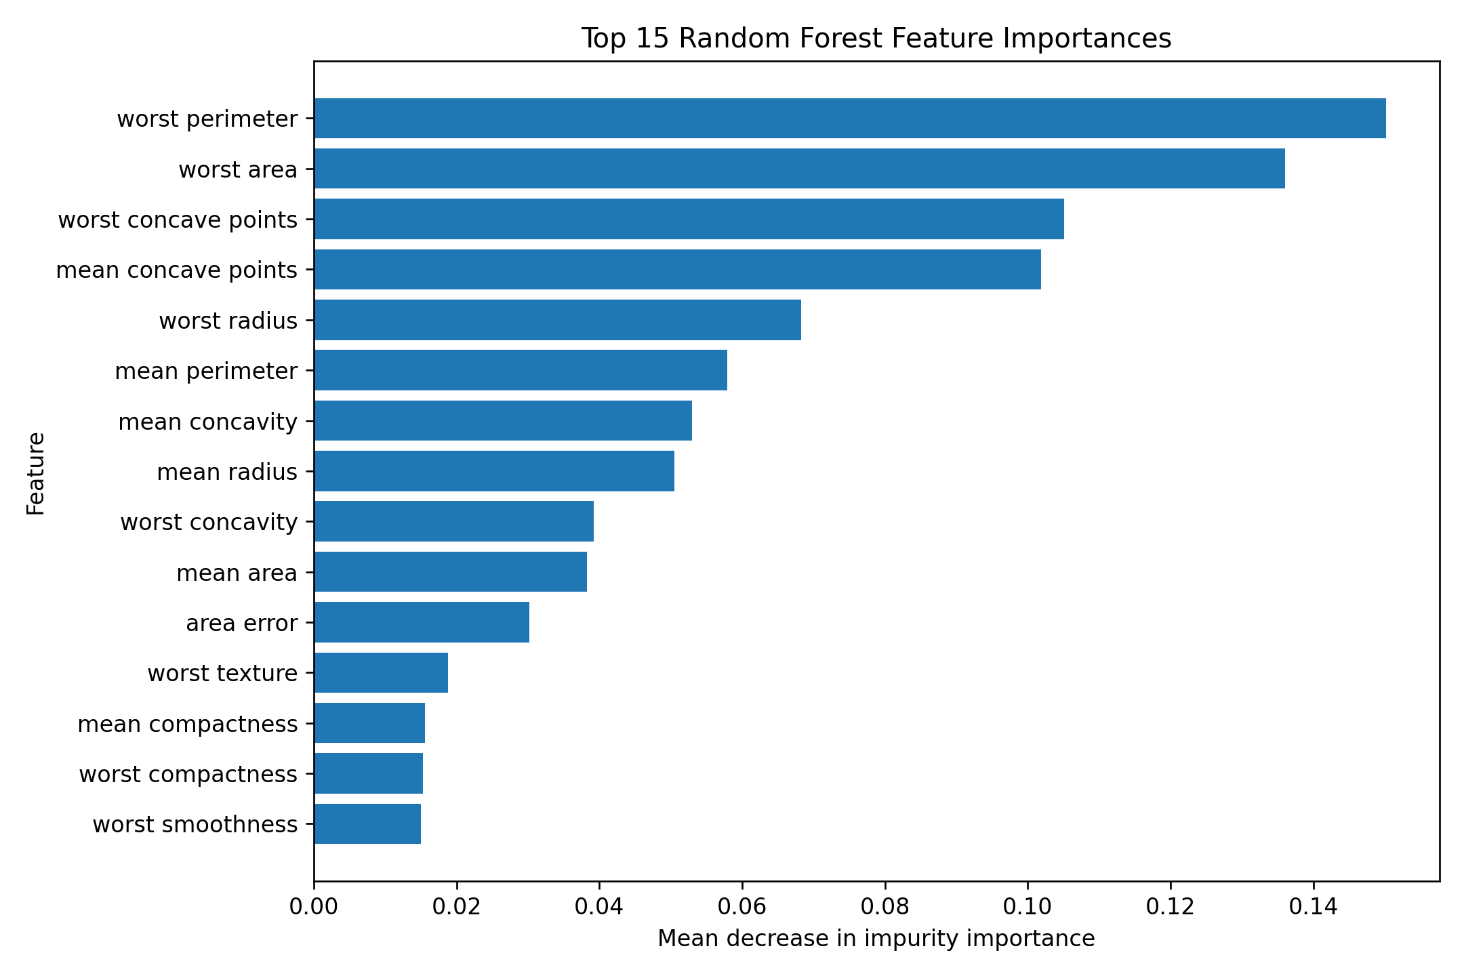

8. Confusion Matrix Interpretation
With malignant as the positive class, TN=72, FP=0, FN=4, TP=38. False negatives are actual malignant cases predicted benign, while false positives are benign cases predicted malignant.

9. Precision, Recall, F1 and ROC-AUC
Precision for malignant cases is 1.000; recall is 0.905; F1-score is 0.950; and ROC-AUC is 0.996. Precision measures how reliable positive predictions are, recall measures how many actual positive cases are found, and F1 balances both. AUC summarizes discrimination across thresholds.

10. Feature Importance
Top features by the fitted model's impurity-based importance: worst perimeter (0.150), worst area (0.136), worst concave points (0.105), mean concave points (0.102), worst radius (0.068), mean perimeter (0.058), mean concavity (0.053), mean radius (0.051). Feature importance is model-specific and does not imply causation.

11. Strengths, Limitations and Future Work
Strengths include nonlinear modeling, ensemble voting, no need for scaling, and feature-importance summaries. Limitations include a single train/test split, modest dataset size, correlated features, and no external clinical validation. Future work can use cross-validation, hyperparameter tuning, Gradient Boosting comparisons, threshold selection, calibration, and independent validation.

12. Conclusion
The model achieved 0.965 accuracy, 1.000 malignant precision, 0.905 malignant recall, 0.950 malignant F1-score, and 0.996 ROC-AUC on this held-out split. Results should not be interpreted as medical advice or clinical validation.

References
- Kaggle — Breast Cancer Wisconsin (Diagnostic): https://www.kaggle.com/datasets/uciml/breast-cancer-wisconsin-data
- UCI — Breast Cancer Wisconsin (Diagnostic): https://archive.ics.uci.edu/dataset/17/breast+cancer+wisconsin+diagnostic
- scikit-learn — load_breast_cancer: https://scikit-learn.org/stable/modules/generated/sklearn.datasets.load_breast_cancer.html

