**Milestone 1: DAX Function**

Data Analysis Expressions (DAX) is a formula language used in Power BI to perform calculations and queries on data. DAX is also known as function language, where the full code is kept inside a function. DAX programming formula contains two data types: Numeric and Other. Numeric includes - integers, currency and decimals, while Other includes: string and binary object.

I have used StudentPerformanceFactors Dataset to use DAX Functions

1. **Total Students Count**  
   Counts the total number of students in the dataset.

TotalStudents = COUNTROWS(StudentPerformanceFactors)

1. **Average Exam Score**  
   Calculates the average Exam_Score across all students.

AverageExamScore = AVERAGE(StudentPerformanceFactors[Exam_Score])

1. **Pass Rate**  
   Calculates the percentage of students who passed, assuming a passing score threshold of 50.

PassRate = DIVIDE(CALCULATE(COUNT(StudentPerformanceFactors[Exam_Score]), StudentPerformanceFactors[Exam_Score] >= 50), [TotalStudents], 0)

1. **Top 10% Score Threshold**  
   Finds the score threshold for the top 10% of students.

Top10PercentScore = PERCENTILE.EXC(StudentPerformanceFactors[Exam_Score], 0.9)

1. **Average Exam Score by Gender**  
   Calculates the average Exam_Score segmented by Gender.

AverageScoreByGender = CALCULATE(AVERAGE(StudentPerformanceFactors[Exam_Score]), ALLEXCEPT(StudentPerformanceFactors, StudentPerformanceFactors[Gender]))

1. **Score Improvement from Previous Scores**  
   Calculates the difference between Previous_Scores and Exam_Score to see the improvement.

ScoreImprovement = StudentPerformanceFactors[Exam_Score] - StudentPerformanceFactors[Previous_Scores]

1. **Total Male Students**  
   Counts the number of male students.

TotalMaleStudents = CALCULATE(COUNT(StudentPerformanceFactors[Gender]), StudentPerformanceFactors[Gender] = "Male")

Here are columns created by using DAX Function:

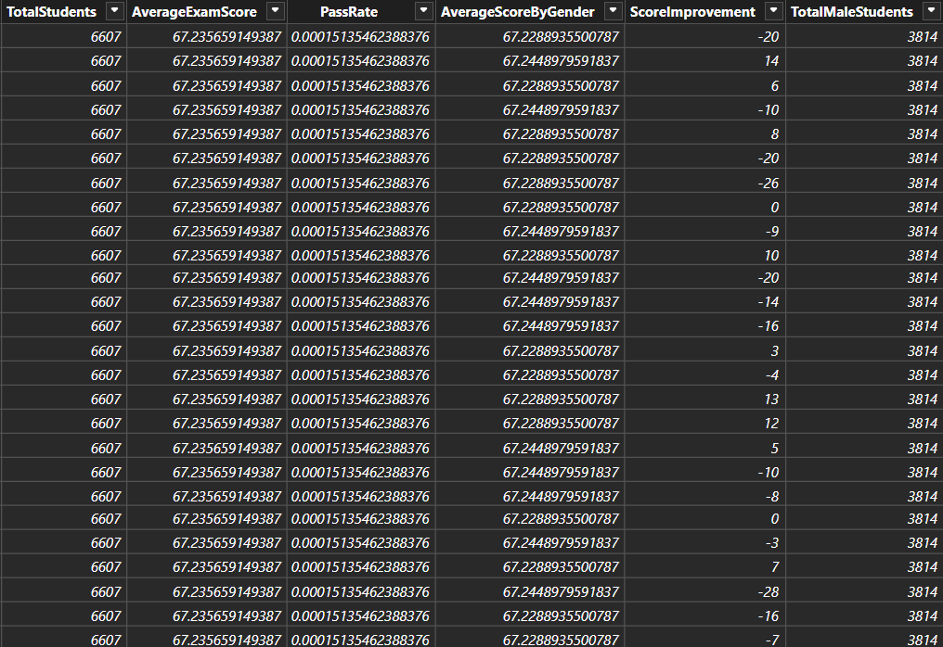

Here is report created by using DAX Function:

