Embedded Interface Design

Project 1: Temperature and Humidity sensor and Qt5

**Description**:

The Temperature and Humidity sensor DHT 22 is being connected to the raspberry pi and the temperature and humidity values are displayed on the qt5 GUI. A 10k ohms resistor was obtained and connected between the terminal 1 (VCC) and the terminal 2 (Data). The Pin 1 of the DHT22 sensor is being connected to the 5V pin of raspberry pi. The Data pin is connected to the GPIO4 of raspberry pi and the GND pin of the sensor is being connected to the GND pin of the raspberry pi board. The qt5 was being installed to create a “**user login**” interface window and a “**sensor data display** window”.

The code files are:

1) data.py the code for the project

2) login.ui and login.py for login window

3) version1_qt.ui and version1_qt.py for display windows

4) The username is “sanika” or “SANIKA” or “Sanika”

**Features:**

1. **Required:**
2. Displaying the current temperature and humidity values from DHT22 on the Qt GUI using an LCD display widget on qt5
3. Displaying the current date and time for each reading of the sensor in qt5 in the format of MM/DD/YYYY and the time in Hours, minutes and seconds format.
4. To handle not receiving data when the sensor is not connected: The status of the sensor is being displayed as ‘connected’ or ‘not connected’.
5. **Extra Credit:**
6. A login screen has been created where-in when **the username** “**sanika” or “SANIKA” or “Sanika”** is being typed in and when enter is being pressed it allows to login the application and opens the window for displaying sensor data. For all other non-matching type usernames, a red color indication is being used and it doesn’t allow the access to the main application.
7. The temperature and the humidity values are being stored in a .csv format file which are then later used for plotting a graph.
8. The average temperature and the humidity values are being displayed on an lcd interface in qt5. These values signify the running average values.
9. The alarm has been set by changing the colors on a graphical viewing display widget. The constant values for temperature and humidity are the standard for comparison with the obtained values and if the obtained values are above the constant set values then a red color indication is used or otherwise the graphical viewer widget displays a green color. There are two alarms one for the temperature reading indication and the other for the humidity value indication
10. The saved .csv file values are then read into lists and the average of these values is performed over the lists (running average), these lists are appended with the new value each time and a new average is calculated for each new value being added which is then displayed. The matplotlib library is used to plot the humidity and the temperature graphs. Two push buttons are used for displaying the temperature and humidity graphs respectively.
11. The refresh button (push button) option is being created to refresh and get the new values each time.

**The screenshots from my project are as follows**:

1. User login screen:

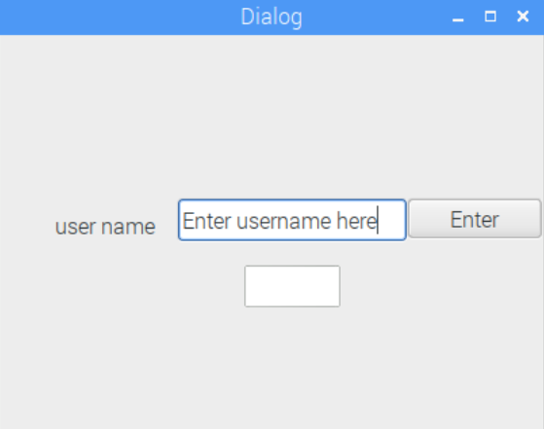

1. **Screenshot for unsuccessful login**: **The username is sanika**. When something else is typed in the graphics viewer’s background is changed to red color and the displaying values window can’t be accessed.

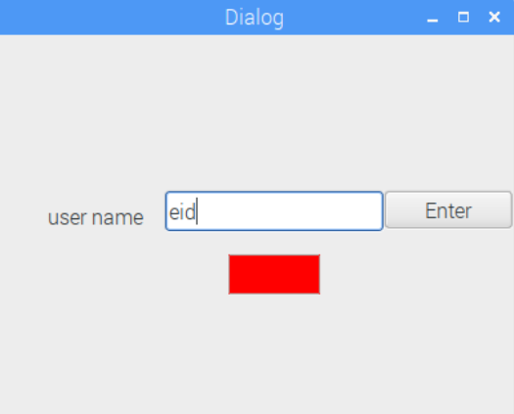

1. The display screen:

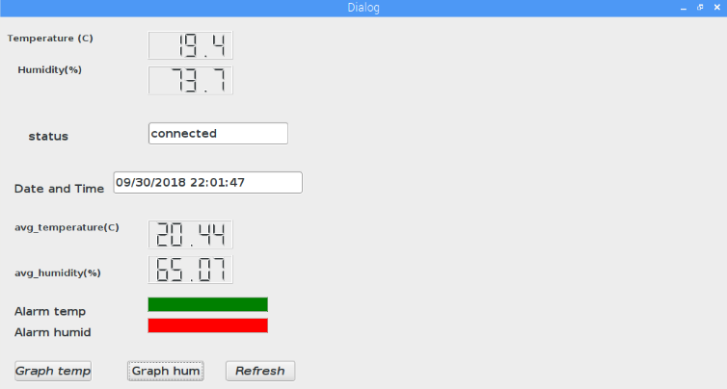

1. Temperature display:

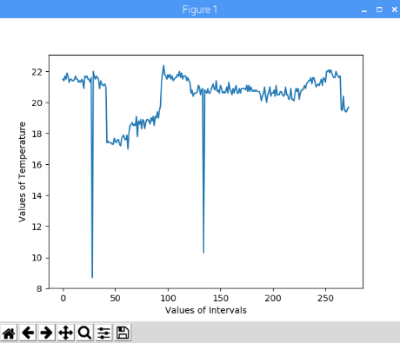

1. Humidity display:

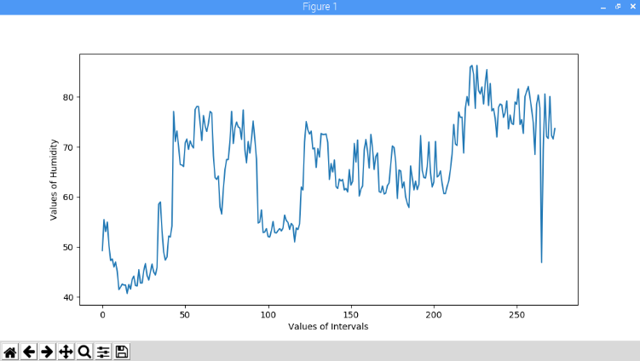

5) The .csv file: The first column displays the temperature values in ( C ) and the second column displays the humidity values in (%)

