**Proposed Methodology**

The system uses a smart, automated approach for soil health monitoring and irrigation management, integrating sensors, microcontrollers (ESP32 and Arduino Nano), and cloud connectivity. It operates autonomously to collect, process, and transmit real-time soil and environmental data.

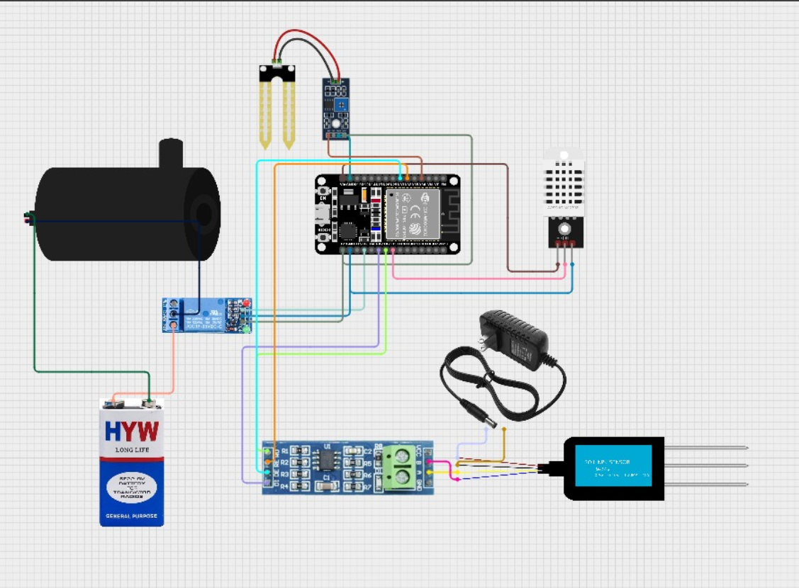

**Key Components & Workflow:**

1. **Power Supply Setup:** Ensures continuous operation of ESP32, Arduino Nano, sensors, relay, and water pump.
2. **Sensor Deployment:**
   * **Soil Moisture Sensor:** Monitors real-time moisture levels.
   * **DHT22:** Measures temperature and humidity.
   * **NPK Sensor:** Analyzes soil nutrients (Nitrogen, Phosphorus, Potassium).
   * **Weather API:** Provides climate forecasts for efficient irrigation planning.
3. **Data Processing:**
   * The ESP32 collects and analyzes sensor data.
   * When moisture drops below threshold, it activates the relay to power the irrigation motor.
   * The system turns off irrigation once optimal moisture is reached.
4. **Cloud Integration:**
   * ESP32 uploads data via Wi-Fi to the cloud for storage and remote monitoring.
   * Farmers can access reports via a mobile/web app for data-driven decisions.
5. **Smart Decision-Making:**
   * Weather forecasts delay irrigation if rain is expected.
   * The system reduces water waste and improves fertilizer use efficiency.

This automated system minimizes manual work, conserves resources, and supports precision agriculture, leading to improved yields and sustainable farming.