Munizer

Sanika Jhanwar

Idea Brief:

Emotional AI Mirror designed to enrich your daily routines by intuitively adapting to your emotions. Through state-of-the-art facial recognition and emotion detection technology, Munizer engages with users in real-time, offering customized experiences based on their mood. Upon detecting a user's presence, it analyzes their facial expressions to gauge their emotional state. Users are then presented with a simple choice of whether they'd like to further engage, indicated by a "Yes" or "No" response. If the user opts for "Yes," Munizer responds by playing music tailored to their current mood. Conversely, if the user selects "No," Munizer gracefully enters standby mode until the next interaction.

In today's fast-paced lifestyle, prioritizing emotional well-being is essential for overall health and happiness. Munizer caters to this need by providing users with a straightforward yet effective method to connect with their emotions. Through the integration of music, a potent tool for regulating mood, Munizer enables users to elevate their spirits and bolster their emotional resilience. Furthermore, Feel Reflector cultivates a sense of connection and empathy by promptly responding to users' emotions, facilitating a personalized and understanding interaction. Whether users are seeking relaxation or a mood boost, Munizer enriches their daily experiences with emotional intelligence and harmonious melodies.

List of Components:

Software:

Image Processing Software: Software algorithms to analyze the facial expressions and extract emotional cues from the captured video frames. This include techniques from computer vision and machine learning.

Emotion Detection Model: A trained machine learning model that interprets facial expressions and recognizes emotions like happiness, sadness, anger, etc., from the processed image data.

Sound Database: A collection of sound files corresponding to different emotions. For example, cheerful music for happiness, calming sounds for relaxation, etc.

Programming Environment: Software development tools and libraries (like Python, OpenCV, TensorFlow, SpotiPy etc.) to implement the image processing, emotion detection, and sound playback functionalities.

Hardware:

Power Supply: A power source (battery or AC adapter) to provide electricity for the module's operation.

Camera: An image sensor to capture video frames of the user's face. It can be a webcam or a dedicated camera module.

Microcontroller/Processor: A microcontroller or processor unit (like Raspberry Pi, Arduino, or a custom board) to handle the image processing and decision-making based on the detected emotions.

Speaker: An audio output device such as a speaker or headphones to play sound based on the detected emotion. The sounds can be pre-recorded or generated dynamically.

User Interface (Optional): A user interface component such as an LCD screen or LED indicators to provide feedback or display information about the detected emotions and the corresponding music being played.

Enclosure/Design: A housing or enclosure to integrate all the components into a compact and aesthetically pleasing module that can be attached to a mirror or placed in a suitable location.

Mic: It takes audio Input and sends it to the microprocessor for the analyzation.

Working:

After turning on the power supply the camera will check for the face as the face is detected it sends the image to the software in raspberry pi . Which detects the emotion and displays it to the user on the display and then the mic is activated and take the input from the user whether to play the song or not as it detects a yes . The speaker connected to the processor (Raspberry Pi) starts to play the song according to the mood .

Connection:

The camera is connected to the raspberry pi via usb cable , speaker and mic via aux port . and the display via gpio pins as shown in picture .

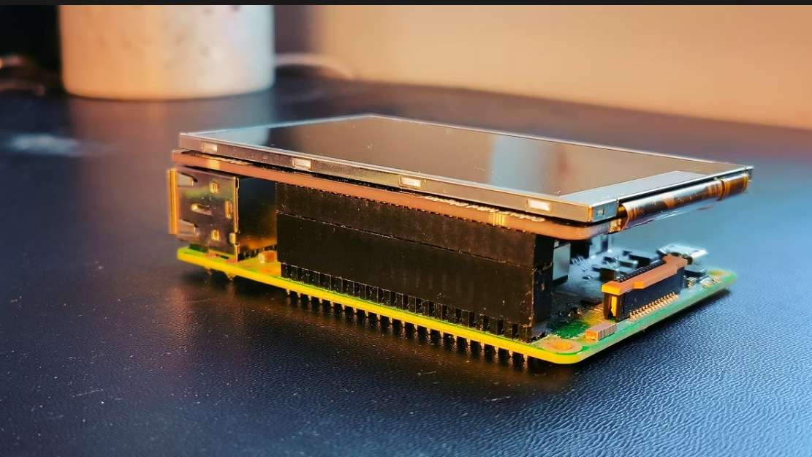

Diagram:



