GATEWICK COSTUME & PROP RENTAL HOUSE
Computer Network Design & Implementation Report
Cisco Packet Tracer Case Study

Field | Details
Author | Sanika Kangane
Program | B.Tech CSE ’29
Prepared for college submission

1. Introduction
Gatewick Costume & Prop Rental House currently has no computer network. This case study proposes a structured IPv4 network for the Warehouse, Fitting Studio, Administration and IT departments, together with a point-to-point WAN connection to the offsite Prop Workshop. The design uses VLSM with 20% spare capacity, VLAN segmentation, IEEE 802.1Q trunking and Router-on-a-Stick inter-VLAN routing.

2. Objectives
- Design an Extended Star topology.
- Apply VLSM to 10.200.0.0/22 with 20% spare capacity.
- Separate departments using VLANs 10, 20, 30 and 40.
- Use access ports for end devices and trunk ports for uplinks.
- Use IEEE 802.1Q and Router-on-a-Stick for inter-VLAN routing.
- Provide a /30 point-to-point WAN link to the Prop Workshop.
- Verify VLANs, trunks, router interfaces and connectivity.

3. Proposed Topology
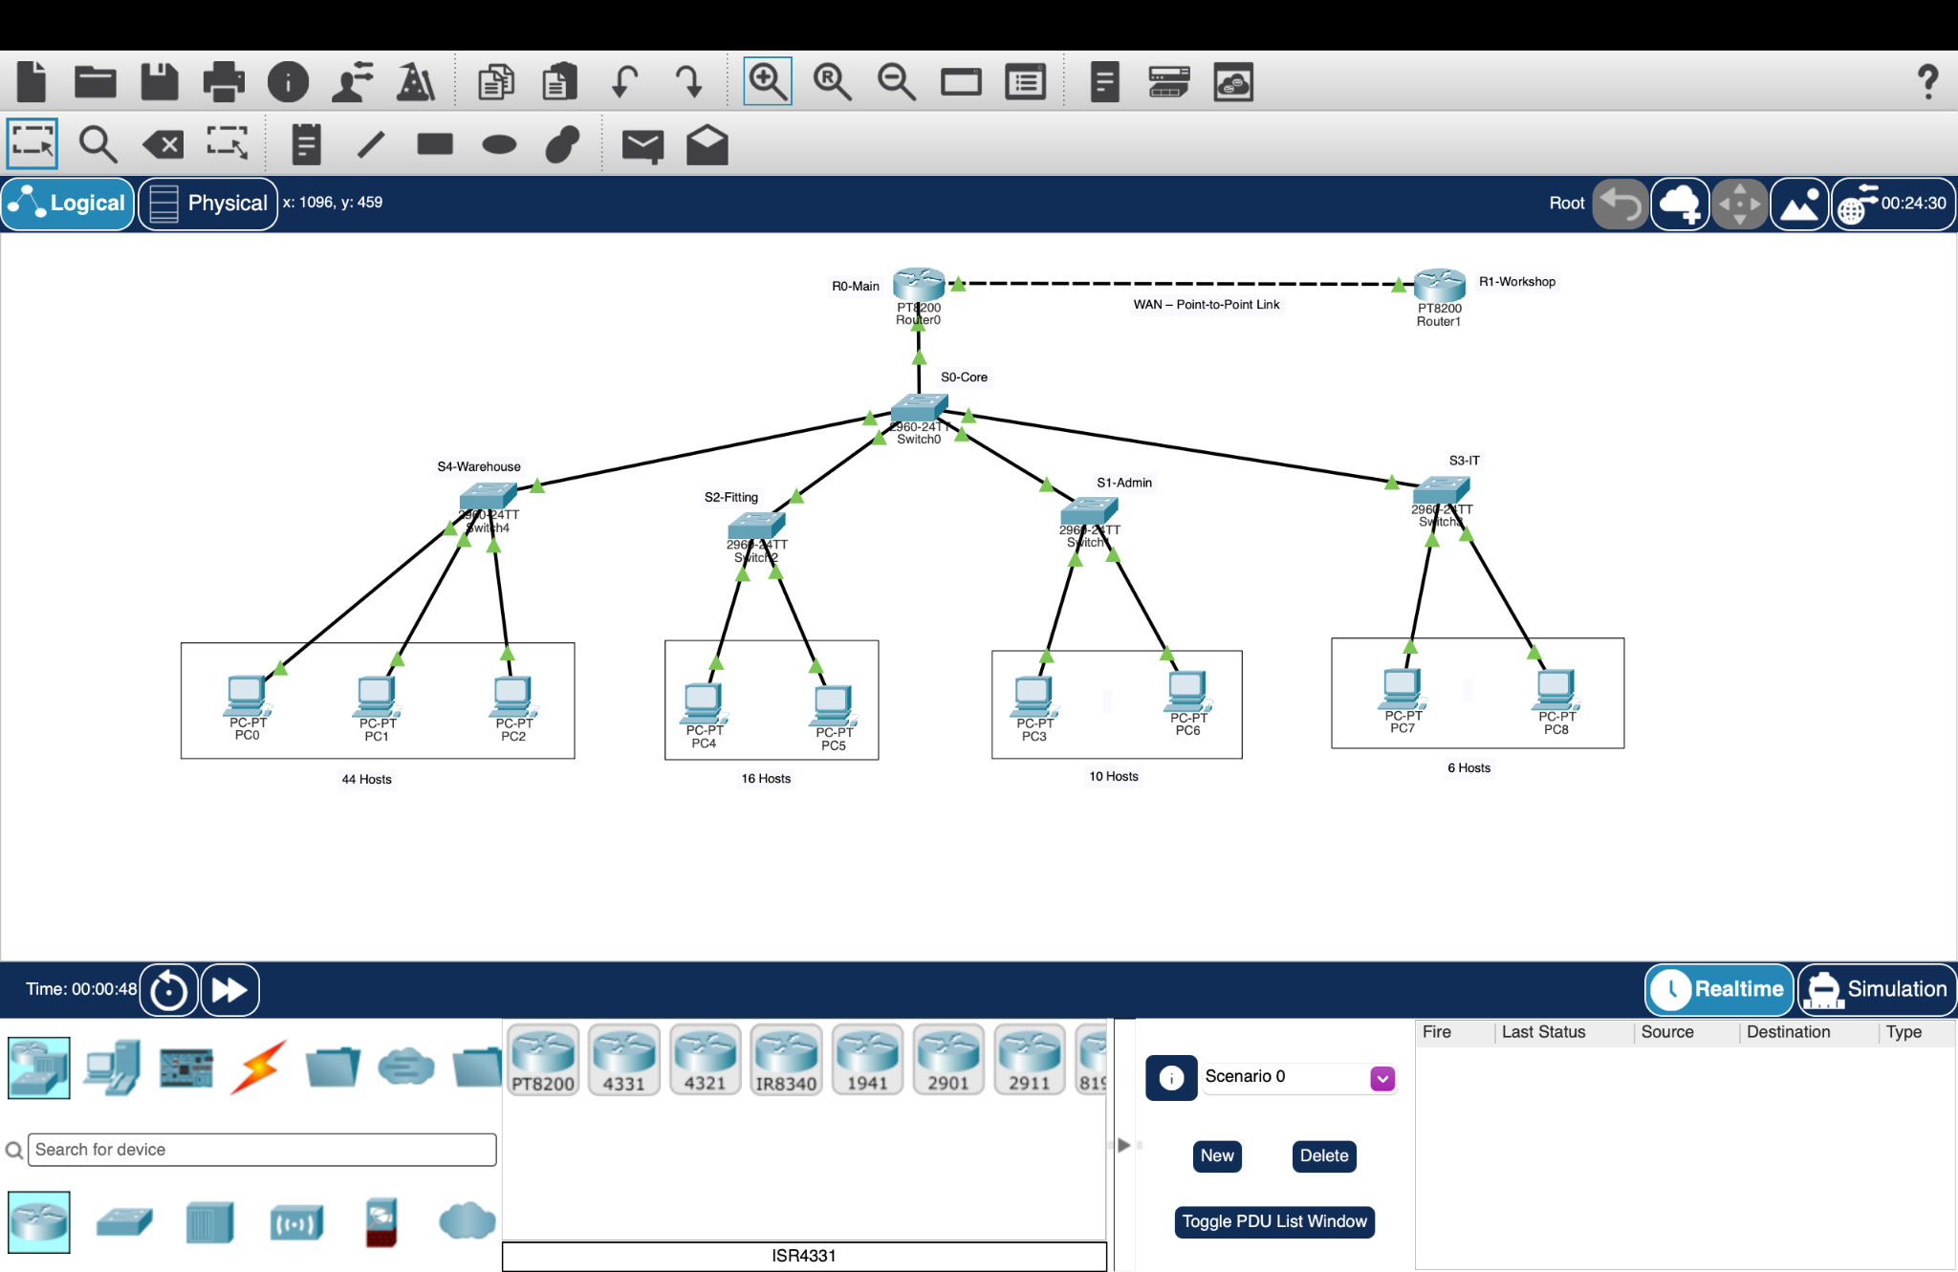
Figure 1. Cisco Packet Tracer topology for the Gatewick network
Source: user-provided Cisco Packet Tracer screenshot. The figure is included as the actual topology reference for this report.
The recommended topology is an Extended Star. S0-Core is the central switch, department switches connect to it, R0-Main provides Router-on-a-Stick routing, and R0-Main connects to R1-Workshop through the point-to-point WAN.
Technology | Purpose
VLANs | Logical separation of departments
Access ports | Connect end devices to their VLAN
Trunk ports | Carry multiple VLANs
IEEE 802.1Q | VLAN tagging on trunks
Router-on-a-Stick | Inter-VLAN routing using subinterfaces
VLSM | Efficient subnet allocation
Point-to-Point WAN | Remote workshop connectivity
IPv4 / ICMP / ARP | Addressing and connectivity testing

4. Physical Connections
From | Interface | To | Interface | Purpose
R0-Main | G0/0/0 | S0-Core | Gi0/1 | Router-to-core trunk
R0-Main | G0/0/1 | R1-Workshop | G0/0/0 | WAN / leased line
S0-Core | Fa0/1 | S2-Fitting | Gi0/1 | Department uplink
S0-Core | Fa0/2 | S4-Warehouse | Gi0/1 | Department uplink
S0-Core | Gi0/2 | S1-Admin | Gi0/1 | Department uplink
S0-Core | Fa0/3 | S3-IT | Gi0/1 | Department uplink

PC Connections
Switch | Connections
S4-Warehouse | Fa0/1 → PC0; Fa0/2 → PC1; Fa0/3 → PC2
S2-Fitting | Fa0/1 → PC4; Fa0/2 → PC5
S1-Admin | Fa0/1 → PC3; Fa0/2 → PC6
S3-IT | Fa0/1 → PC7; Fa0/2 → PC8

5. VLSM and IP Addressing
Starting block: 10.200.0.0/22. The following VLSM plan follows the supplied host requirements and 20% spare-capacity calculations.
Network | Hosts | 20% Capacity | Subnet | Mask | Usable Range | Broadcast | Gateway
Warehouse | 44 | 53 | 10.200.0.0/26 | 255.255.255.192 | 10.200.0.1–10.200.0.62 | 10.200.0.63 | 10.200.0.1
Fitting Studio | 16 | 20 | 10.200.0.64/27 | 255.255.255.224 | 10.200.0.65–10.200.0.94 | 10.200.0.95 | 10.200.0.65
Administration | 10 | 12 | 10.200.0.96/28 | 255.255.255.240 | 10.200.0.97–10.200.0.110 | 10.200.0.111 | 10.200.0.97
IT | 6 | 8 | 10.200.0.112/28 | 255.255.255.240 | 10.200.0.113–10.200.0.126 | 10.200.0.127 | 10.200.0.113
WAN | 2 | 2 | 10.200.0.128/30 | 255.255.255.252 | 10.200.0.129–10.200.0.130 | 10.200.0.131 | —
Remaining spare address space: 10.200.0.132 – 10.200.3.255.

6. VLAN Design
VLAN ID | Department | Network | Gateway
10 | Warehouse | 10.200.0.0/26 | 10.200.0.1
20 | Fitting | 10.200.0.64/27 | 10.200.0.65
30 | Administration | 10.200.0.96/28 | 10.200.0.97
40 | IT | 10.200.0.112/28 | 10.200.0.113
Access ports: S4-Warehouse Fa0/1–Fa0/3 → VLAN 10; S2-Fitting Fa0/1–Fa0/2 → VLAN 20; S1-Admin Fa0/1–Fa0/2 → VLAN 30; S3-IT Fa0/1–Fa0/2 → VLAN 40. Department uplinks are trunks. S0-Core Gi0/1 connects to R0-Main as a trunk.

7. PC IP Addressing
PC | Department | IP Address | Subnet Mask | Gateway
PC0 | Warehouse | 10.200.0.2 | 255.255.255.192 | 10.200.0.1
PC1 | Warehouse | 10.200.0.3 | 255.255.255.192 | 10.200.0.1
PC2 | Warehouse | 10.200.0.4 | 255.255.255.192 | 10.200.0.1
PC4 | Fitting | 10.200.0.66 | 255.255.255.224 | 10.200.0.65
PC5 | Fitting | 10.200.0.67 | 255.255.255.224 | 10.200.0.65
PC3 | Administration | 10.200.0.98 | 255.255.255.240 | 10.200.0.97
PC6 | Administration | 10.200.0.99 | 255.255.255.240 | 10.200.0.97
PC7 | IT | 10.200.0.114 | 255.255.255.240 | 10.200.0.113
PC8 | IT | 10.200.0.115 | 255.255.255.240 | 10.200.0.113
DNS: 0.0.0.0 / blank because no DNS server is configured.

8. Core Networking Concepts
Concept | Simple Explanation
VLAN | A logical network segment that separates devices into different broadcast domains.
Access Port | A switch port assigned to one VLAN, normally used for an end device.
Trunk Port | A link carrying traffic for multiple VLANs.
IEEE 802.1Q | The standard used for VLAN tagging on trunk links.
Subinterface | A logical interface created under a physical router interface for a VLAN.
Router-on-a-Stick | Inter-VLAN routing using one physical router interface with multiple subinterfaces.
Inter-VLAN Routing | Routing traffic between different VLANs or IP subnets.
Default Gateway | The router address used to reach other networks.
VLSM | Variable Length Subnet Masking, which assigns subnet sizes according to host needs.
Subnet Mask | Identifies the network and host portions of an IPv4 address.
WAN | A network connection covering a larger geographic area.
Point-to-Point Connection | A direct link between two devices; /30 provides two usable IPv4 addresses here.
MAC Address | A Layer 2 address used for Ethernet frame delivery.
IP Address vs MAC Address | IP identifies an interface at Layer 3; MAC identifies an Ethernet interface at Layer 2.
ARP | Finds the MAC address associated with a local IPv4 address.
ICMP / Ping | ICMP provides control/diagnostic messages; ping uses ICMP Echo to test reachability.
DHCP | Can automatically provide IP configuration such as address, mask, gateway and DNS.
DNS | Translates names into IP addresses.

9. Router-on-a-Stick Configuration
enable
configure terminal
interface gigabitEthernet 0/0/0
no ip address
no shutdown
exit
interface gigabitEthernet 0/0/0.10
encapsulation dot1Q 10
ip address 10.200.0.1 255.255.255.192
exit
interface gigabitEthernet 0/0/0.20
encapsulation dot1Q 20
ip address 10.200.0.65 255.255.255.224
exit
interface gigabitEthernet 0/0/0.30
encapsulation dot1Q 30
ip address 10.200.0.97 255.255.255.240
exit
interface gigabitEthernet 0/0/0.40
encapsulation dot1Q 40
ip address 10.200.0.113 255.255.255.240
exit
end
WAN addressing: R0-Main G0/0/1 = 10.200.0.129/30; R1-Workshop G0/0/0 = 10.200.0.130/30. R0 ↔ R1 ping was successfully verified with 100% success.

10. VLAN Verification
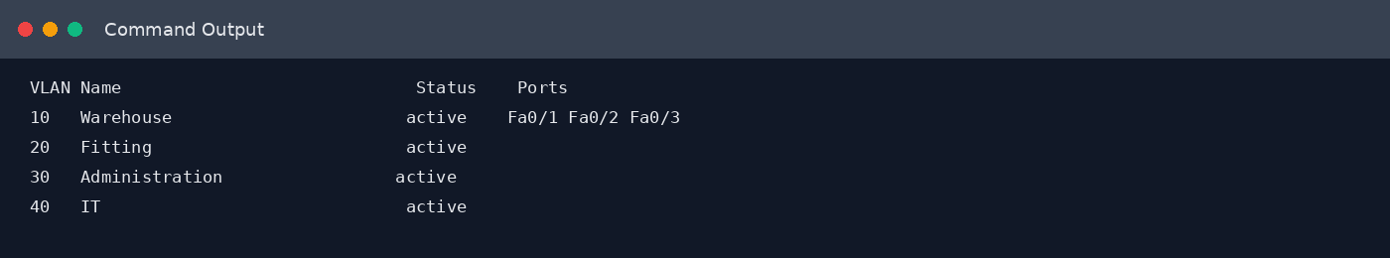
Figure 1. Reconstructed Verification Output — S0-Core show vlan brief. Not an actual Packet Tracer screenshot.

11. Trunk Verification
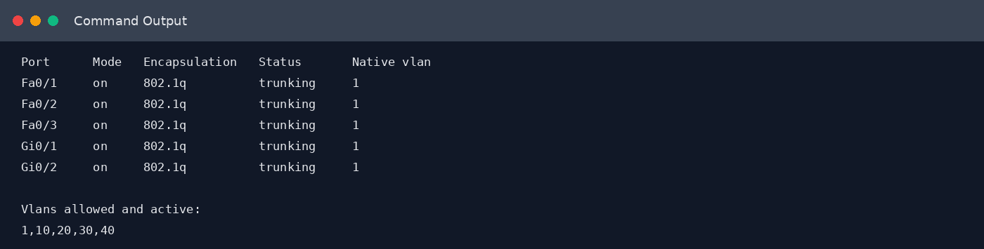
Figure 2. Reconstructed Verification Output — S0-Core show interfaces trunk. Not an actual Packet Tracer screenshot.

12. Router Interface Verification
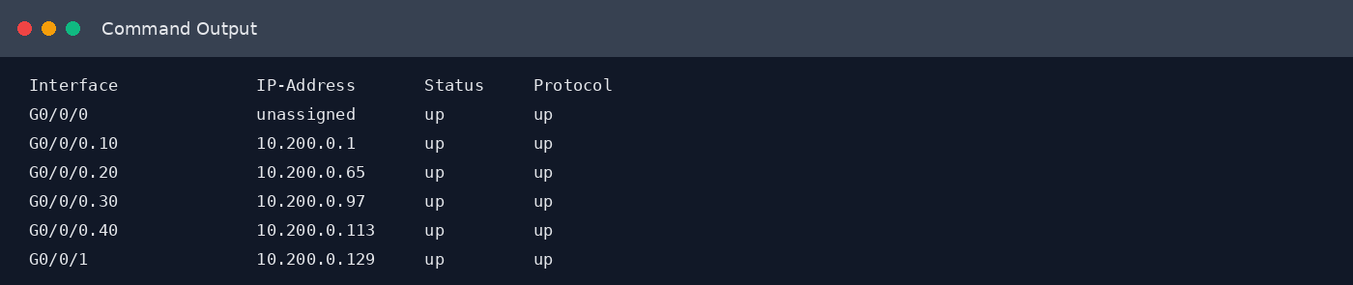
Figure 3. Reconstructed Verification Output — R0-Main show ip interface brief. Not an actual Packet Tracer screenshot.
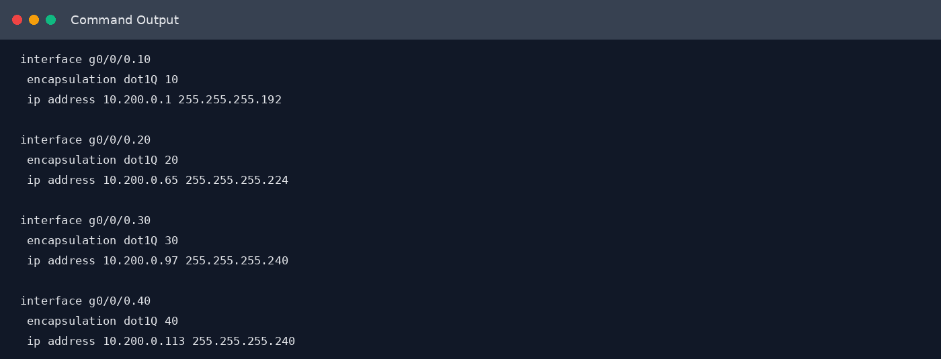
Figure 4. Reconstructed Verification Output — Router-on-a-Stick configuration. Not an actual Packet Tracer screenshot.

13. Connectivity Testing
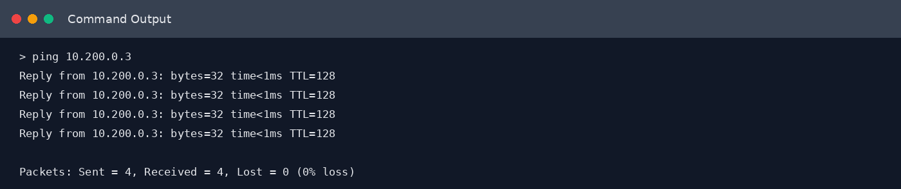
Figure 5. Reconstructed Verification Output — PC0 → PC1. Not an actual Packet Tracer screenshot.
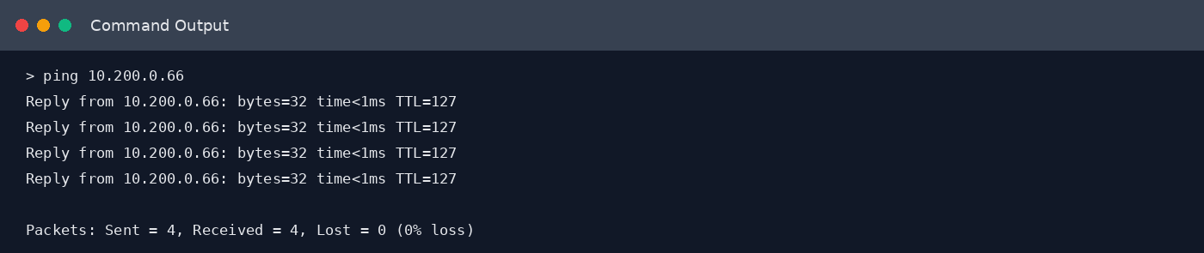
Figure 6. Reconstructed Verification Output — PC0 → Fitting Studio. Not an actual Packet Tracer screenshot.
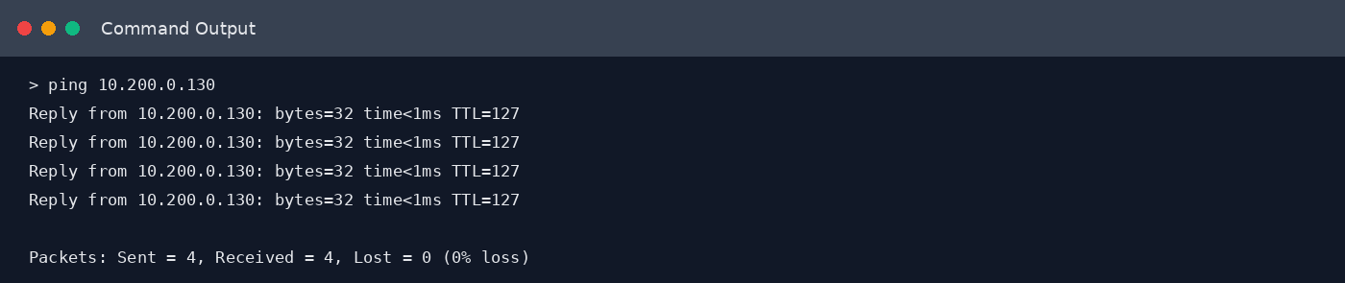
Figure 7. Reconstructed Verification Output — PC0 → R1-Workshop. Not an actual Packet Tracer screenshot.

14. DHCP → ARP → DNS → ICMP
DHCP can provide a host with an IP address, subnet mask, default gateway and DNS server. ARP is then used when the host needs the MAC address associated with a local IPv4 address. DNS translates a domain or host name into an IP address. ICMP is used by tools such as ping to test whether a destination is reachable. For this actual Gatewick project, IP addresses were manually configured, DHCP was not configured, DNS was not configured, and ping/ICMP was used for connectivity testing. Therefore, DHCP and DNS are included as concepts, not as implemented services.

15. OSI / TCP-IP Activity Mapping
Activity | Layer | Reason
Barcode scanner updates inventory dashboard | Application layer | Application-level network service.
Switch forwards a frame using MAC address | Data Link layer | Ethernet frames and MAC addresses.
Faulty cable causes signal loss | Physical layer | Cables and signals operate at the physical layer.
Router chooses the best path | Network layer | Routing uses IP addresses.
Firewall tracks an open inventory-system session | Transport layer | TCP sessions and ports are transport-layer functions.

16. Important Cisco Commands
Command | Simple Explanation
enable | Enters privileged EXEC mode.
configure terminal | Enters global configuration mode.
exit | Moves back one configuration level.
end | Returns to privileged EXEC mode.
interface gigabitEthernet 0/0/0 | Selects the physical router interface.
no shutdown | Activates the interface.
no ip address | Removes an IP address from the interface.
interface g0/0/0.10 | Selects the VLAN 10 subinterface.
encapsulation dot1Q 10 | Associates the subinterface with VLAN 10 using 802.1Q.
ip address | Assigns an IPv4 address and subnet mask.
vlan 10 | Creates or selects VLAN 10.
name Warehouse | Names the VLAN Warehouse.
switchport mode access | Makes a switch port an access port.
switchport access vlan 10 | Places an access port into VLAN 10.
switchport mode trunk | Configures a switch port as a trunk.
show vlan brief | Displays VLANs, status and assigned access ports.
show interfaces trunk | Displays trunk status and VLAN information.
show ip interface brief | Summarizes interface IP addresses and status.
show mac address-table | Displays learned MAC addresses and ports.
ping | Tests reachability using ICMP Echo messages.

17. Troubleshooting
During testing, one failed ping was caused by entering 100.200.0.3 instead of 10.200.0.3. The corrected command, ping 10.200.0.3, returned 4/4 replies with 0% packet loss. The issue was therefore an incorrect destination IP address rather than a network configuration failure.

18. Verification Summary
Test | Expected Result | Result
S0-Core VLANs | VLANs 10,20,30,40 active | Successful
Core/access uplinks | 802.1Q trunking | Successful
R0 subinterfaces | Correct gateway IPs and up/up | Successful
PC0 → PC1 | Same-VLAN communication | 4/4 replies, 0% loss
PC0 → PC4 | Inter-VLAN communication | 4/4 replies, 0% loss
PC0 → R1 | Remote WAN communication | 4/4 replies, 0% loss

19. Conclusion
The Gatewick network design provides a practical structure for a company starting without an existing computer network. VLSM efficiently divides the 10.200.0.0/22 block while preserving spare capacity. VLANs separate departments logically, 802.1Q trunks carry multiple VLANs, Router-on-a-Stick enables inter-VLAN routing, and the /30 WAN subnet supports the two-router point-to-point connection. The supplied verification results show successful VLAN, trunk, interface, same-VLAN, inter-VLAN and WAN connectivity tests.

20. Viva Quick Reference
Question | Short Answer
Why VLSM? | To efficiently use IP addresses by assigning different subnet sizes.
Why VLANs? | To logically separate departments.
Why trunk ports? | To carry multiple VLANs over one link.
Why Router-on-a-Stick? | To route between multiple VLANs using one physical router interface and multiple subinterfaces.
Why /30 for WAN? | It provides exactly two usable IPv4 addresses, suitable for a point-to-point link.
What is the default gateway? | The router address used to reach other networks.
What proves the network works? | Successful ping tests with 0% packet loss, including inter-VLAN and WAN tests.

Device Reference
Type | Names
Routers | R0-Main; R1-Workshop
Switches | S0-Core; S4-Warehouse; S2-Fitting; S1-Admin; S3-IT
Warehouse PCs | PC0; PC1; PC2
Fitting PCs | PC4; PC5
Administration PCs | PC3; PC6
IT PCs | PC7; PC8

21. Cisco Command Prompt Verification
The following pages present Cisco Packet Tracer-style command prompt views used to verify the VLANs, trunk links, router subinterfaces, IP addressing, and connectivity of the Gatewick network. They are formatted as command-prompt verification pages for clear documentation.

21.1 S0-Core - Cisco IOS CLI
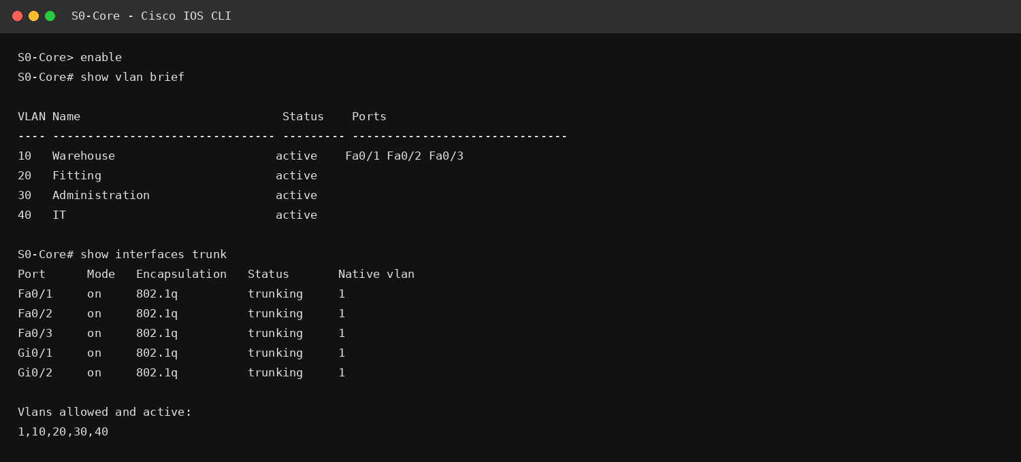
Cisco Packet Tracer-style reconstructed command prompt for report documentation

21.2 R0-Main - Cisco IOS CLI
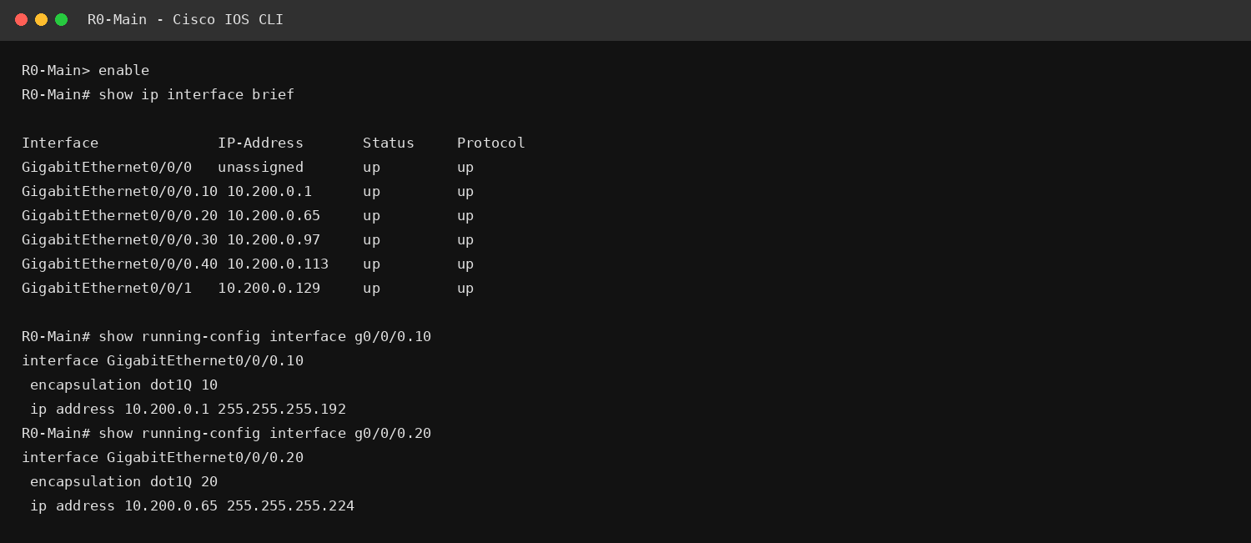
Cisco Packet Tracer-style reconstructed command prompt for report documentation

21.3 PC0 - Packet Tracer Command Prompt
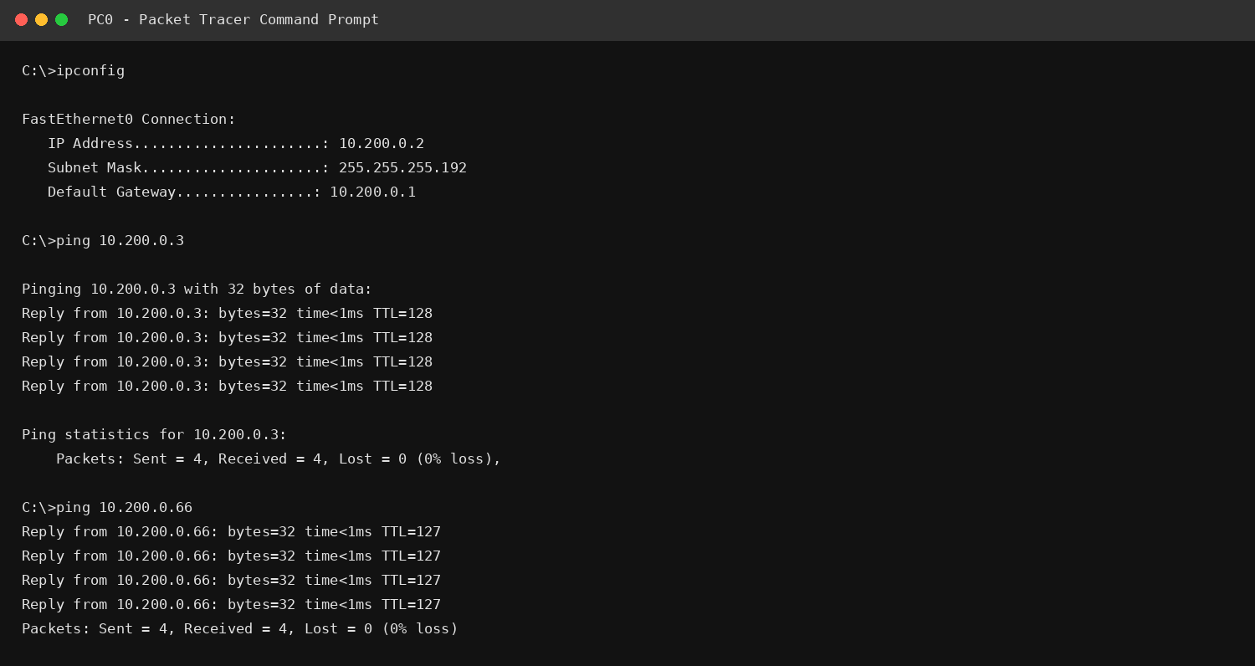
Cisco Packet Tracer-style reconstructed command prompt for report documentation

21.4 R0-Main - WAN Verification
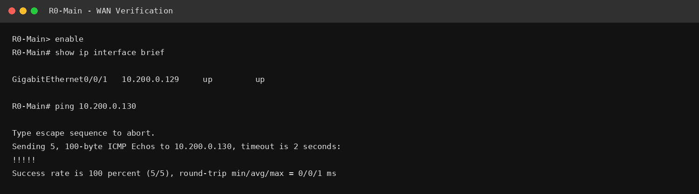
Cisco Packet Tracer-style reconstructed command prompt for report documentation

