DATA CLEANING & VISUALIZATION PROJECT REPORT
DATA CLEANING & VISUALIZATION PROJECT REPORT

Project Title
Titanic Dataset Analysis using Python

Submitted By
Name: Sanika Kurulekar
Course: Computer Engineering(Data Science)
College: JSPM University
Date: 16/05/2026

1. Introduction
Data cleaning and visualization are important steps in data analysis. Raw datasets often contain missing values, duplicate records, and inconsistent information. Cleaning the data improves accuracy and reliability.

In this project, the Titanic dataset was analyzed using Python libraries such as Pandas, Matplotlib, and Seaborn. Various data cleaning techniques and visualizations were performed to understand passenger survival patterns.

2. Objectives
- To load and analyze a real-world dataset
- To handle missing values and duplicates
- To visualize important patterns using graphs
- To understand relationships between dataset variables
- To learn data preprocessing and storytelling techniques

3. Tools & Technologies Used
Tool/Technology | Purpose
Python | Programming Language
Pandas | Data Cleaning & Processing
Matplotlib | Data Visualization
Seaborn | Statistical Visualization
Google Colab | Code Execution Environment

4. Dataset Description
The Titanic dataset contains information about passengers aboard the Titanic ship.

Dataset Features:
- PassengerId: Unique passenger ID
- Survived: Survival status
- Pclass: Ticket class
- Name: Passenger name
- Sex: Gender
- Age: Passenger age
- Fare: Ticket fare
- Embarked: Port of embarkation

5. Data Cleaning Process
Several preprocessing steps were performed on the dataset.
Handling Missing Values
Missing values in columns such as Age, Fare, and Embarked were handled using mean and mode replacement methods.
Example:
- Missing Age values were replaced with average age
- Missing Embarked values were replaced with the most frequent value

Removing Duplicates
Duplicate records were removed using Python functions to improve dataset quality.

Dropping Unnecessary Columns
The Cabin column contained too many missing values and was removed from the dataset.

Outlier Detection
Boxplots were used to identify outliers in numerical columns such as Age and Fare.

6. Data Visualization
Several visualizations were created to analyze the dataset.
Survival Count Graph
A countplot was created to compare survived and non-survived passengers.
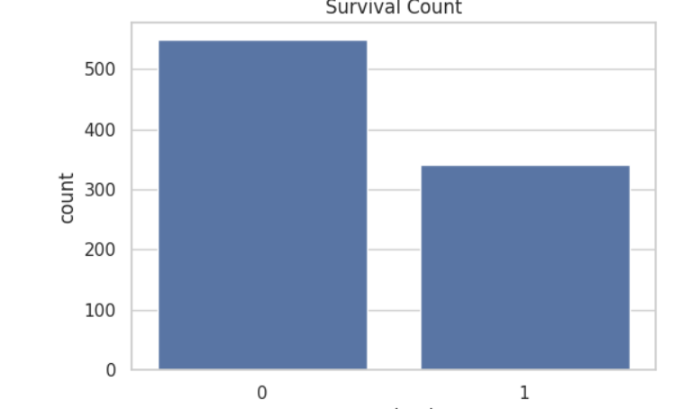
Gender count
A graph was created to compare male and female passengers.
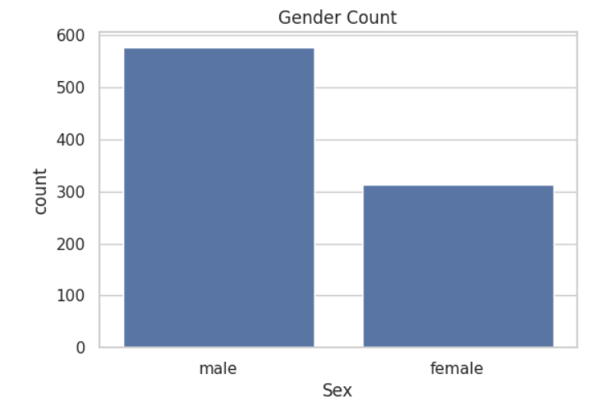

Age Distribution age
A histogram was used to analyse passenger age distribution.
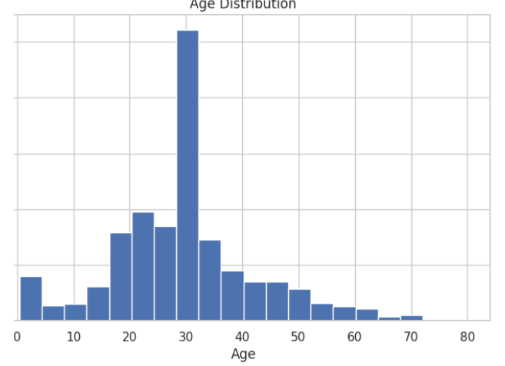
Survival by Gender
A grouped graph was used to compare survival rates by gender.
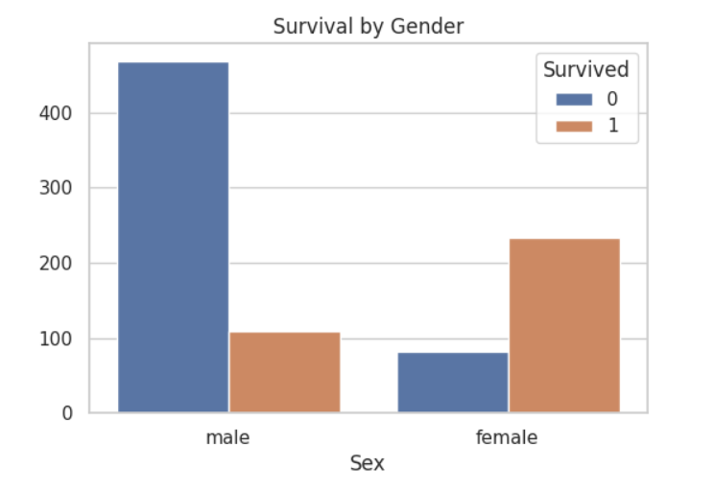

Correlation Heatmap
A heatmap was generated to analyse relationships between numerical variables.
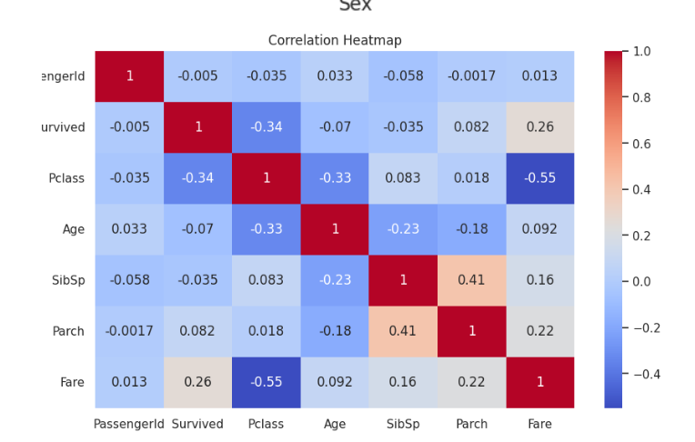.

7. Insights & Findings
1. Most passengers on the Titanic were male.
2. Female passengers had a better survival rate.
3. Most passengers were between 20–40 years old.
4. Some fare values were significantly higher than others.
5. Data cleaning improved dataset consistency and usability.

8. Conclusion
This project demonstrated the importance of data cleaning and visualization in data analysis.
Using Python libraries such as Pandas, Matplotlib, and Seaborn, the Titanic dataset was successfully cleaned and analyzed.
The project helped in understanding:
- Missing value handling
- Duplicate removal
- Data preprocessing
- Graphical analysis
- Data storytelling
Overall, this project improved practical knowledge of Python-based data analysis.

9. Future Scope
- Future improvements can include:
- Building machine learning models
- Predicting survival rates
- Creating interactive dashboards
- Using larger datasets for advanced analysis

10.References
- Kaggle Titanic Dataset
- Pandas Documentation
- Matplotlib Documentation
- Seaborn Documentation

