**Q31 Character in a list of strings**

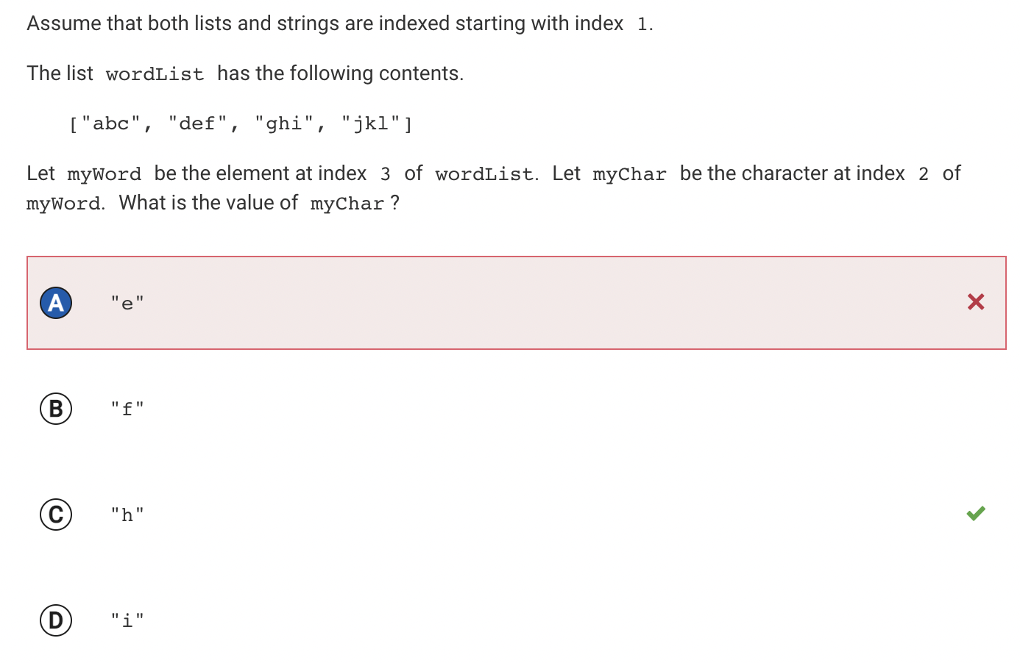

My answer: e

Why is my answer incorrect?

My answer, e, is at index 2 of wordList. The character of index 2 at myWord when myWord is index 2 of wordList, would be e. However, we are observing index 3 of wordList.

Correct answer: h

Why is it correct?

The correct answer, h, is at the correct index 3 of wordList. Therefore the character at index 2 of myWord, is h.

**Q36 Store even numbers in evenList**

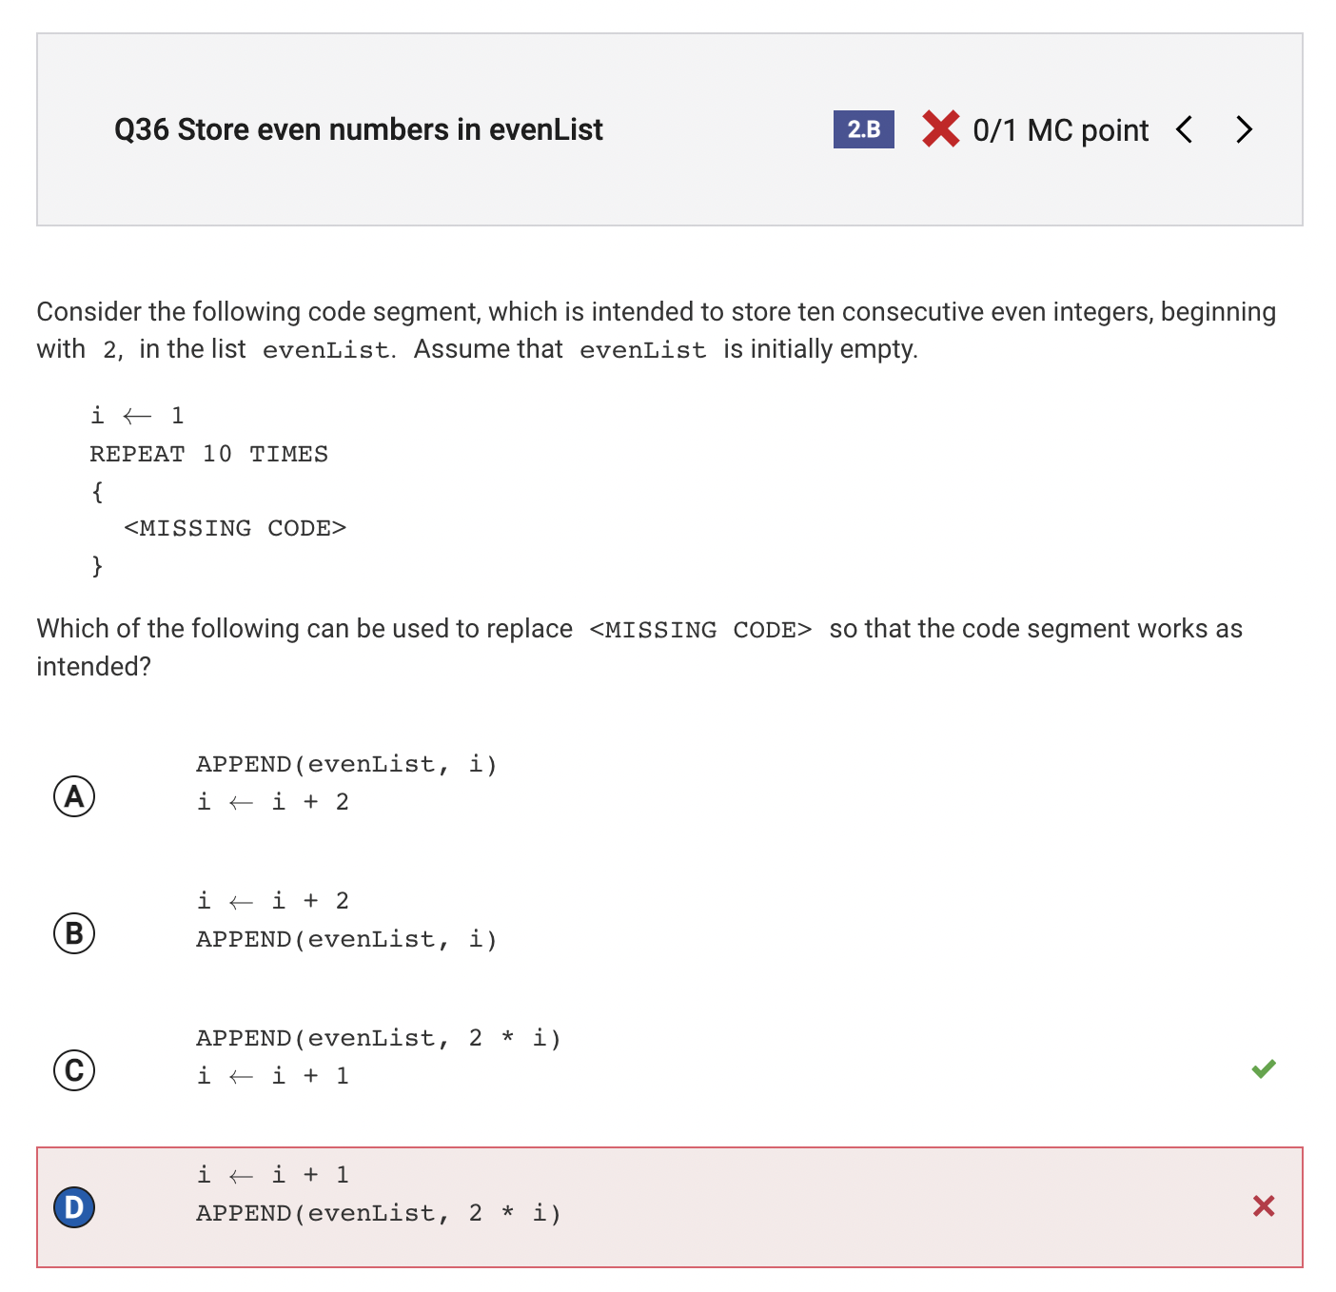

My answer:

i ← i + 1

APPEND (evenList, 2 * i)

Why is my answer incorrect?

This would be the correct solution if i was initialized to 0 instead of 1.

Correct answer:

APPEND (evenList, 2 * i)

i ← i + 1

Why is it correct?

Because i is initialized to 1, in order to begin with 2, it must be multiplied by 2 prior to the addition of 1.

**Q38 Update values of three words**

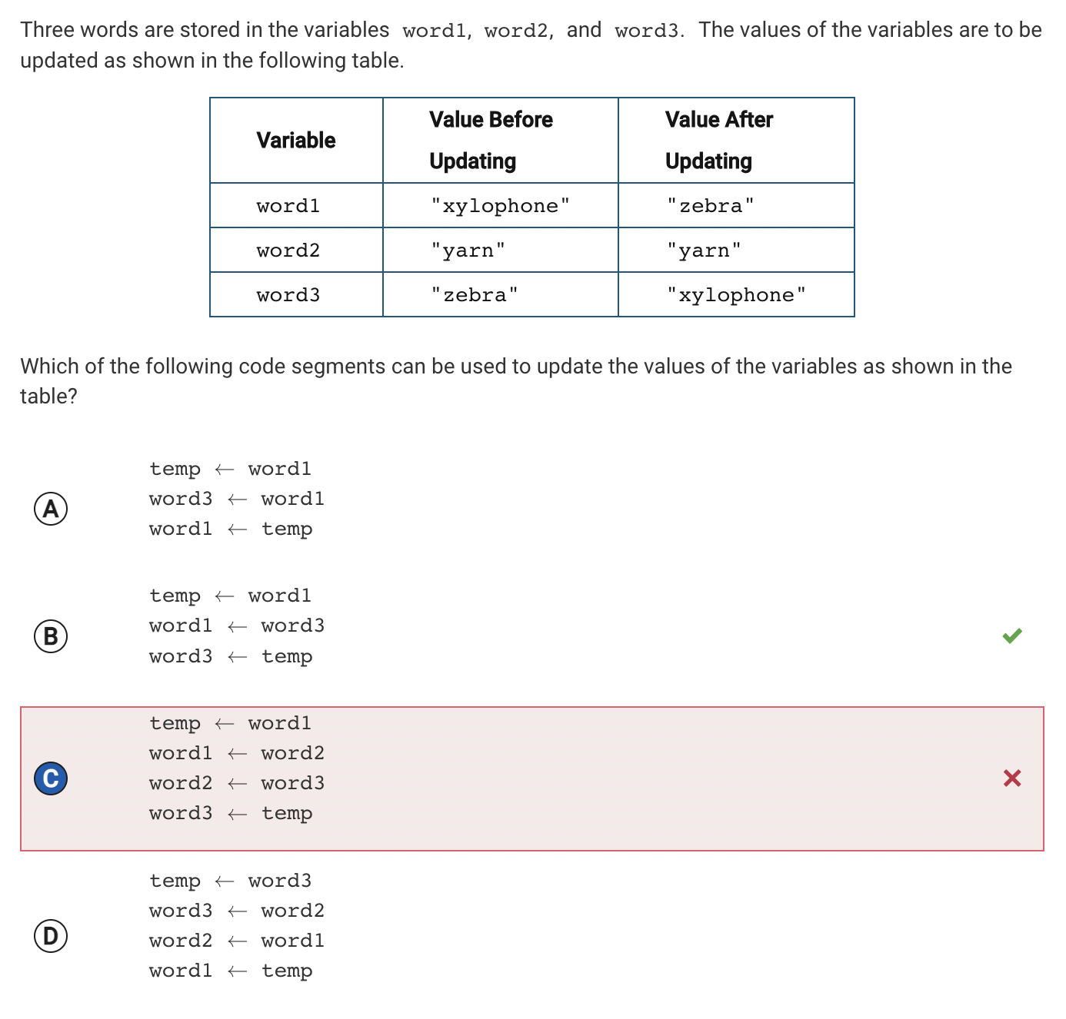

My answer:

temp ← word1

word1 ← word2

word2 ← word3

word3 ← temp

Why is my answer incorrect?

It changes word1 to yarn rather than zebra, and changes word2 when word2 was supposed to stay constant.

Correct answer:

temp ← word1

word1 ← word3

word3 ← temp

Why is it correct?

It switches the output of word1 and word3, as the prompt asks.

**Q47 Values of variable after arithmetic operations**

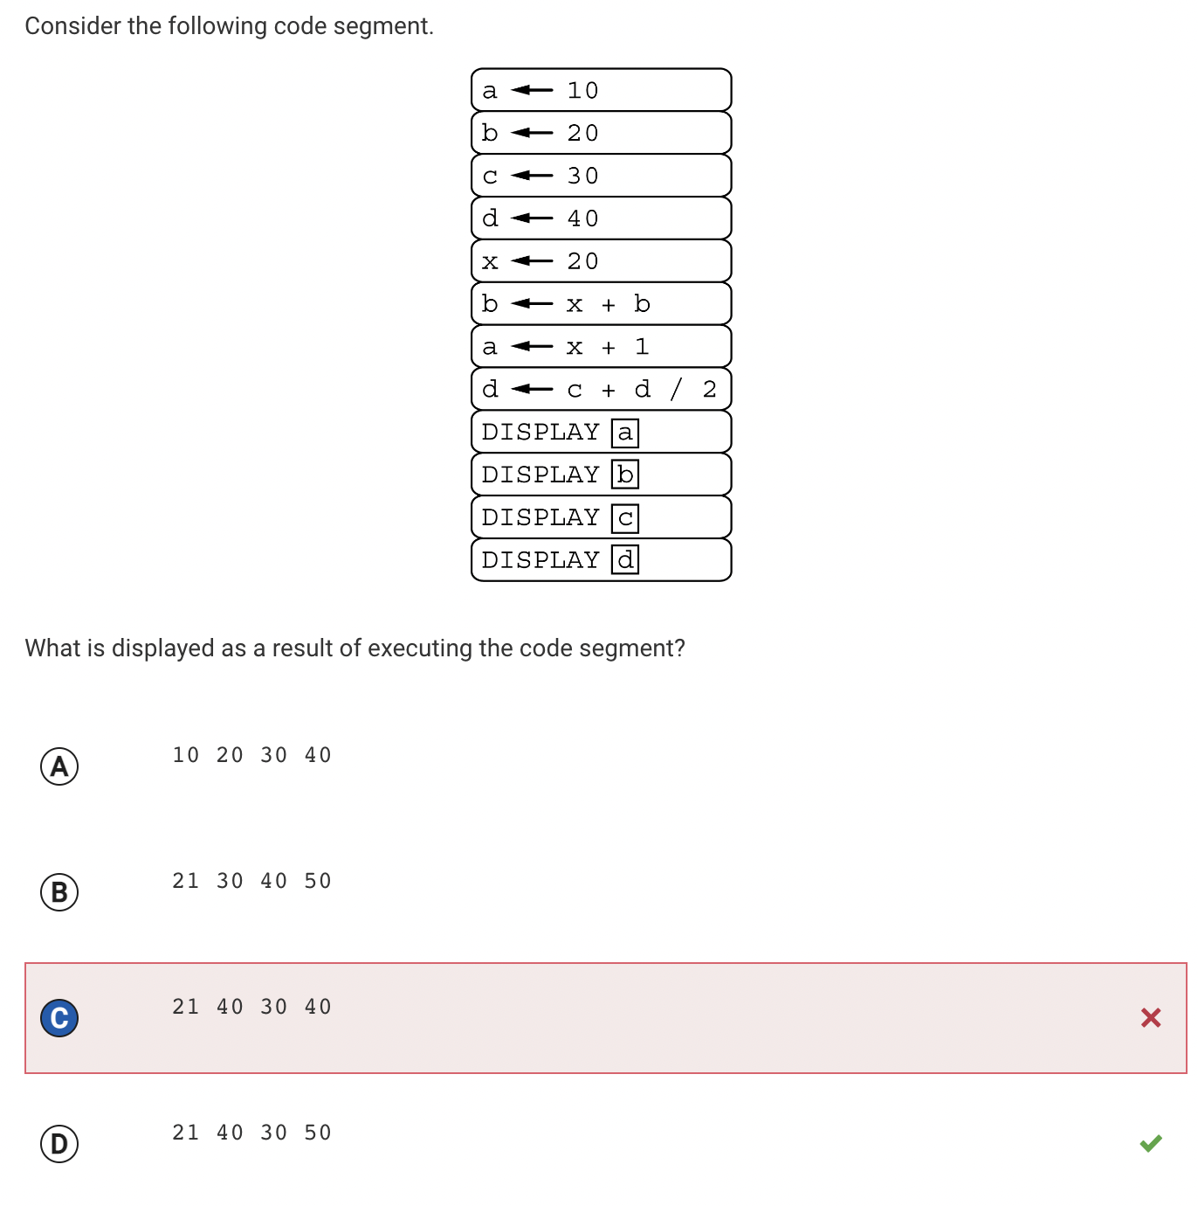

My answer:

21 40 30 40

Why is my answer incorrect?

We did not use pemdas, and therefore calculated d for (c+d)/2

Correct answer:

21 40 30 50

Why is it correct?

c+(d/2) = 50

**Guessed or Confused**

**Q8 Documentation for procedure with lists**

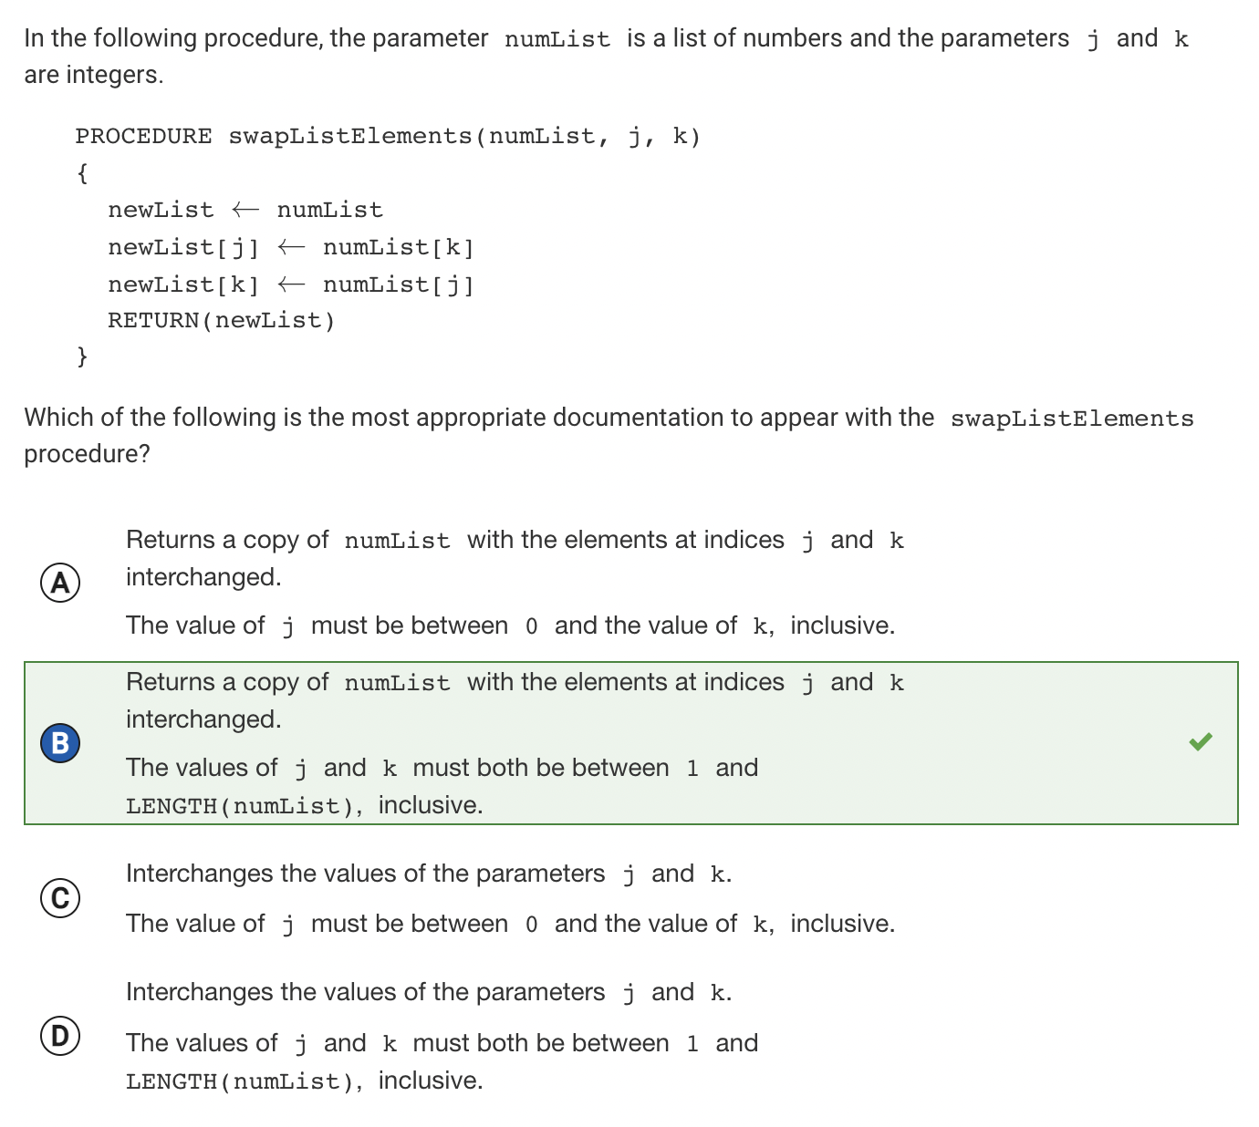

Explanation: The procedure interchanges j and k and returns a copy. Because j and k are integers, they must be between 1 and LENGTH(numList)

**Q19 Adding numbers in 4-bit representation**

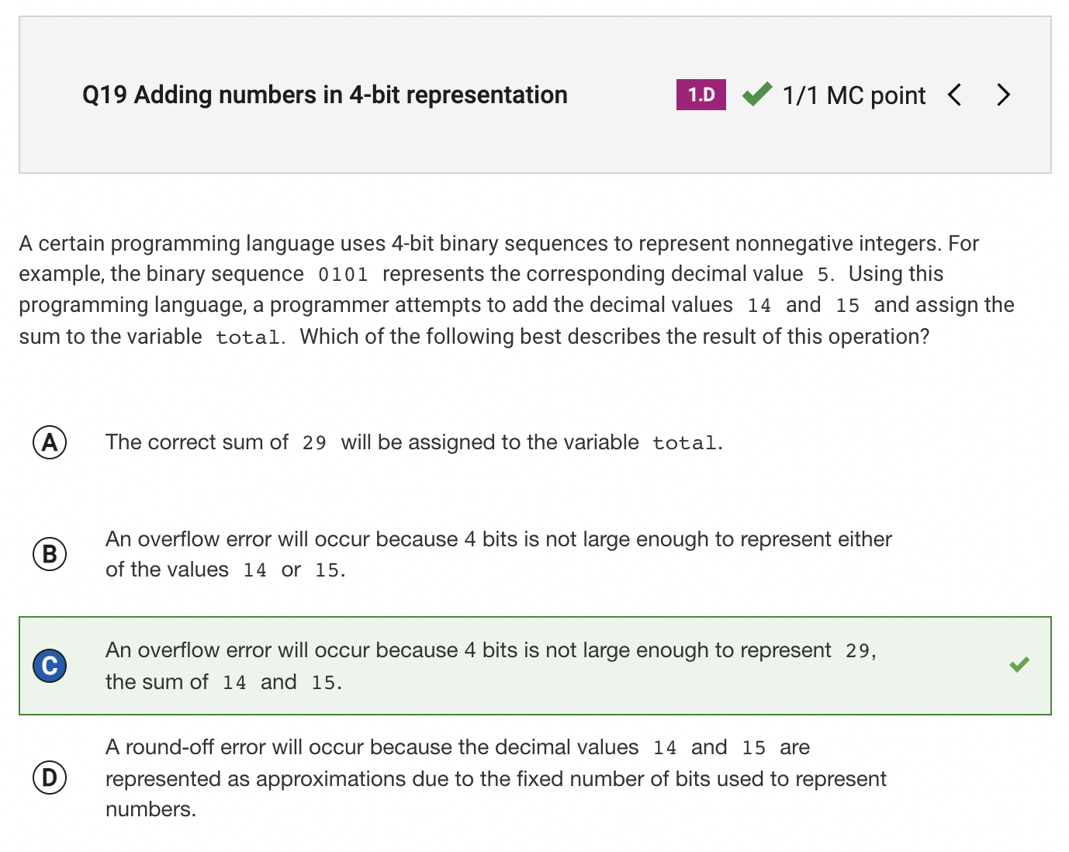

Explanation: Largest binary number that can be represented with 4 bits is 1111, which is 15. 29 is greater than 15.

**Q20 Bits needed to represent directions**

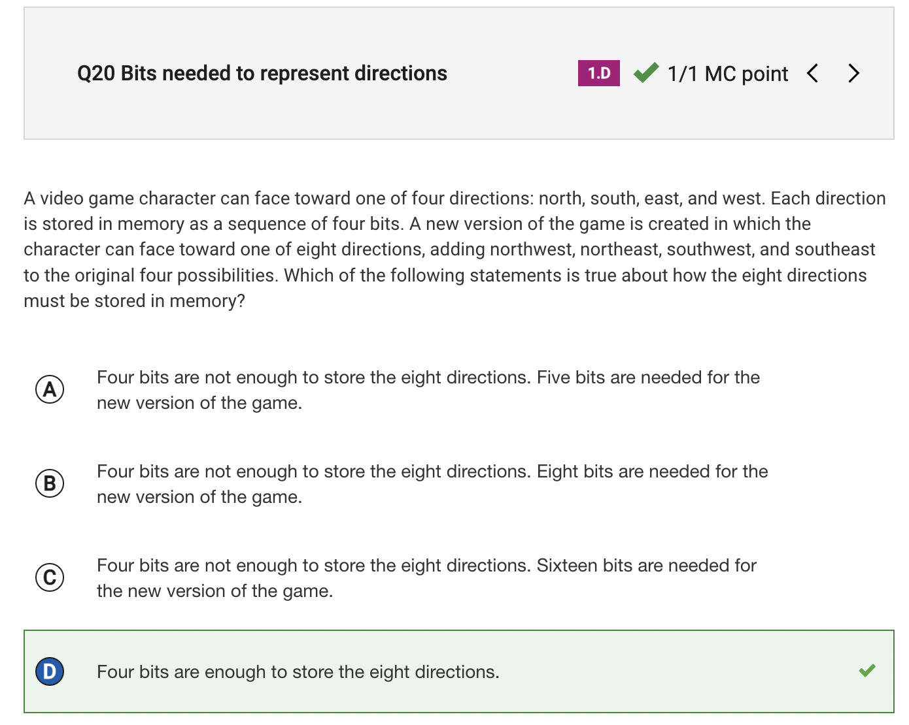

Explanation: Four bits can represent 2^4, which is 16 data pieces.

**Q22 Decimal value not equal to given binary**

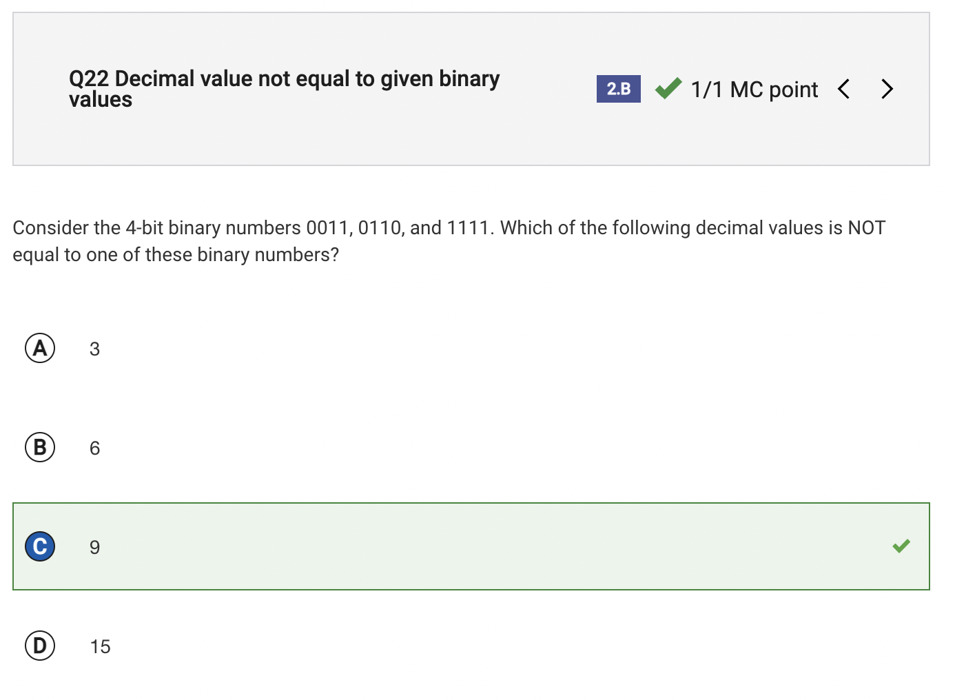

https://www.lifewire.com/how-to-read-binary-4692830

Explanation: Decimal 9 in binary is 1001 (2^0+2^3)