ASSIGNMENT - 6

ANIKEIT SETHI (190001003)

* **Algorithm:**
  1. Create a HashMap to store a key-value pair, i.e., element-frequency pair.
  2. Traverse the array from start to end.
  3. For every element in the array, insert the element in the HashMap if the element does not exist as key, else fetch the value of the key (array[i]), and increase the value by 1
  4. If the count is greater than half then print the majority element and break.
  5. If no majority element is found print “No Majority element”

Code:-

# Python3 program for finding out majority  
def findMajority(arr, size):  
 m = {}  
 for i in range(size):  
 if arr[i] in m:  
 m[arr[i]] += 1  
 else:  
 m[arr[i]] = 1  
 count = 0  
 for key in m:  
 if m[key] > size / 2:  
 count = 1  
 print("Majority found :-", key)  
 break  
 if count == 0:  
 print("No Majority element")  
  
  
arr = list(map(int, input().strip().split()))  
n = len(arr)  
  
# Function calling  
findMajority(arr, n)

Output: -

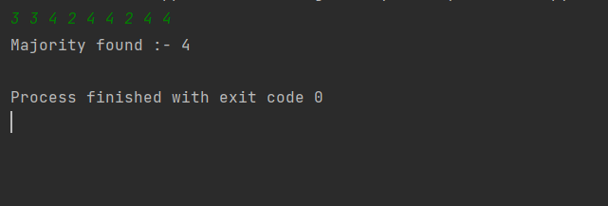

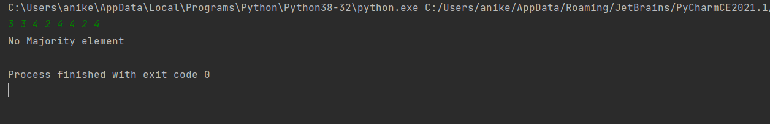

**Complexity Analysis:**

* **Time Complexity:** O(n).
* **Auxiliary Space:** O(n).   
  Since a HashMap requires linear space.