TASK 2 - MESI/MOESI, Cache Lines,
False Sharing & Cache-Line Bouncing
Assigned Members: Dhruv & Dikshit
1. Objective
The main objective of this task is to understand how CPU cache coherence works using MESI and MOESI protocols and to study cache lines, false sharing, and cache-line bouncing.
We also implemented two Java programs: a program that causes false sharing and a padded version that reduces false sharing. Both programs were tested under the same conditions and their execution time and throughput were compared.

2. Basic Theory
2.1 Cache Line
A cache line is the basic unit of data that is transferred between the CPU cache and memory. A common cache line size in modern processors is 64 bytes.
64-Byte Cache Line
+------------------------------------------+
| count1 | count2 | other data ... |
+------------------------------------------+
2.2 Cache Coherence
When multiple CPU cores have copies of the same data in their caches, they need to keep those copies consistent. Cache coherence makes sure that when one core changes data, the other cores do not continue using an incorrect old copy. Protocols such as MESI and MOESI are used for this purpose.

3. MESI Protocol
MESI is a cache coherence protocol with four states: Modified, Exclusive, Shared, and Invalid.
State | Meaning
M - Modified | The cache has modified the data and main memory may have an older value.
E - Exclusive | Only this cache has the cache line and it has not been modified.
S - Shared | More than one cache can have the same clean copy.
I - Invalid | The copy in the cache is no longer valid.

+-----------+
| Modified |
+-----------+
^
|
+---------+---------+
| |
v v
+-----------+ +-----------+
| Exclusive | ----> | Shared |
+-----------+ +-----------+
| |
+---------+---------+
|
v
+-----------+
| Invalid |
+-----------+

The exact transitions depend on what the processor is doing, such as reading, writing, or another core requesting the same cache line.

4. MOESI Protocol
MOESI is an extension of MESI. It has five states: Modified (M), Owned (O), Exclusive (E), Shared (S), and Invalid (I).
The additional state is O (Owned). The Owned state allows one cache to have the latest modified data while another cache can also have a shared copy.

MESI -> M E S I
MOESI -> M O E S I

5. False Sharing
False sharing happens when two different threads modify different variables, but those variables are present in the same cache line. The variables are different, but because they are in the same cache line, the CPU cache coherence mechanism has to keep handling the same cache line between the cores. This creates unnecessary cache coherence traffic.
Same Cache Line
+---------------------------------------+
| count1 | count2 |
+---------------------------------------+
^ ^
Thread 1 Thread 2

6. Cache-Line Bouncing
When two cores repeatedly modify data belonging to the same cache line, the cache line can repeatedly move between the cores or require ownership and invalidation actions. This repeated activity is commonly referred to as cache-line bouncing. It creates extra overhead and can reduce program performance.

Core 1
|
| modifies count1
v
Cache Line
|
| coherence activity
v
Core 2
|
| modifies count2
v
Cache Line
|
| coherence activity
v
Core 1
|
+-----------------> ...

7. Experiment
To observe the effect of false sharing, two Java programs were created.
Version 1 - False Sharing
In the first program, two threads update two adjacent variables. Since the variables are adjacent, they can be placed in the same cache line.
Thread 1 -> count1++
Thread 2 -> count2++
Version 2 - Padded
In the second program, two separate counter objects were used with padding variables. The padding is intended to separate the frequently updated values so that they are less likely to share the same cache line.

8. False-Sharing Benchmark Code
public class FalseSharingBenchmark {
static class Counter {
volatile long count1 = 0;
volatile long count2 = 0;
}
public static void main(String[] args) throws Exception {
Counter c = new Counter();
long start = System.nanoTime();
Thread t1 = new Thread(() -> {
for (int i = 0; i < 100000000; i++) {
c.count1++;
}
});
Thread t2 = new Thread(() -> {
for (int i = 0; i < 100000000; i++) {
c.count2++;
}
});
t1.start();
t2.start();
t1.join();
t2.join();
long end = System.nanoTime();
double time = (end - start) / 1000000.0;
System.out.println("Count 1: " + c.count1);
System.out.println("Count 2: " + c.count2);
System.out.println("Time: " + time + " ms");
}
}

Both threads perform 100 million increments. Therefore, 2 threads x 100,000,000 = 200,000,000 total operations.

Evidence of False-Sharing Benchmark
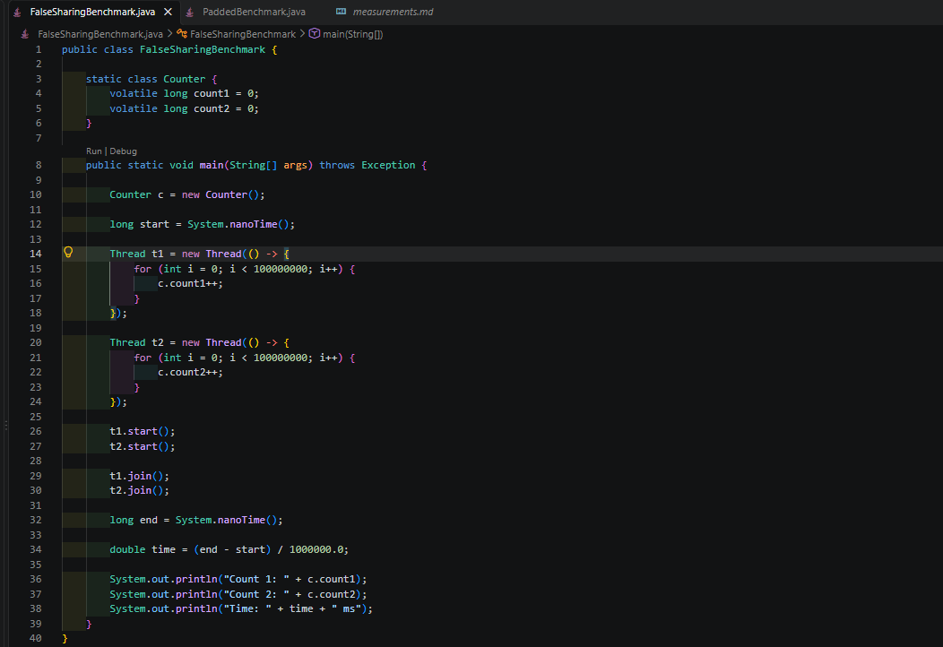 Figure: FalseSharingBenchmark.java in VS Code
9. Padded Benchmark Code
public class PaddedBenchmark {
static class Counter {
volatile long value = 0;
long p1, p2, p3, p4, p5, p6, p7;
}
public static void main(String[] args) throws Exception {
Counter c1 = new Counter();
Counter c2 = new Counter();
long start = System.nanoTime();
Thread t1 = new Thread(() -> {
for (int i = 0; i < 100000000; i++) {
c1.value++;
}
});
Thread t2 = new Thread(() -> {
for (int i = 0; i < 100000000; i++) {
c2.value++;
}
});
t1.start();
t2.start();
t1.join();
t2.join();
long end = System.nanoTime();
double time = (end - start) / 1000000.0;
System.out.println("Counter 1: " + c1.value);
System.out.println("Counter 2: " + c2.value);
System.out.println("Time: " + time + " ms");
}
}
The padding variables are used to increase the distance between the frequently modified values and reduce the chance of false sharing.

Evidence of Padded Benchmark

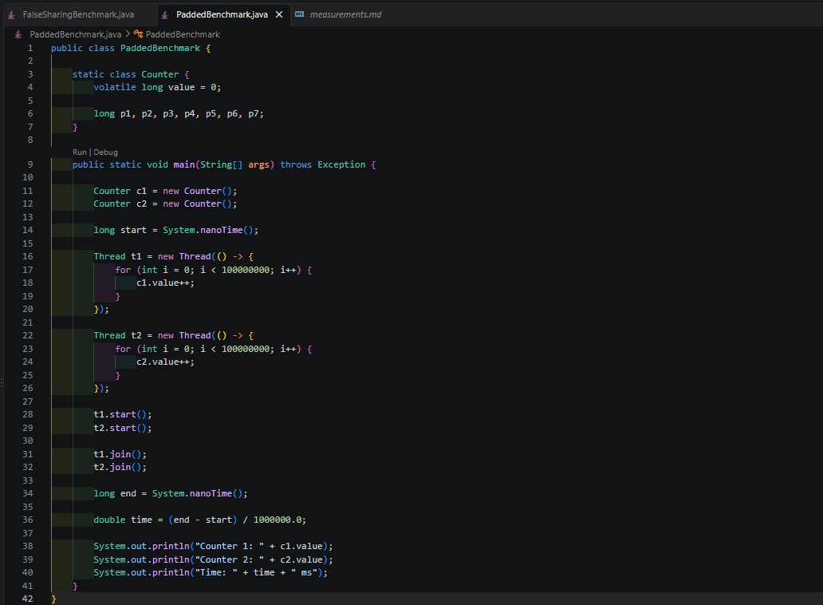
Figure: PaddedBenchmark.java in VS Code

10. Cache-Line Diagram
Without Padding
CACHE LINE
+--------------------------------------------+
| count1 | count2 |
+--------------------------------------------+
^ ^
Core 1 Core 2
| |
+--------- writes --------+
|
v
Cache coherence activity
|
v
Cache-line bouncing
|
v
Performance decreases

With Padding
Core 1 Core 2
| |
v v
Counter 1 Counter 2
| |
v v
+---------------+ +---------------+
| Cache Line A | | Cache Line B |
+---------------+ +---------------+
^ ^
+---- separated by padding --+

11. Experimental Setup

Parameter | Value
CPU | 11th Gen Intel Core i5-1135G7 @ 2.40 GHz
CPU Cores | 4
Logical Processors | 8
Operating System | Windows 11 Home Single Language
Windows Version | 25H2 (OS Build 26200.9457)
JDK | Java 21.0.12
Benchmark Threads | 2
Iterations per Thread | 100,000,000
Total Operations | 200,000,000
Number of Trials | 5

12. Measurement Method
Execution time was measured using Java's System.nanoTime(). The timer was started before the two threads were started and stopped after both threads completed. The execution time was then converted from nanoseconds to milliseconds.
Throughput was calculated using: Throughput = Total Operations / Execution Time. The result is shown in million operations per second (M ops/s). Since each test performs 200 million operations, the same amount of work is performed in both versions.

13. Actual Measurements
13.1 False-Sharing Results
Trial | Execution Time
1 | 3183.1351 ms
2 | 3788.3040 ms
3 | 3001.7870 ms
4 | 3516.4233 ms
5 | 2803.0595 ms
Average | 3258.5418 ms

13.2 Padded Results
Trial | Execution Time
1 | 624.0979 ms
2 | 675.9600 ms
3 | 715.4838 ms
4 | 677.4589 ms
5 | 656.9753 ms
Average | 669.9952 ms

14. Throughput Results
The total number of operations in every trial was 200,000,000 operations.
Implementation | Average Execution Time | Average Throughput
False Sharing | 3258.54 ms | 61.38 M ops/s
Padded | 670.00 ms | 298.51 M ops/s

15. Comparison Charts
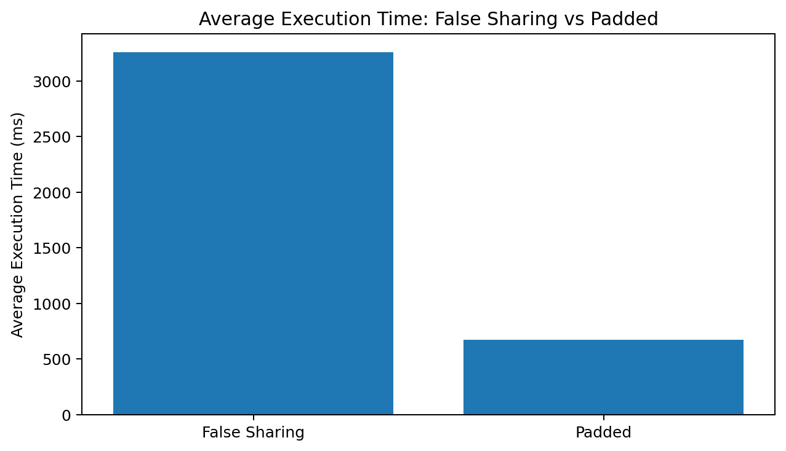
Average Execution Time: Lower execution time is better.
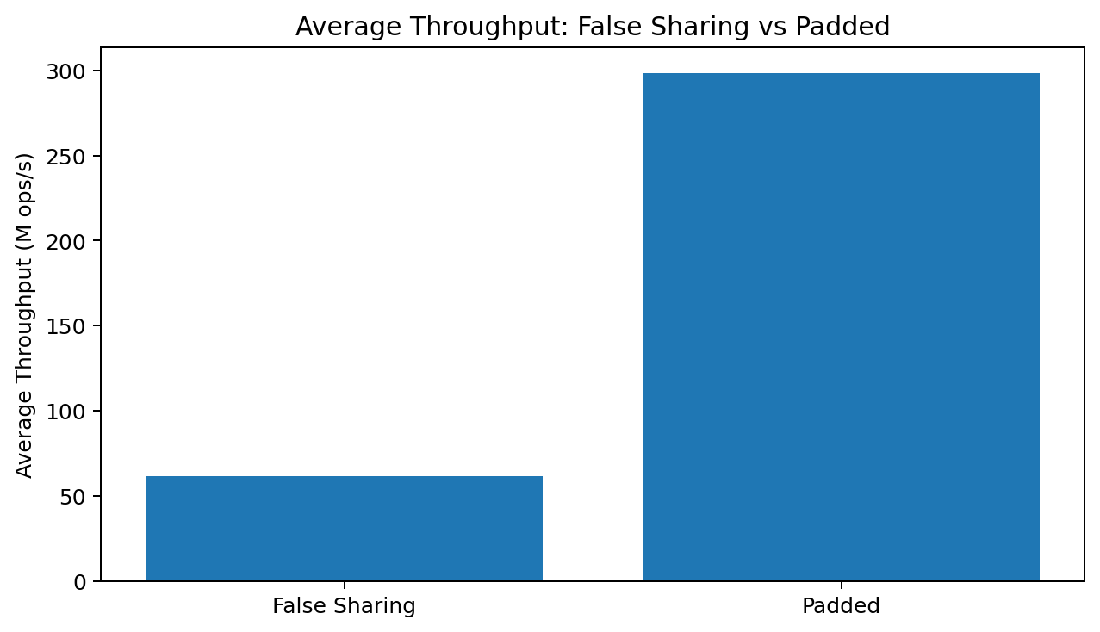
Average Throughput: Higher throughput is better.

16. Performance Analysis
The false-sharing version took an average of 3258.54 ms, while the padded version took only 670.00 ms. Therefore, the padded version was approximately 4.86 times faster in this experiment.
The execution time was reduced by approximately 79.44%. The throughput also increased from 61.38 M ops/s to 298.51 M ops/s.
The main reason for this difference is false sharing. In the first version, the two counters are adjacent and can be present in the same cache line. When the two cores repeatedly modify these values, the cache coherence mechanism has to handle the same cache line repeatedly. This causes extra coherence traffic and cache-line bouncing.
In the padded version, the counters are separated using padding. This reduces the chance of both frequently modified values sharing the same cache line. As a result, there is less cache-line contention and the program performs better.

17. Result
False Sharing
Average Time = 3258.54 ms
Average Throughput = 61.38 M ops/s
Padded
Average Time = 670.00 ms
Average Throughput = 298.51 M ops/s
The padded version performed significantly better than the false-sharing version.

18. Conclusion
In this experiment, we studied cache lines, MESI/MOESI cache coherence, false sharing, and cache-line bouncing.
We created two Java programs with the same amount of work. In the first program, two threads updated adjacent variables, which could cause false sharing. In the second program, padding was used to separate the frequently updated variables.
The results showed that the padded version had lower execution time and much higher throughput. This demonstrates how false sharing and cache-line bouncing can negatively affect the performance of multithreaded programs.
Therefore, avoiding false sharing by properly separating frequently modified variables can improve performance in concurrent applications.

