Executive Hotel Booking EDA Report
Day 15 Assignment — Exploratory Data Analysis Summary

Executive Summary
This report summarizes an end-to-end exploratory data analysis of 25,180 hotel bookings. After cleaning the dataset (removing 180 duplicate records, correcting data types, standardizing inconsistent categorical values, and handling missing values and outliers), the analysis surfaced one dominant finding: a 72.2% overall cancellation rate. This is driven most strongly by booking lead time and deposit type, with clear variation across market segments. These patterns point to concrete, actionable levers management can pull — deposit policy, lead-time-based overbooking, and segment-specific retention efforts — to reduce revenue loss from cancellations.
Metric | Value
Total Bookings Analyzed | 25,180 (25,000 after de-duplication)
Overall Cancellation Rate | 72.2%
Duplicate Records Removed | 180
Columns with Missing Data | 8 of 35

Data Quality Assessment
The raw dataset required meaningful cleanup before analysis:
- Missing values across 8 columns, most notably Company_ID (82% missing).
- 180 duplicate booking records (same Booking_ID appearing more than once).
- Date fields (Booking_Date, Arrival_Date, Reservation_Status_Date) stored as text rather than proper dates.
- Inconsistent category casing (e.g. "CITY HOTEL", "City hotel", "city hotel" all referring to the same value).
- Outliers in ADR, Total_Nights, and Estimated_Revenue, handled by capping at IQR bounds rather than deletion.
Rather than imputing a fabricated value for the mostly-missing Company_ID field, an Is_Corporate_Booking flag was derived instead — preserving the business signal without inventing data.

Key Visual Findings

Cancellation Rate by Market Segment
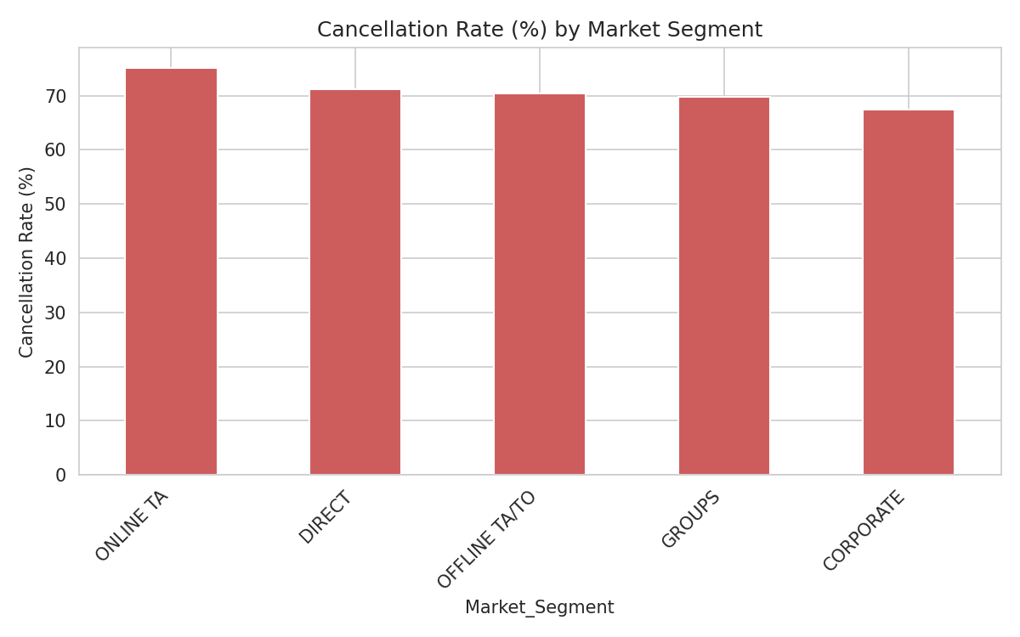
Figure 1: Cancellation rate varies sharply by booking channel.

Cancellation Rate by Deposit Type
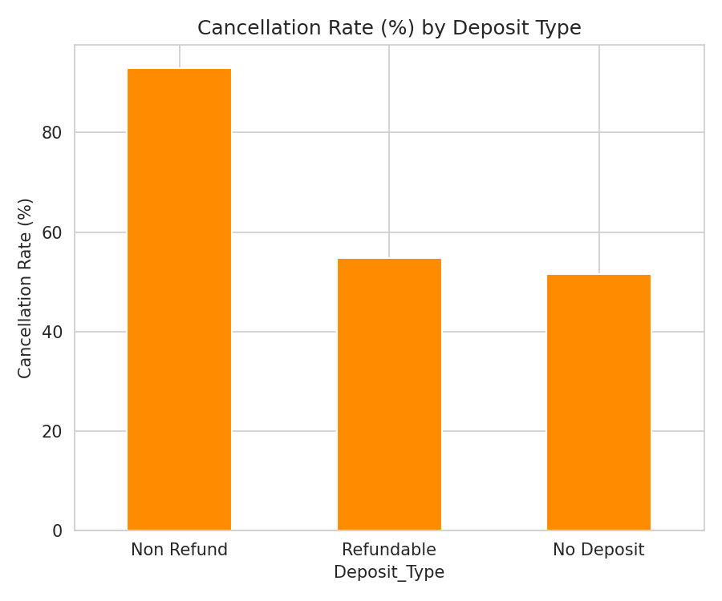
Figure 2: Deposit policy is strongly linked to cancellation behavior.

Lead Time vs. Cancellation
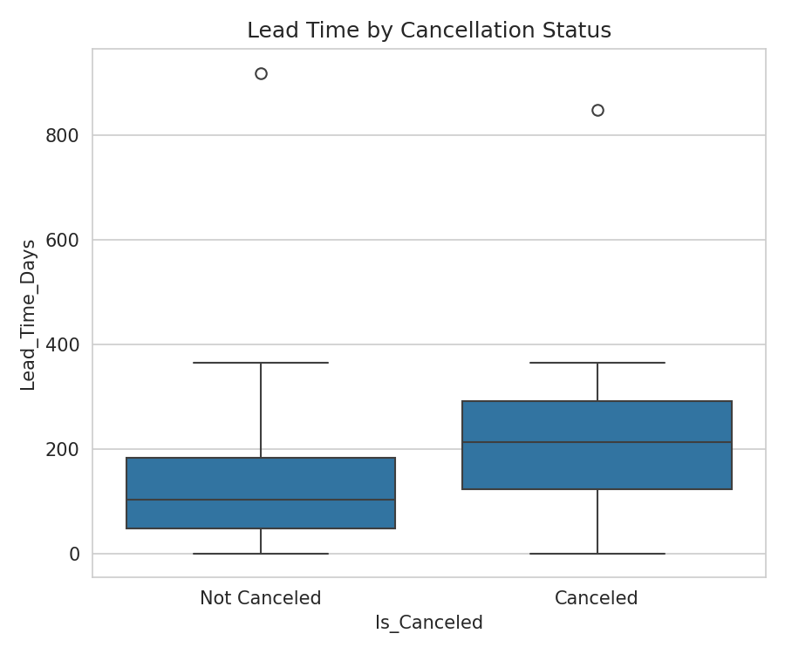
Figure 3: Longer lead times correspond with higher cancellation likelihood.

Average Daily Rate (ADR) by Hotel Type
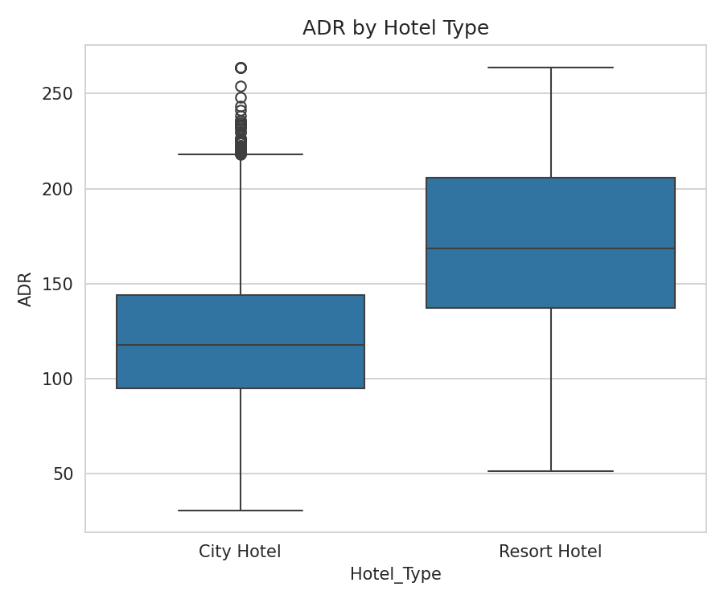
Figure 4: Pricing distribution differs between City and Resort hotels.

Correlation Matrix
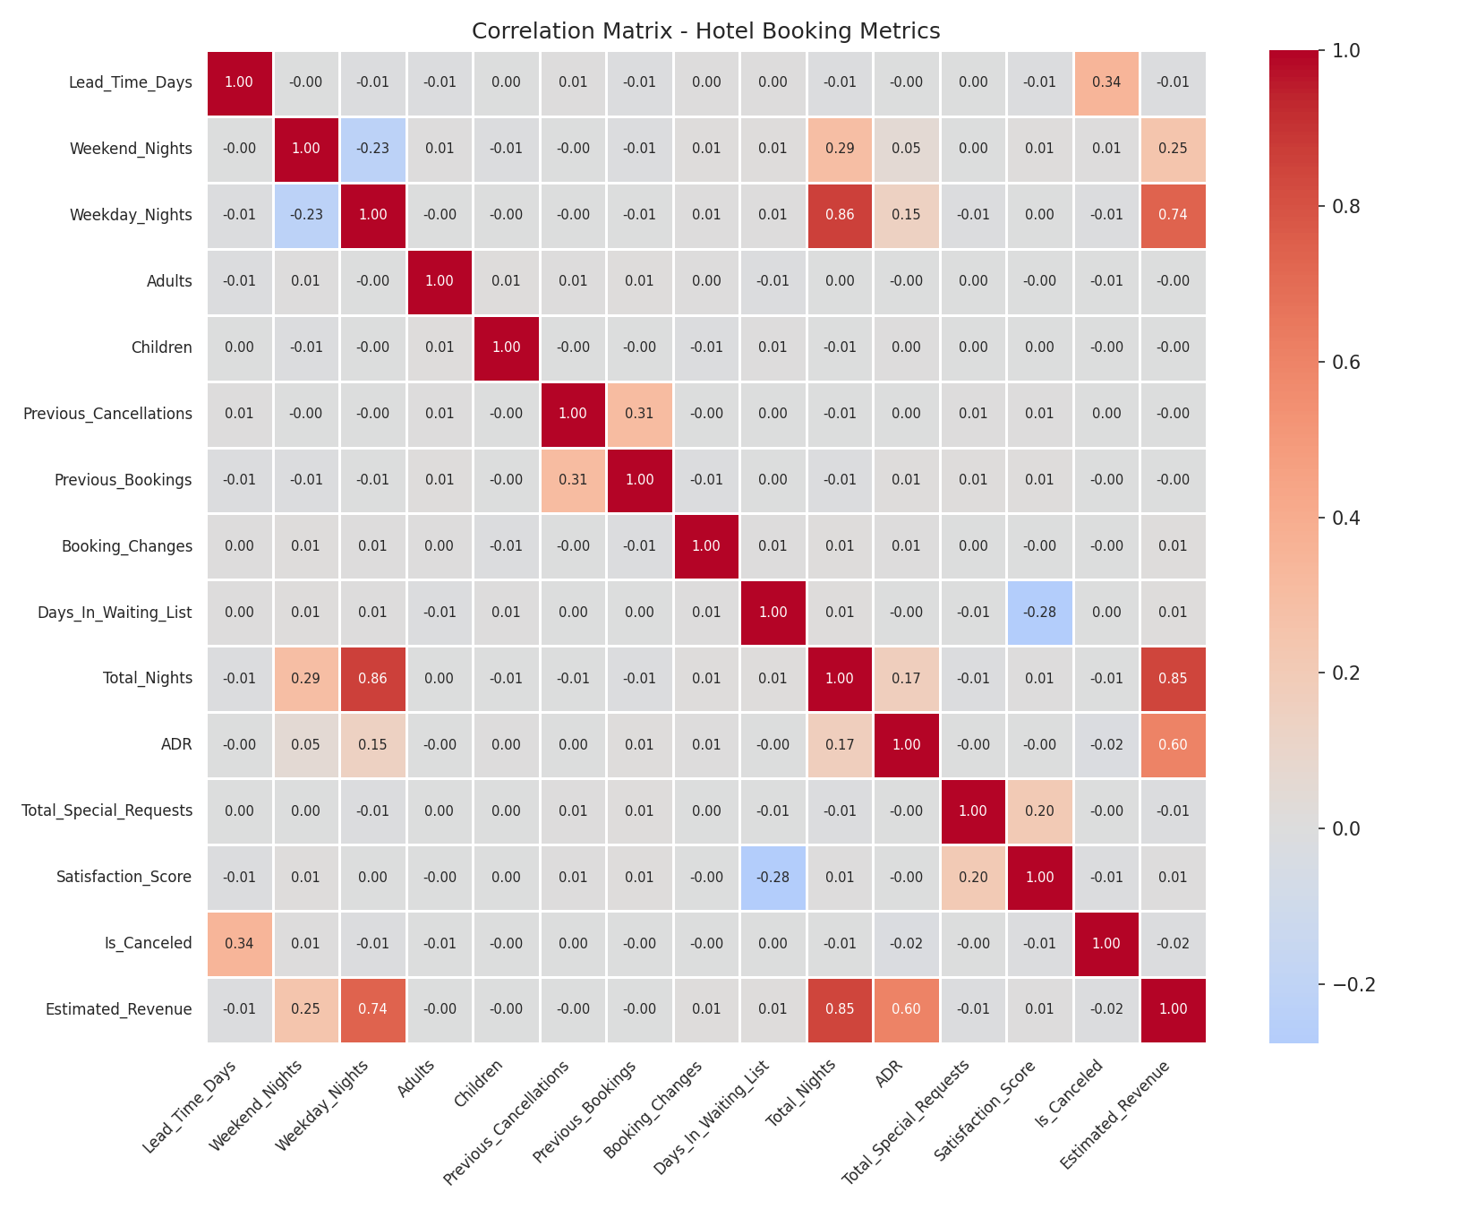
Figure 5: Relationships among key numerical booking metrics.

Top Booking Countries
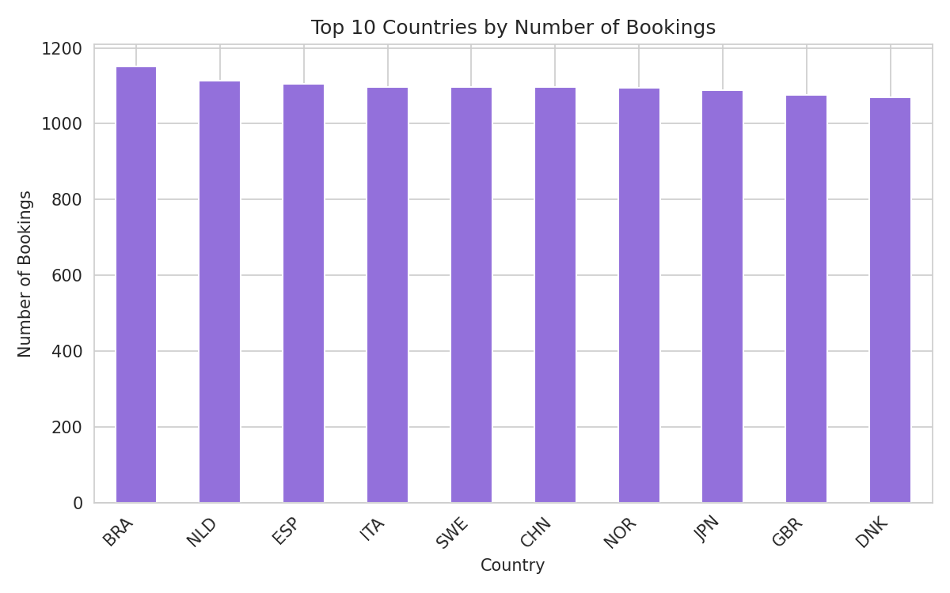
Figure 6: Guest origin is broadly distributed across ten leading countries.

Key Business Insights
1. Cancellations are the dominant outcome, not the exception. Roughly 72% of all bookings in this dataset end in cancellation — far higher than a typical assumption of occasional cancellation.
2. Lead time is meaningfully linked to cancellation risk — the strongest numeric correlate with cancellation in the dataset, though moderate in absolute terms. Bookings made far in advance show noticeably higher cancellation rates than last-minute bookings.
3. Deposit type is one of the strongest predictors of cancellation behavior, confirming deposit policy as a real lever over guest commitment.
4. Market segment drives very different cancellation and pricing behavior, with online travel agency and group bookings showing distinct patterns from direct and corporate bookings.
5. Room reassignment is common but does not appear to strongly drive low satisfaction on its own, based on the correlation analysis.

Recommendations for Management
1. Tighten deposit policy on high-risk segments — require partial non-refundable deposits where cancellation rates are highest.
2. Apply dynamic overbooking strategies calibrated to lead time, since longer-lead-time bookings cancel more often.
3. Prioritize retention efforts (confirmation reminders, incentives) on high-cancellation market segments such as Online TA and Groups.
4. Audit the room assignment process to understand whether mismatches stem from overbooking practices or inventory shortages.
5. Track corporate bookings as a distinct, higher-value segment using the Is_Corporate_Booking flag, given their different cancellation profile.
6. Tighten data quality processes at the point of entry — casing inconsistencies, placeholder values, and duplicate records suggest gaps in input validation.
7. Use satisfaction score as an independent signal rather than a proxy for cancellation or pricing, since it shows only weak correlation with most operational variables.

Methodology Note
This report accompanies a full Jupyter/Google Colab notebook containing the complete analysis: data quality assessment, cleaning and preprocessing steps, univariate and bivariate analysis, descriptive statistics, group-wise analysis by hotel type/market segment/country, full correlation analysis, and all supporting visualizations. This document distills that analysis into an executive-ready summary for decision-makers.

