This is a part of Security Blue Team's course-wrap-up challenge. This is the final challenge of 'Introduction to Digital Forensics' course.

Digital Forensics Challenge
The SOC has received an anonymous report that a user is potentially exfiltrating data from the company. An image of the user’s hard drive has been taken, and you are responsible for analyzing the contents of a perfect copy to find any evidence of malicious activity. Using your newly developed skills, search through the folders and files using techniques to uncover 4 pieces of hidden information (each piece of evidence will contain the string {1 of 4} or similar). You will be tested on your ability to discover this information using all of the techniques taught in this course; Linux CLI navigation, identifying incorrect file extensions, identifying hidden files/folders, steganography, and password cracking.
Download the necessary files from: https://elearning.securityblue.team/home/courses/free-courses/introduction-to-digital-forensics#content#course-capstone#course-capstone#challenge-brief

Practical Challenge Questions
[Evidence 1/4] What is the name of the file where the evidence was found? (filename and extension)
[Evidence 1/4] What is the name of the directory your in where this evidence was found?
[Evidence 1/4] What piece of evidence have you found? (Multiple Choice)
[Evidence 2/4] What is the name of the file where the evidence was found? (filename and extension)
[Evidence 2/4] What is the name of the directory your in where this evidence was found?
[Evidence 2/4] What piece of evidence have you found? (Multiple Choice)
[Evidence 3/4] What is the name of the file where the evidence was found? (filename and extension)
[Evidence 3/4] What is the name of the directory your in where this evidence was found?
[Evidence 3/4] What piece of evidence have you found? (Multiple Choice)
[Evidence 4/4] What is the name of the file where the evidence was found? (filename and extension)
[Evidence 4/4] What is the name of the directory your in where this evidence was found?
[Evidence 4/4] What piece of evidence have you found? (Multiple Choice)

Here is the disk image file that I have extracted in my virtual Kali Linux machine.
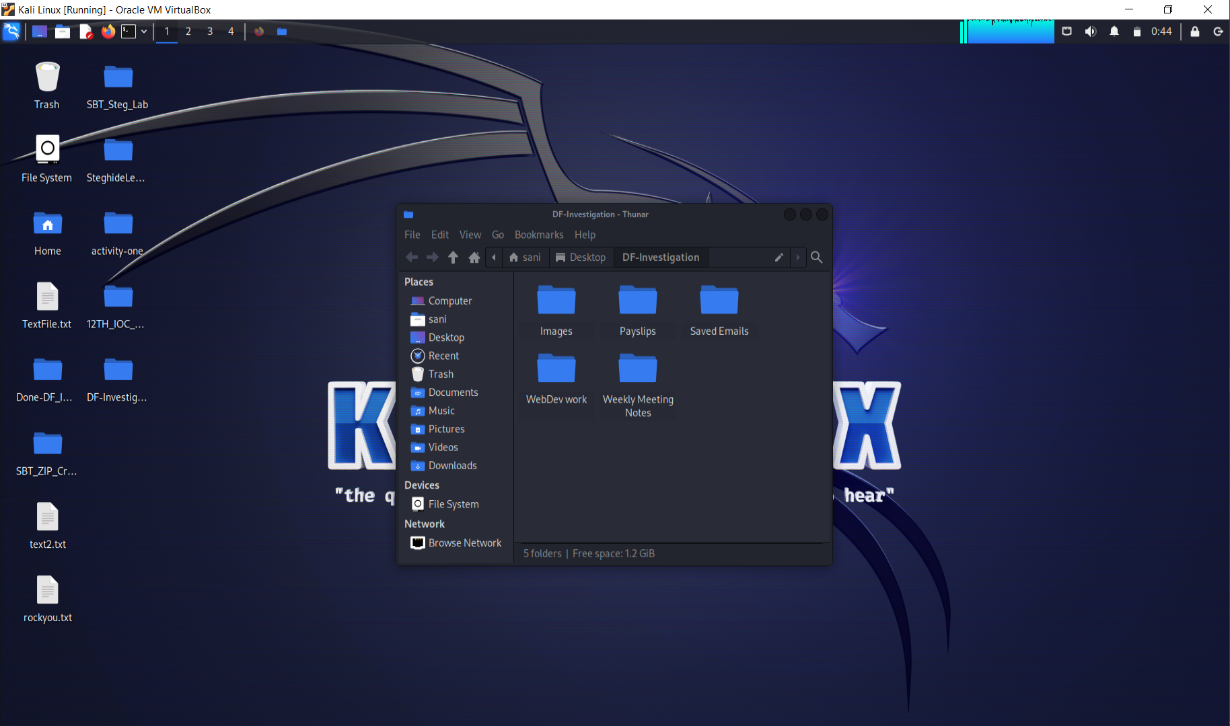
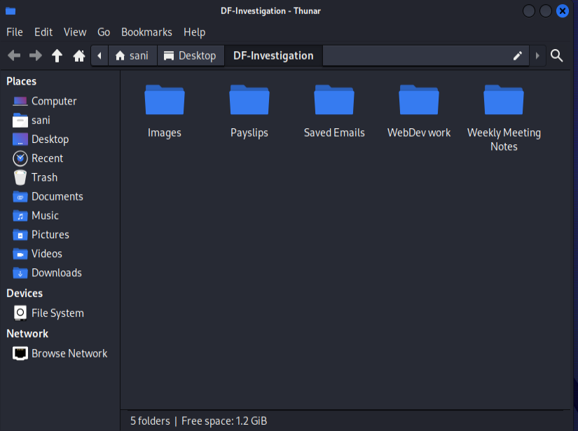
The above is the disk image file that I will be investigating to find evidence of a user exfiltrating data from the company.

Evidence 1
Now, I will open the Linux Command Line and navigate to this directory and use the command 'tree'.
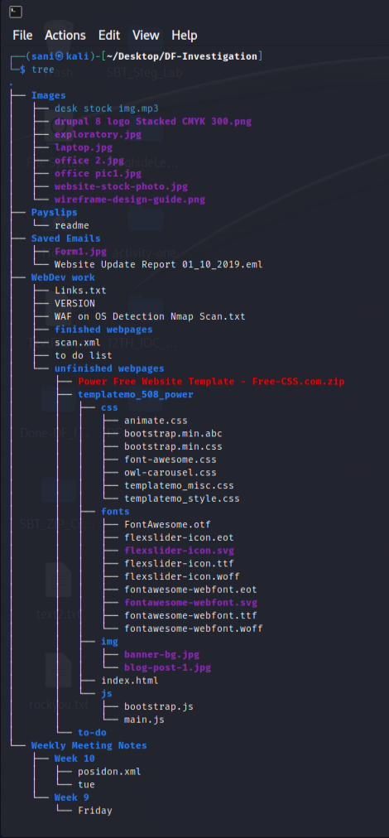
Here, I see all the contents (not hidden ones). Looking at this, I see an empty folder named 'to-do'. I navigate to it. It looks empty but I use the 'ls –a' command that displays all files including hidden files and we have a .zip hidden file.
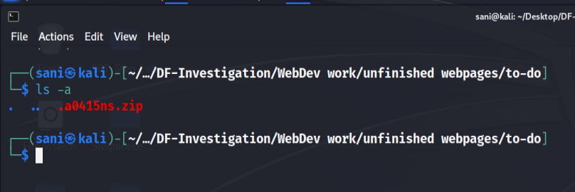
To crack this zip file, I'll use fcrackzip with a dictionary list of the 'rockyou.txt' text file.
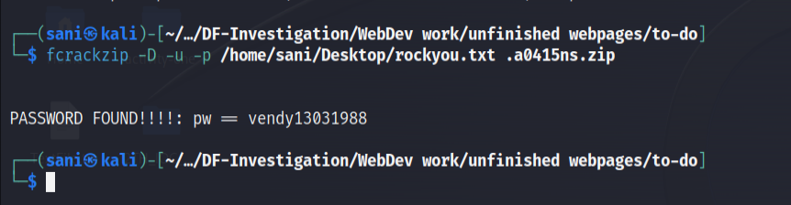
I have cracked the password and now will be extracting the zip file.
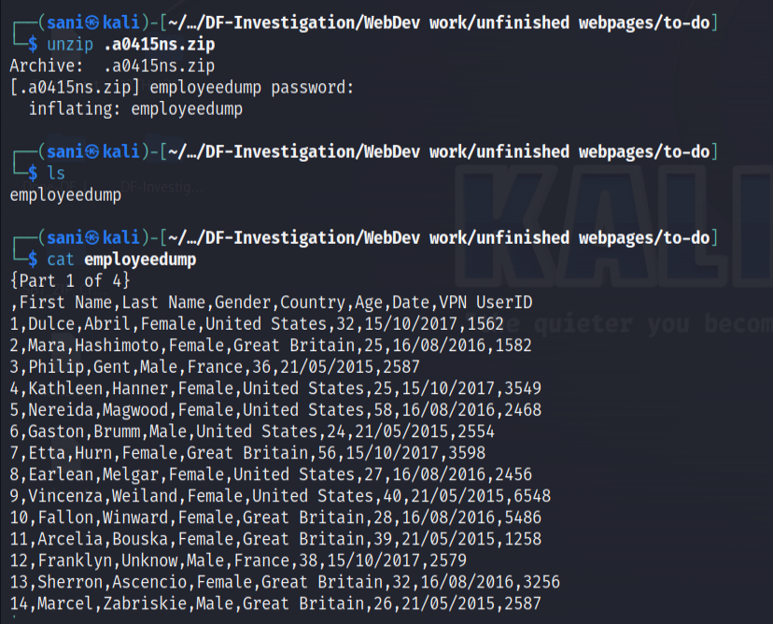
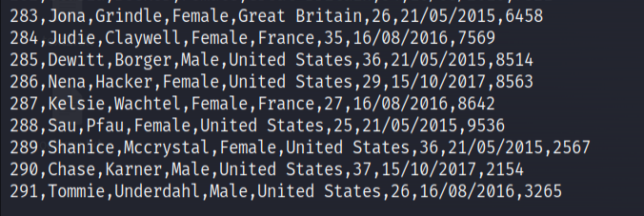
As you can see, this text file contains 291 employees' information. This is Evidence 1 and all the answers to the questions can be found here.

Evidence 2
Looking at the tree again, I notice a Form1.jpg in the 'Saved Emails' and find it suspicious. Why is there an image file in the email folders? So I go there to investigate.
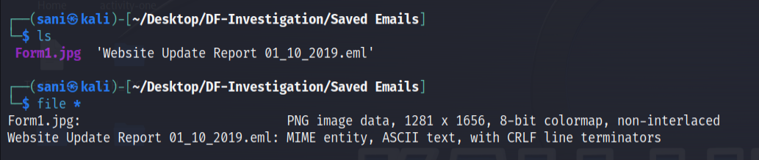
It is a PNG file stored as a jpg. I use the 'strings' command to extract readable strings in the file and there is hidden information at the end.
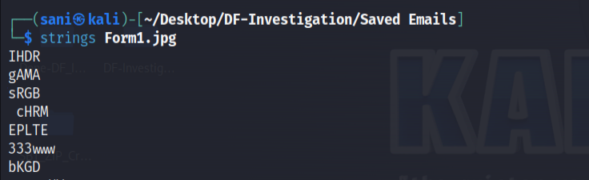
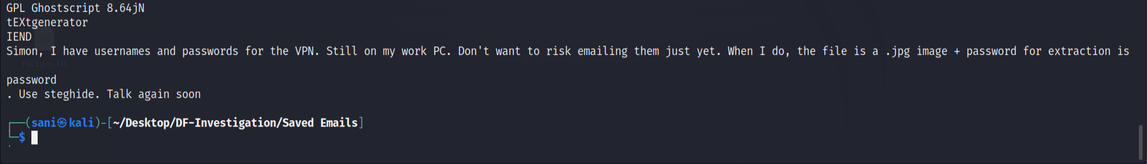
The user has an accomplice named Simon and the jpg files must have hidden text files using steganography using 'password' password. Now, I will start investigating the jpg files using steghide and see if they have text files hiding.
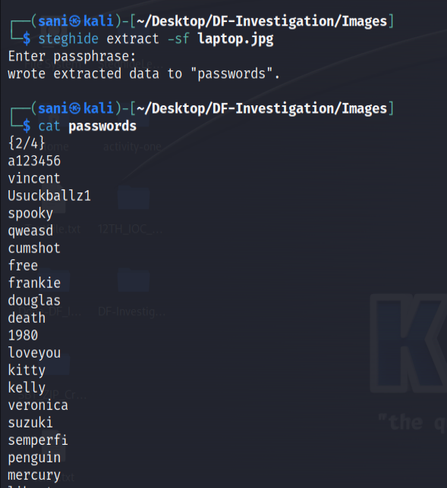
So, the file containing passwords was hidden using laptop.jpg as a cover file.
As you can see, this text file contains password list. This is Evidence 2 and all the answers to the questions can be found here.

Evidence 3
Going back to the tree, I notice an .xml file in the 'Weekly Meeting Notes' Week 10' directory. I again use the 'file *' command to see the file types.
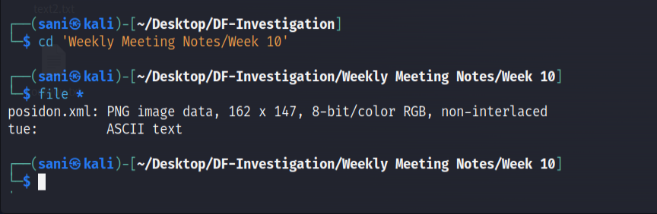
The .xml file is an image actually. There were hints given by SBT for this challenge and it mentioned that I had to also use the GUI to uncover some information so let's do that.
First, let's change this .xml to .png.
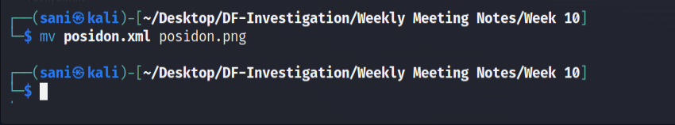
Now, looking at it through the GUI.
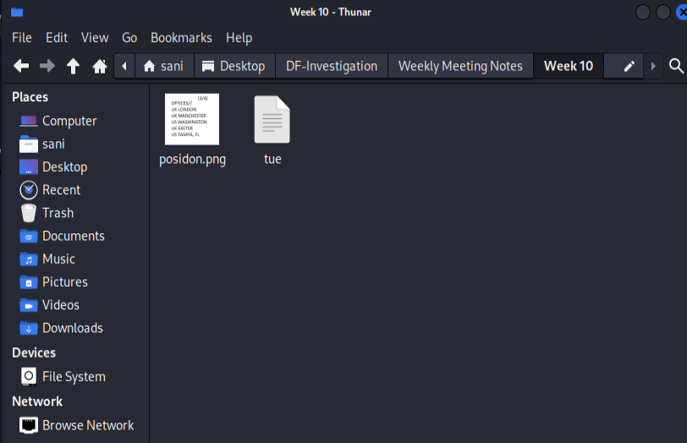
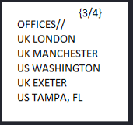
As you can see, this image contains the locations of the offices. This is Evidence 3 and all the answers to the questions can be found here.

Evidence 4
Going back to the tree, I can see there is a .abc file with the .css files. I will be investigating this next.
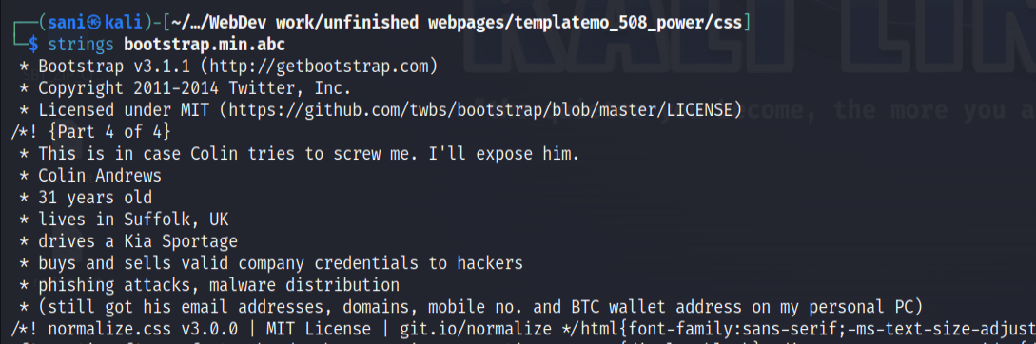
Using strings, the text inside can be seen. Here we see the user threatening his other accomplice perhaps? There is information on this person named Colin Andrews.
As you can see, this .abc file contains the last of the evidence. This is Evidence 4 and all the answers to the questions can be found here.

In conclusion, this is how I have demonstrated what I have learned in this module.

