Table of Content
Scenario 2
Practical Tasks 2
Design of a secure network 3
Network Security Configurations 3
Table 1: IP Addressing Table for network of London College. 3
Firewall and VLANs configuration 6
Use of ACLs 10
Secure Shell, Telnet 12
Network Time Protocol (NTP) 13
Syslog, Prevention Detection System 16
Authentication, Authorization, Accounting (AAA) 17
Network Testing 19
Table 9: Testing firewall. 19
Table 10: Testing ACL. 22
Table 11: Testing SSH and Telnet. 27
Table 12: Testing NTP and Syslog. 30
Table 13: Testing local AAA Authentication. 32

This is a part of the assignment of the course 'Network Security' provided by International School of Management and Technology, partnered with University of Sunderland.
The scenario and tasks are provided by the college.
The work is entirely of the author.

Scenario
Imagine that you have a chance to be recruited at London college, you have been asked to present a project report which demonstrates that are able to converse with confidence several types of Network Security measures as well as associated protocols, cryptographic types, and configuration settings of Network Security environments.
Now, imagine you are doing final level project of your London college, and you need to submit complete practical and theoretical documents concerns about the security. Where you need to identify the security flaws, limitations, drawbacks, benefits, most uses cases and future of security.
Now, your instructor appointed as a System and Network security officer at London College. You have been given the responsibility of collecting and eliciting requirements, planning, designing, and implementing fully operational and functional secured network along with test plans. You need to document the test plans, testing procedure, tested results along with expected results and actual outcome and provide fruitful recommendations for further enhancement and bolstering of network security and finally present it in the form of report of topologies, security enhancement devices, specific devices to form uninterruptable communication with all partner university and all branches of London Colleges in Nepal. Finally, you need to submit complete documents to your instructor.

Practical Tasks
- Configure Network Security for the Network you have designed for London and provide scripts/files/screenshots of the Network security configuration and provide brief comment for each.
- Develop and present a Test Plan for the Network you have designed for London and test the Network using the plan you have developed. Provide screenshots/files/ scripts of the testing and recommends for improvements.

Design of a secure network

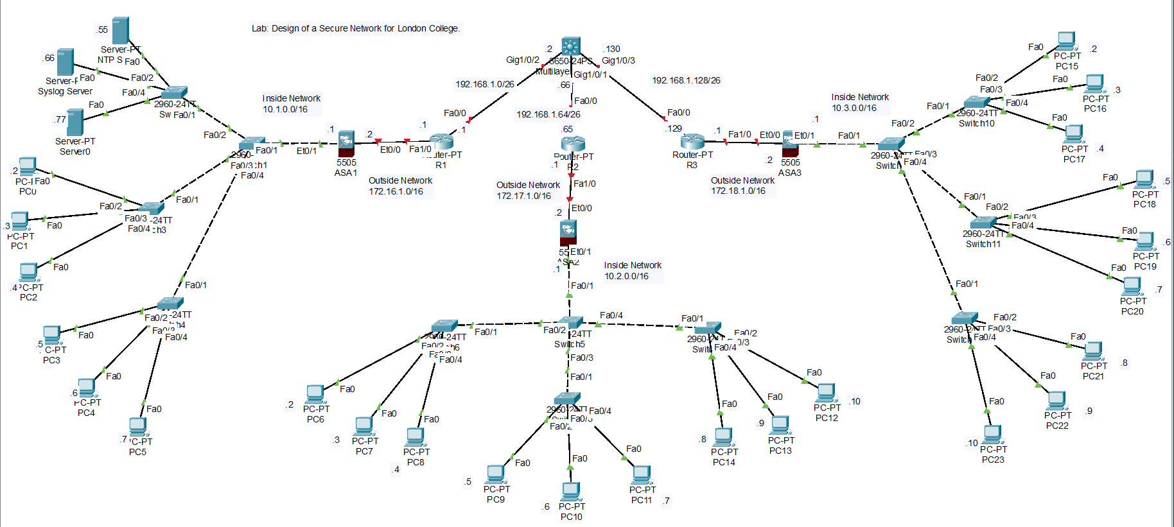

Network Security Configurations
Network security configuration is putting in place various security controls to guard against unwanted access, data breaches, and other security risks. The specific security needs of the company should be taken into account while developing a complete network security strategy that combines technologies, policies, and processes.
The following IP addresses have been assigned to the devices on the network.

Table 1: IP Addressing Table for network of London College.
IP Addressing Table

Device | Interface | IP Address | Subnet Mask | Default Gateway
Multilayer Switch  (MLS) | G1/0/2 | 192.168.1.2 | 255.255.255.192 | N/A
Multilayer Switch  (MLS) | G1/0/1 | 192.168.1.66 | 255.255.255.192 | N/A
Multilayer Switch  (MLS) | G1/0/3 | 192.168.130 | 255.255.255.192 | N/A
R1 | Fa0/0 | 192.168.1.1 | 255.255.255.192 | N/A
R1 | Fa1/0 | 172.16.1.1 | 255.255.0.0 | N/A
R2 | Fa0/0 | 192.168.1.65 | 255.255.255.192 | N/A
R2 | Fa1/0 | 172.17.1.1 | 255.255.0.0 | N/A
R3 | Fa0/0 | 192.168.1.129 | 255.255.255.192 | N/A
R3 | Fa1/0 | 172.18.1.1 | 255.255.0.0 | N/A
ASA1 | Et0/0 (Outside) | 172.16.1.2 | 255.255.0.0 | 172.16.1.1
ASA1 | Et0/1 (Inside) | 10.1.0.1 | 255.255.0.0 | N/A
ASA2 | Et0/0 (Outside) | 172.17.1.2 | 255.255.0.0 | 172.17.1.1
ASA2 | Et0/1 (Inside) | 10.2.0.1 | 255.255.0.0 | N/A
ASA3 | Et0/0 (Outside) | 172.18.1.2 | 255.255.0.0 | 172.18.1.1
ASA3 | Et0/1 (Inside) | 10.3.0.1 | 255.255.0.0 | N/A
NTP Server | NIC | 10.1.0.55 | 255.255.0.0 | 10.1.0.1
Syslog Server | NIC | 10.1.0.66 | 255.255.0.0 | 10.1.0.1
Server0 | NIC | 10.1.0.77 | 255.255.0.0 | 10.1.0.1
PC0 - PC5 | NIC | 10.1.0.2 - 10.1.0.7 | 255.255.0.0 | 10.1.0.1
PC6 - PC14 | NIC | 10.2.0.2 - 10.2.0.10 | 255.255.0.0 | 10.2.0.1
PC15 - PC23 | NIC | 10.3.0.2 – 10.3.0.10 | 255.255.0.0 | 10.3.0.1

Table 2: IP Configuration on MLS and Router interfaces.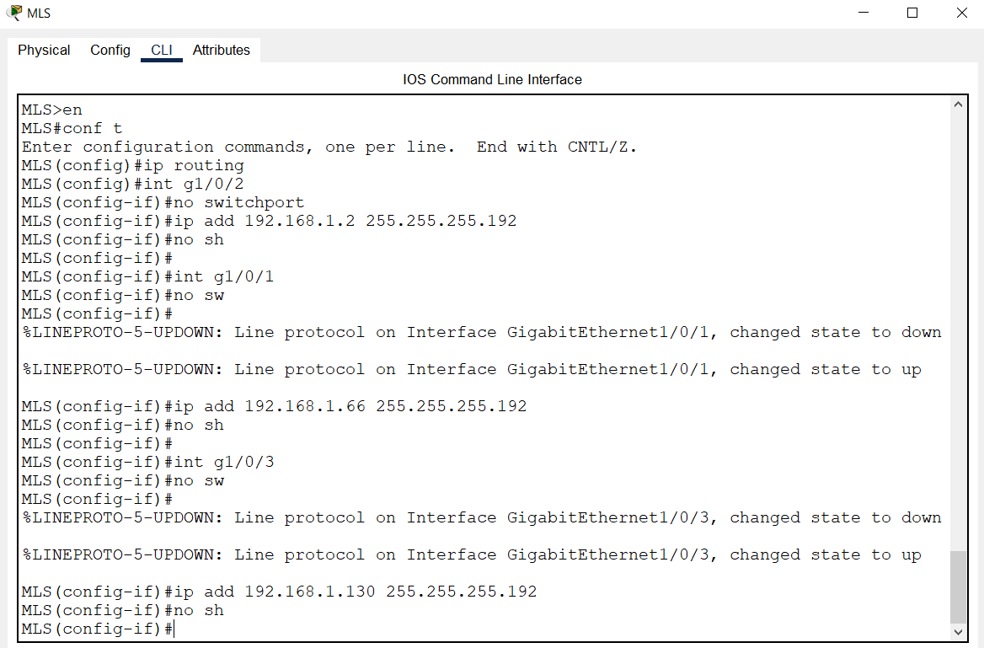
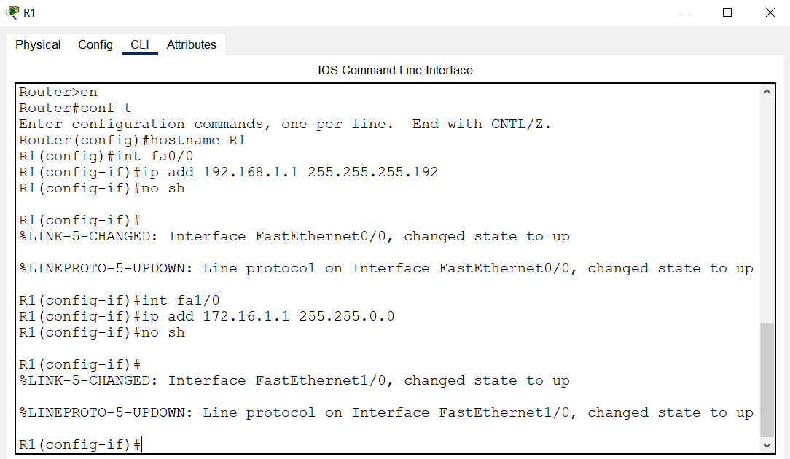
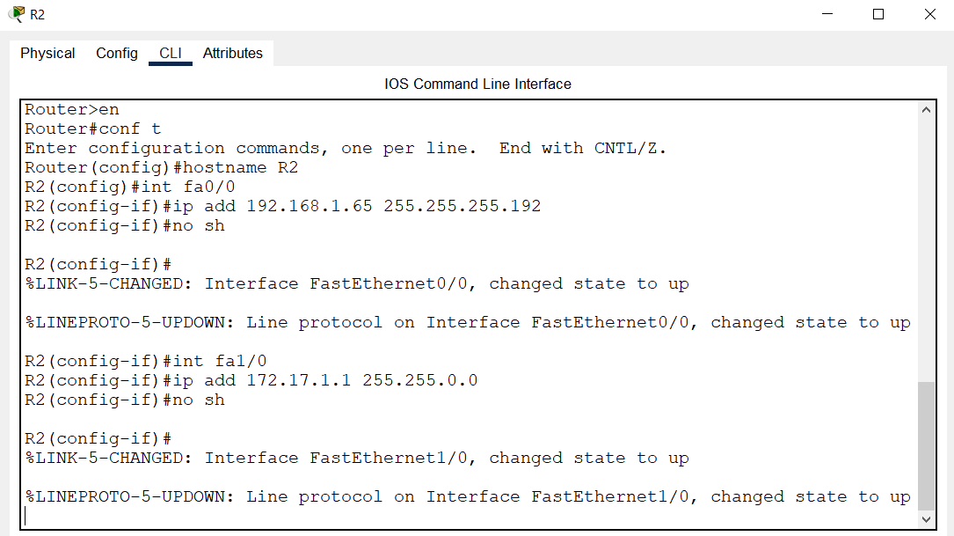
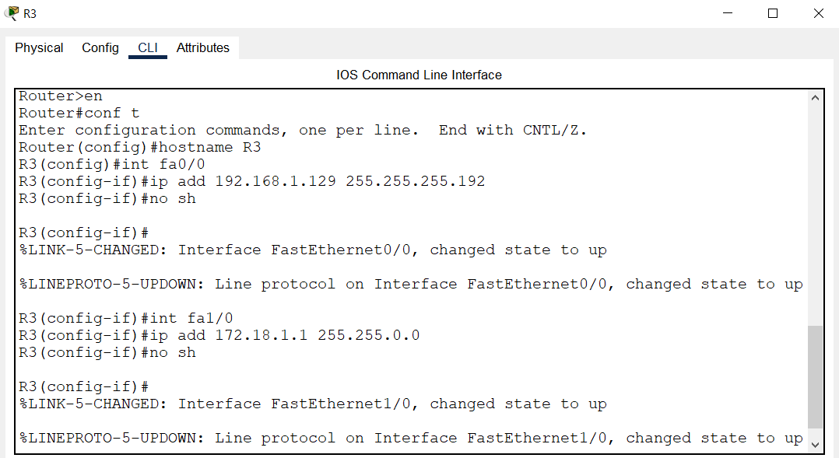

Firewall and VLANs configuration
A firewall is a security tool that keeps track of and filters network traffic according to pre-established security rules. Firewalls can be used in a college network to safeguard sensitive information, such as student and employee records, and to stop illegal access to the system. We can restrict the extent of security incidents and lower the risk of data breaches by utilizing VLANs.
There are 3 firewalls within this network that have been configured consistently with security-level of 100 for the inside network and security-level of 0 for the outside network. The interface with security of level 100 is trusted while the interfaces with security level of 0 are connected to external networks and is restricted to prevent outside traffic.
Table 3: Firewall Configuration on ASA interfaces.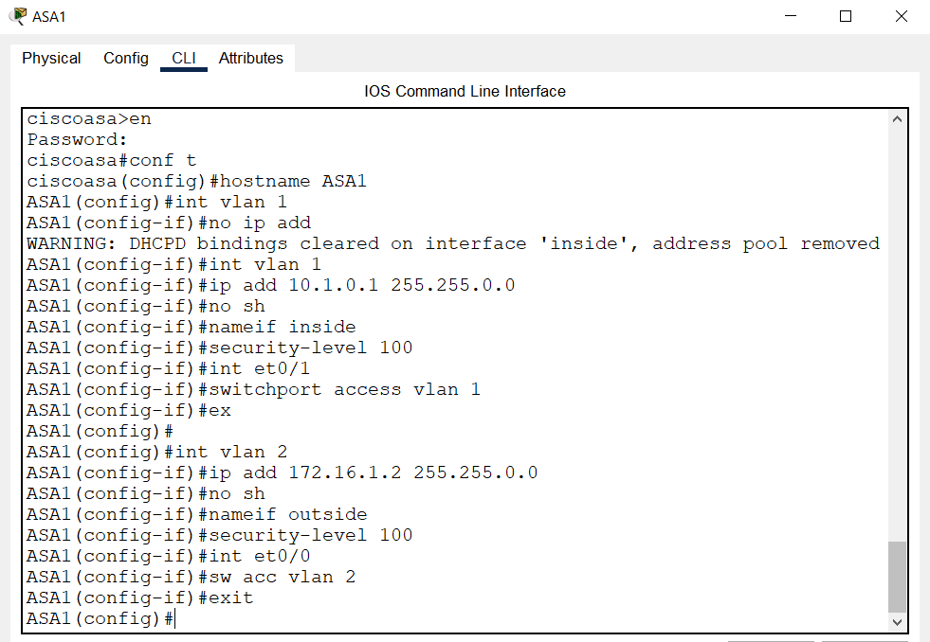
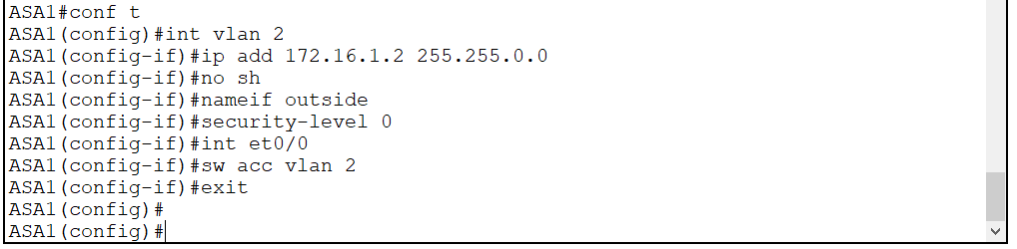
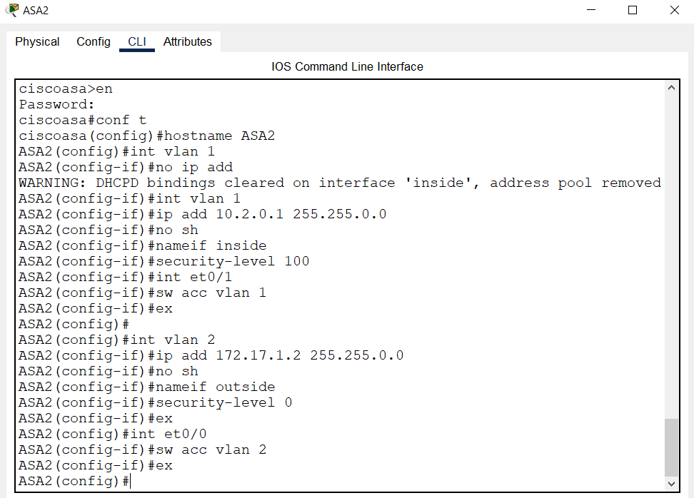
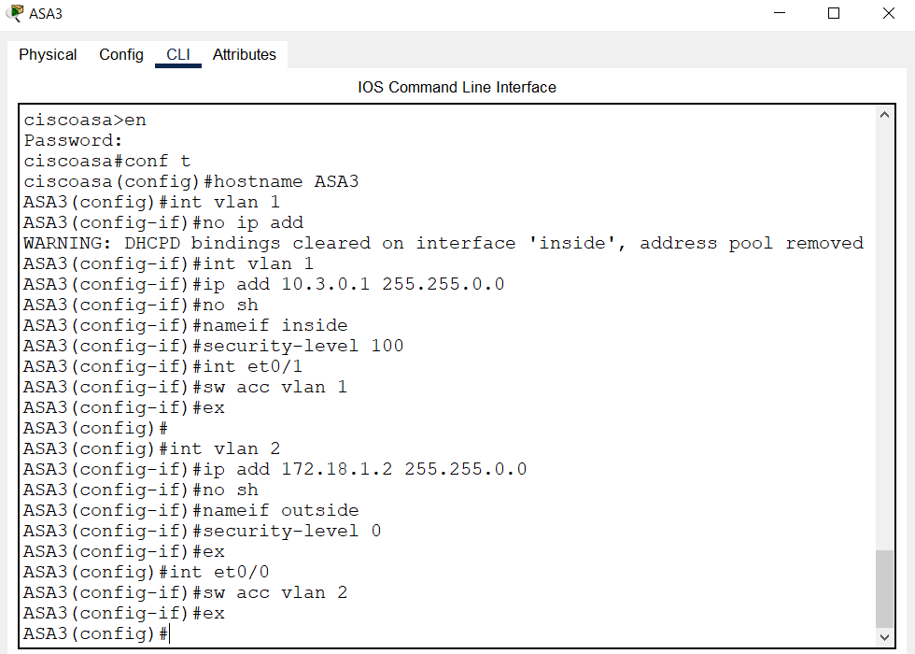

In conclusion, VLANs and firewalls are both crucial elements of a secure college network infrastructure. While VLANs can enhance network performance and reduce the scale of security events, firewalls can defend the network from outside threats and regulate access to network resources.

Use of ACLs
Access Control Lists (ACLs) are an important component of network security that are used to control access to network resources. ACLs can help control network traffic by allowing or blocking specific types of traffic based on predefined rules.
For London college network, each firewall has been configured with dynamic Network Address Translation (NAT) on the firewall. The executed NAT command causes the source IP address of outgoing packets delivered from the internal network to be immediately translated by the firewall to the IP address of the interface linked to the external network. The ACL has been configured to permit TCP (Transmission Control Protocol) and ICMP (Internet Control Message Protocols).
Table 4: ACL Configuration.
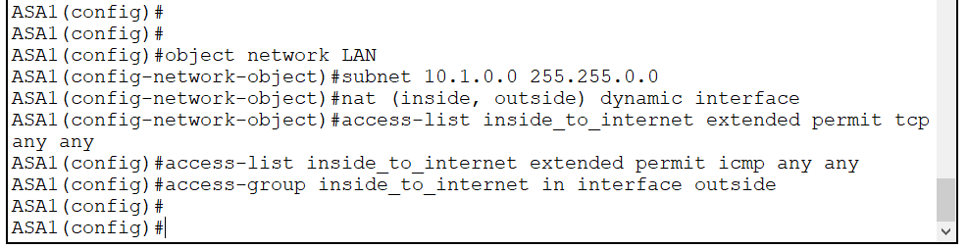
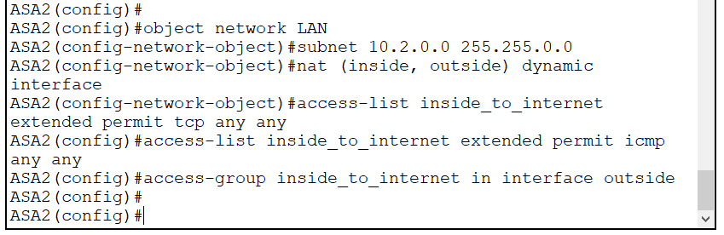
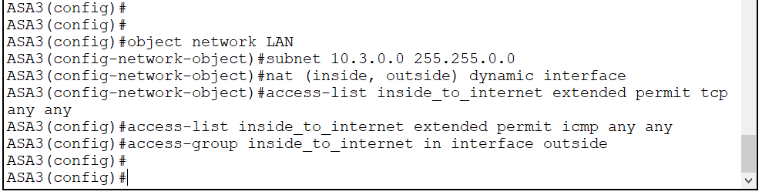

In conclusion, the usage of ACLs is critical for network security because it can enhance network security, manage network traffic, support regulatory compliance, and offer fine-grained access control.

Secure Shell, Telnet
Secure Shell (SSH) is widely used in network administration, as it provides secure remote access to network devices, such as routers, switches, and servers. It reduces the need for physical access to network devices and improves network management proficiency.
Here, I have configured secure shell connection for R1 using ip-domain name as londoncollege.com.

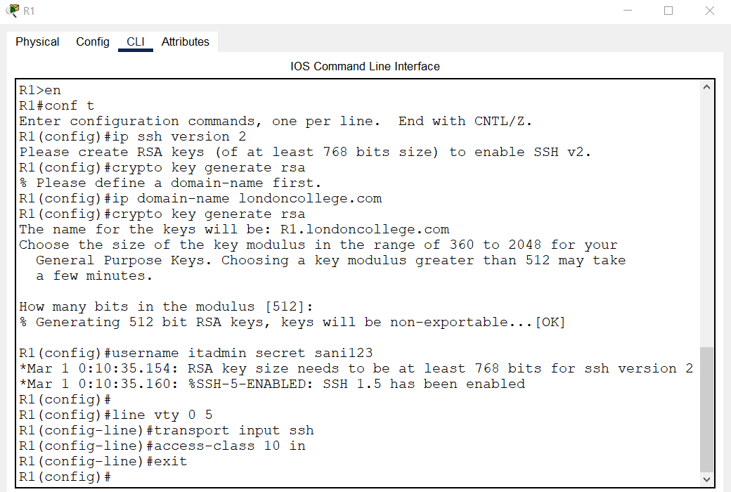
Thus, SSH offers port forwarding capabilities, safe remote access, strong authentication, encrypted communication, and regulatory compliance.
Telnet is an older network protocol used to provide command-line access to remote computers or devices. It has been mainly replaces by more secure protocols like SSH. Telnet can still be utilized in circumstances where security is not a top priority or where access to legacy systems is required.
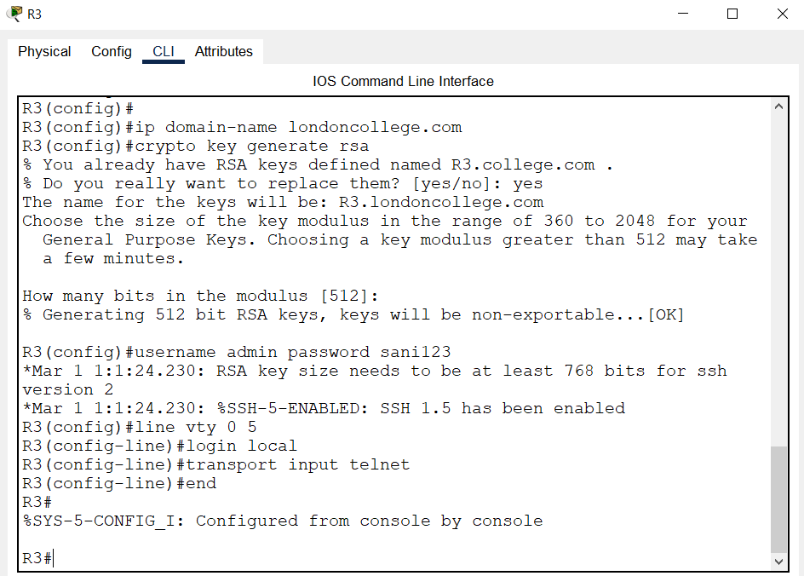
Overall, Telnet is not generally advised for use in current network environments because to its security flaws. However, it may be utilized in specific circumstances, such as for network debugging or older systems.

Network Time Protocol (NTP)
NTP is used to synchronize the time on computers and other networked devices. Many network services and applications depend on reliable time synchronization to ensure that events take place in the right order and that timestamps are valid.
For the routers, I have configured OSPF authentication in Area 0 using message-digest authentication. As a result, each router in Area 0 will need to utilize the same OSPF authentication key. Additionally, it configures message-digest authentication using OSPF.
Table 5: OSPF Configuration for Routers.
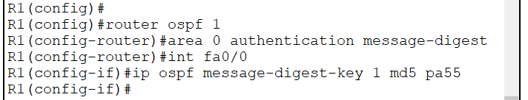
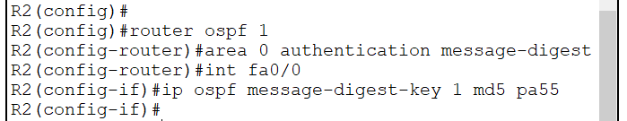
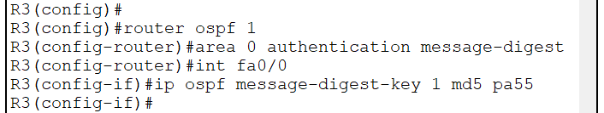

The OSPF authentication key configuration makes it necessary for routers to authenticate themselves before they may take part in OSPF routing. This ensures the integrity of OSPF routing updates and helps to prevent unauthorized access to the network.
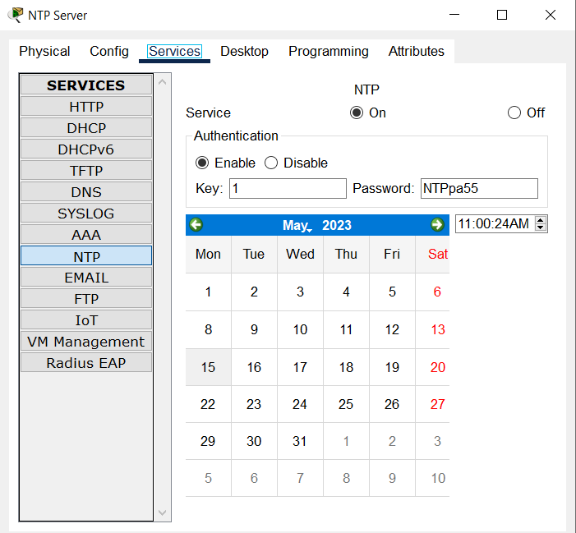
Here, I have configured the routers to use NTP server with the IP address of 10.1.0.55 as a time source for clock synchronization. The routers have also been configured for NTP authentication. I have also enabled logging of timestamps in the device logs with millisecond precision.
Table 6: NTP Configurations on Routers.
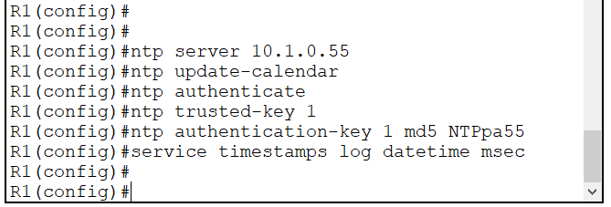
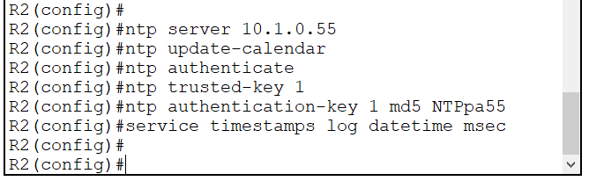
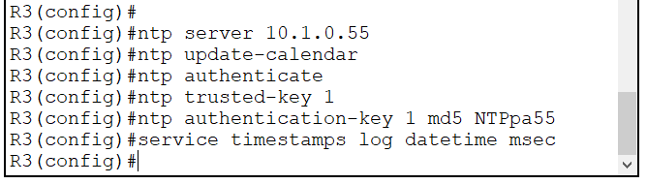

Together, these instructions give the device the ability to update the hardware clock, synchronize with an NTP server, verify NTP packets, and log messages with timestamps. The NTP authentication aids in ensuring that the device is receiving accurate time information from a reliable source.

Syslog, Prevention Detection System
The Syslog Server will provide message logging. I have configured the routers to identify the remote host (Syslog Server) to receive system log messages which allows network administrators to centralize and analyze log messages from multiple devices in a single location.
Table 7: Logging Configuration on Routers.
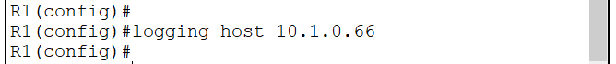
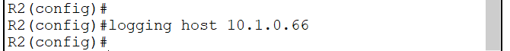
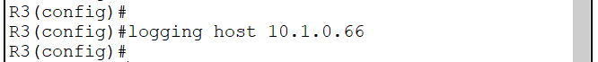

By examining the system log messages produced by the network devices, we can quickly discover and troubleshoot issues on their network by creating a syslog server.

Authentication, Authorization, Accounting (AAA)
AAA is a framework for controlling access to computer resources and enforcing security policies. Here in the college network, I have configured local AAA service and also the username and password for console access on R1, R2 and R3.
Table 8: Local AAA Configuration on Routers.
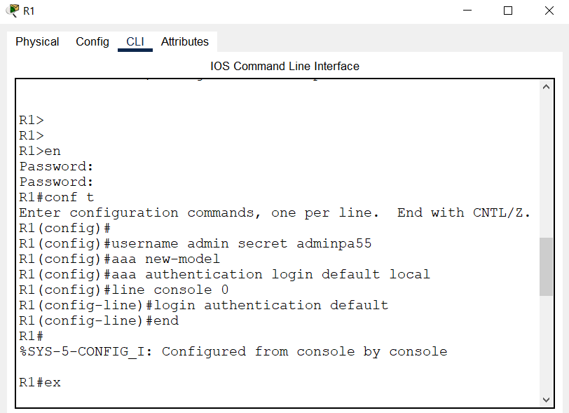
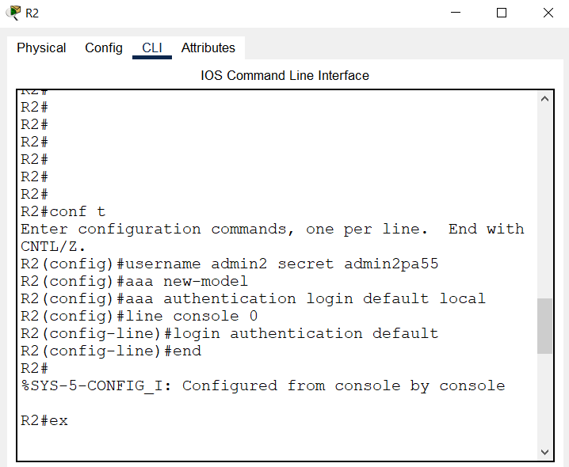
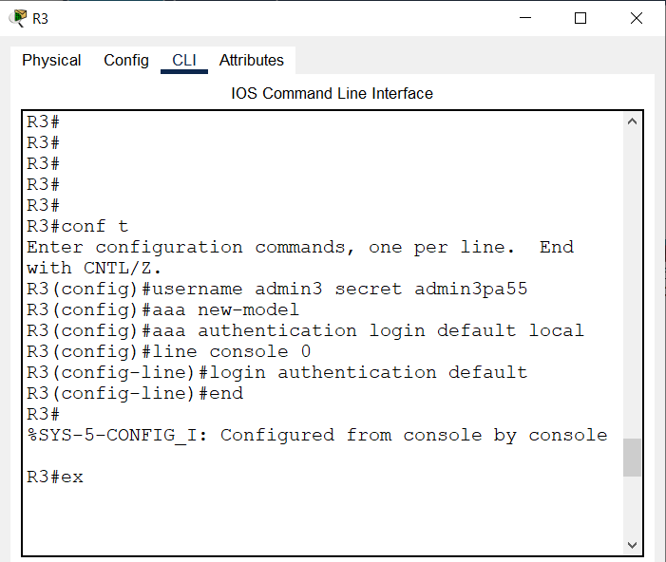

The AAA framework is often used in network security. By using AAA, we can enforce security policies, control access to network resources, and track user activity to improve security and compliance.
Thus, these are all the security configurations for the network. I have implemented firewalls, VLANs, access control lists, NTP, syslog and AAA configurations on various network devices across the network.

Network Testing
Logical workspace of the London College Network:
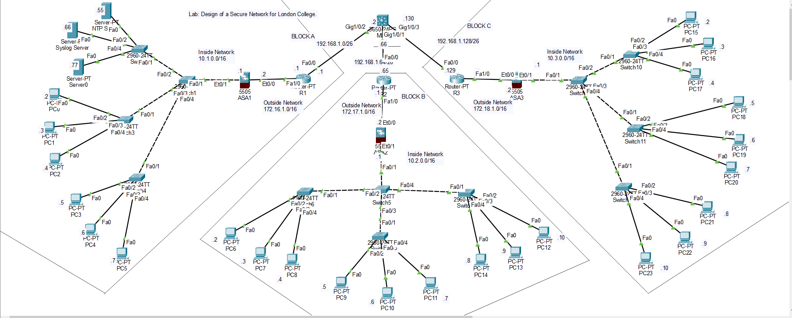

Table 9: Testing firewall.
Test Title | Testing firewall configurations.
Test Scenario | I have setup 2 VLANs: Vlan1 for the inside interface and Vlan2 for the outside interface. The inside interface has been given a security-level of 100 because it is the internal network and more trusted and secure zone within the firewall. The outside interface has been given security-level of 0 as it is the lesser trusted zone. Here we will test if the incoming traffic in the LAN will be blocked or not by the firewall.
Test Steps | - First, let’s confirm the VLANs and security-levels setup for the firewalls.  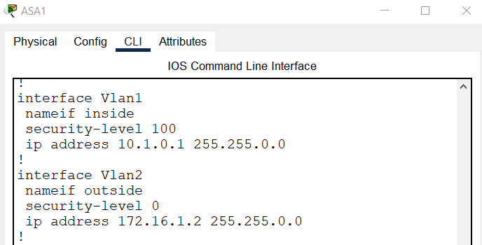  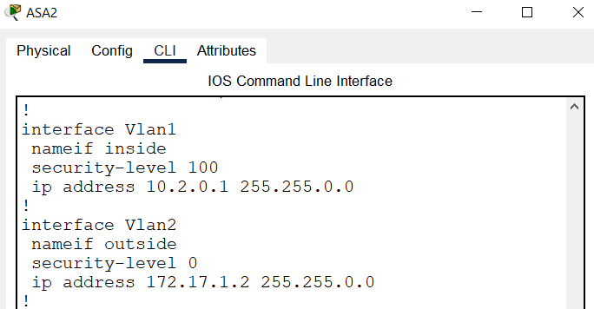  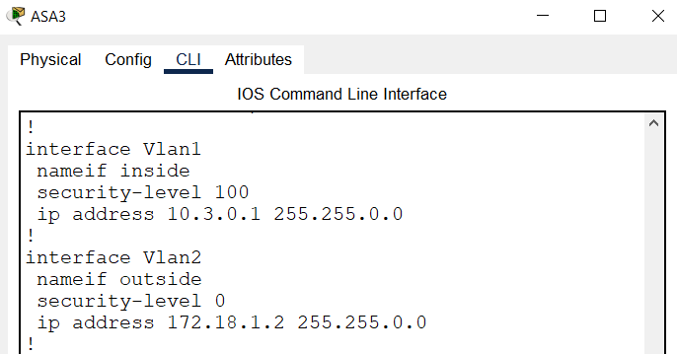  - Now, we will be sending ICMP traffic from within the local area network. Since firewalls typically block ICMP Echo Request and Echo Reply messages, we should see the ping fail.
Expected Result | Blocks ICMP traffic.
Test Data | 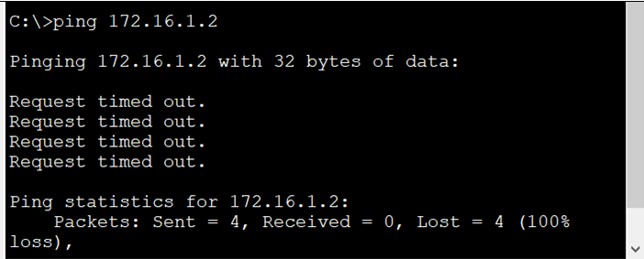  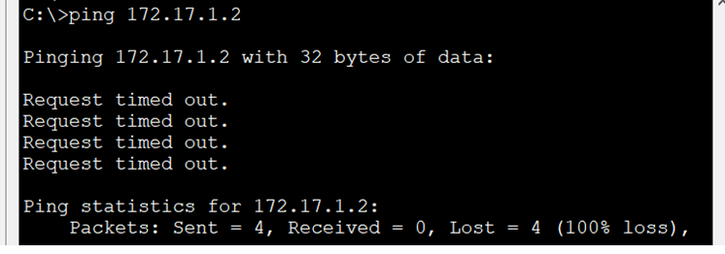  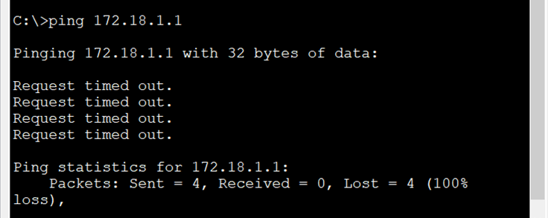
Actual Result | Blocks ICMP traffic.
Analysis | The criteria for the test to be successful has been fulfilled. The ICMP traffic has been blocked.

Table 10: Testing ACL.
Test Title | Testing the Access Control List to allow configured protocols.
Test Scenario | Previously, no ACL had been configured on the firewalls.  When the firewalls were deployed, I set up the security-level of 100 for inside and a level of 0 for outside. So, previously it denied all incoming traffic. The following screenshot shows of a PC in Block A pinging the inside interface of firewall that is successful and the outside of the firewall that has failed.  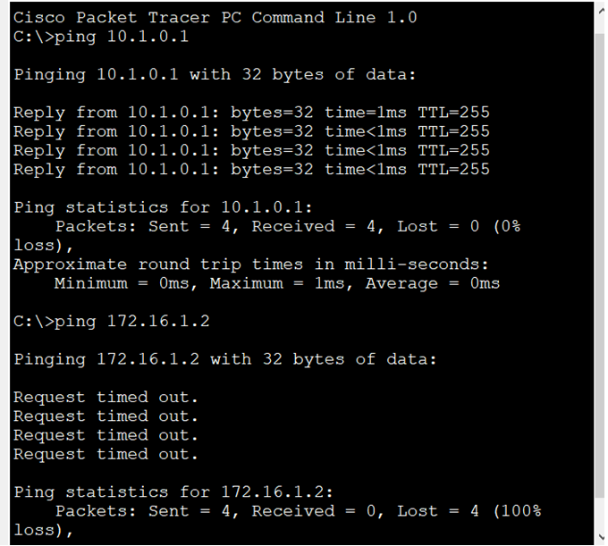  Block B and Block C has been tested similarly.  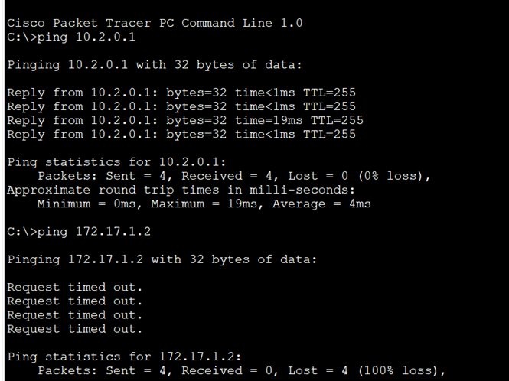  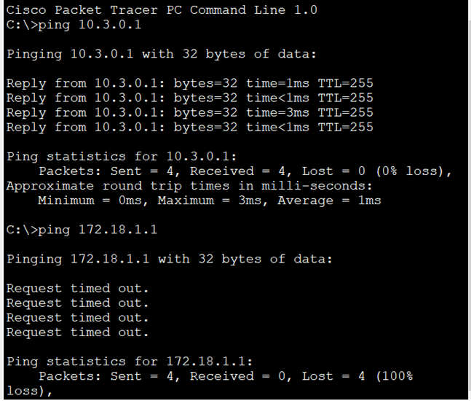  Then, we configured the ACL to allow ICMP and TCP traffic.
Test Steps | - First let’s confirm the access list configuration on ASA1, ASA2, and ASA3.  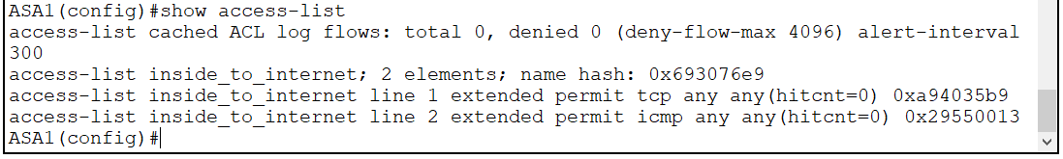  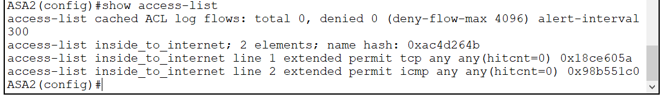  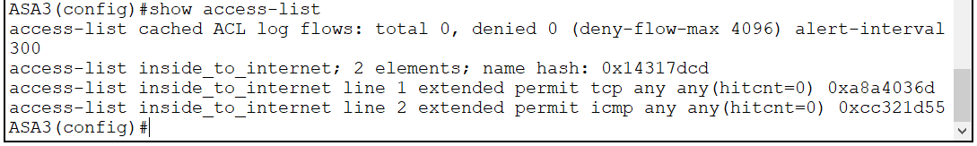  - Ping the device from inside network to outside network on Block A, B and C.
Expected Result | The pings should be successful.
Test Data | 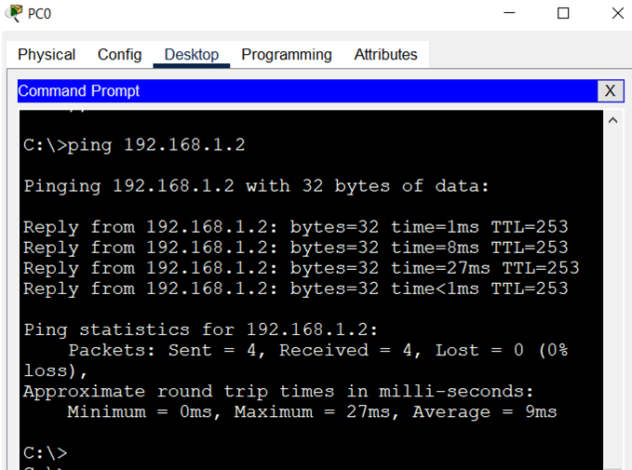  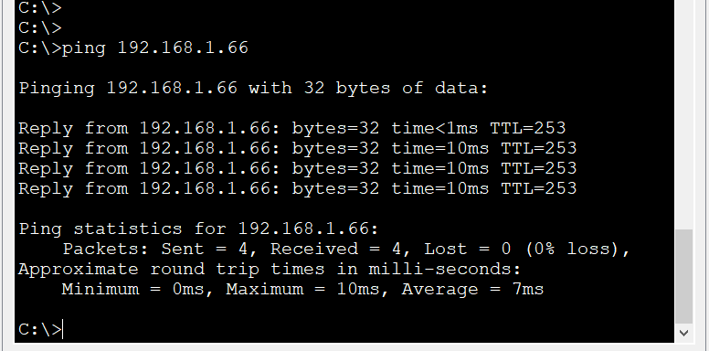  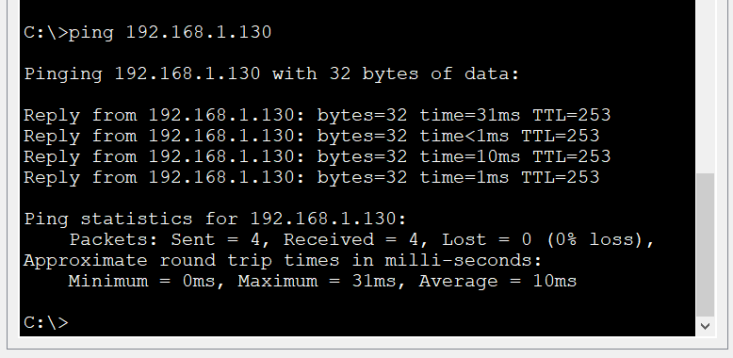
Actual Result | The pings are successful.
Analysis | The criteria for the test to be successful has been fulfilled. The same pings that had failed earlier are now successful because I have configured ACL to allow ICMP traffic. The ICMP traffic is allowed to pass through as configured in the ACL.

Table 11: Testing SSH and Telnet.
Test Title | Testing remote connection using SSH and Telnet.
Test Scenario | Previously, no configurations had been done for remote access and communication with network devices. Remote work has always existed since workers need to travel and some may even be working from home (WFH). We are using both Telnet and SSH for secure management of network devices. This makes it possible for administrators to remotely manage configurations, run commands, and troubleshoot systems in a safe manner.
Test Steps | - First, let’s confirm the setup of SSH and Telnet in the network devices. SSH has been setup in R1 and Telnet has been setup in R3.  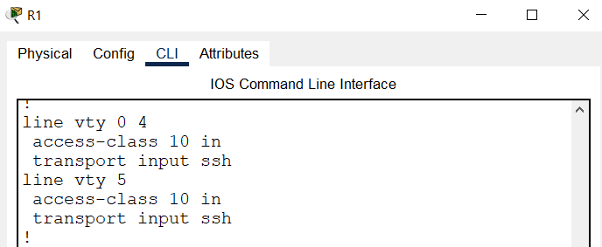  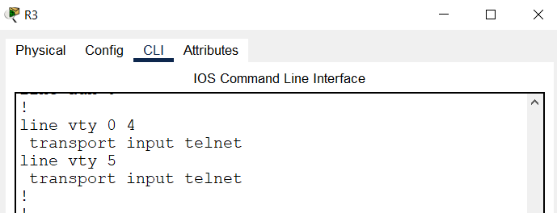  Next, we will do the following:  - Set up a remote connection to the router R1 using SSH.  - Set up a remote connection to the router R3 using Telnet.
Expected Result | Successful connections to the network devices when the login credentials are correct to ensure secure remote connection.
Test Data | For SSH connection:  When using the wrong credentials:  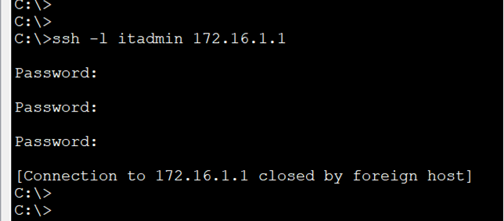  When using the correct credentials:  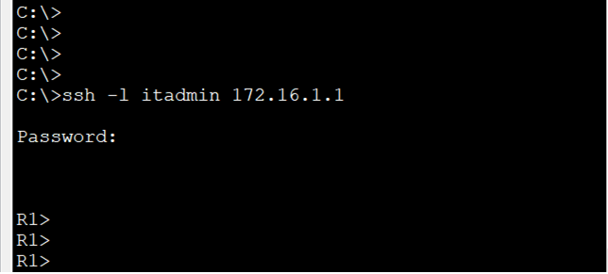  For Telnet connection:  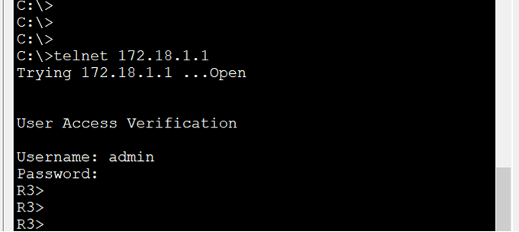
Actual Result | Successful connections to the network devices when the login credentials are correct to ensure secure remote connection.
Analysis | The criteria for the test to be successful has been fulfilled. We are able to set up remote connections to the network devices R1 and R3 through the use of SSH and Telnet.

Table 12: Testing NTP and Syslog.
Test Title | Testing the use of Network Time Protocol and Syslog.
Test Scenario | Previously, no configuration for NTP and syslog had been done and no NTP and syslog servers had been setup. When events from numerous devices are generated by syslog servers, having synchronized clocks aids in precise correlation and log analysis during security incident investigation or troubleshooting tasks. Network devices R1, R2, and R3 have been configured accordingly along with the NTP server and Syslog server.
Test Steps | - Execute several commands in the above mentioned network devices in order to generate some logs in the Syslog server.
Expected Result | Log messages are generated on the Syslog server.
Test Data | 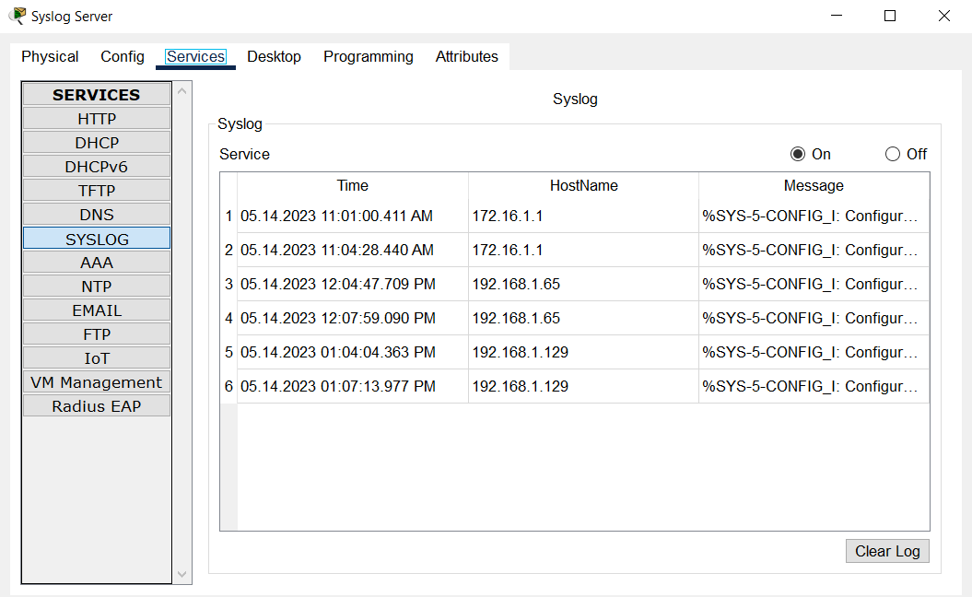  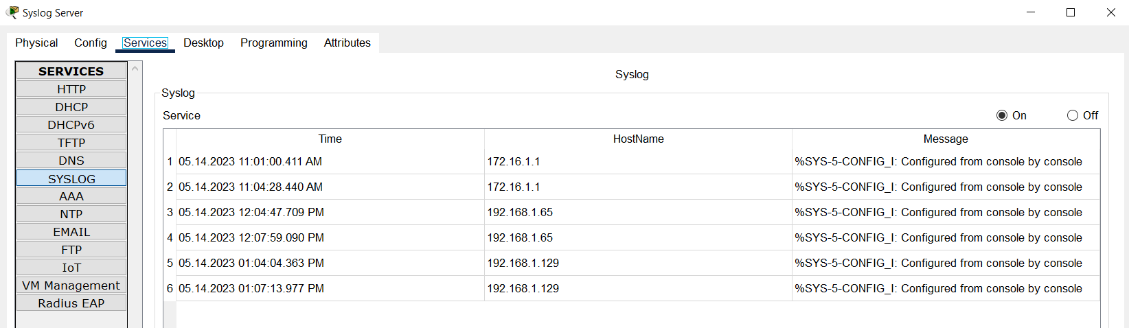
Actual Result | Log messages are generated on the Syslog server.
Analysis | The criteria for the test to be successful has been met. The syslog events have been generated and recorded on different network devices along with the synchronized clocks that helps in correlating and analyzing logs accurately.

Table 13: Testing local AAA Authentication.
Test Title | Testing the local AAA authentication for console access.
Test Scenario | Previously, no configuration for AAA has been setup. Network devices R1, R2, and R3 have been configured with local AAA Authentication for console access. The routers are configured to authenticate users against a local database of usernames and passwords kept on the device itself when configuring local AAA authentication for console access. This adds an extra layer of protection by requiring proper credentials in order to access the console port on the device.
Test Steps | - First, let’s confirm the setup of AAA in the network devices. Local AAA Authentication for console access has been configured on all three routers.  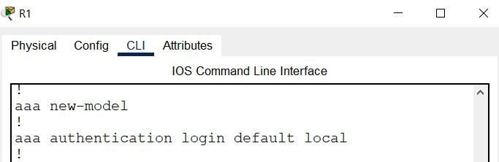  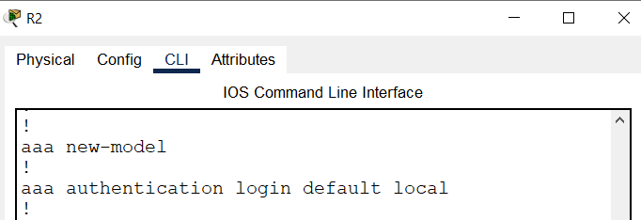  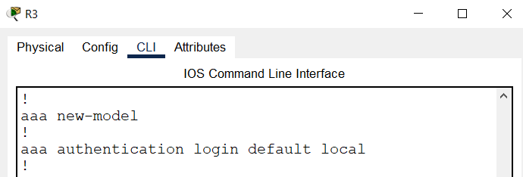  - Now, we verify the user EXEC login using the local database.
Expected Result | Successful login for authorized personnel.
Test Data | 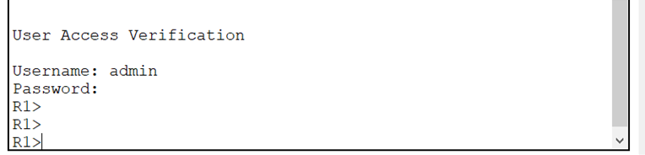  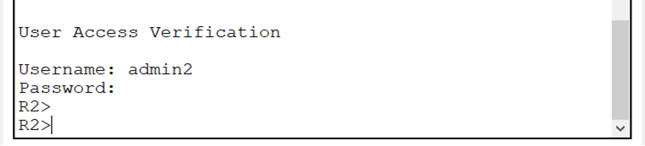  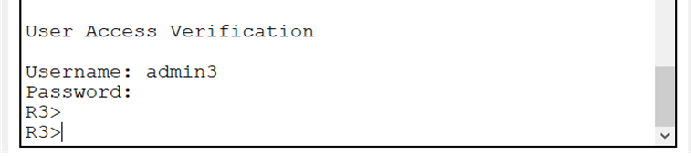
Actual Result | Successful login for authorized personnel.
Analysis | The criteria for the test to be successful has been met. Only when the username and passwords match, access is granted into the network devices.

