This is a part of Security Blue Team's course-wrap-up challenge. This is the final challenge of 'Introduction to Network Analysis' course.

Network Analysis Challenge
Alexis is a fictional cybersecurity company with thousands of employees. An attacker has gained unauthorized entry into its premises and has connected their laptop to an unused port on a switch. The attacker now has access to the company’s internal networks. Within the internal network, there is a central server where critical proprietary data is stored. In this capture, the attacker is attempting to collect SSH credentials that they can use to log into the central server.
Download the necessary files from: https://elearning.securityblue.team/home/courses/free-courses/introduction-to-network-analysis#content#course-capstone#course-capstone#activity-network-analysis-challenge

Challenge Questions
1. What is the MAC address of the attacker?
2. What is the type of attack which is taking place that allows the attacker to listen in on conversations between the central server and another host?
3. What is the file which was downloaded from the central server?
4. What department does Borden Danilevich work in?
5. What is the SSH password of the Domain Administrator?

First, let me open the PCAP file that was provided by SBT for this challenge.
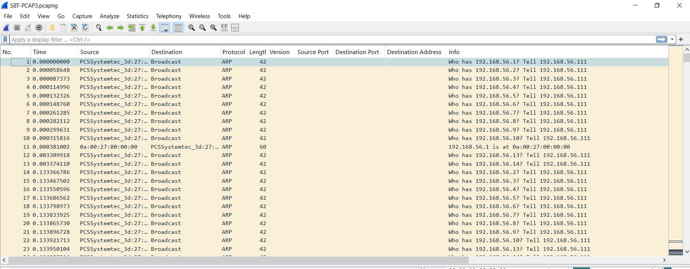
Looking at all these packets, it is safe to assume that 192.168.56.111 has been sending ARP Requests to everyone. This seems like a suspicious behavior and I have flagged this IP as the attacker.
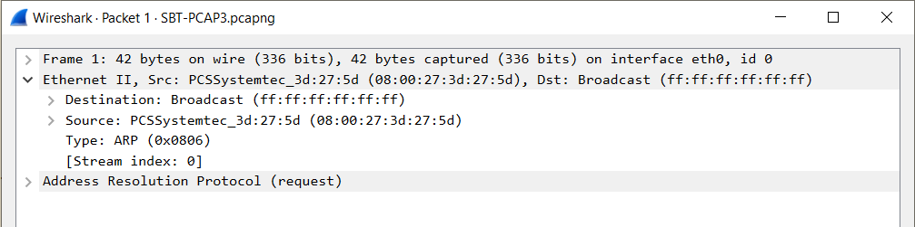
Inspecting the packet and looking at the source MAC, here, we have the answer to Question 1. The MAC Address of the attacker is 08:00:27:3d:27:5d.

The type of attack that allows the attacker to listen in on conversations between the central server and another host is known as Man-In-The-Middle attack, the answer to Question 2.

Now, we have to find which file was downloaded from the central server. For this I will be using the filter feature of Wireshark and use the keyword 'ftp'.
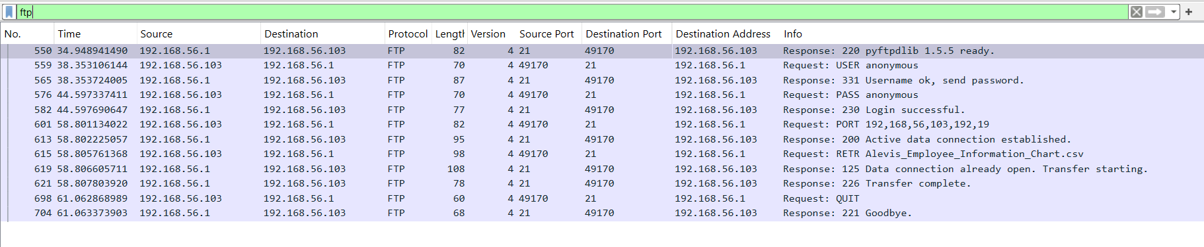
Here, we can see all the ftp packets that have been captured.
Now, we right-click on one of the packets and follow the TCP Stream.
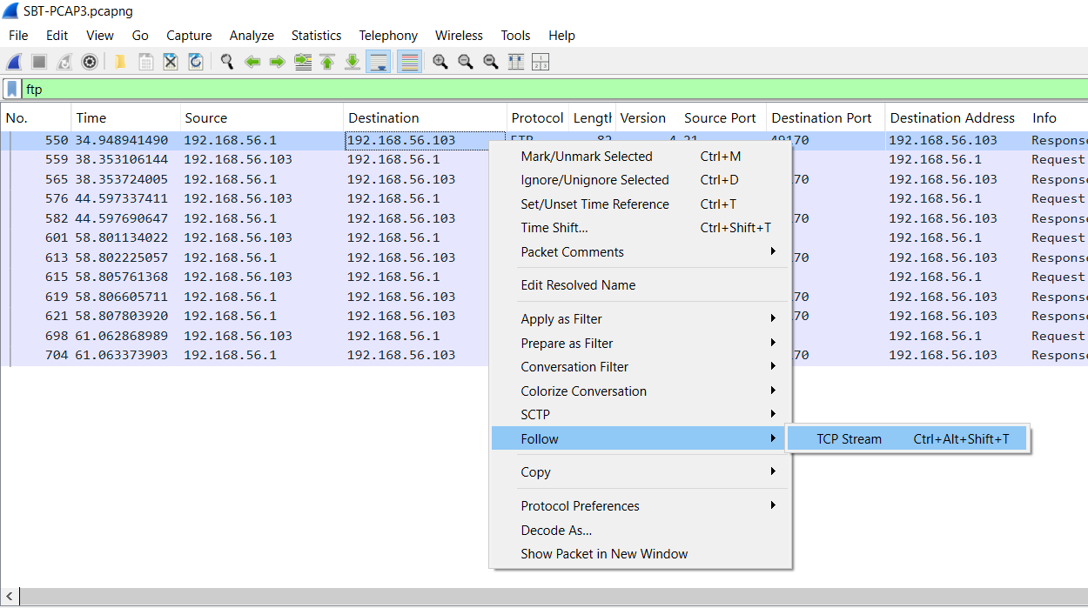

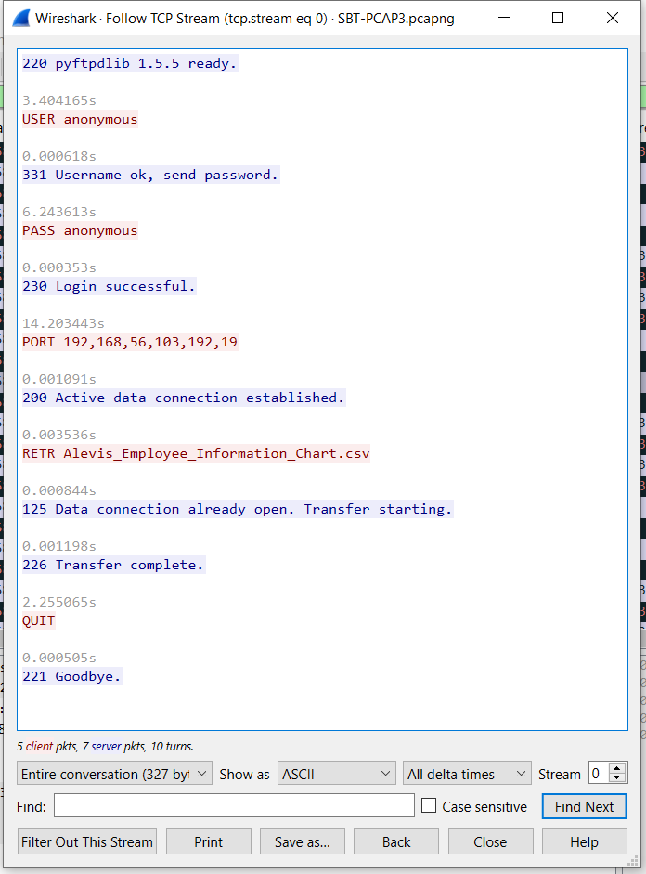
Here, in the stream we see that Alevis_Employee_Information_Chart.csv has been retrieved and transferred. This is the answer to Question 3.

Now, we have to find a user named "Borden Danilevich". Once again, we filter with the keywords ' frame contains "Borden" '.

Now, I follow this stream and search for "Borden" using the Find option.

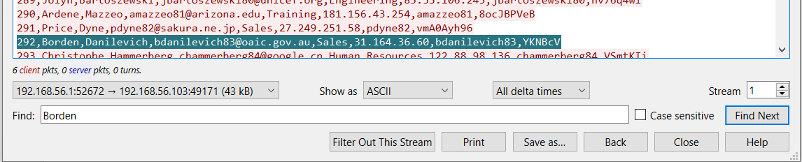
I have found him and also the answer to Question 4. He works in Sales Department.
In the same stream, let me search for 'admin'.
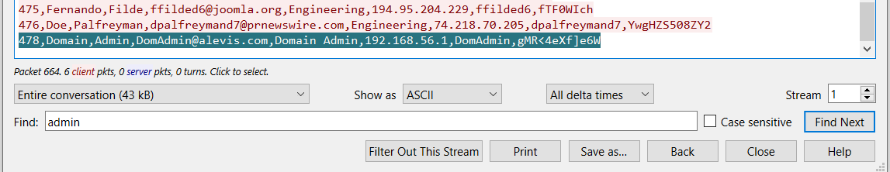

And, here is the answer to Question 4, the SSH password of the Domain Administrator is gMR<4eXf]e6W.

In conclusion, this is how I have demonstrated what I have learned in this module.

