Table of Contents
Scenario 2
Practical Tasks 2
Network Design 3
Table 1: IP Addressing Table (WAN Connections) 4
Table 2: IP Addressing Table (ISP and Public IPs) 4
Table 3: IP Addressing Table (Palpa Branch) 5
Basic configuration commands for network connectivity 6
Table 4: IP Address Configuration on Network Devices. 6
Table 5: Multi-Layer Switching for L3 Switches 9
Table 6: VLAN and Inter-VLAN Routing using SVIs. 10
Table 7: DHCP Configuration. 14
Implementing switch and router redundancy protocols 15
Table 8: Implementing rapid PVST mode in spanning tree. 15
Table 9: Enabling LACP and EtherChannel. 17
Table 10: Configuring HSRP. 18
WAN protocols configuration 19
Table 11: Configuring Frame Relay. (WAN protocol) 19
Deploying network monitoring tools 24
Table 12: Configuring NTP and Syslog. 24
Table 13: Configuring SNMP. 26
VPN 27
Practical demonstration of VPN 27
Documentation of troubleshooting methods 35

This is a part of the assignment of the course 'Transport Network Design' provided by International School of Management and Technology, partnered with University of Sunderland.
The scenario and tasks are provided by the college.
The work is entirely of the author.

Scenario
London College was established in 2018 with a mission to deliver internationally recognized qualifications. London College offers a range of qualifications in collaboration with the University of Sunderland, Pearson BTEC, and ACCA, UK. London College exists to make an impact in the education system in Nepal, with an ambition to deliver industry-relevant education and make higher education accessible and beneficial to all those with the passion and ability to succeed.
London College is committed to the delivery of inclusive, cost-effective, and internationally recognized academic programmes in the context of core local requirements and values. London College main goal is to reach more students with high-quality, life-changing learning that meets their needs and enriches society. At London College, students will gain an internationally recognized UK degree that will open doors to an outstanding future.
Recently London College is going to open new college on Western Development Region of Nepal in Palpa. For build the IT infrastructure you have hire as a network and system administrator of the new college you have to design and implement network for the new college and have to prepare a report also including the following topics:
- Planning for Network infrastructure design and setup
- Prepare L3 and L2 redundancy protocols
- Planning WAN and LAN Connectivity
- Prepare and plan for link aggregation.
- Make Scalable network.
- Implement Network monitoring and network security.

Practical Tasks
- Design and implement a network prototype using a network simulator (or lab devices), which incorporates redundancy at Layer 2 and 3 and link aggregation features with the following requirements:
  - Include at least three Layer 2 switches.
  - Provide redundant link between all the switches. (LACP, Etherchannel)
  - Use Rapid PVST+ as spanning tree protocol.
  - Use link aggregation in the main active link.
  - Provide a redundant gateway using a suitable first-hop redundancy protocol. (HSRP, VRRP, GLBP)
- Configure WAN protocols as part of London College's network solution.
- Deploy network monitoring tools and troubleshooting methods to establish network baselines and produce network documentation. Also, step by step process of troubleshooting methods.

Network Design
As the administrator that has been appointed for the new branch of London College in Palpa, I have designed the following network. It is a three-tier network. There are 2 core routers named LC_Palpa_CR1 and CR2. This naming convention precisely stands for London College Palpa Core Router 1 and 2. They are both connected to two different ISPs so if one fails, we still have a backup that will help us remain connected to the internet. Next is the distribution layer where we have two multilayer switches. They are named LC_Palpa_DSW1 and 2 with same intentions as before. DSW1 and 2 stands for Distribution Switches 1 and 2. The access layer switches also have similar naming conventions to make it easier to separate them. LC_Palpa_ASW1 and so on for Access Switches. Currently, I have designed 5 different VLANs, each for a specific groups of people. There is EtherChannel in the active link between the distribution layer switches.
The ISPs are connected to other devices on the internet. There is also a demonstration of VPN tunneling. The Palpa_WAN_Edge_Router has been connected to the Ktm_WAN_Edge_Router with Frame Relay acting as the WAN protocol. This helps in swift communication between the two branches.
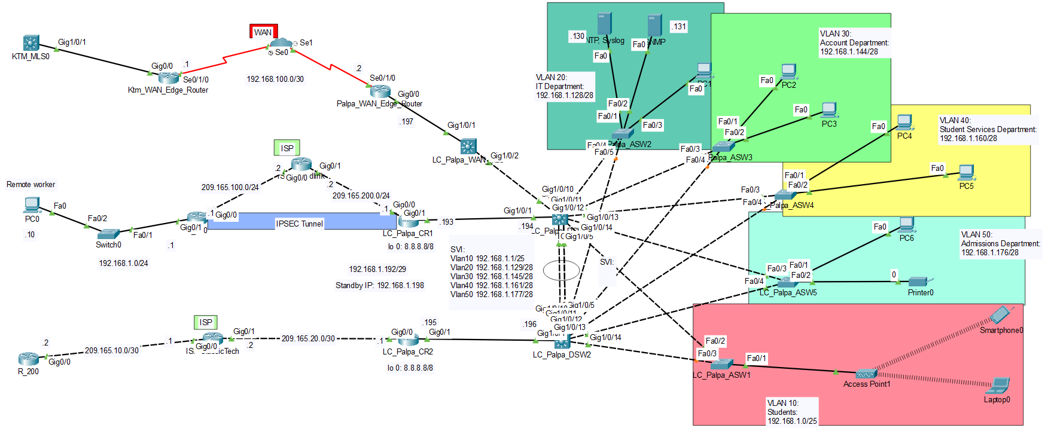
Figure 11: Network Design.

Table 1: IP Addressing Table (WAN Connections)
IP Addressing Table (WAN Connection)
Device | Interface | IP Address | Subnet Mask | DLCI | Default Gateway
KTM_WAN_ Edge_Router | Se0/1/0 | 192.168.100.1 | 255.255.255.252 | 100 | N/A
Palpa_WAN_ Edge_Router | Se0/1/0 | 192.168.100.2 | 255.255.255.252 | 101 | N/A
Palpa_WAN_ Edge_Router | G0/0 | 192.168.1.197 | 255.255.255.248 | - | -

Table 2: IP Addressing Table (ISP and Public IPs)
IP Addressing Table (ISP & Public IPs)
Device | Interface | IP Address | Subnet Mask | Default Gateway
ISP_Worldlink | G0/0 | 209.165.100.2 | 255.255.255.252 | N/A
ISP_Worldlink | G0/1 | 209.165.200.2 | 255.255.255.252 | N/A
ISP_ ClassicTech | G0/0 | 209.165.10.1 | 255.255.255.252 | N/A
ISP_ ClassicTech | G0/1 | 209.165.20.2 | 255.255.255.252 | N/A
LC_Palpa_CR1 | G0/0 | 209.165.200.1 | 255.255.255.252 | 209.165.200.2
LC_Palpa_CR2 | G0/0 | 209.165.20.1 | 255.255.255.252 | 209.165.300.2
R_100 | G0/0 | 209.165.100.1 | 255.255.255.252 | 209.165.100.2
R_100 | G0/1 | 192.168.1.1 | 255.255.255.0 | N/A
R_200 | G0/0 | 209.165.10.2 | 255.255.255.252 | 209.165.400.1

Table 3: IP Addressing Table (Palpa Branch)
IP Addressing Table (Palpa Branch)
Device | Interface | IP Address | Subnet Mask | Default Gateway
LC_Palpa_CR1 | G0/1 | 192.168.1.193 | 255.255.255.248 | 209.165.200.2
LC_Palpa_CR1 | Standby | 192.168.1.198 | 255.255.255.248 | 209.165.200.2
LC_Palpa_CR1 | Loopback | 8.8.8.8 | 255.0.0.0 | N/A
LC_Palpa_CR2 | G0/1 | 192.168.1.195 | 255.255.255.248 | 209.165.20.2
LC_Palpa_CR2 | Standby | 192.168.1.198 | 255.255.255.248 | 209.165.20.2
LC_Palpa_CR2 | Loopback | 8.8.8.8 | 255.0.0.0 | N/A
LC_Palpa_ DSW1 | G1/0/1 | 192.168.1.194 | 255.255.255.248 | 192.168.1.193
LC_Palpa_ DSW2 | G1/0/1 | 192.168.1.196 | 255.255.255.248 | 192.168.1.195
SVI  Switch Virtual Interfaces | Vlan10 | 192.168.1.1 | 255.255.255.128 | 192.168.1.198
SVI  Switch Virtual Interfaces | Vlan20 | 192.168.1.129 | 255.255.255.240 | 192.168.1.198
SVI  Switch Virtual Interfaces | Vlan30 | 192.168.1.145 | 255.255.255.240 | 192.168.1.198
SVI  Switch Virtual Interfaces | Vlan40 | 192.168.1.161 | 255.255.255.240 | 192.168.1.198
SVI  Switch Virtual Interfaces | Vlan50 | 192.168.1.177 | 255.255.255.240 | 192.168.1.198
VLAN 10 Devices | NIC | 192.168.1.1 – 192.168.1.126 | 255.255.255.128 | 192.168.1.1
VLAN 20 Devices | NIC | 192.168.1.129 – 192.168.1.142 | 255.255.255.240 | 192.168.1.129
VLAN 30 Devices | NIC | 192.168.1.145 – 192.168.1.158 | 255.255.255.240 | 192.168.1.145
VLAN 40 Devices | NIC | 192.168.1.161 – 192.168.1.174 | 255.255.255.240 | 192.168.1.161
VLAN 50 Devices | NIC | 192.168.1.177 – 192.168.1.190 | 255.255.255.240 | 192.168.1.177

Basic configuration commands for network connectivity
Below is a basic configuration of all the IP addresses on the different interfaces of the network devices. I have simply followed the above IP configuration table that I designed tediously along with the whole network design.

Table 4: IP Address Configuration on Network Devices.
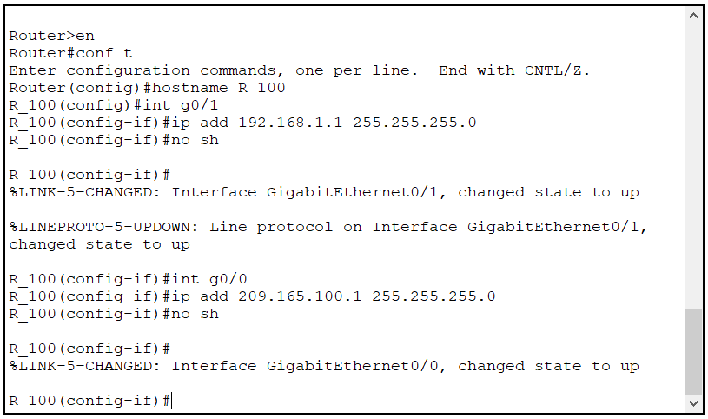
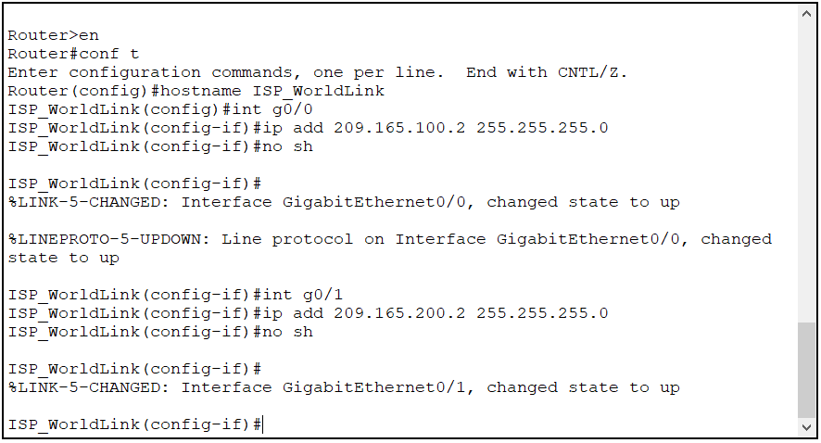
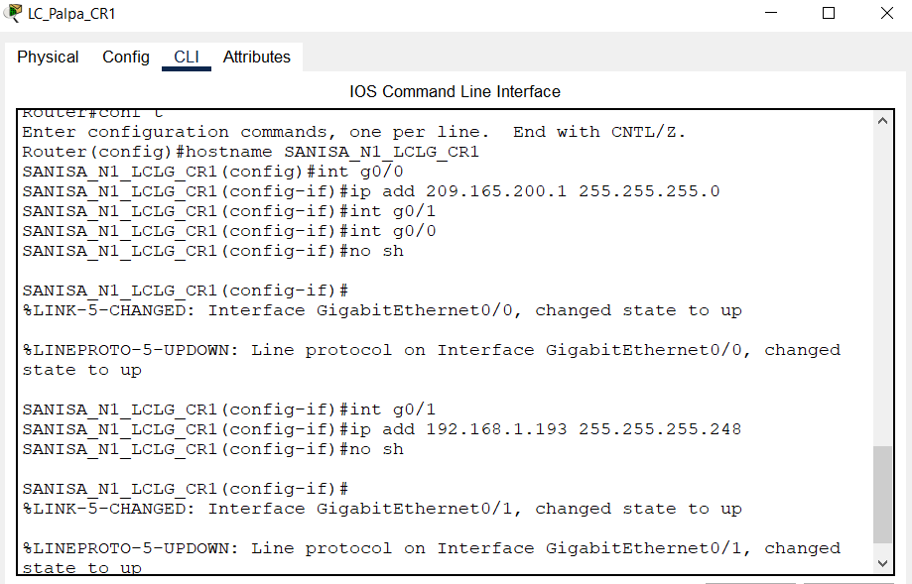
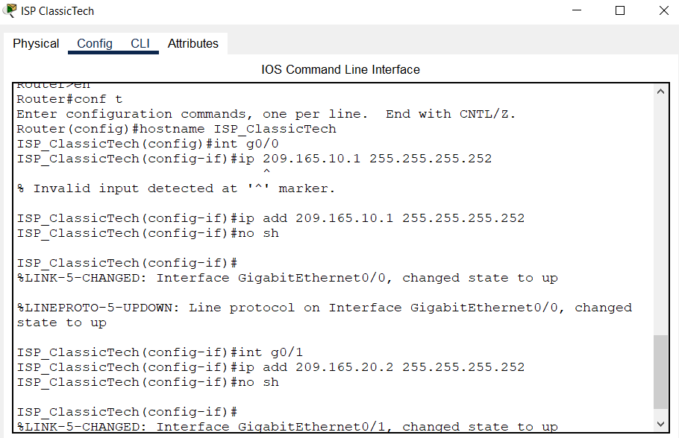
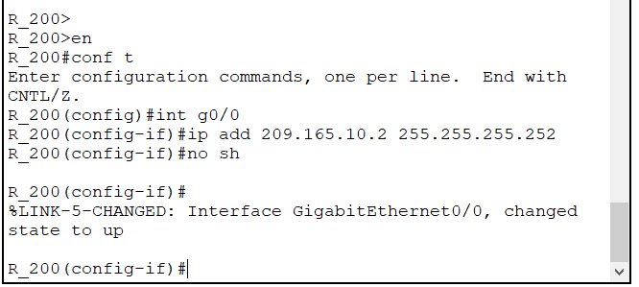
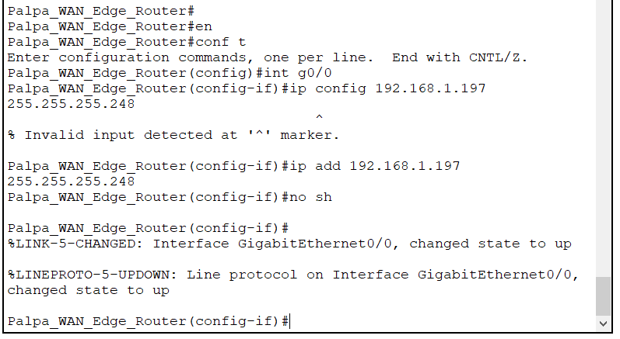

Table 5: Multi-Layer Switching for L3 Switches
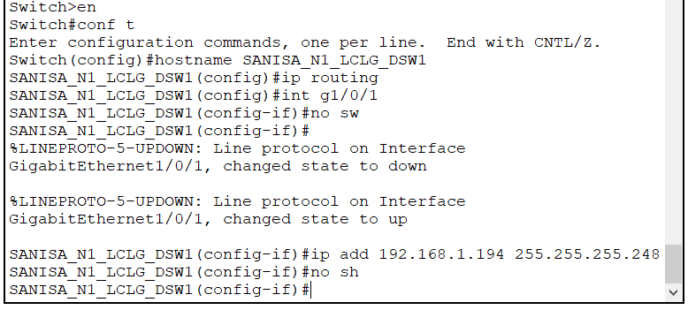
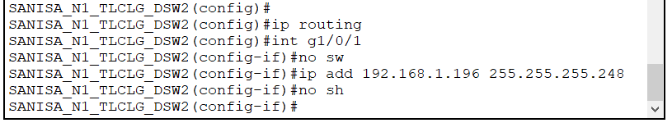

Table 6: VLAN and Inter-VLAN Routing using SVIs.
Next up is the creation of VLANs. VLANs are very important in segmenting one large network to smaller sub networks so each particular department have their very own dedicated connection.
These are all the VLANs that I created for each department and named them accordingly.

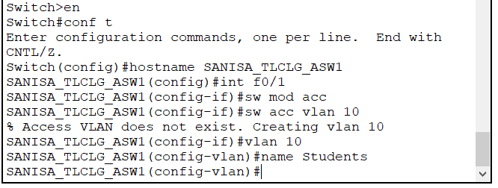
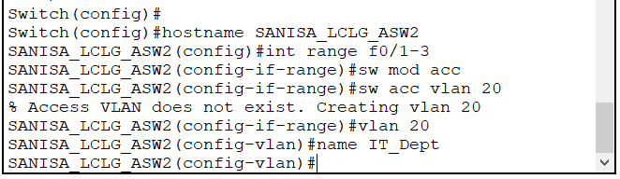
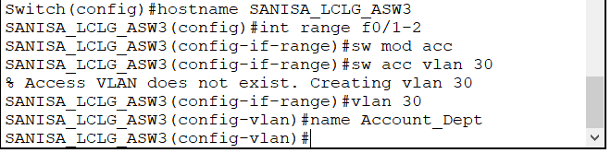
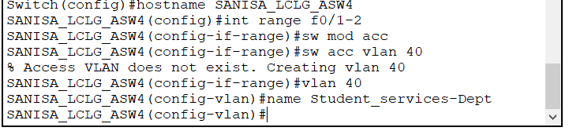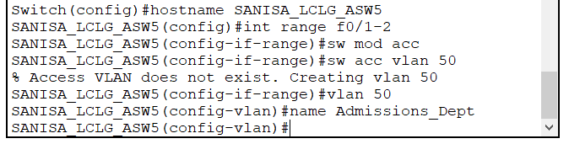
Here, I have implemented trunk modes as it carries more than one VLAN in its link. I have then allowed only VLANs 20,30,40,50 so the students do not have direct access to the other departments.

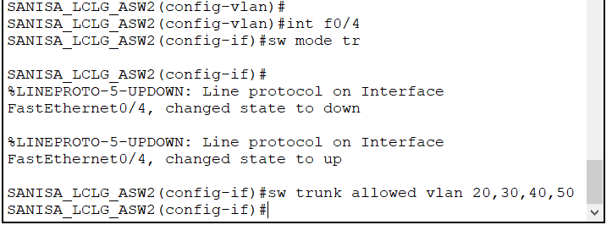
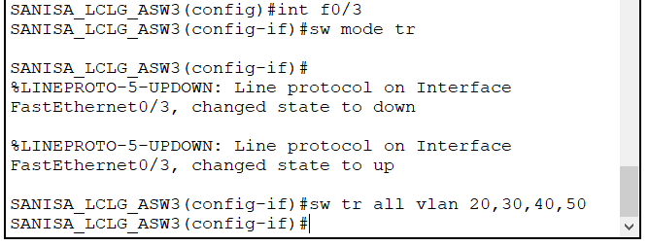
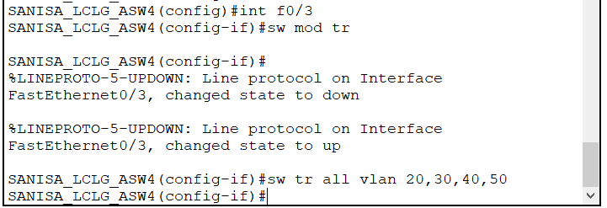
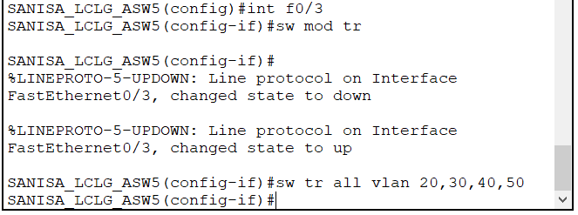
Next, I am in the Distribution Layer multi-switch where I get to assign Switch Virtual Interfaces with the VLAN ID and the corresponding IP address that acts as the default gateway for each VLAN. This lessens network congestion.
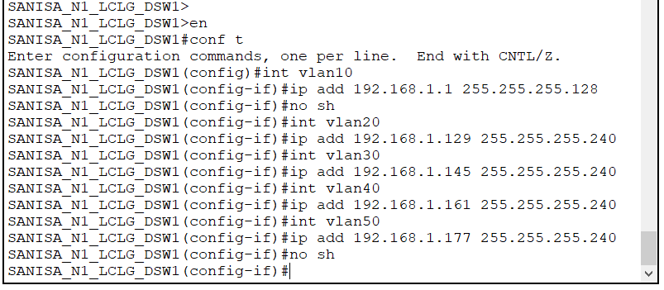
Here, we can confirm that the VLANs have been successfully created and are all administratively UP/UP.
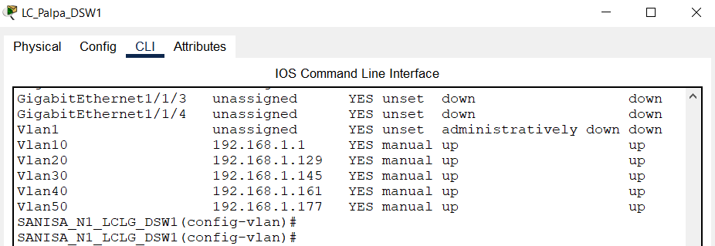
This is just a simple demonstration where I pinged a PC in another VLAN before and after inter-vlan connectivity. As we can see, the pings are successful after the successful configuration of inter-vlan connectivity.
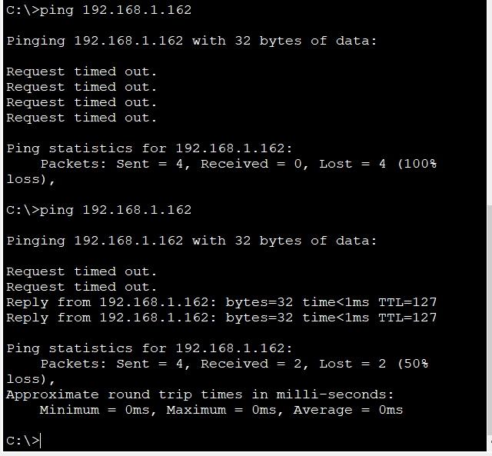

Table 7: DHCP Configuration.
Dynamic Host Configuration Protocol (DHCP) automatically assigns IP addresses to end devices through DORA method. They're really useful when we do not want to spend a lot of time manually configuring IP addresses.
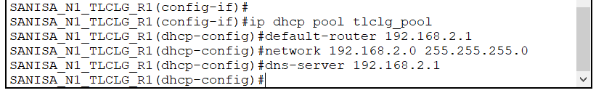
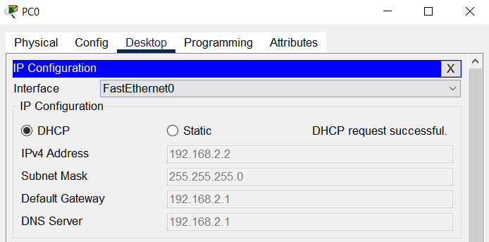
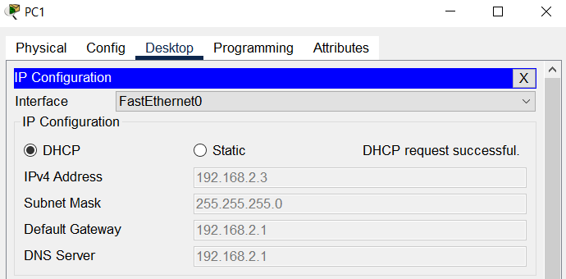

Implementing switch and router redundancy protocols

Table 8: Implementing rapid PVST mode in spanning tree.
Here, I have configured all the switches with Per-VLAN Spanning Tree as per the requirement of the London College branch.

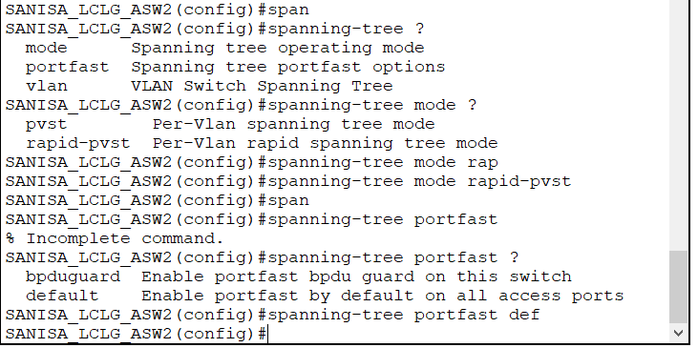
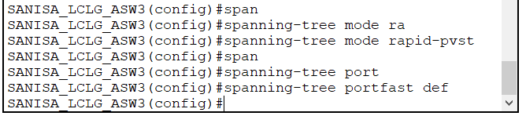
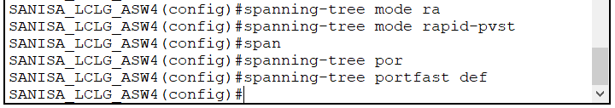
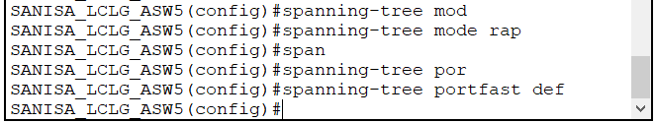
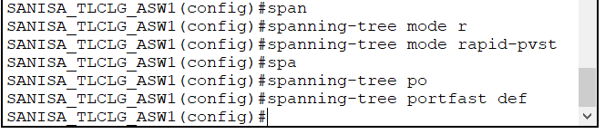

Table 9: Enabling LACP and EtherChannel.
Here, the key word 'active' automatically means we are using Link Aggregation Control Protocol (LACP) to create EtherChannel. It is the industry standard protocol for EtherChannel configuration.
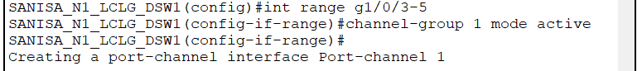

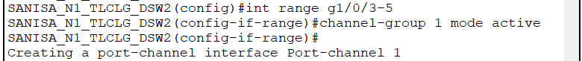
Here, we can see that both the switches have LACP implemented.

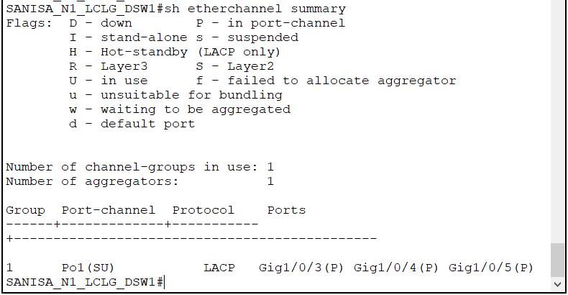

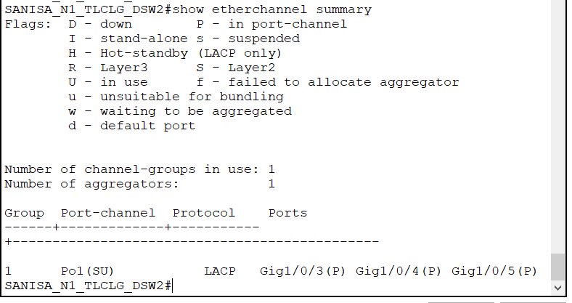

Table 10: Configuring HSRP.
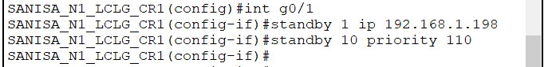
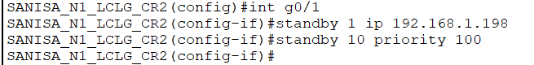
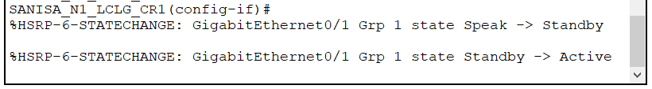
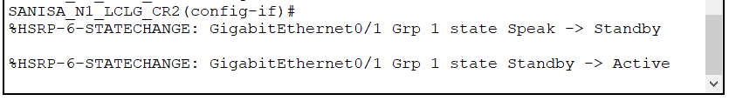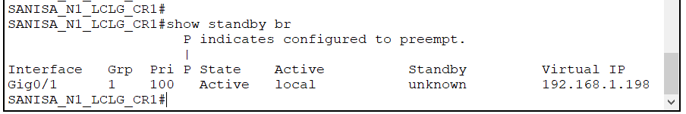

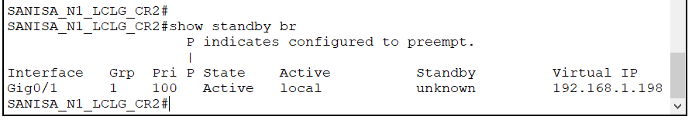

WAN protocols configuration

Table 11: Configuring Frame Relay. (WAN protocol)
Here, I have configured Frame Relay in both the edge routers of the two different branches for easier communication.

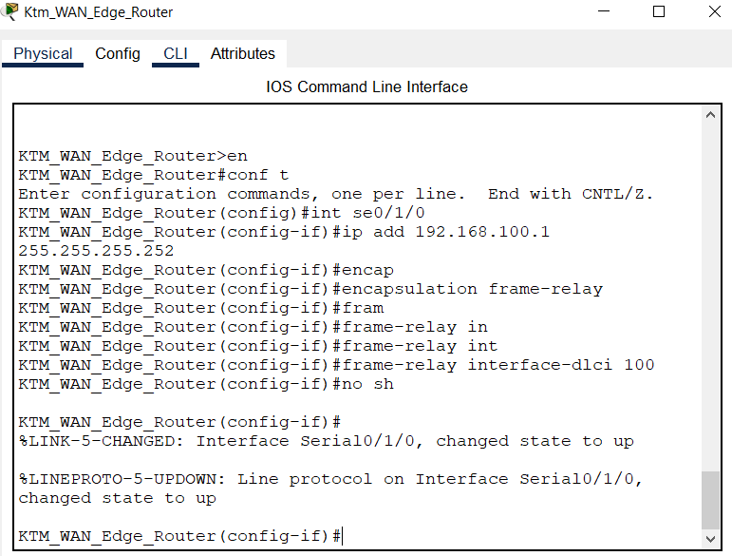

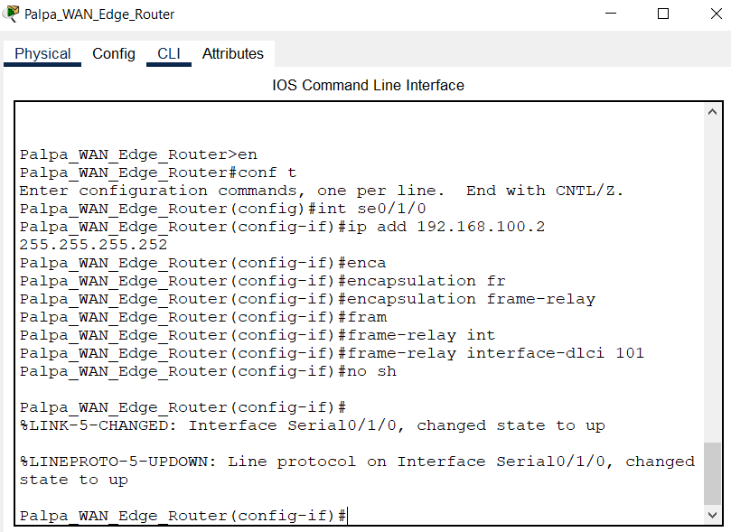
Here, I am adding the DLCI to both the serial ports.

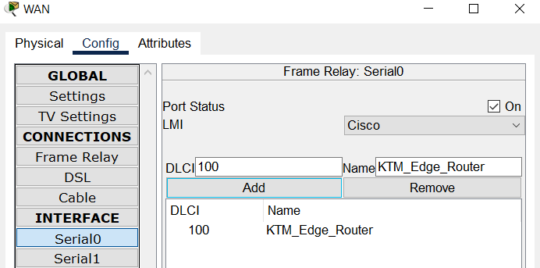
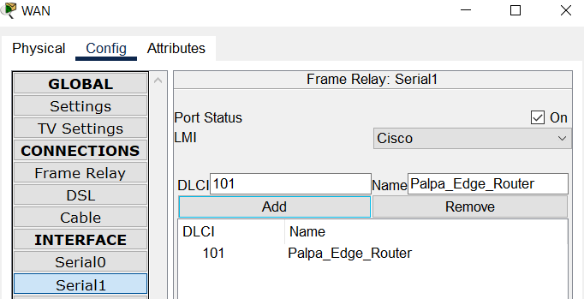
Here, I am creating the Frame Relay connection.

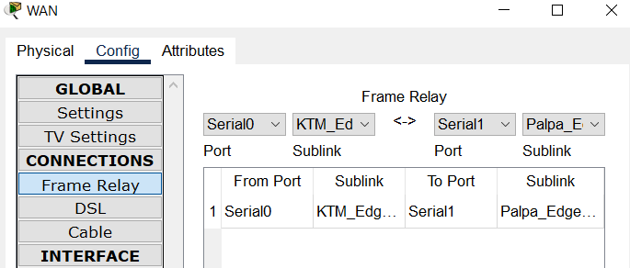
We can see the link is active.
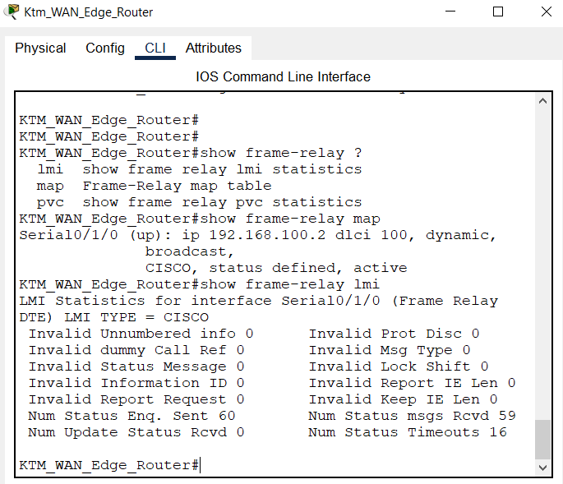
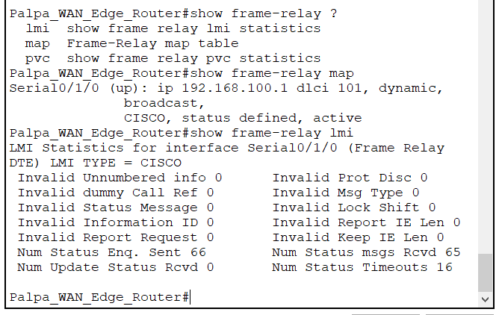
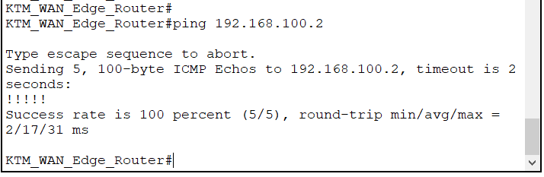

Deploying network monitoring tools

Table 12: Configuring NTP and Syslog.
This is before the time is synchronized.

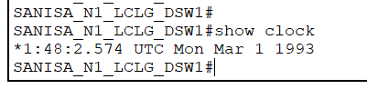
Here, I have added the ntp server to the switch.

Now, the clock shows the correct synchronized time. This is important to record events in the Syslog server.

Here, we can see the different logs.

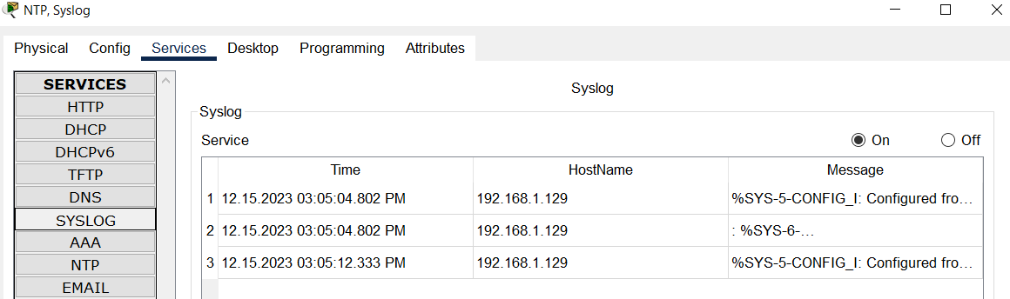

Table 13: Configuring SNMP.
Simple Network Management Protocol helps us to manage our network devices in one place.
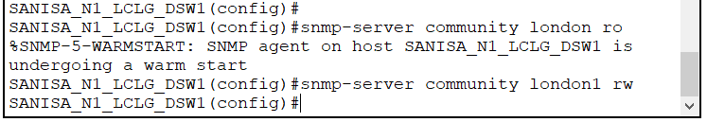
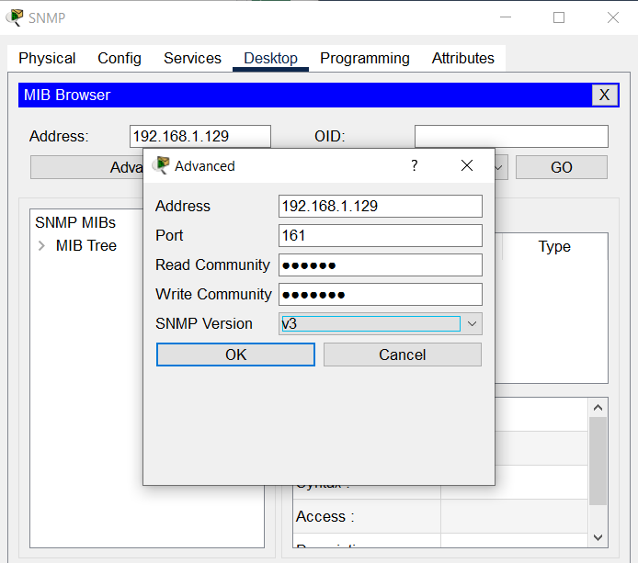
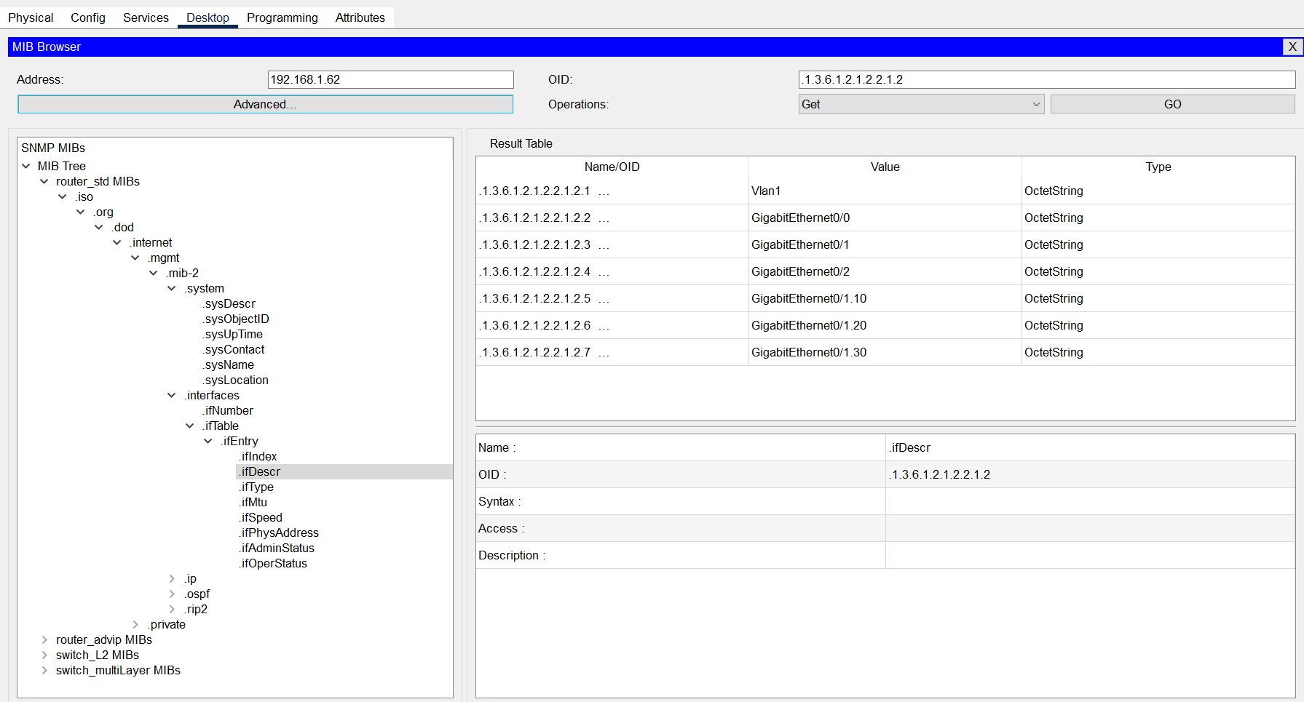

VPN

Practical demonstration of VPN
Virtual Private Networks are necessary when connecting a secure access within a private organization from a remote location.
Table 16: Configuring VPN.
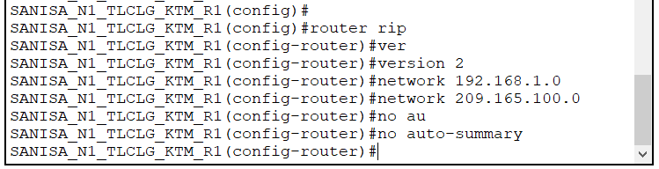

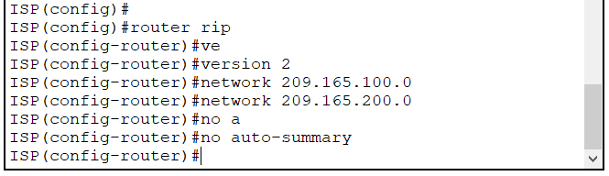

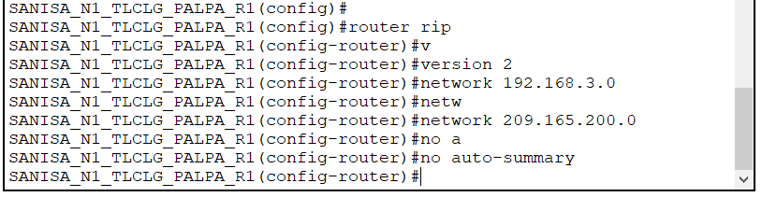
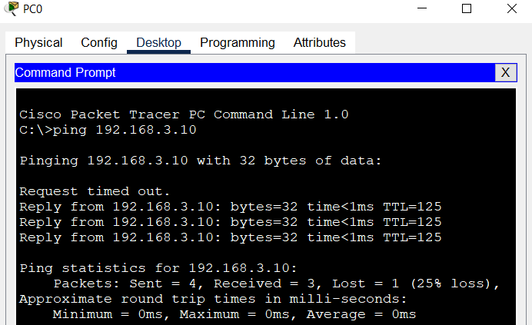
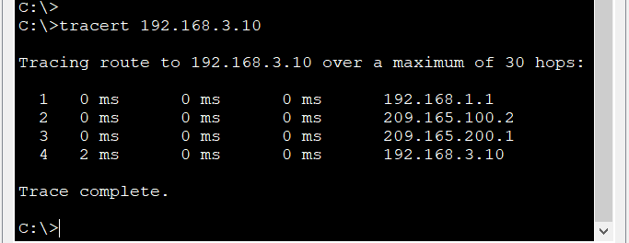
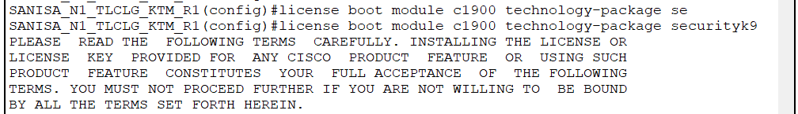
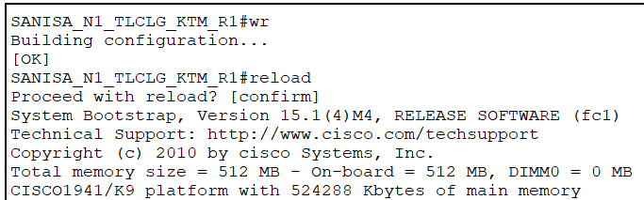
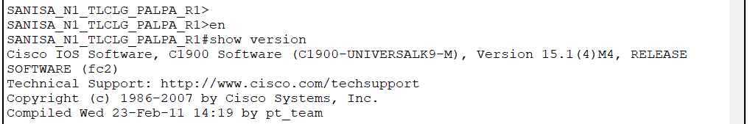
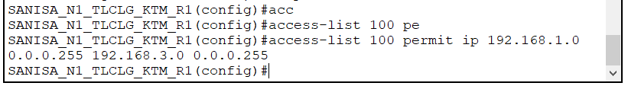

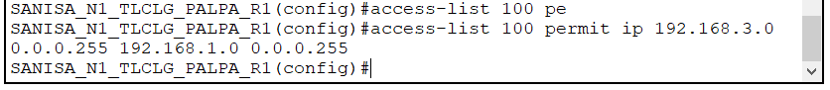
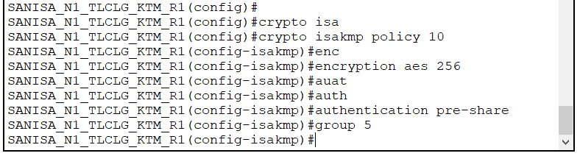

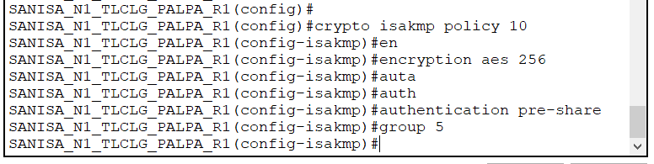

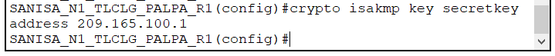
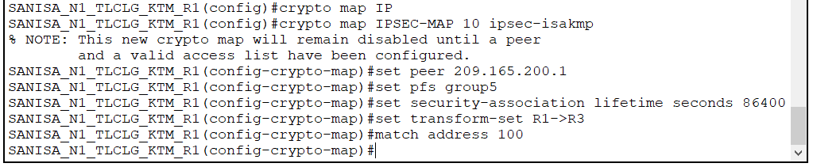

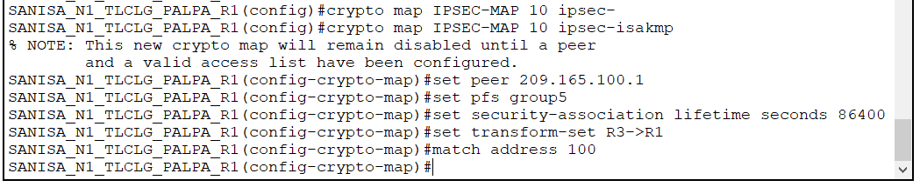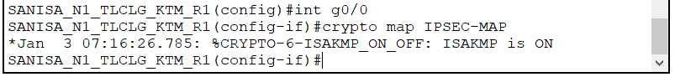

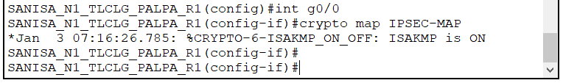
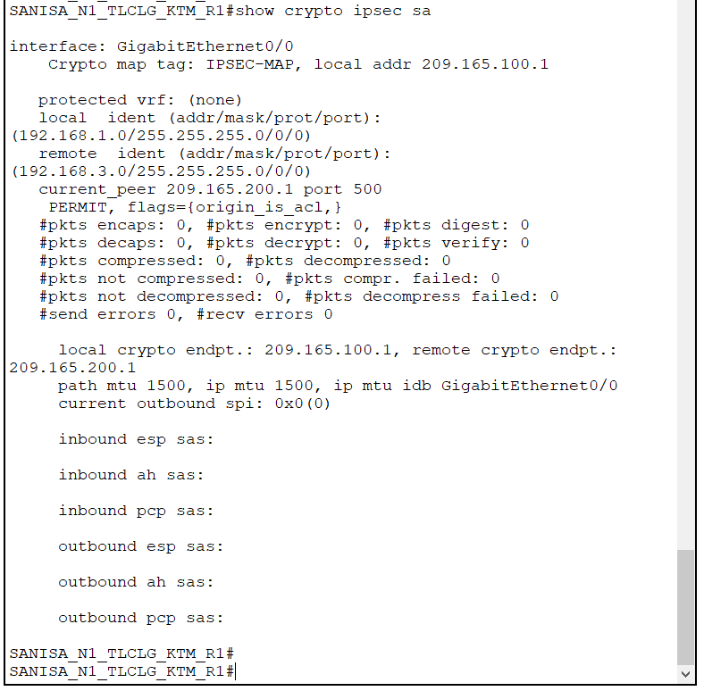
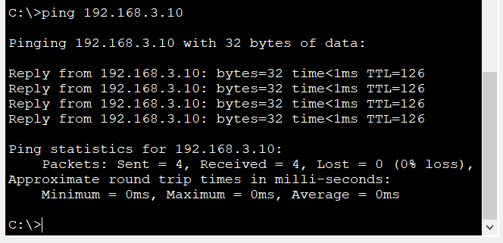
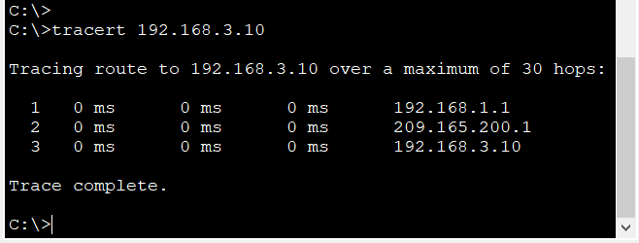
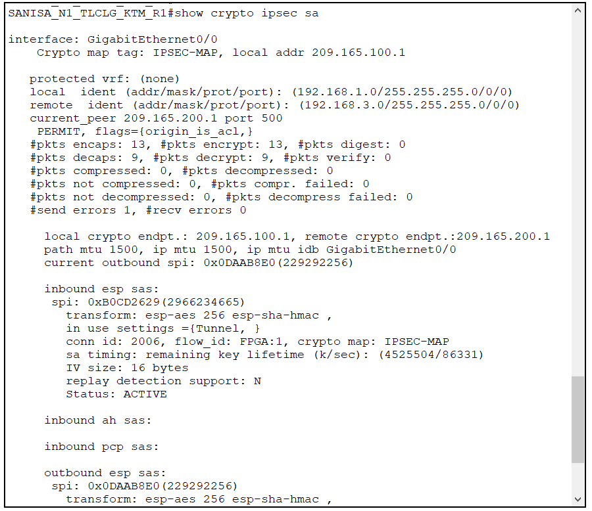

Documentation of troubleshooting methods
Table 14: IPconfig, ping, tracert and nslookup.
Ipconfig shows us all the different ip configurations on our device.

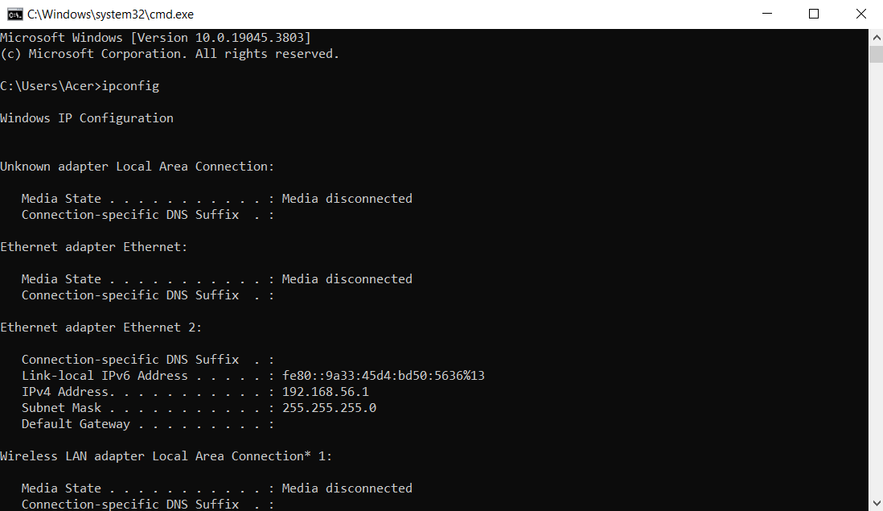
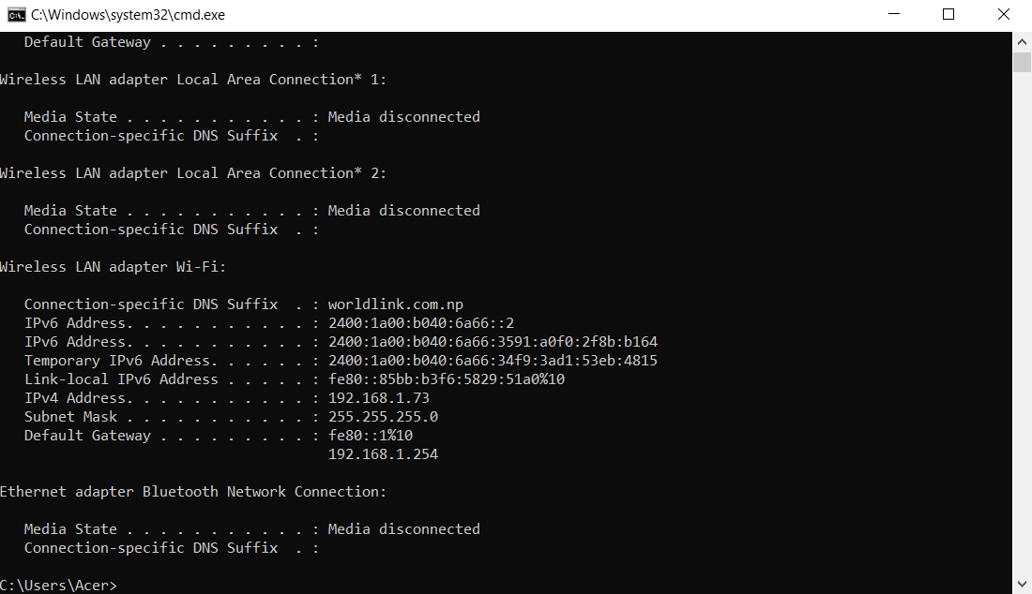
Ping helps us know if there is a connection to the site that we want to connect to. It guarantees availability of the sire when successful.
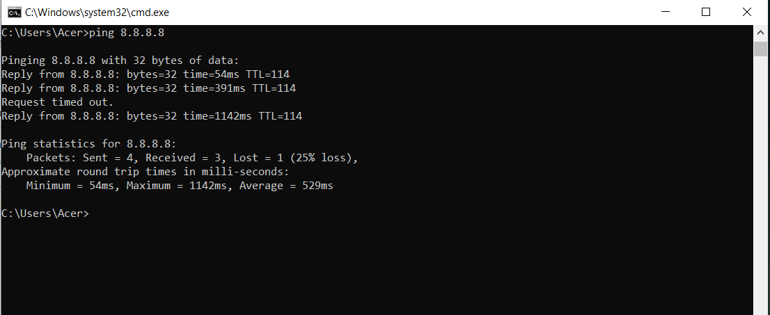

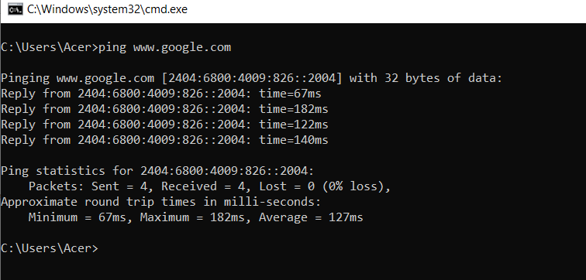
Tracert is for counting the number of hops to the website that we want to reach to.
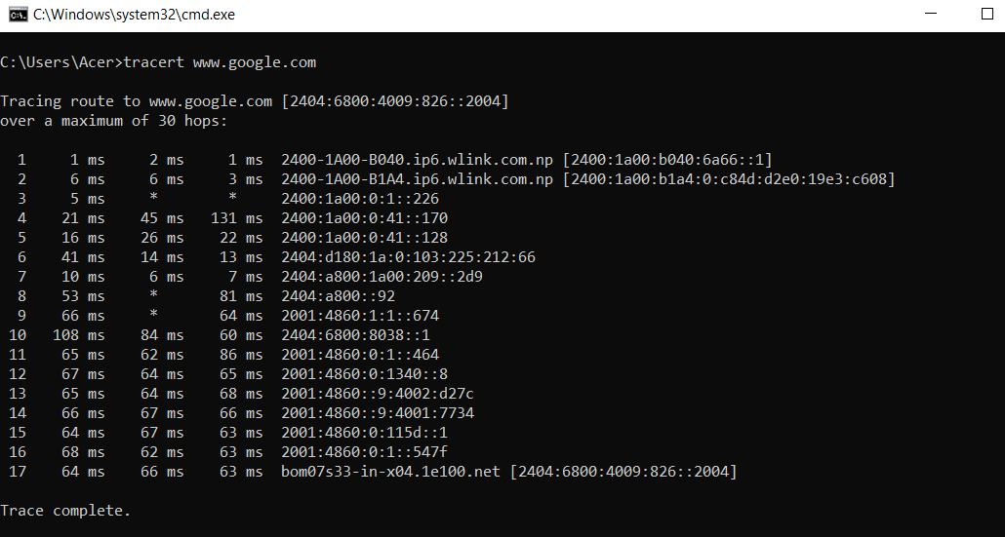
NSlookup is for looking up the IP address of a domain name that we already know.
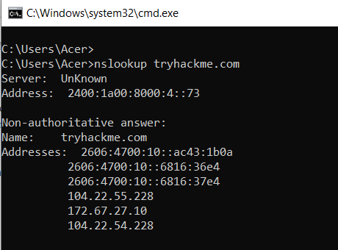

Table 15: Show commands. (IP interface, routes, VLANs).
These are all different show commands.

