MERIDIAN
Software Requirements Specification

Project:
Meridian – Real-Time Collaborative Document Editor

Project Type:
Software Engineering Group Project

Prepared by Group B
Members:
Chakma Miyebee
Panjieva Bakhor
Jurakulov Botirjon Jasur Ugli
Thapa Bijay
Prajapati Sanish
E Noor Khadija
Benthara Mapalagama Acharige Bimalsa Supunara

Version 1.0
2026. 10. 07

Table of Contents
- Introduction ........................................................................ 4
1.1 Purpose ............................................................................. 4
1.2 Scope ................................................................................ 4
1.3 Intended Audience .............................................................. 4
1.4 Definitions and Abbreviations ............................................. 4

- Overall Description ................................................................. 4
2.1 Product Perspective ........................................................... 4
2.2 Product Functions .............................................................. 5
2.3 User Classes ....................................................................... 5

- System Context and External Interfaces ................................. 6

- Functional Requirements ..........................................................6
4.1 User Management ...............................................................6
4.2 Document Management ....................................................... 6
4.3 Real-Time Collaborative Editing .........................................7
4.4 Collaboration Awareness ................................................... 7
4.5 Sharing and Permissions .................................................... 7
4.6 Comments and Discussion .................................................. 8
4.7 AI Assistant ........................................................................ 8
4.8 Grammar and Spelling Correction ...................................... 8
4.9 Version Management .......................................................... 8
4.10 Collaborative Responsibility Management ......................... 8
4.11 Offline Support ................................................................. 8

- Non-Functional Requirements ................................................. 8
5.1 Security .............................................................................. 8
5.2 Reliability ............................................................................ 9
5.3 Consistency ......................................................................... 9
5.4 Performance ....................................................................... 9
5.5 Usability .............................................................................. 9
5.6 Compatibility ...................................................................... 9
5.7 Safety .................................................................................. 9
5.8 Business Roles .................................................................... 9

- Additional Modern Non-Functional Requirements .................. 9

- System Constraints ...................................................................10

- System Architecture ..................................................................10
8.1 Client Layer .........................................................................11
8.1.1 Web Application ..........................................................11
8.1.2 Collaborative Editing Engine ......................................11
8.2 Application Layer ...............................................................11
8.2.1 WebSocket Gateway ...................................................11
8.2.2 Operational Transformation (OT) Service ..................11
8.2.3 Document Service ......................................................12
8.2.4 Presence Service ........................................................12
8.3 Data Layer ...........................................................................13
8.3.1 PostgreSQL Database ................................................ 13
8.3.2 Redis Cache ................................................................. 13
8.4 Communication Between Layers ........................................ 13
8.5 Security and Data Reliability ............................................ 13

- Testing Requirements ............................................................... 14
9.1 Unit Testing ......................................................................... 14
9.2 Integration Testing ............................................................ 14
9.3 System Testing .................................................................... 14
9.4 Regression Testing ............................................................. 15
9.5 Performance and Volume Testing ...................................... 15
9.6 User Acceptance Testing (UAT) ......................................... 15

- Acceptance Criteria ................................................................. 15

- Stakeholder Overview ............................................................. 16
11.1 Internal Stakeholders ....................................................... 16
11.2 Primary Stakeholders ....................................................... 16
11.3 Secondary and External Stakeholders ............................. 16

- Scope Note .............................................................................. 17

Introduction

Purpose
This Software Requirements Specification defines the functional and non-functional requirements of Meridian, a
web-based real-time collaborative document editor. Meridian allows multiple users to create, edit, view, share, comment on, and manage documents simultaneously, with emphasis on synchronization, concurrent editing, conflict resolution, presence, versioning, permissions, and offline synchronization.

Scope
Meridian will provide user registration and authentication; document creation and management; real-time collaborative editing; concurrent editing and conflict resolution; user presence and collaborative cursors; document sharing and permissions; comments and discussion threads; document version history; offline editing and synchronization; search and notifications; and collaborative responsibility/task tracking.

Intended Audience
Project developers, requirements analysts, software testers, project supervisors, future system users, and other stakeholders are involved in development and evaluation.

Definitions and Abbreviations
FR — Functional Requirement: a requirement describing a specific function or behavior that the Meridian system must provide. For example, FR-011 specifies that Meridian shall allow multiple users to edit the same document simultaneously.

Term | Meaning
SRS | Software Requirements Specification
FR | Functional Requirement
CRDT | Conflict-Free Replicated Data Type
OT | Operational Transformation
WebSocket | Protocol for real-time two-way communication
CRUD | Create, Read, Update, Delete
UI | User Interface
API | Application Programming Interface
Redis | In-memory system for real-time state and communication
PostgreSQL | Relational database for persistent data

Overall Description

Product Perspective
Meridian is a web-based software application designed to support collaborative work on shared documents. It provides a common digital workspace where multiple users can work together without relying on separate files or exchanging documents repeatedly. The system combines document editing, communication, and task coordination within one platform. It operates through a web browser and uses backend services and a database to manage information and support collaboration.

Product Functions

Meridian provides the following main functions:

User Management | Register accounts, log in, and manage user access.
Document Management | Create, edit, organize, and search documents.
Real-Time Collaboration: | Allow multiple users to edit the same document simultaneously.
Sharing and Communication: | Share documents, manage permissions, and exchange comments.
Version History: | Review previous versions of documents.
Offline Support: | Edit documents without an internet connection and synchronize changes when reconnected.
Responsibility Tracking: | Assign tasks, track progress, and mark completed work.
AI Writing Assistant: | Detect writing errors and provide grammar corrections, rewriting, and writing suggestions.

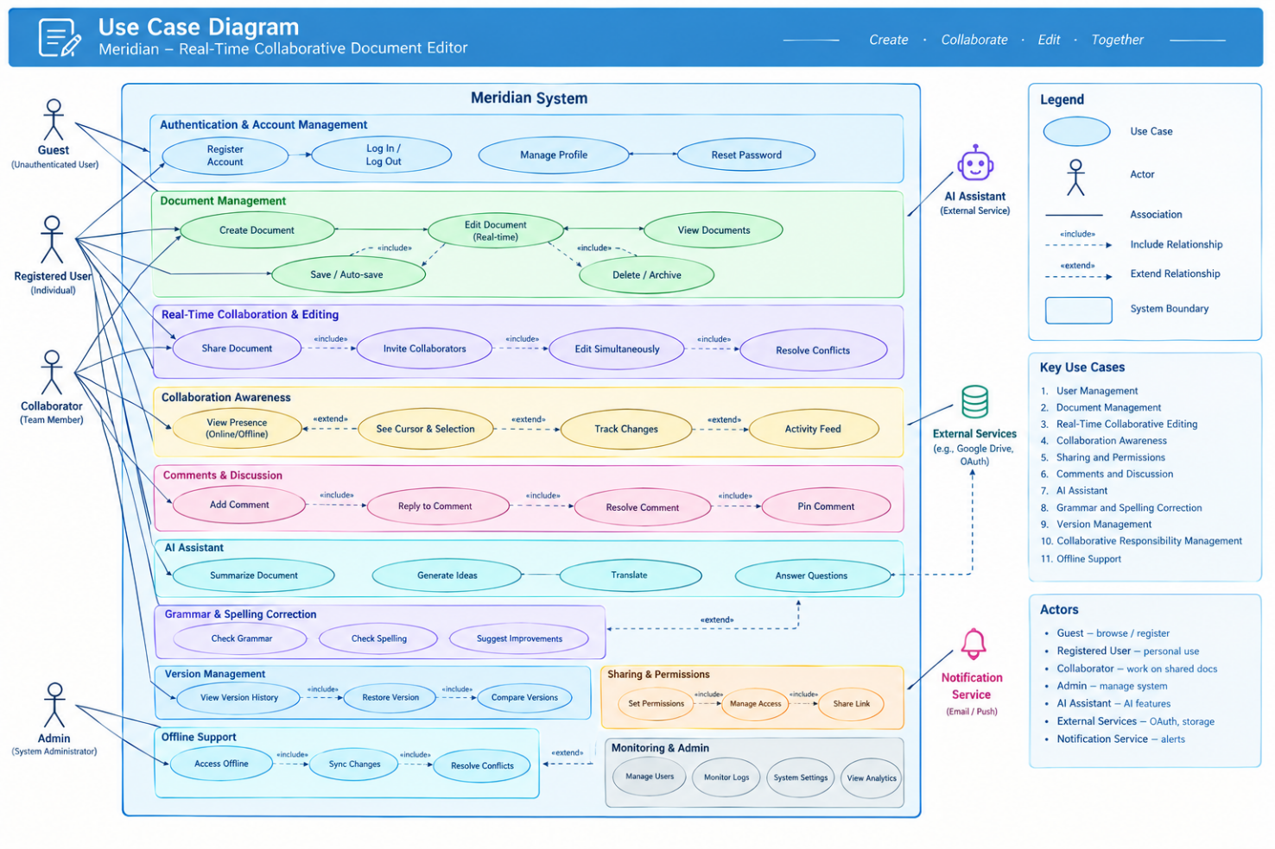
Figure 1: Meridian Use Case Diagram

User Classes
Guest: registration/login access without private-document access.
Document Owner: manages documents, sharing, permissions, and version restoration.
Editor: edits shared documents, partially has similar access as a Document Owner.
Commenter: views documents and adds/replies to comments.
Viewer: views permitted documents, comments, and history.

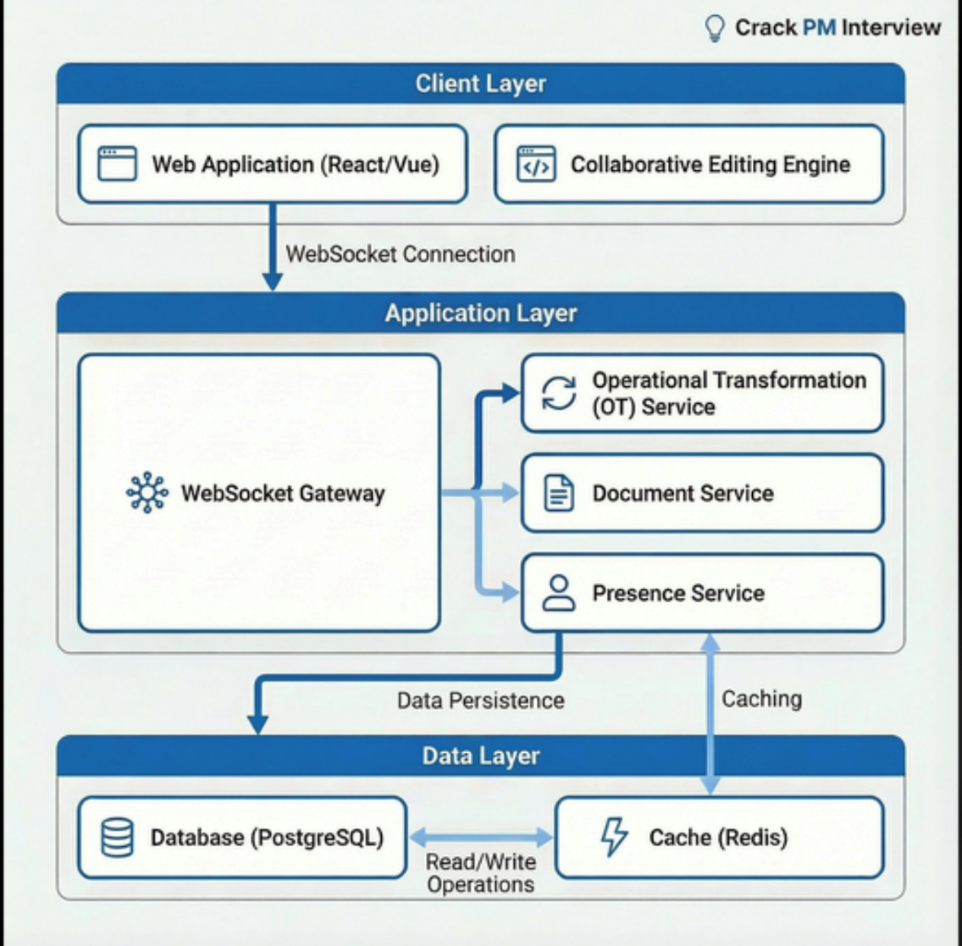
Figure 2: Meridian System Context Diagram

System Context and External Interfaces
Meridian operates within an environment containing users, web browsers, networks, and external infrastructure. The context boundary should distinguish Meridian's internal components from external entities and services.
- End Users — interact with Meridian through a web browser.
- Web Browser — provides the user interface and communication with Meridian.
- Cloud Hosting Infrastructure — hosts the deployed application.
- Notification Service — may deliver email or collaboration notifications.
- University/Organization — potential environment for academic or organizational use.
PostgreSQL, Redis, the WebSocket server, authentication mechanisms, and the collaboration layer are treated as components of Meridian rather than external systems.

Functional Requirements

User Management
FR-001 The system shall allow a new user to create an account using their name, email address, and password.
FR-002 The system shall allow registered users to log in and log out securely.
FR-003 The system shall maintain authenticated sessions and prevent unauthorized access to private documents.

Document Management
FR-004 The system shall allow authenticated users to create documents.
FR-005 The system shall allow users with appropriate permissions to modify document content.
FR-006 The document owner shall be able to rename a document.
FR-007 The document owner shall be able to delete a document.
FR-008 The system shall allow authenticated users to search documents they have access to.

Real-Time Collaborative Editing

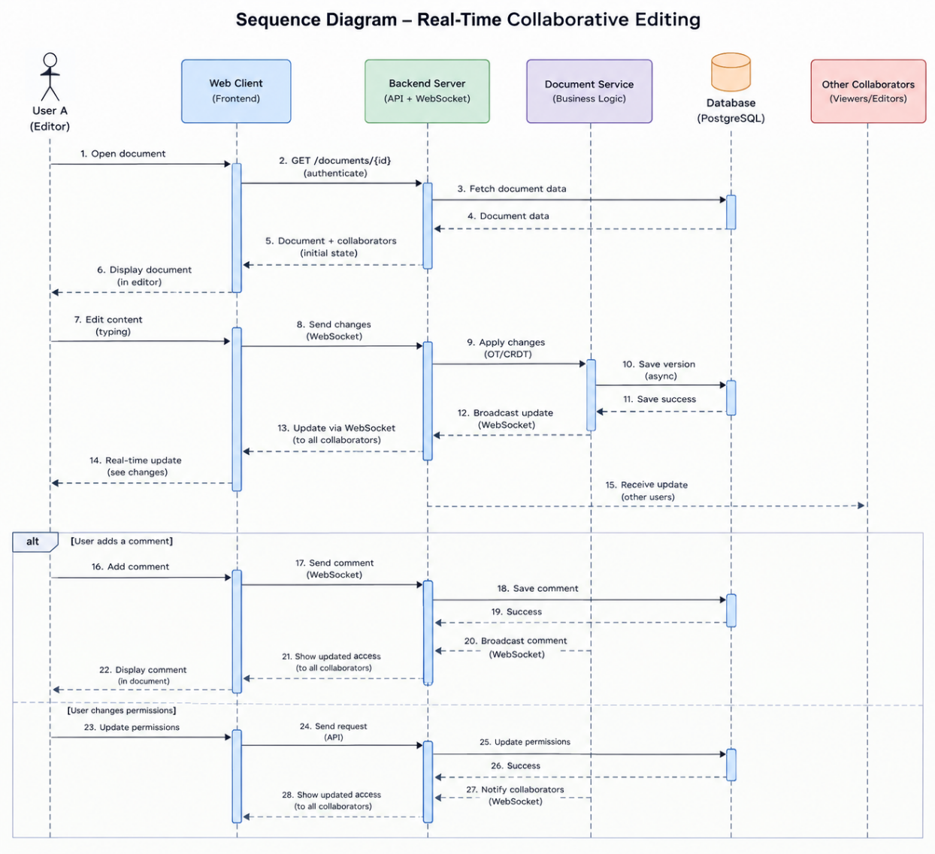
Figure 3: Meridian Real-Time Collaborative Editing Sequence Diagram

FR-009 The system shall establish a WebSocket connection when a user opens a collaborative document.
FR-010 Changes made by one user shall be transmitted to other connected users without manual refresh.
FR-011 The system shall allow multiple users to edit the same document simultaneously.
FR-012 The system shall resolve conflicting changes and ensure connected clients eventually converge on the same document state.
FR-013 The system shall synchronize locally stored changes when a disconnected user reconnects.

Collaboration Awareness
FR-014 The system shall display users currently viewing or editing a document.
FR-015 The system shall display collaborators' cursor positions and selections.
FR-016 The system shall indicate whether the user is connected, connecting, or offline.

Sharing and Permissions
FR-017 The document owner shall be able to share a document with another registered user.
FR-018 The owner shall be able to assign Viewer, Commenter, or Editor permissions.
FR-019 The system shall prevent users from performing operations outside their assigned permission level.

Comments and Discussion
FR-020 Authorized users shall be able to add comments to document content.
FR-021 Users shall be able to reply to existing comments.
FR-022 Authorized users shall be able to resolve comment threads.

AI Assistant

FR-023 The system shall provide an AI assistant within the document editor

FR-024 Users shall be able to submit questions and writing-related requests to the AI assistant.

FR-025 Users shall be able to request rewriting, summarization, and writing suggestions for selected text.

FR-026 The system shall allow users to humanize text by improving its naturalness, fluency, and readability while preserving its original meaning.

FR-027 The system shall allow users to review AI-generated content before inserting it into a document.

Grammar and Spelling Correction

FR-028 The system shall identify grammatical, spelling, and punctuation errors in document text.

FR-029 The system shall provide correction suggestions for identified errors.

FR-030 Users shall be able to accept or reject suggested corrections.

FR-031 The system shall suggest improvements to sentence clarity and structure while preserving the original meaning.

Version Management
FR-032 The system shall automatically maintain document revision information.
FR-033 Authorized users shall be able to view previous document versions.
FR-034 Authorized users shall be able to restore a previous version without destroying existing revision history.

Collaborative Responsibility Management
FR-035 The system shall allow collaborators to assign tasks or responsibilities related to a shared document.
FR-036 Users shall be able to mark assigned responsibilities as completed.
FR-037 The system shall display the responsible collaborator and completion status for each task.
FR-038 Responsibility information shall only be editable by authorized collaborators.

Offline Support
FR-038 The system shall maintain a local copy of documents when necessary for offline operation.
FR-039 Users shall be able to continue editing documents while disconnected.
FR-040 Offline changes shall be temporarily stored until connectivity is restored.
FR-041 The system shall synchronize local changes with the server after reconnection.

Non-Functional Requirements

Security
NFR-01 The system shall prevent unauthorized users from accessing documents and restricted features.
NFR-02 The system shall protect sensitive information during transmission and storage using appropriate security controls.
NFR-03 The system shall validate user input to reduce the risk of injection attacks and other malicious activity.
NFR-04 The system shall terminate or invalidate sessions when users log out, or their sessions expire.
NFR-05 The system shall record security-relevant events to support monitoring and investigation.

Reliability

NFR-06 Confirmed document changes must remain available during temporary network interruptions.

NFR-07 Once connectivity returns, the system must synchronize changes saved offline.

NFR-08 After an unexpected error, the system must recover without corrupting stored document data.

NFR-09 Users must be informed when synchronization fails or needs their attention.

NFR-010 Users must be able to restore an earlier version of a document.

Consistency

NFR-011 After concurrent changes have been synchronized, all connected collaborators must see the same document content.

NFR-012 The system shall reject changes made by users who are not authorized to modify a protected document.

NFR-013 Each document change must remain correctly linked to its corresponding version-history record.

NFR-014 Reprocessing a synchronized change must not apply that change more than once or unintentionally alter the document.

Performance
NFR-015API responses must be returned within 300 milliseconds at the 95th percentile under normal test conditions.
NFR-016Collaboration propagation target must be below 200 milliseconds at the 95th percentile under normal network conditions.
NFR-017 The system shall load a document within 2 seconds under normal operating conditions.
NFR-018 Editing shall remain responsive while multiple authorized users collaborate on the same document.

Usability
NFR-019 The system shall provide a consistent interface across its main features.
NFR-020 The system shall display clear feedback when users save, share, edit, or synchronize documents.
NFR-021 Error messages must explain the problem and, where possible, suggest how to resolve common errors.
NFR-022 Users shall be able to navigate essential document-editing and management functions using a keyboard.
NFR-023 The system shall aim to meet the WCAG 2.2 Level AA accessibility criteria.

Compatibility

NFR-024 The system shall support the agreed versions of major web browsers, including Chrome, Edge, Firefox, and Safari.

NFR-025 The interface must remain usable across supported desktop, tablet, and mobile screen sizes.

NFR-026 Exported documents must retain their formatting in each supported file format.

NFR-027 After a browser refresh or reconnection, previously confirmed document changes must remain available.

Safety

NFR-028 AI-generated changes must be shown to the user for confirmation before they are applied to document content.

NFR-029 The system shall preserve the original document content when AI-generated suggestions are rejected.

NFR-030 The system shall inform users that AI-generated content may contain inaccurate or inappropriate suggestions.

NFR-031 Users shall be able to undo applied changes whatever the document editor supports undo.

Business Roles
NFR-032 Document owners can manage permissions and decide which collaborators are authorized to access a document.
NFR-033 Editors shall be able to modify document content according to their assigned permissions.
NFR-034 Commenters shall be able to add comments without modifying the main document content.
NFR-035 Viewers shall be able to read documents without editing their content.
NFR-036 The system shall enforce role-based permissions consistently across document access and collaboration functions.

Additional Modern Non-Functional Requirements

Privacy and Data Protection

The system shall restrict the processing of document content by external AI services to the purposes disclosed to users.

Scalability

The system shall support an agreed number of simultaneous users without exceeding defined performance limits.

Maintainability

The system shall separate major software components to facilitate testing, debugging, and future modification.

Observability

The system shall record operational errors and relevant performance metrics to support troubleshooting.

Auditability

The system shall maintain records of important permission changes and document-management activities where required.

Data Portability

The system shall allow authorized users to export documents in supported formats.

System Constraints
SC-001- Platform: Meridian shall operate as a web-based application accessible through supported web browsers.
SC-002- Technology: The system shall use the programming languages, frameworks, and database technologies selected for the project.
SC-003- Network Dependency: Real-time collaboration shall require an active internet connection, while offline functionality shall be limited to supported operations.
SC-004- External AI Dependency: AI writing features shall depend on the availability and capabilities of the selected AI service.
SC-005- Data Storage: The system shall operate within the storage capacity and technical limitations of its designated infrastructure.
SC-006- Access Restrictions: Access to documents and system functions shall be governed by assigned user permissions.
SC-007- Resource Limitations: Development and deployment shall remain within the available budget, infrastructure, and project resources.
SC-008- Feature Scope: The system shall exclude video conferencing, voice calls, spreadsheet and presentation editing, AI-generated documents, native mobile applications, collaborative drawing, advanced enterprise administration, and large-scale file storage.

System Architecture

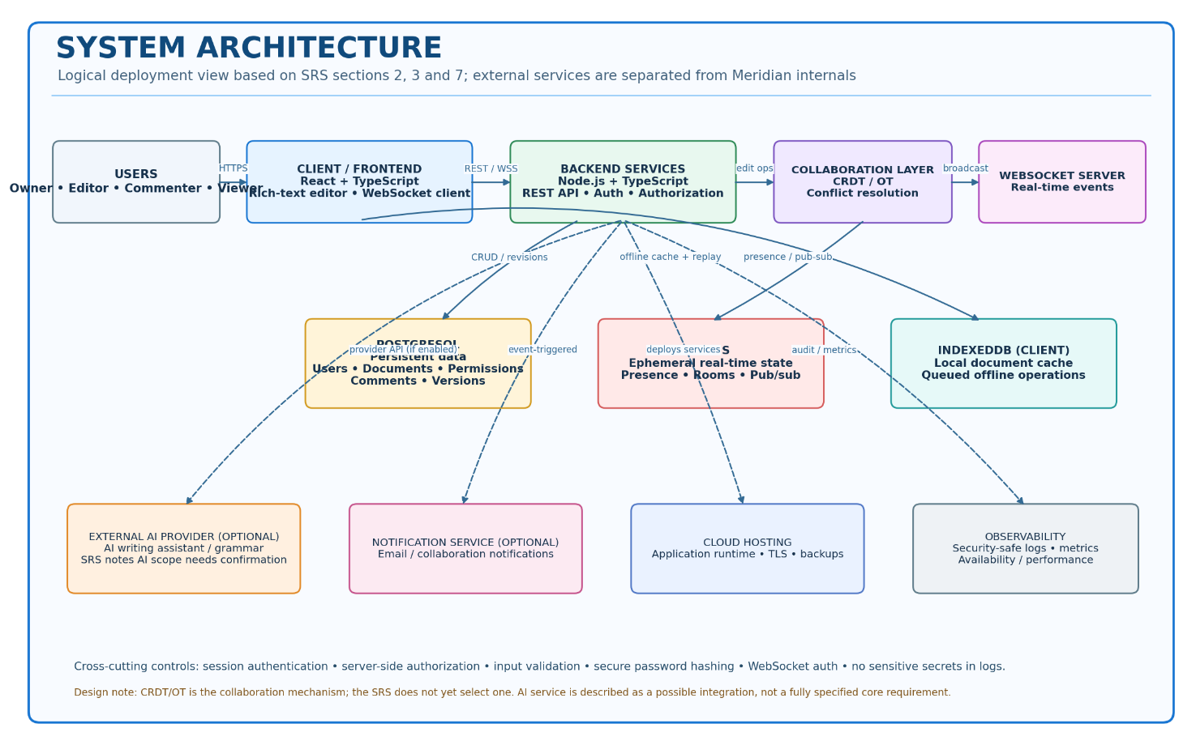
Figure 4: Meridian System Architecture Diagram
The system shall use a layered client-server architecture consisting of a Client Layer, an Application Layer, and a Data Layer. These layers shall communicate with one another to support real-time collaborative document editing, document management, user presence, and persistent data storage. The architecture shall use WebSocket communication for real-time updates, PostgreSQL for persistent data storage, and Redis for caching and temporary collaboration-related data.

8.1 Client Layer
The Client Layer shall provide the user interface and collaborative editing capabilities through which users interact with the system. It shall consist of a Web Application and a Collaborative Editing Engine.

8.1.1 Web Application
The Web Application shall provide a browser-based interface through which users can access and manage documents. The proposed frontend technologies are React and TypeScript.
The Web Application shall allow users to create, open, edit, and manage documents according to their assigned permissions. It shall display document content, collaborator presence, comments, task progress, and version history where these features are implemented.
The interface shall communicate with the Application Layer to submit user requests and receive document data, permission information, and collaboration updates. It shall establish a WebSocket connection to support real-time communication between users participating in the same collaborative editing session.

8.1.2 Collaborative Editing Engine
The Collaborative Editing Engine shall process document editing operations initiated by users and coordinate the presentation of collaborative changes in the client interface.
It shall communicate with the Application Layer to submit editing operations and receive updates generated by other collaborators. The engine shall work with the selected conflict-resolution mechanism to support concurrent document editing and maintain a consistent document state.
The editing engine shall support the synchronization of document changes when multiple users edit the same document. Where offline editing is implemented, it shall also support the submission of locally stored changes after network connectivity is restored.

8.2 Application Layer
The Application Layer shall process client requests, manage document operations, coordinate real-time communication, and enforce application rules. It shall consist of a WebSocket Gateway, an Operational Transformation (OT) Service, a Document Service, and a Presence Service.

8.2.1 WebSocket Gateway
The WebSocket Gateway shall establish and maintain WebSocket connections between connected clients and the Application Layer. It shall receive real-time messages from clients and route collaboration events to the appropriate application services.
The gateway shall support the transmission of document editing operations, collaboration updates, and user presence events. It shall ensure that messages are handled within the appropriate collaborative session and that access restrictions are respected.
The gateway shall also support connection management and reconnection handling to allow clients to resume communication following temporary network interruptions.

8.2.2 Operational Transformation (OT) Service
The Operational Transformation (OT) Service shall coordinate concurrent document editing operations submitted by multiple users. It shall process editing operations and transform conflicting operations when necessary to maintain a consistent shared document state.
The service shall coordinate with the Document Service to ensure that accepted editing operations are applied and persisted correctly. It shall also communicate with the WebSocket Gateway to distribute processed document updates to connected collaborators.
The OT Service shall support simultaneous editing without requiring users to refresh the document manually to see changes made by other collaborators.

8.2.3 Document Service
The Document Service shall manage document-related operations, including document creation, retrieval, editing, updating, and deletion. It shall process requests received from the WebSocket Gateway or other authorized application components.
The service shall verify user permissions before allowing access to protected documents or modification of document content. It shall coordinate with the OT Service when collaborative editing operations require processing and with the Data Layer when document information must be retrieved or persisted.
The Document Service shall ensure that document updates are stored reliably and that authorized users can retrieve the latest persisted document state.

8.2.4 Presence Service
The Presence Service shall manage temporary information about users participating in collaborative editing sessions. It shall track relevant collaboration state, such as active participants and their connection status.
The service shall coordinate with the WebSocket Gateway to communicate presence updates to other authorized users in the same collaborative session. It shall update temporary presence information as users join, leave, disconnect, or reconnect.
The Presence Service shall use the caching infrastructure where appropriate to support efficient access to temporary collaboration state without requiring every presence update to be stored permanently in the primary database.

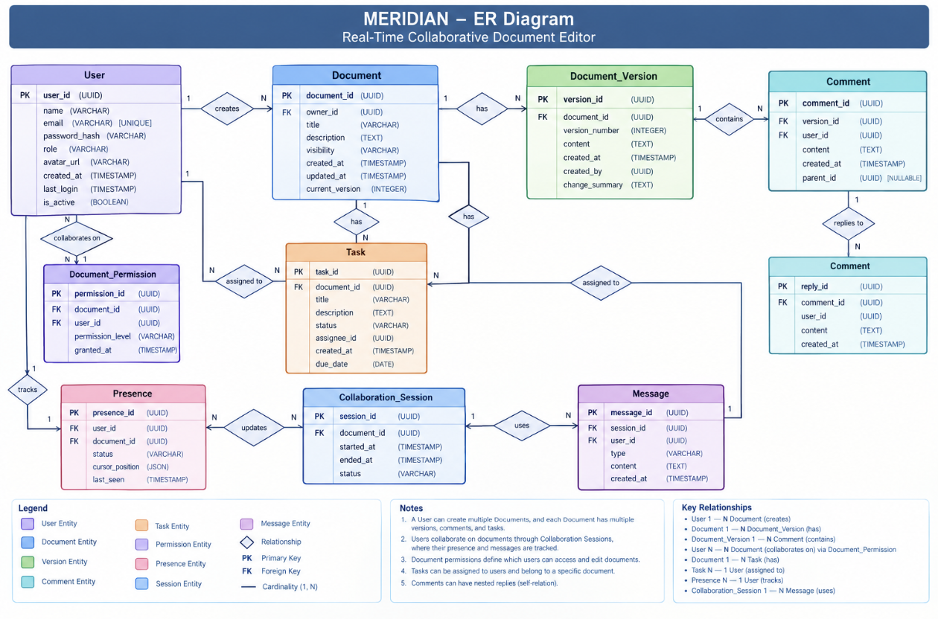
Figure 5: Meridian System Entity-Relationship (ER) Diagram

8.3 Data Layer
The Data Layer shall provide persistent storage and caching facilities required by the Application Layer. It shall consist of a PostgreSQL database and a Redis cache.

8.3.1 PostgreSQL Database
PostgreSQL shall serve as the primary relational database for persistent system information. It shall store user accounts, document metadata, access permissions, comments, task information, and version records, as applicable to the implemented features.
The database shall support read and write operations initiated by authorized application services. It shall maintain data integrity through appropriate database constraints and transaction mechanisms.
Document content and collaborative editing updates shall be persisted using a storage mechanism compatible with the selected editing and synchronization approach. The database shall also support the retrieval of stored document information and version records when requested by authorized users.
Appropriate backup and recovery procedures shall be established to protect persistent data against accidental loss or system failure.

8.3.2 Redis Cache
Redis shall provide caching and temporary data storage to support the performance of real-time collaboration features. It may store frequently accessed temporary information, including active collaboration sessions, user presence data, and other short-lived application state.
The Application Layer shall communicate with Redis when temporary collaboration information needs to be stored, retrieved, or updated. The cache shall reduce unnecessary access to persistent storage for information that changes frequently and does not require permanent retention.
Redis shall not replace PostgreSQL as the primary persistent database. Persistent document information and other essential records shall be stored in the database or another explicitly defined persistent storage mechanism.
The system shall manage cached data appropriately so that expired or invalid temporary information does not interfere with active collaboration sessions.

8.4 Communication Between Layers
The Client Layer, Application Layer, and Data Layer shall communicate through defined interfaces to support reliable system operation.
The Web Application shall communicate with backend application services for standard document operations. WebSocket connections shall be used to transmit real-time editing operations, collaboration updates, and presence events.
The Application Layer shall communicate with PostgreSQL to retrieve and persist permanent data and with Redis to access or update temporary collaboration information.
The OT Service, Document Service, and Presence Service shall coordinate their operations to ensure that document changes are processed, stored, and distributed to authorized collaborators.
The system shall support connection recovery and the synchronization of pending changes after temporary network interruptions, subject to the capabilities of the implemented client and synchronization mechanism.

8.5 Security and Data Reliability
The system shall enforce authentication and authorization before granting access to protected documents and collaborative editing sessions. The backend shall verify permissions for document operations rather than relying solely on restrictions implemented in the client interface.
Communication between clients and backend services shall be protected using appropriate transport security. Database access shall be restricted to authorized application components, and sensitive information shall be handled according to the system's security requirements.
The system shall provide appropriate backup and recovery procedures for persistent data. It shall also handle temporary connection failures without treating unconfirmed client-side changes as successfully persisted.
The architecture shall be designed to support reliable document storage, controlled access, and consistent collaboration between authorized users.

Testing Requirements

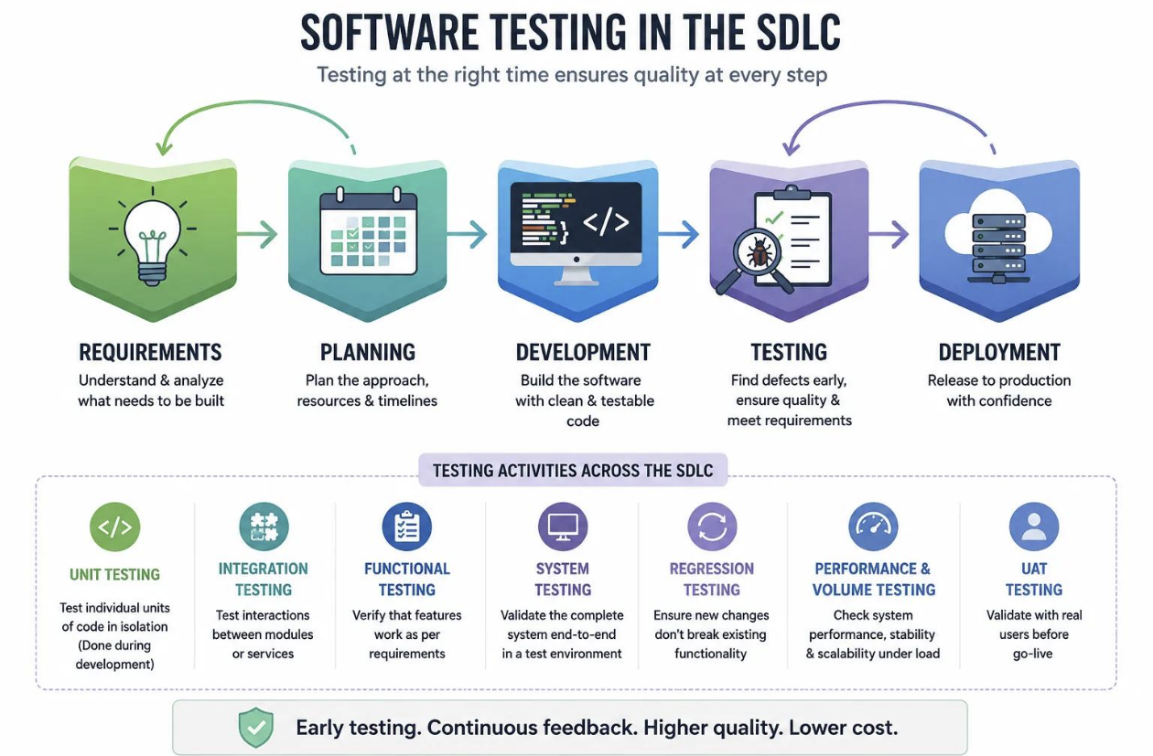
Figure 6: Software Testing within the Software Development Life Cycle (SDLC)

Unit Testing

Unit testing shall verify that individual functions and modules operate correctly.

TR-001: The system's authentication, authorization, and permission-checking functions shall be tested independently.

TR-002: Document management, comment, task assignment, and version management functions shall be tested independently.

TR-003: Document synchronization and conflict-resolution functions shall be tested using predefined test cases.

Integration Testing
Integration testing shall verify that connected components communicate and exchange data correctly.
TR-004: The frontend and backend shall be tested to verify correct API communication.
TR-005: Database operations shall be tested to verify accurate document storage and retrieval.
TR-006: WebSocket communication shall be tested to verify that document updates reach connected collaborators.
TR-007: Authentication and authorization shall be tested across API requests and real-time collaboration connections.

System Testing

System testing shall verify that the complete application satisfies its specified functional and non-functional requirements.

TR-008: The system shall be tested for document creation, editing, sharing, and permission management.

TR-009: Multiple users shall be able to edit the same document simultaneously without permanent loss of confirmed changes.

TR-010: The system shall be tested for comments, version history, task tracking, and offline synchronization.

TR-011: The system shall be tested to verify that unauthorized users cannot access or modify protected documents.

Regression Testing

Regression testing shall verify that modifications do not adversely affect existing functionality.

TR-012: Existing document management and permission functions shall be retested after relevant code changes.

TR-013: Collaboration and synchronization tests shall be repeated after changes to the editing or conflict-resolution mechanisms.

TR-014: Relevant existing test cases shall be rerun after bug fixes and updates to verify that previously resolved defects do not recur.

Performance and Volume Testing

Performance and volume testing shall evaluate the system's responsiveness and stability under different workloads and data volumes.

TR-015: The system shall be tested with multiple users editing a shared document simultaneously.

TR-016: Response times and document synchronization delays shall be measured under defined normal and peak workloads.

TR-017: The system shall be tested with increasing numbers of documents, comments, and stored versions to evaluate performance as data volume grows.

TR-018: The system shall be tested under sustained workloads to identify performance degradation, resource limitations, and failures.

User Acceptance Testing (UAT)

User acceptance testing shall verify that system user needs and the agreed project requirements.

TR-019: Users shall be able to complete the main workflows for creating, editing, sharing, and managing documents.

TR-020: Users shall be able to collaborate on shared documents and observe updates from other collaborators.

TR-021: Document owners shall be able to manage permissions and restore previous document versions.

TR-022: Users shall be able to assign responsibilities, update task progress, and mark tasks as completed.

TR-023: The system shall be accepted for release only when the agreed acceptance criteria have been satisfied.

Acceptance Criteria
The system shall be considered acceptable when the following criteria are satisfied:
AC-001 — User Management: Users can register, log in, and access the system according to their authentication status.
AC-002 — Document Management: Authorized users can create, edit, rename, search for, and delete documents according to their permissions.
AC-003 — Real-Time Collaboration: Multiple users can edit the same document, and changes are synchronized without requiring manual page refreshes.
AC-004 — Conflict Resolution: Concurrent edits are handled without permanent loss of confirmed changes or corruption of document content.
AC-005 — Collaboration Awareness: Users can identify active collaborators and view their cursors or selections where supported.
AC-006 — Sharing and Permissions: Document owners can share documents and assign permissions that restrict unauthorized viewing, editing, or commenting.
AC-007 — Comments and Discussion: Authorized users can add comments and participate in discussion threads according to their permissions.
AC-008 — Version Management: Users with appropriate permissions can review previous document versions and restore a selected version.
AC-009 — Offline Support: Supported offline edits are retained locally and synchronized after connectivity is restored.
AC-010 — Responsibility Tracking: Users can assign responsibilities, view task progress, and mark assigned work as completed.
AC-011 — AI Writing Assistance: If included in the implemented release, users can request writing assistance, review generated suggestions, and choose whether to apply them.
AC-012 — Security: Unauthorized users cannot access or modify protected documents through either standard API requests or real-time connections.
AC-013 — Reliability: Confirmed document changes remain recoverable following supported network interruptions and application recovery scenarios.
AC-014 — Performance: The system meets the response-time and collaboration-latency targets defined in the non-functional requirements under the specified test workload.
AC-015 — Acceptance: All mandatory functional requirements pass their associated tests, and no unresolved critical defects prevent the system from meeting its intended purpose.

Stakeholder Overview

Internal Stakeholders

Stakeholder | Responsibility
Project Manager | Coordinates the project schedule, tasks, and team responsibilities.
Software Development Team | Designs, develops, and maintains Meridian.
Business Analyst / Requirements Engineer | Identifies user needs and translates them into software requirements.
Quality Assurance (QA) Engineer | Verifies that the system meets its functional and non-functional requirements.
UI/UX Designer | Designs an intuitive and accessible collaborative editor.
Database Administrator (DBA) | Ensures reliable document storage, revision management, and data integrity.
DevOps / System Administrator | Handles deployment, infrastructure, monitoring, and availability.
Project Sponsor | Provides financial, technical, or organizational support for the project.

11.2 Primary Stakeholders

Stakeholder | Responsibility
End Users | Use Meridian to create, edit, and share documents.
Document Owners | Manage document access, sharing permissions, and collaborators.
Collaborators (Editors and Commenters) | Edit documents, exchange feedback, and work together.
Viewers | Access shared documents without modifying their content.
University Faculty / Academic Supervisors | Use or evaluate Meridian for academic collaboration.

11.3 Secondary and External Stakeholders
Stakeholder | Responsibility
University IT Department | Provides technical guidance and may support institutional deployment.
Cloud Service Providers | Supply hosting and infrastructure for the application.
Cybersecurity Specialists | Assess authentication, authorization, and data protection.
Legal / Data Protection Advisors | Advise on privacy and applicable data-protection obligations.
Third-Party Technology Providers | Maintain services or libraries on which Meridian depends.
Future Clients / Business Organizations | May adopt Meridian for workplace collaboration.
Open-Source Contributors | Could contribute improvements, fixes, and new features if the project becomes open source.

Scope Note
Meridian is a web-based real-time collaborative document editor designed to support individuals and teams in creating, editing, sharing, and managing documents within a shared workspace.
The project scope includes user registration and authentication, document management, real-time collaborative editing, concurrent edit synchronization, conflict resolution, collaborator presence, document sharing and permissions, comments and discussions, version history, offline editing and synchronization, search, notifications, and collaborative responsibility tracking. The system also includes AI-powered writing assistance for grammar correction, rewriting, summarization, and writing suggestions, subject to the features implemented in the project release.
The initial release focuses on essential document collaboration and task coordination through a web application. Video conferencing, voice calls, spreadsheet and presentation editing, AI-generated documents from scratch, native mobile applications, collaborative drawing, advanced enterprise administration, and large-scale file storage are outside the initial project scope.
The project aims to demonstrate the application of software engineering principles in requirements specification, system design, implementation, testing, and evaluation of a collaborative web-based system.

