14A, Paul Obi Ihejirika Street,

Palmsville Estate, Ajah,

Lagos State.

7th December, 2022.

The Hall Administrator,

Nelson Mandela Hall,

Babcock University,

Ogun State,

Nigeria.

Dear Sir,

**REQUEST FOR THE RELEASE OF SANNI COLLINS OJOCHONU FROM SCHOOL**

I am the mother of **SANNI COLLINS OJOCHONU** who is a four hundred level Computer Science student of Babcock University residing in Nelson Mandela hall.

I wish to seek the permission of the Hall Administrator to release him from Thursday 8th to Sunday 11th of December, 2022 to come home for the wedding of a family friend (The sister of Adediji Emmanuel who is also a student of Babcock).

Thank you in anticipation of your positive response to my request.

Yours Faithfully,

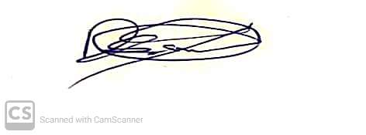

___________________

Mrs Sanni Deborah.



