Netflix Movies & TV Shows Analysis – Power BI Project

Objective
The objective of this project is to analyze the Netflix Movies and TV Shows dataset using Power BI to gain insights into the content available on the platform. The analysis focuses on understanding the distribution of movies and TV shows, genre-wise availability, release year trends, and content characteristics such as ratings, directors, and cast. The goal is to support data-driven insights into Netflix’s content strategy.

Process / Methodology
- Understood the dataset structure containing movie and TV show details such as genre, director, cast, ratings, and release year.
- Cleaned the data by handling null values, removing duplicates, and validating data types in Power query
- Loaded the dataset into Power BI and performed data modeling.
- In Power query Created new columns custom column, also used delimator,To separate out genre
- Used newly generated table with separated genre connect with original using id.
- Created DAX measures for total titles, total movies, and total TV shows.
- Built genre-wise slicers to dynamically analyze the number of movies and TV shows.
- Designed interactive visuals including cards, charts, and tables for insights.

Dashboard-
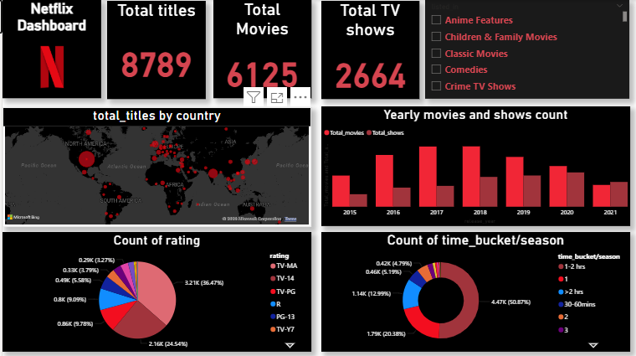

Uncovered till now-
Total titles-8789
Total movies-6125
Total TV shows-2664
Max rating-36%-TV MA
Max shows/movies time-1-2 hrs
Max movies-767(2018),shows-436(2020)

Conclusion
This Power BI dashboard provides a comprehensive overview of Netflix’s content library. It highlights key trends such as genre dominance, content distribution between movies and TV shows, and changes across release years. The use of DAX measures and slicers enhances interactivity, making the dashboard effective for exploring and understanding Netflix content patterns.

