Chemohormonal Therapy in Metastatic Hormone-Sensitive Prostate Cancer: Long-term Sfurvival Analysis of the Randomized Phase III E3805: CHAARTED Trial

Kyriakopoulos et al

Figure 1 Supplementary. Hazard Ratios for Death in Subgroups
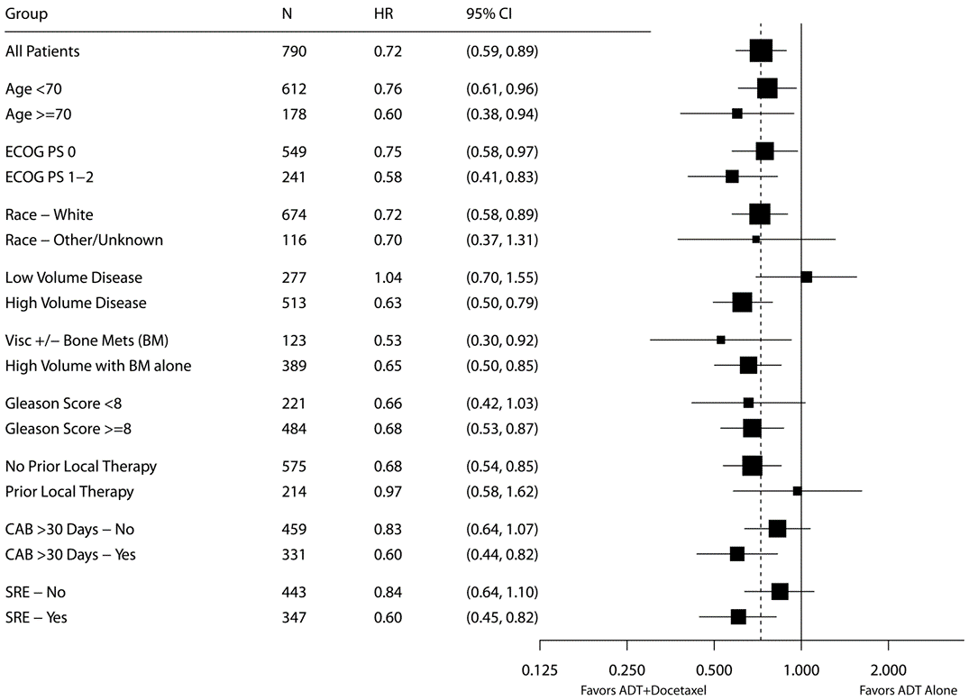
Note: The x-axis of the forest plot is scaled according to the natural logarithm of the hazard ratio. The size of the squares is proportional to the inverse of the variance of the log hazard ratio (small squares correspond to large variances).

Figure 2 Supplementary: Kaplan-Meier Estimates of PFS by survival and CRPC A: All patients, B: High-volume patients and C: Low-volume patients.
A. | B.
C.

Figure 3 Supplementary: Kaplan-Meier Estimates of PFS by survival and clinical progression A: All patients, B: High-volume patients and C: Low-volume patients.
A. | B.
C.

Table 1 Supplementary: PFS by survival and CRPC
 | ADT+D |  | ADT alone |  | p value*
 | Median (months) | 95% CI | Median (months) | 95% CI
All patients | 18.8 | 16.6-22.6 | 11.6 | 10.7-14.2 | <0.0001
High-volume | 14.9 | 12.3-17.2 | 8.5 | 6.7-10.3 | <0.0001
Low-volume | 29.5 | 22.8-40.9 | 22.5 | 18.6-29.1 | 0.048
*stratified log rank test

Table 2 Supplementary: PFS by survival and clinical progression
 | ADT+D |  | ADT alone |  | p value*
 | Median (months) | 95% CI | Median (months) | 95% CI
All patients | 30.3 | 26.4-34.9 | 18.7 | 16.7-20.9 | <0.0001
High-volume | 24.6 | 19.4-29.8 | 12.5 | 11.1-15.8 | <0.0001
Low-volume | 42.5 | 33.7-53.9 | 41.1 | 27.9-49.4 | 0.46
*stratified log rank test

