Dataset Understanding & ER Schema
Healthcare relational data model, grain, keys, dependencies, and messy-data design

1. Dataset Scale
File/Table | Approx. Size | Purpose
patients_raw | 12,090 rows | Patient master with 90 intentional duplicate master records
admissions_raw | 30,130 rows | Admission-level fact table with duplicate admissions and orphan patient IDs
treatments_raw | 90,160 rows | Treatment/procedure level fact table with cost outliers and missing costs
billing_claims_raw | 30,080 rows | Billing and payer fact table with claim-status inconsistencies
pharmacy_orders_raw | 70,090 rows | Medication order lines with missing amounts
lab_results_raw | 60,000 rows | Lab test events with missing values and critical/abnormal flags
followups_raw | 30,000 rows | Post-discharge follow-up tracking
doctors, departments, hospitals | Reference dimensions | Used for joins, rollups, and performance analysis

2. ER Schema Diagram
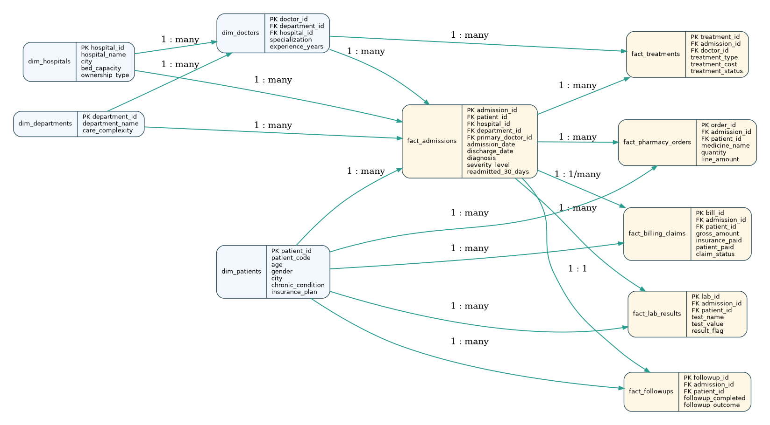
The model follows an analytical star-like design with admissions as the central fact table. Clinical, financial, pharmacy, lab, and follow-up records connect back to admissions and patients.

3. Primary Grain of Each Table
Table | Grain
patients | One row per patient master record. Duplicate patient codes exist intentionally.
admissions | One row per hospital admission. This is the main analytical grain.
treatments | One row per treatment/procedure performed during an admission.
billing_claims | One billing/claim record per admission with intentional duplicate rows and claim-status mismatch.
pharmacy_orders | One medicine order line per admission.
lab_results | One lab test result per admission and patient.
followups | One follow-up tracking record per admission.

4. Intentional Data Problems
Issue Type | Examples in this dataset
Missing values | age, city, chronic condition, discharge_date, diagnosis, treatment_cost, gross_amount, lab test values
Data mismatch | gender values such as M/F/male/Femle; readmission values such as Yes/Y/TRUE; claim status paid/PAID/Rejected
Outliers | age = 150 or -3; treatment_cost = 999999 and 2500000; negative treatment cost
Duplicates | duplicate patient master rows, duplicate admissions, duplicate treatment/billing/pharmacy rows
Referential integrity | admissions with patient IDs not available in patients; billing/treatment rows pointing to non-existing admissions
Dependency issues | length_of_stay cannot be calculated when discharge_date is missing; cost_per_day fails if LOS is zero or missing

5. Recommended Analytical Dataset
Build a cleaned admission-level analytical table by joining admissions with patients, hospitals, departments, doctors, aggregated treatment cost, billing amount, pharmacy spend, lab summary, and follow-up status.
Feature examples: length_of_stay, total_treatment_cost, total_pharmacy_cost, gross_amount, patient_paid, readmission_gap_days, previous_admissions, followup_completed_flag, age_group, chronic_flag, high_cost_flag, risk_score.

6. Data Dictionary Sample
Table | Column | Type | Sample Values
hospitals | hospital_id | int64 | 1 | 2 | 3
hospitals | hospital_name | object | MedNova Hospital - Hyderabad | MedNova Hospital - Bengaluru | MedNova Hospital - Chennai
hospitals | city | object | Hyderabad | Bengaluru | Chennai
hospitals | ownership_type | object | Private | Private | Trust
hospitals | bed_capacity | int64 | 420 | 360 | 310
hospitals | launch_year | int64 | 2009 | 2012 | 2014
departments | department_id | int64 | 1 | 2 | 3
departments | department_name | object | Cardiology | Neurology | Orthopedics
departments | care_complexity | object | High | High | Medium
doctors | doctor_id | int64 | 1 | 2 | 3
doctors | doctor_name | object | Dr. Sai Sharma | Dr. Raj Nair | Dr. Ishaan Khan
doctors | department_id | int64 | 4 | 12 | 9
doctors | specialization | object | General Medicine | ICU | Emergency
doctors | hospital_id | int64 | 8 | 7 | 6
doctors | experience_years | int64 | 9 | 10 | 16
doctors | doctor_grade | object | Consultant | Resident | Consultant
patients | patient_id | int64 | 1 | 2 | 3
patients | patient_code | object | P00001 | P00002 | P00003
patients | patient_name | object | Patient_BKOKF | Patient_KXPSW | Patient_TJAJT
patients | age | float64 | 46.0 | 58.0 | 51.0
patients | gender | object | Female | Male | Female
patients | city | object | Hyderabad | Hyderabad | Ahmedabad
patients | primary_chronic_condition | object | Heart Failure | Heart Failure | Hypertension
patients | insurance_plan | object | Premium Insurance | Basic Insurance | Government Scheme

