ML and DS Internship Practical

Month 1 – Python Fundamentals

Student Management System
Submitted By:
Saniya Shaikh

Submitted To: -
Mr. Farhan Memon (Groot Technology)
Technology Used: Python
Development Environment: Visual Studio Code

Table of Contents
Sr. No. | Contents | Page No.
1 | Objective | 3
2 | Introduction | 3
3 | Features | 3
4 | Concepts Used | 4
5 | Project Workflow | 5
6 | Learning Outcomes | 6
7 | Advantages | 6
8 | Limitations | 6
9 | Testing Report | 7
10 | Screenshots | 11
11 | Conclusion | 12
12 | GitHub Repository Link | 13

1 Objective: -
The objective of this project is to develop a console-based Student Management System using Python. The application enables users to manage student records efficiently by performing operations such as adding, viewing, searching, updating, and deleting student information.
2 Introduction: -
The Student Management System is a menu-driven Python application designed to manage student records. It allows users to store and maintain student details in an organized manner. The project demonstrates the practical implementation of Python fundamentals and provides hands-on experience with data management operations.
3 Features: -
- Add Student Record
- View All Student Records
- Search Student by Student ID
- Update Student Information
- Delete Student Record
- Input Validation
- Menu-Driven Interface
- User-Friendly Console Output

Input Validation Features
The system ensures that all required fields are entered before saving or updating student records.
- If Student ID is empty, the message "Please enter Student ID" is displayed.
- If Student Name is empty, the message "Please enter Student Name" is displayed.
- If Course is empty, the message "Please enter Course" is displayed.
- If Marks are empty, the message "Please enter Marks" is displayed.
- If Marks are entered 100 >, the message "Marks must be between 0 and 100. Please Enter Valid Marks."
4 Concepts Used: -

Variables
Used to store student details such as ID, name, course, and marks.
Data Types
- Integer (Student ID)
- String (Student Name, Course)
- Float (Marks)
Input and Output Operations
Used to receive user input and display results.
Conditional Statements
Used for decision-making and validating user inputs.
Loops
- while loop for displaying the menu repeatedly.
- for loop for traversing student records.
Functions
Functions used in the project:
- add_student()
- view_students()
- search_student()
- update_student()
- delete_student()

Lists
A list is used to store multiple student records.
Dictionaries
Each student record is stored as a dictionary containing student information.
Input Validation
Validation ensures that all mandatory fields are entered correctly before processing.

CRUD Operations
- Create → Add Student
- Read → View/Search Student
- Update → Update Student Details
- Delete → Delete Student Record
Menu-Driven Programming
The application operates through a menu that allows users to select different actions.
5 Project Workflow: -
- The application displays the main menu.
- The user selects an operation.
- The system performs the requested action.
- Student records are stored and managed using lists and dictionaries.
- The menu is displayed again until the user exits the program.
6 Learning Outcomes: -
Through this project, the following concepts were learned:
- Python Syntax
- Variables and Data Types
- Conditional Statements
- Loops
- Functions
- Lists
- Dictionaries
- Input Validation
- CRUD Operations
- Problem Solving Skills
7 Advantages: -
- Easy to use
- Beginner-friendly
- Improves programming skills
- Prevents incomplete student records
- Enhances logical thinking
8 Limitations: -
- Data is stored temporarily in memory.
- Records are lost when the application is closed.
- No database integration.

9 Testing Report: -

Test Case ID | Test Description | Test Input | Expected Result | Status
TC01 | Add Student with valid data | ID=101, Name=Saniya, Course=BCA, Marks=85 | Student added successfully | Pass
TC02 | View student records | Select View Option | All student records displayed | Pass
TC03 | Search existing student | ID=101 | Student found | Pass
TC04 | Search non-existing student | ID=999 | Student not found message displayed | Pass
TC05 | Update existing student | ID=101 | Student details updated successfully | Pass
TC06 | Delete existing student | ID=101 | Student deleted successfully | Pass
TC07 | Search deleted student | ID=101 | Student not found message displayed | Pass
TC08 | Enter empty Student ID | Blank Input | "Please enter Student ID" displayed | Pass
TC09 | Enter empty Student Name | Blank Input | "Please enter Student Name" displayed | Pass
TC10 | Enter empty Course | Blank Input | "Please enter Course" displayed | Pass
TC11 | Enter empty Marks | Blank Input | "Please enter Marks" displayed | Pass
TC12 | Enter alphabet in Student ID | abc | Student ID must be contain numbers only | Pass
TC13 | Enter special characters in Student ID | @#$ | Student ID must be contain numbers only | Pass
TC14 | Enter negative marks | -10 | "Marks must be between 0 and 100.Please Enter Valid Marks” | Pass
TC15 | Enter marks greater than 100 | 120 | "Marks must be between 0 and 100.Please Enter Valid Marks” | Pass
TC16 | Enter invalid menu choice | 9 | "Invalid Choice" displayed | Pass
TC17 | Add multiple students one by one | 3 Student Records | All records stored successfully | Pass
TC18 | Update non-existing student | ID=999 | Student not found message displayed | Pass
TC19 | Delete non-existing student | ID=999 | Student not found message displayed | Pass
TC20 | Exit application | Option 6 | Program terminated successfully | Pass

10 Screenshot: -
Menu Options
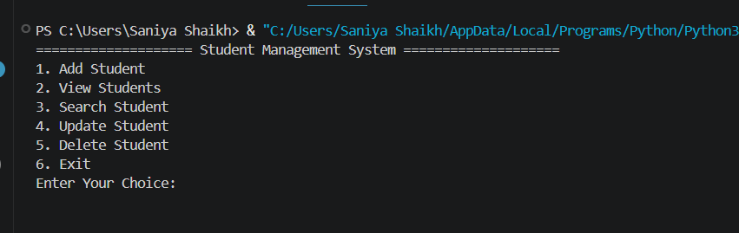

1 Add Student process succesfully
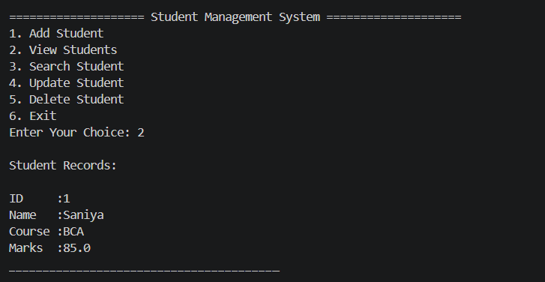

2 View Student
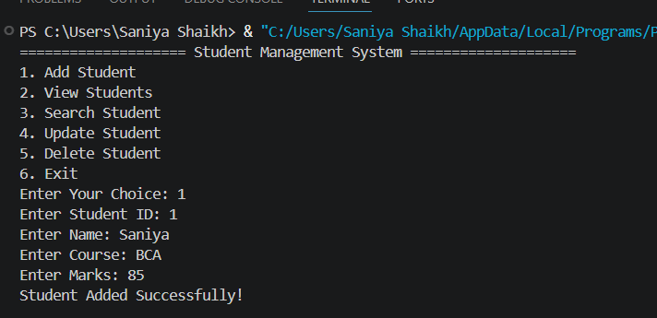

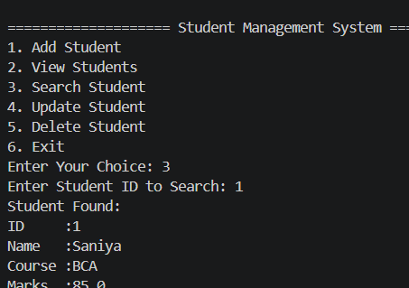
3 Search Student

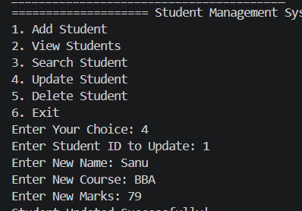
4 Update Student

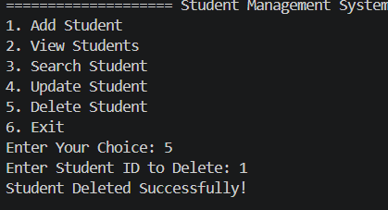
5 Delete Student

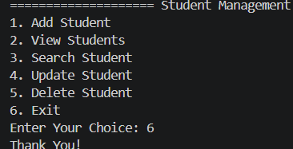
6 Exit

11 Conclusion: -
The Student Management System successfully demonstrates the implementation of Python fundamentals including variables, data types, loops, functions, lists, dictionaries, and input validation. The project provides practical experience in developing a menu-driven application and performing CRUD operations. It also improves problem-solving skills and serves as a strong foundation for more advanced software development projects.

12 GitHub Repository Link: -

