NAME:SANIYA GOUTAM
PRN:23070521126
BATCH B2
PRACTICAL 8
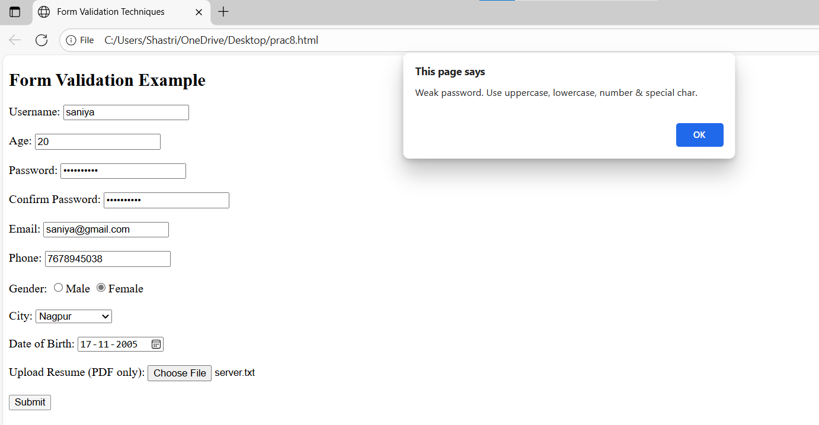

<!DOCTYPE html>
<html>
<head>
<title>Form Validation Techniques</title>
<script>
function validateForm() {
let username = document.getElementById("username").value;
let age = document.getElementById("age").value;
let password = document.getElementById("password").value;
let confirmPassword = document.getElementById("confirmPassword").value;
let email = document.getElementById("email").value;
let phone = document.getElementById("phone").value;
let gender = document.querySelector('input[name="gender"]:checked');
let city = document.getElementById("city").value;
let dob = new Date(document.getElementById("dob").value);
let today = new Date();
let file = document.getElementById("resume").files[0];
// 1. Required Field Validation
if (username.trim() === "") {
alert("Username is required");
return false;
}
// 2. Data Type Validation (Age)
if (isNaN(age)) {
alert("Age must be a number");
return false;
}
// 3. Length Validation (Password)
if (password.length < 6) {
alert("Password must be at least 6 characters");
return false;
}
// 4. Range Validation
if (age < 18 || age > 60) {
alert("Age must be between 18 and 60");
return false;
}
// 5. Pattern / Regex Validation (Email)
let emailPattern = /^[^ ]+@[^ ]+\.[a-z]{2,3}$/;
if (!email.match(emailPattern)) {
alert("Invalid email format");
return false;
}
// 6. Compare Fields Validation (Password match)
if (password !== confirmPassword) {
alert("Passwords do not match");
return false;
}

// 7. Numeric Validation (Phone)
if (!/^[0-9]+$/.test(phone)) {
alert("Phone must contain only digits");
return false;
}
// 8. Email Validation (same as above, extra check)
if (!email.match(emailPattern)) {
alert("Invalid email address");
return false;
}
// 9. Password Strength Validation
let passPattern = /^(?=.*[A-Z])(?=.*[a-z])(?=.*[0-9])(?=.*[@#$%^&+=]).{8,}$/;
if (!password.match(passPattern)) {
alert("Weak password. Use uppercase, lowercase, number & special char.");
return false;
}
// 10. Checkbox / Radio Validation
if (!gender) {
alert("Please select your gender");
return false;
}
// 11. Dropdown Validation
if (city === "") {
alert("Please select a city");
return false;
}
// 12. Date Validation
if (dob > today) {
alert("Date of Birth cannot be in the future");
return false;
}

// 13. File Upload Validation
if (file) {
if (file.size > 2 * 1024 * 1024) {
alert("File too large (Max 2MB)");
return false;
}
if (!file.name.endsWith(".pdf")) {
alert("Only PDF files are allowed");
return false;
}
} else {
alert("Please upload your resume");
return false;
}
alert("Form submitted successfully!");
return true;
}
// 15. Real-time (Live) Validation
function checkUsername() {
let username = document.getElementById("username").value;
let error = document.getElementById("error");
if (username.length < 3) {
error.innerText = "Must be at least 3 characters";
} else {
error.innerText = "";
}
}
</script>
</head>
<body>
<h2>Form Validation Example</h2>
<form onsubmit="return validateForm()">

<label>Username:</label>
<input type="text" id="username" oninput="checkUsername()" required>
<span id="error" style="color:red"></span>
<br><br>
<label>Age:</label>
<input type="number" id="age" required><br><br>
<label>Password:</label>
<input type="password" id="password" required><br><br>
<label>Confirm Password:</label>
<input type="password" id="confirmPassword" required><br><br>
//14 email validating
<label>Email:</label>
<input
type="email"
name="email"
required
oninvalid="this.setCustomValidity('Enter a valid email!')"
oninput="this.setCustomValidity('')" >
<br><br>
<label>Phone:</label>
<input type="text" id="phone" required><br><br>
<label>Gender:</label>
<input type="radio" name="gender" value="male">Male
<input type="radio" name="gender" value="female">Female<br><br>
<label>City:</label>
<select id="city">
<option value="">--Select City--</option>
<option value="Nagpur">Nagpur</option>
<option value="Pune">Pune</option>
<option value="Mumbai">Mumbai</option>
</select><br><br>
<label>Date of Birth:</label>
<input type="date" id="dob"><br><br>

<label>Upload Resume (PDF only):</label>
<input type="file" id="resume"><br><br>
<input type="submit" value="Submit">
</form></body>
</html>

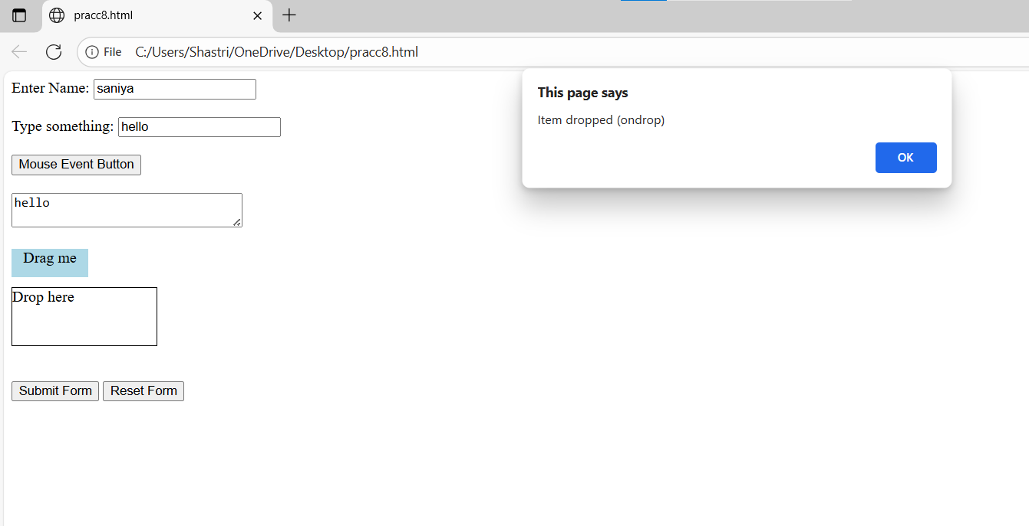
<!DOCTYPE html>
<html>
<head>
<script>
function formSubmitted() {
alert("Form submitted (onsubmit)");
return false;
}
function formReset() {
alert("Form reset (onreset)");
}
function formInput() {
console.log("Form input detected (onforminput)");
}
function formChange() {
console.log("Form element changed (onformchange)");
}
function onChange() {
alert("Value changed (onchange)");
}
function onFocusExample() {
console.log("Input focused (onfocus)");
}
function onBlurExample() {
console.log("Input lost focus (onblur)");
}
function onFocusInExample() {
console.log("Focus entered (onfocusin)");
}
function onFocusOutExample() {
console.log("Focus left (onfocusout)");
}

function keyDown() {
console.log("Key pressed down (onkeydown)");
}
function keyUpExample() {
console.log("Key released (onkeyup)");
}

// Mouse Events
function doubleClickExample() {
alert("Double-clicked (ondblclick)");
}
function mouseDownExample() {
console.log("Mouse down (onmousedown)");
}
function mouseUpExample() {
console.log("Mouse up (onmouseup)");
}
function mouseMoveExample() {
console.log("Mouse moved (onmousemove)");
}
function mouseOverExample() {
console.log("Mouse entered (onmouseover)");
}
function mouseOutExample() {
console.log("Mouse left (onmouseout)");
}

function onCopy() {
alert("Copied text (oncopy)");
}
function onCutExample() {
alert("Cut text (oncut)");
}
function onPasteExample() {
alert("Pasted text (onpaste)");
}
function dragStartExample() {
console.log("Drag started (ondragstart)");
}
function dragOverExample(event) {
event.preventDefault();
console.log("Dragging over target (ondragover)");
}
function dropExample(event) {
event.preventDefault();
alert("Item dropped (ondrop)");
}

// Other Useful Events
function onSelectExample() {
alert("Text selected (onselect)");
}
function onWheelExample() {
console.log("Mouse wheel used (onwheel)");
}
</script>
</head>

<body>

<form onsubmit="return formSubmitted()"
onreset="formReset()"
onforminput="formInput()"
onformchange="formChange()">

<!-- Input & Field Events -->
<label>Enter Name:</label>
<input type="text"
onchange="onChangeExample()"
onfocus="onFocusExample()"
onblur="onBlurExample()"
onfocusin="onFocusInExample()"
onfocusout="onFocusOutExample()">
<br><br>

<!-- Keyboard Events -->
<label>Type something:</label>
<input type="text" onkeydown="keyDownExample()" onkeyup="keyUpExample()">
<br><br>

<!-- Mouse Events -->
<button type="button"
ondblclick="doubleClickExample()"
onmousedown="mouseDownExample()"
onmouseup="mouseUpExample()"
onmousemove="mouseMoveExample()"
onmouseover="mouseOverExample()"
onmouseout="mouseOutExample()">
Mouse Event Button
</button>
<br><br>
<textarea rows="2" cols="30"
oncopy="onCopyExample()"
oncut="onCutExample()"
onpaste="onPasteExample()">
copy or paste
</textarea>
<br><br>
<div draggable="true"
ondragstart="dragStartExample()"
style="width:80px;height:30px;background-color:lightblue;text-align:center;">
Drag me
</div>
<div ondragover="dragOverExample(event)"
ondrop="dropExample(event)"
style="width:150px;height:60px;border:1px solid black;margin-top:10px;">
Drop here
</div>
<br><br>

<input type="submit" value="Submit Form">
<input type="reset" value="Reset Form">
</form>
</body>
</html>

