NAME:SANIYA GOUTAM
TEAM MEMBER :
SHREYASI GIDMARE
PRN:23070521126 , 23070521146
TASK1:
1. To-Do List With a Twist (Emoji Mode)
● What to build:
A basic to-do list, but every task must have an emoji selected from a
dropdown.
● DOM Skills:
getElementById to get input and dropdown values.
createElement to create new list items.
appendChild to display the task with emoji.
querySelector to select tasks for edit/remove.

Extra fun challenge:
● Add a “Random Emoji” button that automatically selects a random emoji
from a predefined array.
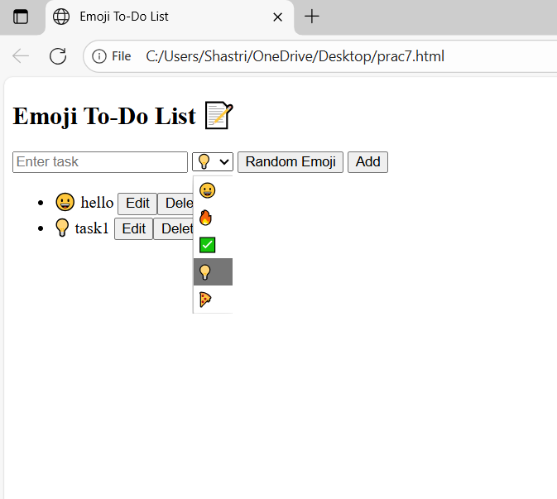<!DOCTYPE html>
<html lang="en">
<head>
<meta charset="UTF-8">
<title>Emoji To-Do List</title>
</head>
<body>
<h2>Emoji To-Do List 📝</h2>

<input type="text" id="taskInput" placeholder="Enter task">
<select id="emojiSelect">
<option value="😀">😀</option>
<option value="🔥">🔥</option>
<option value="✅">✅</option>
<option value="👍">💡</option>
<option value="🍕">🍕</option>
</select>
<button id="randomBtn">Random Emoji</button>
<button id="addBtn">Add</button>

<ul id="taskList"></ul>

<script>
const taskInput = document.getElementById("taskInput");
const emojiSelect = document.getElementById("emojiSelect");
const taskList = document.getElementById("taskList");
const addBtn = document.getElementById("addBtn");
const randomBtn = document.getElementById("randomBtn");

const emojis = ["😀","🔥","✅","💡","🍕","🚀","🌟","🐱","🎉","📚"];

randomBtn.onclick = () => {
const randomEmoji = emojis[Math.floor(Math.random() * emojis.length)];
emojiSelect.value = randomEmoji;
};

addBtn.onclick = () => {
const text = taskInput.value.trim();
if (text === "") return;

const li = document.createElement("li");

const span = document.createElement("span");
span.textContent = emojiSelect.value + " " + text + " ";

const editBtn = document.createElement("button");
editBtn.textContent = "Edit";
editBtn.className = "edit-btn";

const delBtn = document.createElement("button");
delBtn.textContent = "Delete";
delBtn.className = "delete-btn";

li.appendChild(span);
li.appendChild(editBtn);
li.appendChild(delBtn);
taskList.appendChild(li);

taskInput.value = "";
};

taskList.addEventListener("click", (e) => {
if (e.target.classList.contains("edit-btn")) {
const li = e.target.closest("li");
const span = li.querySelector("span");
const newTask = prompt("Edit task:", span.textContent.trim());
if (newTask) span.textContent = emojiSelect.value + " " + newTask + " ";
}

if (e.target.classList.contains("delete-btn")) {
e.target.closest("li").remove();
}
});
</script>
</body>
</html>

