NAME:SANIYA GOUTAM
PRN:23070521126
TASK1
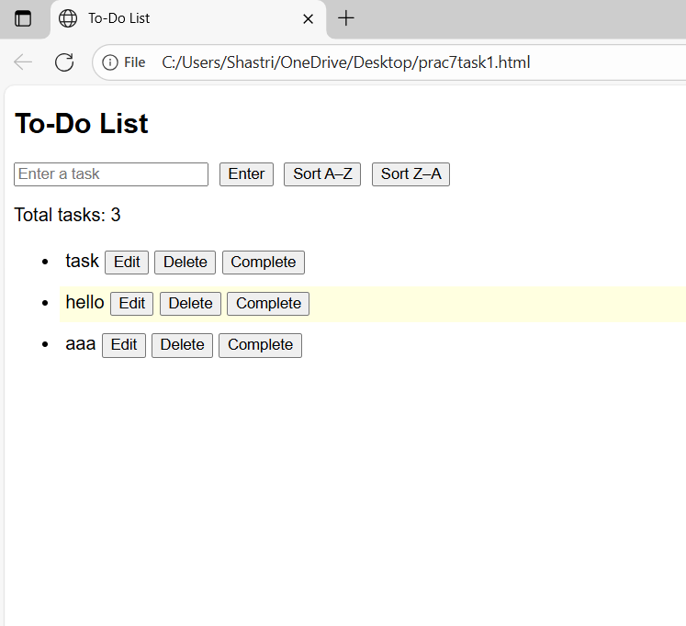
<!DOCTYPE html>
<html lang="en">
<head>
<meta charset="UTF-8">
<title>To-Do List</title>
<style>
body { font-family: Arial, sans-serif; }
#todoList li { margin: 5px 0; padding: 5px; }
#todoList li:hover { background-color: lightyellow; }
.completed span { text-decoration: line-through; color: gray; }
button { margin-left: 5px; }
</style>
</head>
<body>
<h2>To-Do List</h2>
<input type="text" id="taskInput" placeholder="Enter a task">
<button onclick="addTask()">Enter</button>
<button onclick="sortTasks(true)">Sort A–Z</button>
<button onclick="sortTasks(false)">Sort Z–A</button>
<p>Total tasks: <span id="taskCount">0</span></p>
<ul id="todoList"></ul>

<script>
const input = document.getElementById('taskInput');
const taskList = document.getElementById('todoList');

input.addEventListener("keypress", function(e) {
if (e.key === "Enter") addTask();
});

function addTask(taskText = null, completed = false) {
const text = taskText || input.value.trim();
if (!text) return;

const tasks = document.querySelectorAll('#todoList span');
for (let t of tasks) {
if (t.textContent === text) {
if (!taskText) alert("Task already exists!");
return;
}
}

const li = document.createElement('li');
const span = document.createElement('span');
span.textContent = text;

const editBtn = document.createElement('button');
editBtn.textContent = 'Edit';
editBtn.onclick = function () {
const inputEdit = document.createElement('input');
inputEdit.type = "text";
inputEdit.value = span.textContent;
li.insertBefore(inputEdit, span);
li.removeChild(span);
inputEdit.focus();
inputEdit.onblur = function () {
if (inputEdit.value.trim() !== "") {
span.textContent = inputEdit.value.trim();
}
li.insertBefore(span, inputEdit);
li.removeChild(inputEdit);
updateCount();
saveTasks();
};
};

const deleteBtn = document.createElement('button');
deleteBtn.textContent = 'Delete';
deleteBtn.onclick = function () {
if (confirm("Delete this task?")) {
li.remove();
updateCount();
saveTasks();
}
};

const completeBtn = document.createElement('button');
completeBtn.textContent = 'Complete';
completeBtn.onclick = function () {
li.classList.toggle('completed');
saveTasks();
};

if (completed) li.classList.add('completed');

li.appendChild(span);
li.appendChild(editBtn);
li.appendChild(deleteBtn);
li.appendChild(completeBtn);
taskList.appendChild(li);

if (!taskText) input.value = "";
updateCount();
saveTasks();
}

function updateCount() {
document.getElementById("taskCount").textContent =
document.querySelectorAll("#todoList li").length;
}

function saveTasks() {
const allTasks = [];
document.querySelectorAll("#todoList li").forEach(li => {
allTasks.push({
text: li.querySelector("span").textContent,
completed: li.classList.contains("completed")
});
});
localStorage.setItem("tasks", JSON.stringify(allTasks));
}

window.onload = function () {
const saved = JSON.parse(localStorage.getItem("tasks") || "[]");
saved.forEach(task => {
addTask(task.text, task.completed);
});
};

function sortTasks(asc = true) {
let tasks = Array.from(document.querySelectorAll("#todoList li"));
tasks.sort((a, b) => {
let t1 = a.querySelector("span").textContent.toLowerCase();
let t2 = b.querySelector("span").textContent.toLowerCase();
return asc ? t1.localeCompare(t2) : t2.localeCompare(t1);
});
taskList.innerHTML = "";
tasks.forEach(li => taskList.appendChild(li));
saveTasks();
}
</script>
</body>
</html>

