NAME: SANIYA GOUTAM
PRN:23070521126
PRACTICAL 3 FINAL TASK
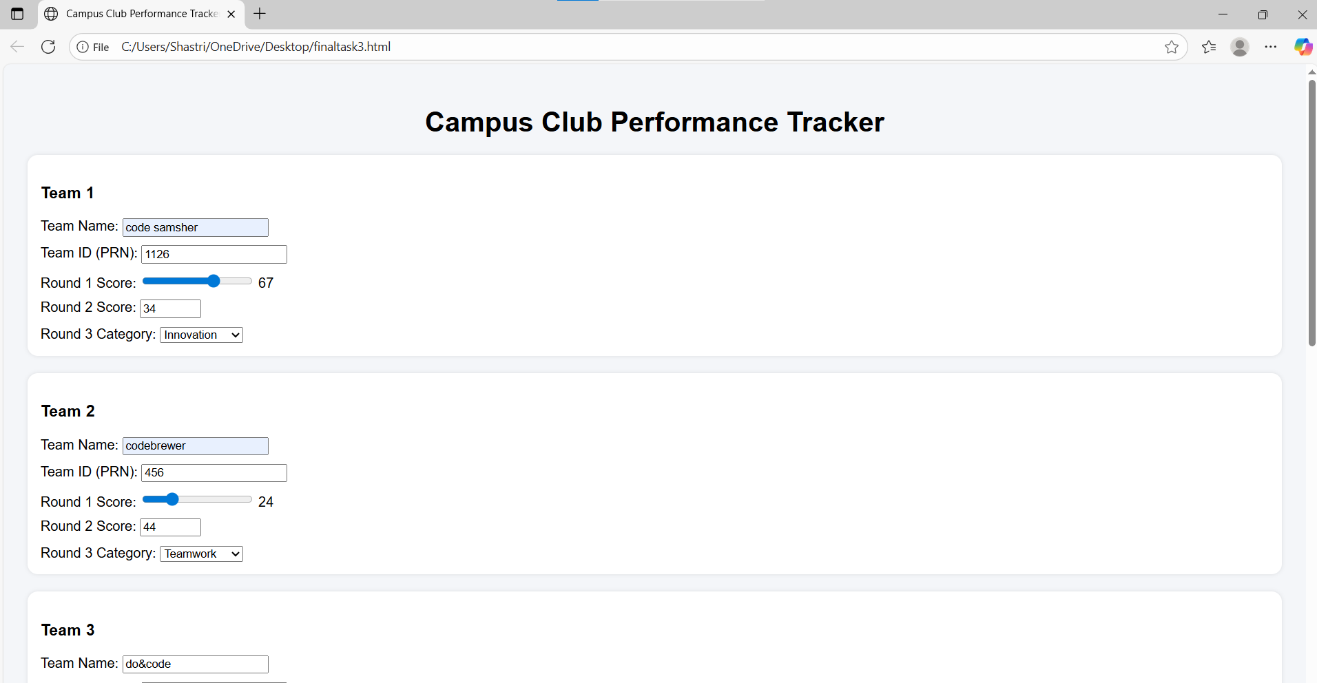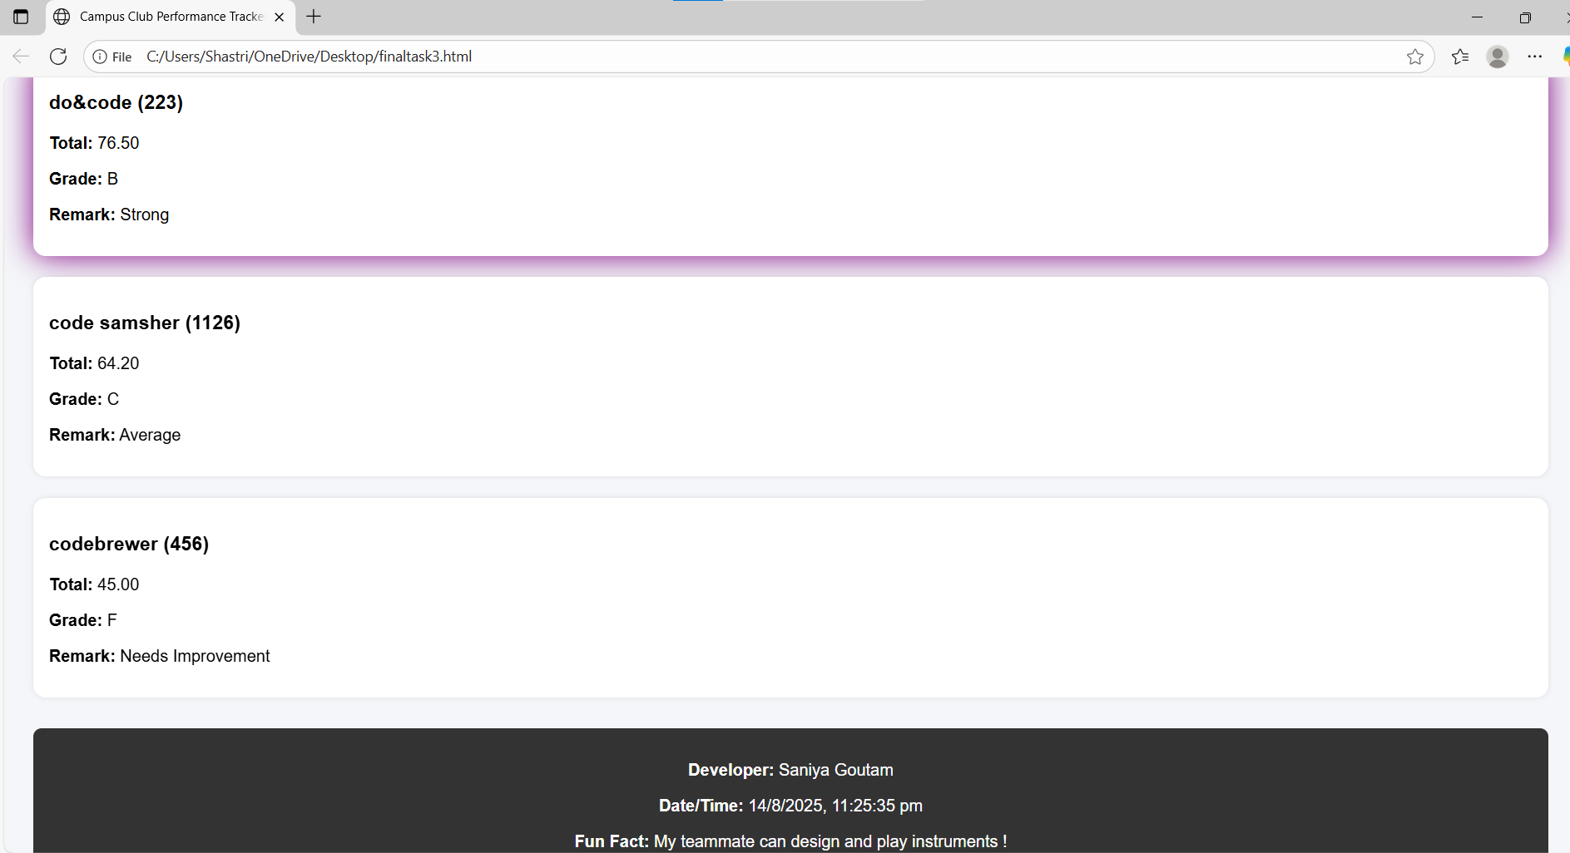
CODE
<!DOCTYPE html>
<html lang="en">
<head>
<meta charset="UTF-8">
<title>Campus Club Performance Tracker</title>
<style>
body { font-family: Arial, sans-serif; background: #f4f6f9; padding: 20px; }
h1 { text-align: center; margin-bottom: 20px; }
.team-card {
background: white;
border-radius: 12px;
padding: 15px;
margin-bottom: 20px;
box-shadow: 0 0 5px rgba(0,0,0,0.1);
transition: all 0.4s ease;
}
/* Purple highlight for top scorer */
.team-card.highlight {
box-shadow: 0 0 20px 5px purple;
animation: glowPulse 1s infinite alternate;
}
@keyframes glowPulse {
0% { box-shadow: 0 0 10px purple; }
100% { box-shadow: 0 0 30px purple; }
}
.flip { animation: flipCard 0.8s forwards; }
@keyframes flipCard {
0% { transform: rotateY(0); }
100% { transform: rotateY(360deg); }
}
footer {
margin-top: 30px;
padding: 15px;
background: #333;
color: white;
text-align: center;
border-radius: 8px;
}
label { display: block; margin-top: 10px; }
</style>
</head>
<body>
<h1>Campus Club Performance Tracker</h1>
<form id="trackerForm">
<div class="team-card">
<h3>Team 1</h3>
<label>Team Name: <input type="text" name="teamName1" required></label>
<label>Team ID (PRN): <input type="number" name="teamId1" required></label>
<label>Round 1 Score: <input type="range" name="r1_1" min="0" max="100" value="50" oninput="this.nextElementSibling.textContent=this.value"> <span>50</span></label>
<label>Round 2 Score: <input type="number" name="r2_1" min="0" max="100" required></label>
<label>Round 3 Category: <select name="cat1"></select></label>
</div>

<div class="team-card">
<h3>Team 2</h3>
<label>Team Name: <input type="text" name="teamName2" required></label>
<label>Team ID (PRN): <input type="number" name="teamId2" required></label>
<label>Round 1 Score: <input type="range" name="r1_2" min="0" max="100" value="50" oninput="this.nextElementSibling.textContent=this.value"> <span>50</span></label>
<label>Round 2 Score: <input type="number" name="r2_2" min="0" max="100" required></label>
<label>Round 3 Category: <select name="cat2"></select></label>
</div>
<div class="team-card">
<h3>Team 3</h3>
<label>Team Name: <input type="text" name="teamName3" required></label>
<label>Team ID (PRN): <input type="number" name="teamId3" required></label>
<label>Round 1 Score: <input type="range" name="r1_3" min="0" max="100" value="50" oninput="this.nextElementSibling.textContent=this.value"> <span>50</span></label>
<label>Round 2 Score: <input type="number" name="r2_3" min="0" max="100" required></label>
<label>Round 3 Category: <select name="cat3"></select></label>
</div>
<button type="submit">Calculate Results</button>
</form>
<div id="results"></div>
<footer id="footer"></footer>
<script>
const categories = ["Innovation", "Teamwork", "Creativity", "Presentation"];
const weights = { r1: 0.4, r2: 0.35, r3: 0.25 };
document.querySelectorAll("select").forEach(sel => {
[...categories].sort(() => Math.random() - 0.5).forEach(cat => {
let opt = document.createElement("option");
opt.value = cat;
opt.textContent = cat;
sel.appendChild(opt);
});
});
document.getElementById("trackerForm").addEventListener("submit", function(e) {
e.preventDefault();
const formData = new FormData(e.target);
const resultsDiv = document.getElementById("results");
resultsDiv.innerHTML = "";
let teams = [];
for (let i = 1; i <= 3; i++) {
let name = formData.get(`teamName${i}`).trim();
let id = formData.get(`teamId${i}`);
let r1 = parseFloat(formData.get(`r1_${i}`));
let r2 = parseFloat(formData.get(`r2_${i}`));
let cat = formData.get(`cat${i}`);
if ([r1, r2].some(v => v < 0 || v > 100)) {
alert("Scores must be between 0 and 100!");
return;
}
let r3Score = (cat === "Innovation") ? 90 : 80;
let total = r1 * weights.r1 + r2 * weights.r2 + r3Score * weights.r3;
if (r2 > 80) total += 5;
if (cat === "Innovation") total += 3;
let grade;
if (total >= 90) grade = "A";
else if (total >= 75) grade = "B";
else if (total >= 60) grade = "C";
else grade = "F";
let remark;
switch (grade) {
case "A": remark = "Outstanding"; break;
case "B": remark = "Strong"; break;
case "C": remark = "Average"; break;
default: remark = "Needs Improvement";
}teams.push({ name, id, total: total.toFixed(2), grade, remark });
}teams.sort((a, b) => {
if (b.total == a.total) return a.name[0].localeCompare(b.name[0]);
return b.total - a.total;
});
let topScore = teams[0].total;
teams.forEach(team => {
let card = document.createElement("div");
card.className = "team-card flip";
if (team.total == topScore) card.classList.add("highlight");
card.innerHTML = `
<h3>${team.name} (${team.id})</h3>
<p><b>Total:</b> ${team.total}</p>
<p><b>Grade:</b> ${team.grade}</p>
<p><b>Remark:</b> ${team.remark}</p>
`;
resultsDiv.appendChild(card);
});
let now = new Date();
document.getElementById("footer").innerHTML =
`<p><b>Developer:</b> Saniya Goutam</p>
<p><b>Date/Time:</b> ${now.toLocaleString()}</p>
<p><b>Fun Fact:</b> My teammate can !</p>`;
});
</script>
</body>
</html>

