NAME: SANIYA GOUTAM
PRN:23070521126 BATCH “B2”
PRACTICAL 5 PART 3
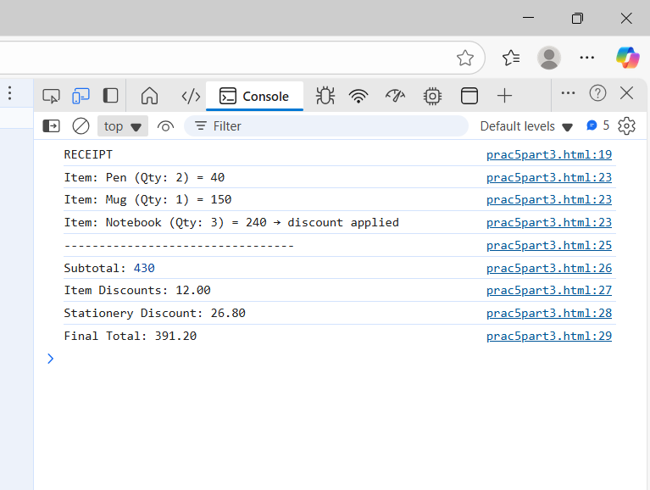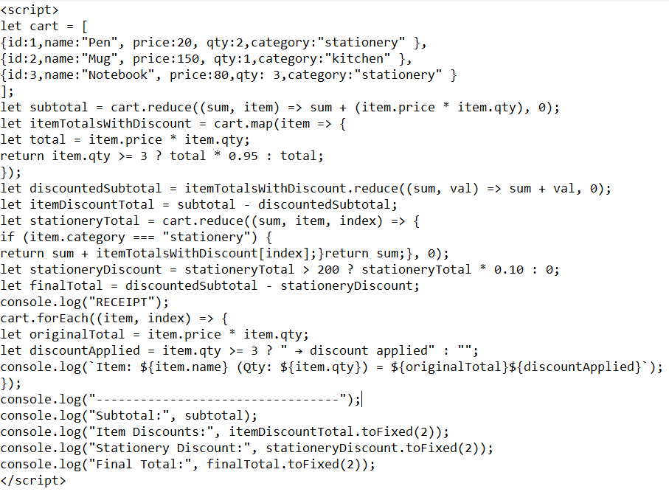
Q.Which function (map, filter, reduce, forEach) was hardest to apply? Why?
The hardest part for me was using filter(), since I needed to carefully pick out just the stationery items. Then I had to use reduce() to calculate their subtotal, and figuring out how to connect these functions took me a little while to get the hang of.
Q. How could this program be extended (e.g., tax, coupons, shipping)?
This program could be made even more useful by adding tax calculations, shipping fees based on the order or location, and options for discounts or loyalty points. It could also track inventory so you always know what’s in stock.e.g
let coupon = 50;
finalTotal -= coupon;
console.log("Coupon Discount:", coupon);

